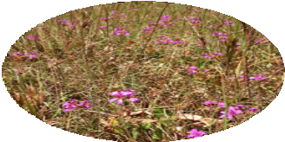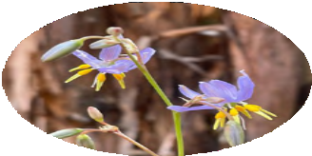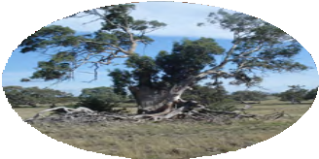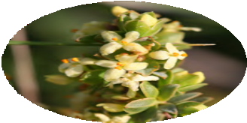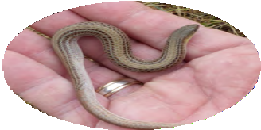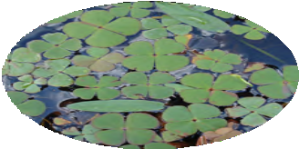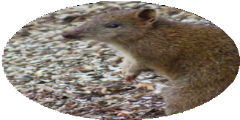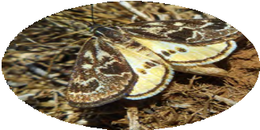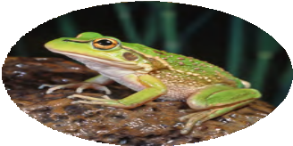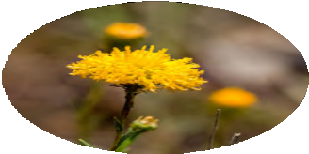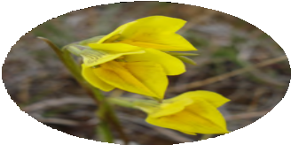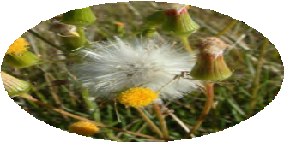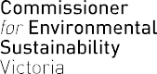

Strategic Audit of the Implementation of
Melbourne Strategic Assessment Conservation Outcomes 2022 Report

COVER IMAGE: Natural Temperate Grassland, Grassy Eucalypt Woodland, Golden Sun Moth, Matted Flax-lily, Spiny Rice-flower, Seasonal Herbaceous Wetland, Growling Grass Frog, Button Wrinklewort, Large-fruit Groundsel, Striped Legless Lizard, Southern Brown Bandicoot, Small Golden Moths Orchid © Images courtesy of DELWP
ISSN 2653-6099
Published by the Commissioner for Environmental Sustainability, Melbourne, Victoria, October 2022
© The State of Victoria, Commissioner for Environmental Sustainability 2022
This publication is copyright. No part may be reproduced by any process except in accordance with the provisions of the Copyright Act 1968.
Please print on recycled paper.
Authorised by the Victorian Commissioner for Environmental Sustainability, Level 36, 2 Lonsdale Street, Melbourne, Victoria 3000
For further information, email the Commissioner for Environmental Sustainability at info.ces@ces.vic.gov.au or visit www.ces.vic.gov.au
Disclaimer
This report may be of assistance to you and every effort has been made to ensure that the information provided is correct. It is based largely on data and information provided by the Victorian Government. The Commissioner for Environmental Sustainability does not guarantee that the report is without flaw of any kind or is wholly appropriate for your purposes and therefore disclaims all liability for any error, loss or other consequence which may arise from you relying on any information in this publication.

Traditional Owners
The Commissioner for Environmental Sustainability proudly acknowledges Victoria’s Aboriginal community and their rich culture and pays respect to their Elders past and present. We acknowledge Aboriginal people as Australia’s first peoples and as the Traditional Owners and custodians of the land and water on which we rely. We recognise and value the ongoing contribution of Aboriginal people and communities to Victorian life, and how this enriches us. We embrace the spirit of reconciliation, working towards the equality of outcomes and ensuring an equal voice.

Commissioner’s foreword

I am pleased to present this Strategic Audit of the Implementation of Melbourne Strategic Assessment (MSA) Conservation Outcomes Report, which comes at a critical stage in the evolution of the MSA program.

Delivering Melbourne’s Newest Sustainable Communities is the Victorian Government’s plan for four growth areas of Melbourne covering approximately 60,000 ha.1 The growth areas are designed to accommodate Melbourne’s future population growth and urban expansion.
The MSA program was established in 2008 in the interest of Ecologically
Sustainable Development (ESD). It is an intrinsic part of the Government’s plan for urban development in growth areas to consider the care and protection of biodiversity, consistent with Victorian and Australian environmental laws protecting Matters of National Environmental Significance (MNES). The MSA Act 2020 requires that a biennial strategic audit of the implementation of the Melbourne Strategic Assessment Conservation Outcomes be completed by the Victorian Commissioner for Environmental Sustainability.
Under the MSA program, conservation areas were identified for protection of MNES, including two large reserves containing some of the last remaining critically endangered grassland habitats on Melbourne's outskirts. These areas are intended to provide habitat for threatened species and protect endangered
ecosystems impacted by development in surrounding growth areas.
This inaugural strategic audit under the MSA Act 2020 assesses the conservation outcomes for 12 MNES including three ecological communities, five plant species and four animal species. It provides a scientific baseline – status, trend and data confidence assessments – for future, biennial reporting by the Commissioner.
The science presented applies the existing MSA monitoring and reporting framework of the Victorian Department of Environment, Land, Water and Planning (DELWP), to assess the ecological status and trend of the 12 MNES against objectives defined formally in the Notice
of the Conservation Outcomes published in the Victorian Government Gazette on 27 January 2022.2
Specifically, this strategic audit aims to:
- assess the extent to which conservation outcomes are being achieved through the MSA program
- evaluate whether the processes and activities established to achieve outcomes are adequate
- inform adaptive management and improvements.

- Department of Environment and Primary Industries (DEPI) 2009, ‘Delivering Melbourne’s Newest Sustainable Communities: Program Report’, East Melbourne, Victoria.
- State Government of Victoria 2022, Victorian Government Gazette Issue G4, ‘Melbourne Strategic Assessment (Environment Mitigation Levy) Act 2020 – Notice of the Conservation Outcomes’ http://www.gazette.vic.gov.au/gazette/Gazettes2022/GG2022G004.pdf Accessed 27 January 2022.

In 2019, the Victorian Auditor-General’s Office (VAGO) undertook an audit ‘Protecting Critically Endangered Grasslands’ 3 focusing on the implementation of the MSA program with respect to its commitments to protect two of the 12 MNES – Natural Temperate Grasslands and Grassy Eucalypt Woodlands. VAGO made seven recommendations to DELWP, all of which were accepted. I acknowledge the significant research and analysis undertaken by VAGO, DELWP and others in recent years and reference this work where relevant, throughout this report.
This strategic audit presents 16 recommendations. It found that limitations with the current MSA
Monitoring and Reporting Framework (MRF)4 are hampering the ability of the MSA program to provide sufficient evidence to demonstrate that it is on track to fulfil its objectives and inform the systemic improvement required.
Accordingly, recommendations 1 to 4 relate to improving the MSA program implementation and design while recommendations 5 to 16 focus on each of the 12 MNES – the ecological communities, plants and animals that are protected by the MSA program, including the last known population of the Small Golden Moths Orchid.
Sincere thanks to everyone who has contributed, in small and large part, to the preparation of this report.

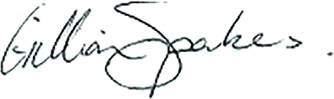
Dr Gillian Sparkes AM
Commissioner for Environmental Sustainability, Victoria

- VAGO 17 June 2020, Protecting Critically Endangered Grasslands, https://www.audit.vic.gov.au/report/protecting-critically-endangered- grasslands?section= Accessed 27 January 2022.
- DELWP 2015, ‘Monitoring and Reporting Framework – Melbourne Strategic Assessment’, East Melbourne, Victoria.

Table of contents
Commissioner’s foreword 3
Acronyms and abbreviations 6
Summary of figures and tables 7
Acknowledgements 9
Executive summary 10
Summary of recommendations and challenges 14
Part 1: Summary of findings 26
MSA program design and implementation 30
MNES Conservation Outcomes 37
MNES 1: Natural Temperate Grassland 37
MNES 2: Grassy Eucalypt Woodland 44
MNES 3: Seasonal Herbaceous Wetland 47
MNES 4: Golden Sun Moth 50
MNES 5: Matted Flax-lily 52
MNES 6: Spiny Rice-flower 53
MNES 7: Southern Brown Bandicoot 55
MNES 8: Growling Grass Frog 56
MNES 9: Small Golden Moths Orchid 57
MNES 10: Striped Legless Lizard 58
MNES 11: Button Wrinklewort 60
MNES 12: Large-fruit Groundsel 61
Part 2: Scientific assessments 62
MNES 1: Natural Temperate Grassland 73
MNES 2: Grassy Eucalypt Woodland 88
MNES 3: Seasonal Herbaceous Wetlands 94
MNES 4: Golden Sun Moth 103
MNES 5: Matted Flax-lily 109
MNES 6: Spiny Rice-flower 115
MNES 7: Southern Brown Bandicoot 122
MNES 8: Growling Grass Frog 128
MNES 9: Small Golden Moths Orchid 134
MNES 10: Striped Legless Lizard 137
MNES 11: Button Wrinklewort 141
MNES 12: Large-fruit Groundsel 146
Appendix 1 – Historical and legislative context 150
Appendix 2 – Summary of MNES monitoring methods and changes to MRF since 2015 170

Acronyms and abbreviations

Acronyms
ARI Arthur Rylah Institute
CES Commissioner for Environmental Sustainability, Victoria
BCS Biodiversity Conservation Strategy
CI Confidence Interval
DELWP Victorian Department of Environment, Land, Water and Planning
DEPI Department of Environment and Primary Industries
KPI Key Performance Indicator
LGA Local Government Area
MNES Matters of National Environmental Significance
MRF Monitoring and reporting framework
MSA Melbourne Strategic Assessment
NNL No Net Loss
PAO Public Acquisition Overlay
PVA Population Viability Analysis
SPOM Stochastic Patch Occupancy Model
STM State-and-Transition Model
UGB Urban Growth Boundary
VAGO Victorian Auditor-General’s Office

Abbreviations
MSA Outcomes Report 2014–2020 .................................................... the MSA Ecological Outcomes Report 2014-15 to 2019–20
CaLP Act Catchment and Land Protection Act 1994
CES Act Commissioner for Environmental Sustainability Act 2003
the Commissioner the Commissioner for Environmental Sustainability, Victoria EPBC Act Environment Protection and Biodiversity Conservation Act 1999
the Minister the Minister for Environment and Climate Action
MSA Act Melbourne Strategic Assessment (Environment Protection Mitigation Levy) Act 2020
P&E Act Planning & Environment Act 1987
the Secretary the Secretary of the Department of Environment, Land, Water and Planning, Victorian Government

Summary of figures and tables

Figures
Figure 1: Matters of National Environmental Significance (MNES) monitored under the MSA program 12
Figure 2: Map of the MSA program area 26
Figure 3: Annual monitoring being undertaken by DELWP staff at Truganina Cemetery 63
Figure 4: Example of a KPI indicator chart, in this case the KPI was recorded as achieved 70
Figure 5: Natural Temperate Grassland in the Western Grassland Reserve 73
Figure 6: Map of Natural Temperate Grassland monitoring locations (north) 75
Figure 7: Map of Natural Temperate Grassland monitoring locations (west) 76
Figure 8: Cover of native perennial forbs in Natural Temperate Grassland, displayed by state 77
Figure 9: Richness of native perennial forbs in Natural Temperate Grassland, displayed by state 78
Figure 10: Cover of Kangaroo Grass (Themeda triandra), displayed by state 79
Figure 11: Cover of perennial native grasses (excluding Themeda triandra) in Natural Temperate Grassland,
displayed by state 80
Figure 12: Percentage cover of all perennial vegetation comprised of weeds 82
Figure 13: Grassy Eucalypt Woodland of the Victorian Volcanic Plain 88
Figure 14: Map of monitored locations of Grassy Eucalypt Woddland 90
Figure 15: Example of Seasonal Herbaceous Wetlands after filling 94
Figure 16: The locations of the subject wetlands within the protected Western Grassland Reserve 97
Figure 17: The richness of native forbs for each wetland 98
Figure 18: The percentage of all perennial vegetation comprised of weeds for each wetland 99
Figure 19: Male Golden Sun Moth in the Western Grassland Reserve 103
Figure 20: Map of monitored areas for the Golden Sun Moth 105
Figure 21: The proportion of plots in which Golden Sun Moth was detected 106
Figure 22: A flowering Matted Flax-lily 109
Figure 23: A clump of Matted Flax-lily (foreground) 109
Figure 24: Map of monitored locations for the Matted Flax-lily 112
Figure 25: Matted Flax-lily plants detected in the first four years of monitoring at Kalkallo Common,
expressed as a percentage of the total number of plants known in each year 113
Figure 26: Spiny Rice-flower 115
Figure 27: Map of monitored locations of Spiny Rice-flower 117
Figure 28: Population count of Spiny Rice-flower at Radio and Truganina Cemetery in 2019 and 2021
(not monitored in 2020) 118
Figure 29: Two Spiny Rice-flower recruits, Truganina Cemetery 119
Figure 30: Southern Brown Bandicoot 122

Figure 31: Map of Southern Brown Bandicoot management area 124
Figure 32: The modelled proportion of sites occupied by Southern Brown Bandicoot
and the detection probability for Southern Brown Bandicoot 125
Figure 33: Growling Grass Frog 128
Figure 34: Known Growling Grass Frog areas under MSA management 130
Figure 35: Small Golden Moths Orchid 134
Figure 36: Map of Conservation Area 3 135
Figure 37: Striped Legless Lizard within the Western Grassland Reserve 137
Figure 38: Map of monitored areas for Striped Legless Lizard 138
Figure 39: Button Wrinklewort 141
Figure 40: Map of monitored areas for Button Wrinklewort 143
Figure 41: Population count of Button Wrinklewort at Truganina Cemetery, 2015–2021 143
Figure 42: Large-fruit Groundsel 146
Figure 43: Map of monitored areas of Large-fruit Groundsel 148
Figure 44: Population count Large-fruit Groundsel at Little Raven, 2017–2021 148
Figure 45: Timeline of regulatory changes enabling the MSA program 166
Figure 46: A point-intercept plot used to sample Natural Temperate Grassland 172
Figure 47: Hydrological phases of the Seasonal Herbaceous Wetlands 179
Figure 48: The small plot used to sample Seasonal Herbaceous Wetland 180

Tables
Table 1: Summary of recommendations and challenges 14
Table 2: The distribution of all plots according to bare ground categories 81
Table 3: Percentage of population formed by recruits 119
Table 4: Detections of Striped Legless Lizard at permanent monitoring plots (phase 3) by year 139
Table 5: Monitoring timeframes 154
Table 6: KPIs met as at 28 February 2022 159
Table 7: KPIs not met as at 28 February 2022 161
Table 8: KPIs not assessed as at 28 February 2022 161
Table 9: Sampling intensity for Natural Temperate Grassland, showing how the different
plot types have been dispersed across the states in different years 173
Table 10: Definitions of woodland structural types 178
Table 11: Details of occupancy model covariates and the AIC values for each model 187

Acknowledgements

The Victorian Minister for Environment and Climate Action is the responsible Minister, and the Victorian Department of Environment, Land, Water and Planning (DELWP) Secretary is the accountable officer, for implementing the Melbourne Strategic Assessment (MSA) program.
However, many different public land management agencies are involved in the program’s implementation. We thank the many teams and individuals from DELWP, Arthur Rylah Institute (ARI) and Parks Victoria for their contribution to this Strategic Audit of the Implementation of the MSA Conservation Outcomes 2022 Report.

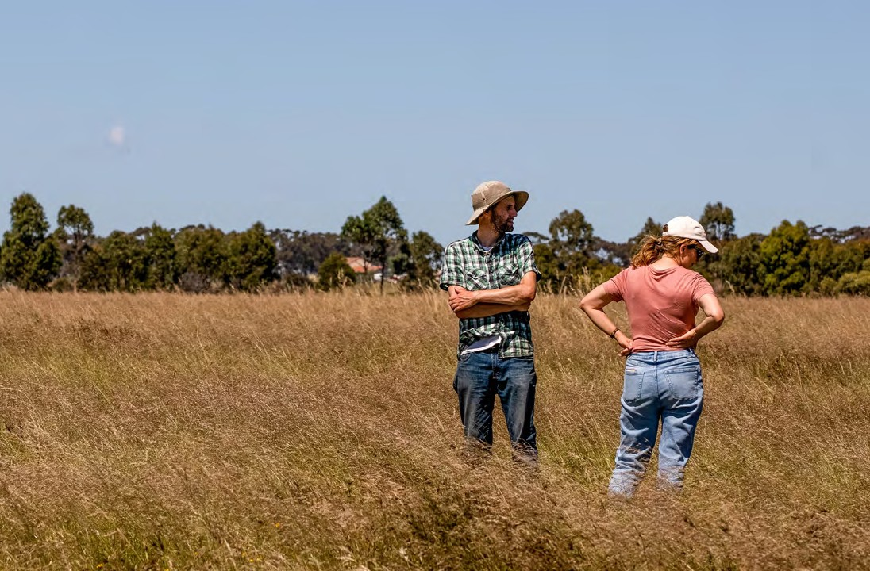
MSA Sinclair Power Grassland Source: Marcia Riederer

Executive summary

This Strategic Audit of the Implementation of Melbourne Strategic Assessment (MSA) Conservation Outcomes Report comes at a critical stage in the evolution of the MSA program as Melbourne’s population is predicted to reach six million by 2030.5 The MSA program was established under the Commonwealth Environment Protection and Biodiversity Conservation (EPBC) Act 1999 to mitigate the environmental impacts
of urban development in Melbourne’s growth corridors on Matters of National Environmental Significance (MNES), including state and federally listed threatened species and communities (Figure 1).

An objective of the EPBC Act 1999 is to ensure that ‘nationally significant’ values including animals, plants, habitats and places are identified and any potential negative impacts on them, are carefully considered before changes in land use or new developments are approved.6 These values are referred to as MNES and this strategic audit assesses the conservation outcomes for 12 MNES including three ecological communities, five plant species and four animal species.
The MSA program covers four growth corridors and seven local government areas (LGA) on Melbourne’s outskirts (Figure 2). Assessments are based on data supplied by DELWP, Arthur Rylah Institute (ARI) and Parks Victoria. The data is assessed for status, trend and data confidence of the conservation outcomes for 12 MNES defined in the monitoring and reporting framework (MRF),7 and published in the Victorian Government Gazette,8 for the reporting period 1 July 2020 to 30 June 2022.
Background
The MSA program aligns State and Commonwealth biodiversity regulation under one program, aiming to ensure that urban development within Melbourne’s growth areas complies with all biodiversity requirements in a streamlined way. The program aims to implement a range of conservation commitments to ensure that urban development occurs in a
way that protects Matters of National Environmental Significance.
The Melbourne Strategic Assessment (Environment Mitigation Levy) Act 2020 (MSA Act) was introduced to improve the MSA program’s operational and financial transparency, to set levies to reflect increasing land values and to ensure the ongoing viability of the program to 2060.9 It also outlines statutory controls aiming to ensure that spending is directed solely to acquiring, managing and protecting the habitat areas identified under the MSA program.10 DELWP manages the delivery of the program on behalf of the DELWP Secretary.

- Australian Government, Centre for Population 2020, Population Statement: Insights from Australia’s first population statement, shorturl. at/aeHU8 Accessed 27 January 2022.
- Department of Agriculture, Water and the Environment, https://www.environment.gov.au/epbc/what-is-protected Accessed 20 July 2021.
- DELWP 2015, ‘Monitoring and Reporting Framework – Melbourne Strategic Assessment’, East Melbourne, Victoria.
- State Government of Victoria 2022, Victorian Government Gazette, Issue G4, ‘Melbourne Strategic Assessment (Environment Mitigation Levy) Act 2020 - Notice of the Conservation Outcomes’, http://www.gazette.vic.gov.au/gazette/Gazettes2022/GG2022G004.pdf Accessed 27 January 2022.
- Parliamentary Debates (Hansard), Legislative Assembly, Parliament of Victoria, 16 October 2019, ‘Minister’s second reading speech – Melbourne Strategic Assessment (Environment Mitigation Levy) Bill 2019.
- Parliamentary Debates (Hansard), Legislative Assembly, Parliament of Victoria, 16 October 2019, ‘Minister’s second reading speech – Melbourne Strategic Assessment (Environment Mitigation Levy) Bill 2019.

The MSA program’s strategic biodiversity offsetting program was established with the aim to achieve No Net Loss (NNL) for biodiversity throughout implementation of Growth Area Framework Plans.
The Victorian Government committed to establishing a Natural Temperate Grassland reserve as an offset by 2022, via acquisition through use of a public acquisition overlay (PAO). A PAO is a planning mechanism that is used by the State Government to designate areas for protection through planning scheme amendments on Crown land. It
also committed to establishing a Grassy Eucalypt Woodland reserve as an offset by 2020.11 These two reserves are
considered two of Victoria’s most important and biodiverse ecological communities.
Natural Temperate Grassland used
to be widespread across the Victorian Volcanic Plain in Victoria’s south-west. While these grasslands once covered over a third of the state, they are now small and fragmented.
In June 2008 and June 2009, the Australian Government listed Natural Temperate Grassland and Grassy Eucalypt Woodland
respectively as critically endangered under the Environment Protection and Biodiversity Conservation Act 1999 (EPBC Act).

Major offsets under the MSA program include the establishment of:
- a 15,000-hectare Western Grassland Reserve near Werribee
- a 1,200-hectare Grassy Eucalypt Woodland protected area near Whittlesea
- 4,000 ha of reserve, across 36 Conservation Areas, within new suburbs inside the urban growth boundary (UGB).

The MSA program aims to streamline the biodiversity assessment and approvals process for developers by removing
the need for Federal and State planning approvals. Developers are required to pay a one-off Environmental Mitigation Levy to offset biodiversity impacts.
Funds go towards conservation programs and reserves, the ongoing protection
and management of MNES, as well as environmental monitoring and reporting.
Provisions under the MSA Act 2020 delegate responsibility for reporting on DELWP’s implementation of the

MSA conservation outcomes to the Commissioner for Environmental Sustainability (the Commissioner). These delegations are reproduced in the Commissioner for Environmental Sustainability Act 2003 (CES Act). The
Commissioner is tasked with conducting strategic audits of, and preparing a report on, the progress of the MSA program’s conservation outcomes in relation to MNES every two years.
Further information on this report’s historical and legislative context is provided in Appendix One.

- DEPI 2009, ‘Delivering Melbourne’s Newest Sustainable Communities: Program Report’, East Melbourne, Victoria.

Growling Grass Frog
Matters of National Environmental Significance
What are Matters of National Environmental Significance (MNES) under the EPBC Act?
The Environment Protection and Biodiversity Conservation Act 1999 (EPBC Act) ensures that ‘nationally significant’ values – including animals, plants, habitats and places – are identified, and any potential negative impacts
on them are carefully considered before changes in land use or new developments are approved.12 These values are officially referred to as Matters of National Environmental Significance (MNES) and there are 12 listed under DELWP’s management of the MSA program.

What MNES are covered under the MSA program?
This report assesses the conservation outcomes for 12 MNES reliant on land that is currently under the MSA program management. These 12 MNES are:
Ecosystems: Natural Temperate Grassland, Grassy Eucalypt Woodland and Seasonal Herbaceous Wetland.
Threatened species: Golden Sun Moth, Matted Flax-lily, Spiny Rice-flower, Southern Brown Bandicoot, Growling Grass Frog, Small Golden Moths Orchid, Striped Legless Lizard, Button Wrinklewort, and Large-fruit Groundsel.
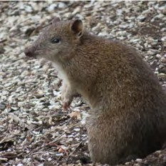
Southern Brown Bandicoot
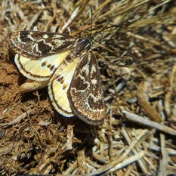
Golden Sun Moth
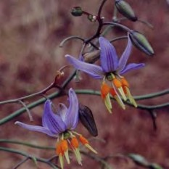
Matted Flax-lily

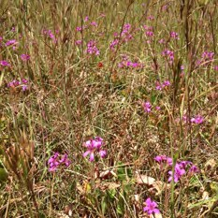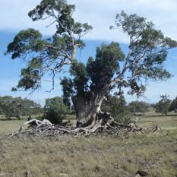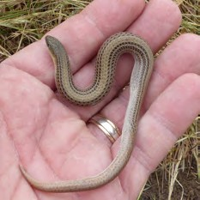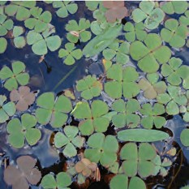

Natural Temperate Grassland
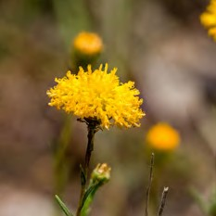
Button Wrinklewort
Grassy Eucalypt Woodland
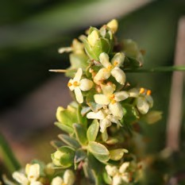
Spiny Rice-flower
Striped Legless Lizard
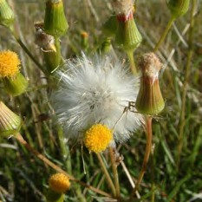
Large-fruit Groundsel
Seasonal Herbaceous Wetland
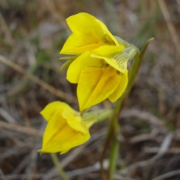
Small Golden Moths Orchid

Figure 1: Matters of National Environmental Significance (MNES) monitored under the MSA Program Source: DELWP

- Department of Agriculture, Water and the Environment, https://www.environment.gov.au/epbc/what-is-protected Accessed 20 July 2021.

This is the first Strategic Audit of the Implementation of MSA Conservation Outcomes Report by the Commissioner in accordance with section 18(A) of the CES Act 2003 and part 9 (Division 2) of the MSA Act 2020. It aims to establish a scientific baseline for the conservation outcomes for 12 MNES on land protected under the MSA program.

Consultation with DELWP between May and September 2021 led to the development of two key evaluation questions to frame this audit:
- Are the conservation outcomes for each of the 12 MNES being met?
- Is the current DELWP framework for MSA monitoring and reporting on the conservation outcomes adequate?

Consultation with DELWP and PV continued into 2022 and involved interviews and meetings, as well as formal requests for information. Throughout the consultation period there were opportunities for DELWP to provide context for the limitations in the current framework – their comments have been recorded and referenced in this report as ‘personal communications’ where relevant to the conservation outcomes for MNES.
DELWP staff provided data and evidence for the findings in this report, collected based on the methodologies of the Monitoring and Reporting Framework (MRF).13
Informal changes to the MRF have occurred since the official publication of the document in 2015. DELWP’s Arthur Rylah Institute (ARI) detailed these in its MSA Outcomes Report 2014/15– 2019/20.14 ARI has since made further informal updates to the monitoring protocol for 2020–2022 via an internal document,15 and these changes are included in Appendix Two.
The lack of published data and interpretation on many of the MNES conservation outcomes meant that this strategic audit relies on expert opinion (through personal communications) of DELWP and PV staff.
DELWP and PV were provided with an expert review draft of the scientific assessments contained within this report in May 2022 to:
  - review these personal communications
  - ensure that no relevant scientific evidence had been missed in the production of this report
  - provide technical advice and corrections relating to information obtained in interviews and review of the science in the MRF.
Definitions of the MSA conservation outcomes for the purpose of the Commissioner’s report are based on those outlined in the formal notice in the Government Gazette published 27 January 2022.16 There are discrepancies between the gazetted conservation outcomes and the conservation outcomes statements contained within DELWP’s MRF.
To avoid confusion, both the gazetted conservation outcomes definitions and MRF conservation outcomes definitions are presented with the full scientific assessments for each MNES in Part 2 of this report.

- DELWP 2015, ‘Monitoring and Reporting Framework – Melbourne Strategic Assessment’, East Melbourne, Victoria.
- Bruce M, Batpurev K, Bryant D, Sinclair S and Kohout M 2020, ‘Melbourne Strategic Assessment: Ecological Outcomes Report 2014–15 to 2019–20.’ Department of Environment, Land, Water and Planning, Heidelberg, Victoria.
- DELWP, internal document, Accessed 6 February 2022.
- State Government of Victoria 2022, Victorian Government Gazette, Issue G4, ‘Melbourne Strategic Assessment (Environment Mitigation Levy) Act 2020 – Notice of the Conservation Outcomes’, http://www.gazette.vic.gov.au/gazette/Gazettes2022/GG2022G004.pdf Accessed 27 January 2022.

Summary of recommendations and challenges

Table 1: Summary of recommendations and challenges Source: DELWP
Theme Monitoring, evaluation and reporting on the Conservation Outcomes

Recommendation

01
That DELWP undertakes a review of the MSA ecological monitoring and reporting framework (MRF), including a redesign of existing methods and KPI measures where required, to achieve landscape-scale, MNES conservation outcomes.
This would include establishing a research strategy to address priority knowledge gaps and improve understanding of MNES and their management.

Challenges the recommendation addresses
The MSA program design is limited in scope to monitoring and reporting on MNES outcomes defined under the original agreement with the Commonwealth, with a focus on evidence to demonstrate maintaining the existence of species. However, comprehensive analysis of biodiversity values at an ecosystem scale, coupled with rehabilitation, is required to achieve whole-of-landscape outcomes.
Furthermore, limitations of the MRF are impacting on an ability to adequately assess program impacts on MNES:
- Data collected for the current MRF reveals little about whether DELWP is on track to fulfilling its conservation commitments.17
- The current MRF will benefit from a review and redesign of measures to ensure clear definitions of what constitutes success.
- There is no requirement or intention under the existing MRF to assess and report on how effective management options are and how they impact on threatened species’ persistence under various scenarios.
The MSA program has yet to establish long-term datasets for many threatened species under its management. Gaps in critical data and knowledge underpinning species models and decision-support tools continue to hamper the MSA program’s ability to adequately assess whether it is meeting its conservation commitments.
There is also a lack of leveraging of existing partnerships, citizen science capabilities, Traditional Owner knowledge and community programs.

- Bruce M, Batpurev K, Bryant D, Sinclair S and Kohout M 2020, ‘Melbourne Strategic Assessment: Ecological Outcomes Report 2014–15 to 2019–20.’ Department of Environment, Land, Water and Planning, Heidelberg, Victoria.

Theme Traditional Owner rights, knowledge, values and participation

Recommendation

02
That DELWP implements a strategy to embed Traditional Owner rights, knowledge, values and participation in the MSA program design and implementation. This includes mechanisms for the inclusion of cultural heritage and Traditional Owner values into the MSA program logic and monitoring and reporting framework (MRF).

Challenges the recommendation addresses
There is a general and historical lack of documented and strategic consideration of Aboriginal cultural heritage and Traditional Owner values in the design and implementation of the MSA program delivery model, and no apparent mechanism for the inclusion of these values into the current scope of management.

Theme Program design, governance and coordination (Program logic)

Recommendation

03
That DELWP:
- undertakes a contemporary redesign of the MSA program logic in consultation with Traditional Owners, scientists, land managers and community, and
- establishes a governance framework that supports better decision-making and risk management practices at all levels of MSA planning and implementation.

Challenges the recommendation addresses
There are limitations in the current MSA program logic hampering an ability to assess program effectiveness and adjust management actions accordingly. Links between program objectives, actions, outputs and conservation outcomes remain unclear, and assumptions underpinning the original offsets model remain untested.18
At the time the MSA agreement was made in 2010, regulations and landscape-scale assessments of habitat extent and quality defined impacts to MNES and determined the associated offsets required to compensate for those impacts for the program to achieve No Net Loss (NNL). Current implementation requirements are based on these original assessments. DELWP has no obligation to assess whether these requirements are appropriate or effective if delivered, nor has any obligation to adjust these requirements or keep pace with change should new information potentially influence outcomes for MNES (including Aboriginal cultural heritage and Traditional Owner knowledge and values).
There is a lack of formal governance arrangements for the MSA program to improve coordination of existing resources, effort and investments and enable better outcomes for MNES.19 Addressing this gap would encourage participation from stakeholders across all levels of MSA management.

- VAGO 2020, Recommendation 7 in ‘Protecting Critically Endangered Grasslands’, Independent assurance report to Parliament 2019–20: 16.
- VAGO 2020, ‘Protecting Critically Endangered Grasslands’, Independent assurance report to Parliament 2019–20: 16.

Theme Program design, governance and coordination (Land acquisition)

Recommendation

04
That DELWP actively implements a risk-based land acquisition strategy that prioritises MNES conservation outcomes. The land acquisition strategy must include the identification of interim management needs to support outcomes for MNES in priority areas where delays in acquisition have occurred and/or are likely to occur.

Challenges the recommendation addresses
The limited acquisition of land is impacting on the MSA program outcomes. Monitoring is ostensibly on the values in the secured land, which is approximately 10.6% of the program area in the Western Grassland Reserve.20 There exists no formal, structured process or strategy for systematically prioritising what, when and how areas earmarked for protection are acquired.21
There is a need to prioritise urgent protection of MNES most immediately under threat and optimise outcomes for MNES across the landscape more broadly, including improved interim management in privately held areas where the risk of degradation is high.

- VAGO 2020, ‘Protecting Critically Endangered Grasslands’, Independent assurance report to Parliament 2019–20: 9.
- VAGO 2020, ‘Protecting Critically Endangered Grasslands’, Independent assurance report to Parliament 2019–20: 9.

Theme Natural Temperate Grassland

Recommendation

05

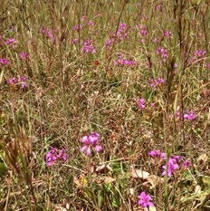
Natural Temperate Grassland
That DELWP:
- modifies the monitoring methods for Natural Temperate Grassland to organise by management unit as well as by state, and include ‘time since acquisition’ as a parameter
- enhances interpretation of results by adding an overall ’grassland quality’ metric to the KPI reporting suite, and
- addresses areas where measures indicate grassland condition is deteriorating.

Challenges the recommendation addresses
Interpretation of results under DELWP’s framework for Natural Temperate Grassland is challenging, with seven KPIs that collectively represent grassland condition. These KPIs are disaggregated across five grassland states, each with separate baselines.
It is possible that KPIs for Natural Temperate Grassland could be organised by management unit (i.e. stratify results by parcel of land) to highlight variation in the different land use histories and management regimes across the landscape.
There is no monitoring of variation in grassland condition as a function of time since acquisition. Such monitoring would help to inform a clearer picture of whether interim management actions are required or have been effective if applied.
Current findings indicate that grassland condition is deteriorating at some sites (e.g. the cover of native forbs in nutrient-enriched grassland states).

Theme Grassy Eucalypt Woodland

Recommendation

06

Grassy Eucalypt Woodland
That DELWP:
- delivers the Grassy Eucalypt Woodland baseline by 2026 as planned and immediately adopts interim management arrangements to prevent deterioration in the condition of those areas most at risk
- changes the monitoring methods for the Grassy Eucalypt Woodland to be organised by management unit as well as by state, measure ‘time since acquisition’, and
- adds an overarching ’grassland quality’ metric to the KPI reporting suite.

Challenges the recommendation addresses
Under the MSA program, 2021 was the first year that Grassy Eucalypt Woodland has been protected and the first year that this community was able to be monitored. Therefore, there is not enough data to establish baseline measures to report against the associated KPIs.
Furthermore, interpretation of results under DELWP’s framework for Grassy Eucalypt Woodland is challenging, with seven KPIs reported that collectively represent grassland condition. These KPIs are disaggregated across five grassland states, each with a separate baseline.
It is possible that KPIs for Grassy Eucalypt Woodland could be organised by management unit (i.e. stratify results by parcel of land) to highlight variation in the different land use histories and management regimes across the landscape.
There is no monitoring of variation in grassland condition as a function of time since acquisition. This may help to inform a clearer picture of whether interim management actions are required or have been effective if applied.

Theme Seasonal Herbaceous Wetland

Recommendation

07

Seasonal Herbaceous Wetland
That DELWP:
- increases weed control efforts and funding for land managers to protect Seasonal Herbaceous Wetland
- undertakes further research on the impacts of grazing, hydrological modification, and supplementary plantings of other native species, and
- broadens the KPI suite for future monitoring and reporting on wetland condition.

Challenges the recommendation addresses
Weeds appear to be increasing across the monitored sites, despite levels remaining within the 95% confidence interval tolerance of the defined baseline in each case.
Lack of weed control and recent restrictions to grazing in the surrounding Western Grassland Reserve is a likely factor in the increase in weed cover.
DELWP has focused on monitoring of floristics in the design of KPIs for the wetlands, however there is potential for monitoring of other correlates of wetland condition to improve inferences, including the presence of certain fauna such as invertebrates, macroinvertebrates, birds and frogs.

Theme Golden Sun Moth

Recommendation

08

Golden Sun Moth
That DELWP:
- considers changes to the monitoring regime of the Golden Sun Moth, and
- undertakes research into biomass control impacts.

Challenges the recommendation addresses

With additional Golden Sun Moth sites expected to come under MSA management over the next 18 months, there is a need to review the current monitoring regime.
The Golden Sun Moth was detected at four of 11 plots in the 2021–22 season, suggesting an overall decline in population numbers. This is the first year that the KPI has been in breach of the baseline for Golden Sun Moth and occupancy is the lowest recorded in eight years of monitoring.22
The moths are presumed to eat C3 grasses, not Kangaroo Grass. DELWP’s Population Viability Analysis (PVA) modelling highlighted the importance of bare ground and
C3 dominance grasses. Monitoring data show generally high grassland biomass levels (and correspondingly less bare ground) in 2021, compared with previous years.23 DELWP speculates that this factor may have had a detrimental effect on moth emergence and detectability. Studies have not yet been undertaken to assess the relationship between biomass control regimes and persistence of the Golden Sun Moth.

- M Bruce, K Batpurev, D Bryant. S Sinclair and M Kohout 2020, ‘Melbourne Strategic Assessment: Ecological Outcomes Report 2014-15 to 2019-20.’ DELWP Heidelberg, Victoria.
- DELWP Officer, personal communication, 15 February 2022.

Theme Matted Flax-lily

Recommendation

09
That DELWP schedules periodic genetic sampling of future populations of the Matted Flax-lily to ensure viability and develop a biomass control plan for the species.

Matted Flax-lily

Challenges the recommendation addresses
There is potentially some level of error in the counting of plants, at low levels, due to clonality.24 Periodic genetic sampling of future populations will be important to account for clonality.
Biomass control will be a necessary management intervention going forward for the species,25 as the species risks decline if shaded out.

Theme Spiny Rice-flower

Recommendation

10
That DELWP:
- clarifies the monitoring design
- assesses the adequacy of the current 10 year monitoring and reporting threshold, and
- develop a biomass control plan for the Spiny Rice-flower.

Spiny Rice-flower

Challenges the recommendation addresses
The Spiny Rice-flower recruits periodically, roughly every 10 years and according to rainfall. Further testing may be required to assess the adequacy of the 10-year window in capturing the variable recruitment dynamics.
Areas in which this species are found need a biomass control regime.26 As the MSA program scales up, it will be important to maintain efforts to control biomass and manage the risk of degradation to current and new populations.

- DELWP Officer, personal communication, 15 February 2022.
- DELWP Officer, personal communication, 15 February 2022.
- DELWP Officer, personal communication, 15 February 2022.

Theme Southern Brown Bandicoot

Recommendation

11
That DELWP undertakes research into habitat preferences and species responses to pressures and management regimes for the Southern Brown Bandicoot. This would include designing a protocol for leveraging citizen science and empowering partner organisations to contribute to reporting on the KPIs.

Southern Brown Bandicoot

Challenges the recommendation addresses
Southern Brown Bandicoot occupancy appears to vary by site, which suggests that they may have distinct habitat preferences relating to various pressures in the local environment (including fox predation and urbanisation) and management regimes (including planned burning, predator control, weed control and native vegetation restoration).
There is unused potential to leverage citizen science to inform a more complete picture of the population dynamics of the Southern Brown Bandicoot. DELWP may assist in addressing the gap in monitoring standards, through providing information on appropriate methods or tools for citizen science data to be included in the broader analyses.

Theme Growling Grass Frog

Recommendation

12
That DELWP establishes baseline monitoring for new corridors for the Growling Grass Frog, evaluate threats and management responses, and encourage citizen science to supplement conventional monitoring.

Growling Grass Frog

Challenges the recommendation addresses
There is an outstanding need to establish baseline occupancy monitoring for new Growling Grass Frog corridors. Mitigating threats (reduced groundwater, pollutants, pests and urbanisation) to the Growling Grass Frog and monitoring and evaluating responses is a critical knowledge gap.

Theme Small Golden Moths Orchid

Recommendation

13
That DELWP urgently assesses the impacts of biomass and pests on the Small Golden Moths Orchid.

Small Golden Moths Orchid

Challenges the recommendation addresses
It is unclear if, and how well, the species is persisting, as the area containing the remnant grassland habitat of Small Golden Moths Orchid has yet to be protected. Currently, there is no direct interim management of the species where it is known to occur.
As this is the last known population of the Small Golden Moths Orchid, the species is considered extremely vulnerable to threats and pressures such as subtle changes in biomass and rabbits.

Theme Striped Legless Lizard

Recommendation

14
That DELWP:
- redesigns the KPI and monitoring protocol for the Striped Legless Lizard, such that the measure for persistence is a randomly sampled measure for occupancy across all sites and accounts for new locations, and
- undertakes research to assess habitat preferences and population dynamics for the Striped Legless Lizard.

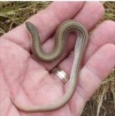
Striped Legless Lizard

Challenges the recommendation addresses
Overall, the species is viewed to be increasingly more common and widespread than was thought at the beginning of the MSA program.27 However, habitat preferences for the species remains unclear. Some monitored sites in poorer condition have higher rates of detection, with other larger sites (assumed more suitable habitat) having much lower rates of detection. Further research is required to better understand the Striped Legless Lizard’s habitat preferences to inform and target management responses.
Limitations with the existing monitoring protocol and indicator design mean the dataset is currently biased to locations where the lizard has been previously detected – this makes the assessment of any trends unclear and confidence in the data is low. Monitoring is also limited by the design of the KPI; there is no baseline for comparison to assess trends.

- DELWP Officer, personal communication, 14 July 2021.

Theme Button Wrinklewort

Recommendation

15
That DELWP assesses the causes of recruitment failure for the Button Wrinklewort population – including research into germination – and develop a management plan for the species based on the findings.

Button Wrinklewort

Challenges the recommendation addresses
At Truganina Cemetery, adult Button Wrinklewort plants are surviving at the anticipated rate,28 however recruitment is failing. Targeted research is required to determine the cause of this and the role of pests, invertebrates, urbanisation and drought. This is in addition to research and experimental observation to better understand the effect of interventions on the long-term persistence of the population.

Theme Large-fruit Groundsel

Recommendation

16
That DELWP undertakes research into the benefits of population augmentation of the Large-fruit Groundsel via the planting of tube stock.

Large-fruit Groundsel

Challenges the recommendation addresses
There is not enough data (in part due to lack of protected populations on MSA land) to conclude definitive insights on the species or management implications.29 Given the small numbers, the population remains vulnerable to external pressures.

- DELWP Officer, personal communication, 15 February 2022.
- DELWP Officer, personal communication, 15 February 2022.

Part 1: Summary of findings

This section provides a summary of the findings as they relate to the 16 recommendations presented in Table 1. Detailed scientific assessments are included in Part 2 of this report.

Geographical scope
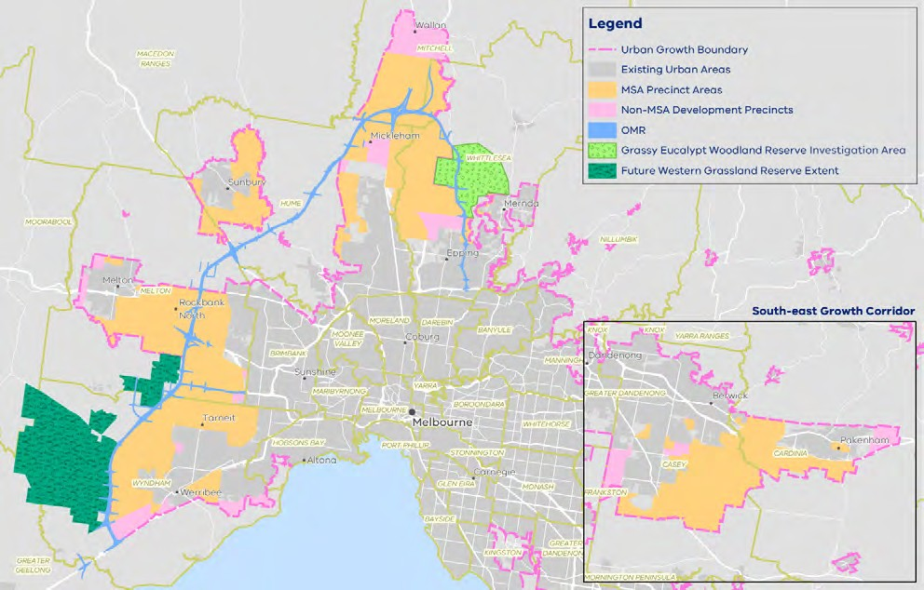
Figure 2: Map of the MSA program area Source: DELWP

Figure 2 shows the map of the full spatial extent of the MSA program area, covering four growth corridors (northern, north-western, western, south-eastern) and seven LGAs (Cardinia Shire Council, Casey City Council, Hume City Council, Melton City Council, Mitchell Shire Council, Whittlesea City Council, Wyndham City Council) within the 2010 UGB.
The Western Grasslands Reserve (WGR) and proposed Grassy Eucalypt Woodland investigation area form the majority of the MSA program’s consolidated offsets.
What is not shown on the map are the biodiversity conservation areas within the UGB. These are areas of high value, defined in the MSA Biodiversity Conservation Strategy (BCS) for permanent protection. Several of these areas are small and fragmented parcels that can’t be viewed at this resolution. Full maps of proposed precincts and conservation areas are presented in detail in the 2009 Delivering Melbourne’s Newest Sustainable Communities: Program Report (MSA Program Report)30 and BCS.31

- DEPI 2009, ‘Delivering Melbourne’s Newest Sustainable Communities: Program Report’, East Melbourne, Victoria.
- DEPI 2013, ‘Biodiversity Conservation Strategy for Melbourne’s Growth Corridors’, East Melbourne, Victoria.

DELWP undertakes ecological monitoring of MNES in sites across the program area. Sites include:
  - The Western Grassland Reserve
  - Banda Bail Nature Conservation Reserve
  - Kalkallo Common and Donnybrook Cemetery Grassland
  - Truganina Cemetery
  - Truganina South Nature Conservation Reserve
  - Several private land parcels at Mount Ridley
  - The creek corridors of the Merri, Darebin, Cardinia and Kororoit creeks
  - 100 sites across almost 60,000 ha in Melbourne’s south-east, including the Royal Botanic Gardens Cranbourne.

Data source
This report presents data supplied by DELWP and Parks Victoria in relation to status and trend information against conservation outcomes for MNES defined in the MRF and published in the Victorian Government Gazette,32 with the data acquisition period for this report ending on 28 February 2022.

Status 2020–2022
The status for each MNES conservation outcomes KPI is assessed as either ‘Met’, ‘Not met’ or ‘Not assessed’ according to the objective defined by the KPI. For each MNES under MSA management, DELWP has created performance targets that determine these statuses. Targets vary according to the characteristics of the species or community – however, there are several consistent themes:
  - most KPIs are assessed against a baseline, which sets the measure that the relevant attribute must remain above (for desirable attributes such as populations of threatened species) or below (for undesirable attributes such as weeds). In
all such cases, the KPI is not met once the 95% confidence interval on the measure fails to meet the baseline.
  - all baseline values that are derived from means (for percentage cover and species counts) are rounded to the nearest whole number.

- State Government of Victoria 2022, Victorian Government Gazette, Issue G4, ‘Melbourne Strategic Assessment (Environment Mitigation Levy) Act 2020 – Notice of the Conservation Outcomes’, http://www.gazette.vic.gov.au/gazette/Gazettes2022/GG2022G004.pdf Accessed 27 January 2022.

In most cases, baselines are set by the conditions at the commencement of monitoring. This means that the target is to maintain or improve on what was present when MSA management commenced. In these cases, the baseline is calculated not from the first survey, but from the mean of the first five years of monitoring data. This approach is intended to dampen fluctuations between monitoring periods that are not related to management or long-term success (e.g. fluctuations in vegetation cover due to recent fires, or responses by animals to weather conditions).
A continuous improvement approach applies to some KPIs, which DELWP has designed to encourage positive outcomes (‘maintain gains’) for MNES. In these cases, if the measured mean in a five-yearly reporting cycle is an improvement from the baseline, the measured mean sets a new target for the next five-year reporting period. DELWP states that this approach is beneficial for measures where the most desirable outcome is always ‘complete removal’ (e.g. weeds) or ‘as high as possible’ (e.g. abundance of
a listed species). For other KPIs, the baseline is set and does not change, regardless of the results. Such set baselines are considered appropriate in cases where the attribute is desired at moderate levels. For example, it is desirable for the cover of Kangaroo Grass in Natural Temperate Grasslands to be maintained within a range, so a continuous improvement model is not appropriate.
There are exceptions to these general approaches, which are based on considerations of the ecology and survey techniques applicable to the measure in question. These are described and explained in the MRF.
Many KPIs are currently unable to be assessed, the reasons for which are outlined below.

Reason for non-assessment
For many of the KPIs an assessment was unable to be made, with reasons for this varying with each KPI. Reasons for non-assessments are defined below.
  - N/A (not applicable): The KPI was able to be assessed.
  - Baseline not yet set: For many of the KPIs, not enough time has elapsed for the baseline to have been set – as this occurs after the fifth year of monitoring once enough data has been collected. This means the baseline is set as the mean measure of five years of data for that KPI from the commencement of monitoring.
  - Baseline set in 2022: For some of the KPIs, the baseline was set in 2022, meaning that not enough time has elapsed for the baseline to have been set.
  - Change in monitoring method: DELWP indicates that some changes to the monitoring methods have been necessary over time as new information comes in, and knowledge of the species and systems improve. This has impacted the ability for an assessment to be made for some KPIs, as previous data collected according to outdated methodology is no longer valid.
  - Data not provided: For some of the KPIs, data may have been collected but was not formally provided by DELWP for assessment.
  - Lack of drawdown event: For some of the Seasonal Herbaceous Wetlands KPIs, data may only be collected after a drawdown event has occurred. An assessment has not been made due to lack of this event occurring in the defined reporting period.

  - Not monitored in 2020–2022: Some KPIs were not monitored over 2020–2022, and therefore an assessment cannot be made for this period.
  - Population not yet under MSA management: Some areas earmarked for monitoring of MNES KPIs are not yet under MSA management (due to land not yet being acquired), and therefore remain unassessed.

Trend
The trend summary presents an overall analysis of the trend assessments for each KPI. The trend identifies whether the status of the indicator is deteriorating, improving or stable. The legend for trend in the report card reads as follows:

Improving
Stable

Deteriorating
Unclear

Data confidence
Data confidence reflects on knowledge gaps and data limitations when assessing the status and trend of each KPI. The legend for data quality in the report card is:
  - N/A (not applicable): A KPI data confidence assessment has not been made, because status and trend assessments have not been made for this indicator.
  - Insufficient evidence: There is negligible evidence (that is, suitable data and/or thresholds) and no status and trend assessments can be made.
  - Low: An assessment can be made, but there is only minimal evidence to guide the assessment.
  - Moderate: Limited evidence or limited consensus.
  - High: Adequate high-quality evidence and high level of consensus.

Year that baseline was/will be set
In many cases, the baselines for KPIs have not yet been set, the reasons for which may include:
  - a lack of data for the baselines to be set under the current definitions. For some KPIs, the baseline is calculated not from the first survey, but from the mean of the first five years of monitoring data. In such instances, not enough time has elapsed for the baseline to be calculated
  - monitoring has not yet commenced due to lack of protection of monitored areas
  - the KPI is not measured against a baseline.

MSA program design and implementation

The four recommendations in this section inform practical measures to drive continuous improvement of the MSA program itself to support and improve the conservation outcomes of the MNES.

Theme Monitoring, evaluation and reporting on the Conservation Outcomes

Recommendation

01
That DELWP undertakes a review of the MSA ecological monitoring and reporting framework (MRF), including a redesign of existing methods and KPI measures where required, to achieve landscape-scale, MNES conservation outcomes.
This would include establishing a research strategy to address priority knowledge gaps and improve understanding of MNES and their management.

Clarifying the objective: rehabilitation or maintenance
The MSA program design is limited in scope to monitoring and reporting on MNES outcomes defined under the original agreement with the Commonwealth, with a focus on evidence to demonstrate maintaining the existence of species. However, comprehensive analysis of biodiversity values at an ecosystem scale, coupled with rehabilitation, is required to achieve whole-of-landscape outcomes.
Many areas within the Western Grassland Reserve are acquired in poor condition and, as such, much of the focus is on weed management and protection of higher quality areas from weed encroachment. DELWP has indicated that restoration to improve grassland condition has not been a realistic or feasible objective.33 However, comprehensive analysis of biodiversity values at an ecosystem scale is required to achieve whole-of-landscape outcomes.

Focus of MRF review
The MSA ecological monitoring program is undertaken with scientific rigour by well- respected and qualified scientists; however, there is a need to improve metrics, define thresholds to measure success or failure, triggers for management intervention and to establish counterfactual controls.
Specifically, there are three aspects of the MRF that require attention:
Data collection: Data collected for the current MRF framework reveals little about whether DELWP is on track to fulfil its conservation commitments. This may be due, in many cases, to the fact that there is not enough data for the current KPIs to be properly assessed. Consequently, reporting on the conservation outcomes to date has not presented detailed analyses or interpretation of the monitoring results.34

- DELWP Officer, personal communication, 20 July 2021.
- Bruce M, Batpurev K, Bryant D, Sinclair S and Kohout M 2020, ‘Melbourne Strategic Assessment: Ecological Outcomes Report 2014–15 to 2019–20.’ Department of Environment, Land, Water and Planning, Heidelberg, Victoria.

KPI development: The current MRF will benefit from a review and redesign of some measures to ensure that they are current and tailored to each MNES, including clearer definitions of what constitutes success or failure (in an ecological sense). Another issue with the existing KPI design is that maintaining the current standard satisfies outcomes for Commonwealth reporting (see above) with no imperative to improve outcomes.
Management integration: There is no requirement or intention under the existing framework to assess and report on how effective management options are and how they impact on threatened species’ persistence under various scenarios. Without tangible measures and targets allowing an assessment of management performance, DELWP is unable to provide assurance to the public about the protection of MNES under MSA management – nor about the cost effectiveness of their actions. Explicit and time-bound targets should be introduced to the MSA’s monitoring framework
for the management of MNES to guide management performance. A significant issue with the MSA program’s monitoring design is that it does not include counterfactual controls (monitoring of areas that are not included under MSA management), limiting the ability to compare and evaluate MSA management against other management (including ‘no management’) scenarios.

Research strategy
Following the review of the MRF, a research strategy must be developed to support its implementation. The strategy should aim to leverage existing partnerships, citizen science capabilities and community programs where practical.
The MSA program has yet to establish long-term datasets for many threatened species under its management. Gaps in critical data and knowledge underpinning species models and decision-support tools continue to hamper the program’s ability to adequately assess whether it is meeting conservation commitments.
The research strategy would ensure best practice in data governance and information integrity, underpinned by enhanced capabilities to maintain centralised multi-agency information repositories, including spatial information.

Theme Traditional Owner rights, knowledge, values and participation

Recommendation

02
That DELWP implements a strategy to embed Traditional Owner rights, knowledge, values and participation in the MSA program design and implementation. This includes mechanisms for the inclusion of cultural heritage and Traditional Owner values into the MSA program logic and monitoring and reporting framework (MRF).

There is a lack of documented and strategic consideration of Aboriginal cultural heritage and Traditional Owner values in the design and implementation of the MSA program and no apparent formal mechanism for the inclusion of these values under the current delivery model. This is a significant gap which, if addressed, has great potential to support Aboriginal Self-Determination and to reflect current-day partnerships and expectations around healing and caring for Country.35
Historically, much of the focus on Traditional Owner values has been on the mitigation of impacts to cultural heritage at the precinct structure planning phase. The Program Report refers only to cultural heritage (in the form of artifacts) and the requirement for Cultural Heritage Management Plans during precinct structure planning. 36
There is potential to expand MSA processes to redefine and retain Aboriginal cultural heritage and to improve Traditional Owner involvement ensuring cultural values are properly recognised and protected under the MSA program and acknowledge Traditional Owner rights to inform culturally sensitive land use and management.
In partnership with Traditional Owners, DELWP released a Strategy for establishing a Grassy Eucalypt Woodland Protected Area,37 in June 2021, which outlines an approach to the protection of this area with the help of Trust for Nature, Hume City Council and informed by Traditional Owner knowledge and values. The strategy details high-level objectives for management, co-developed with Traditional Owners. DELWP applied
a multi-tenure approach to land protection through either Crown land reserves or negotiated on-title land management agreements on private land. A 4.9 ha reserve containing Grassy Eucalypt Woodland was secured in 2021, and monitoring has now commenced in this area. However, Traditional Owners were not included in the design of associated KPIs.
Program logic and MRF redesign should build on recent partnerships to address pathways and mechanisms enabling the inclusion of Aboriginal cultural heritage and Traditional Owner knowledge and values into MSA frameworks.

- DELWP 2020, ‘Pupangarli Marnmarnepu 'Owning Our Future’ Aboriginal Self-Determination Reform Strategy 2020–2025’.
- DEPI 2009, ‘Delivering Melbourne’s Newest Sustainable Communities: Program Report’, East Melbourne, Victoria.
- DELWP 2021, ‘Strategy for establishing a Grassy Eucalypt Woodland Protected Area – Melbourne Strategic Assessment’.

Theme Program design, governance and coordination (Program logic)

Recommendation

03
That DELWP:
- undertakes a contemporary redesign of the MSA program logic in consultation with Traditional Owners, scientists, land managers and community, and
- establishes a governance framework that supports better decision-making and risk management practices at all levels of MSA planning and implementation.

Program logic
The current MSA program logic38 is hampering the ability to assess program effectiveness and adjust management actions. Accordingly, the program logic requires redesign to better establish links between program objectives, actions, outputs, and conservation outcomes (also part of VAGO Recommendation 7).39 Noting also that the assumptions underpinning the original offsets model remain untested.
This redesign process should be undertaken in consultation with traditional owners, scientists, land managers and community. A collaborative, co-design process will help to foster genuine partnerships essential to the ongoing success of the program.

Testing assumptions
DELWP’s current performance reporting is based on the original MSA program agreement, according to requirements under the Commonwealth approved MSA Program Report40 and Biodiversity Conservation Strategy,41 where 2011 timestamped native vegetation datasets and values assessments performed in the original
2009 Strategic Impact Assessment are applied.42 There was no expectation in the original MSA design that these timestamped values would be re-evaluated, however these assumptions must be revisited – particularly in respect to the inclusion of a restoration objective in the redesigned MRF (see Recommendation 1).
At the time the MSA agreement was made in 2010, regulations and landscape-scale assessments of habitat extent and quality impacts to MNES determined the associated offsets required to compensate for those impacts for the program to achieve NNL. Current implementation requirements are based on these original assessments.

- MSA program logic is defined as ‘the relationships between program activities and processes, program outputs and program outcomes and how activities are expected to lead to outcomes. It provides a framework for determining program assumptions, key evaluation questions and key performance indicators (KPIs).’ DELWP 2015, ‘Monitoring and Reporting Framework – Melbourne Strategic Assessment’, East Melbourne, Victoria: 10.
- VAGO 2020, Recommendation 7 in ‘Protecting Critically Endangered Grasslands’, Independent assurance report to Parliament 2019–20: 16.
- DEPI 2009, ‘Delivering Melbourne’s Newest Sustainable Communities: Program Report’, East Melbourne, Victoria.
- DEPI 2013, ‘Biodiversity Conservation Strategy for Melbourne’s Growth Corridors’, East Melbourne, Victoria.
- Department of Sustainability and Environment (DSE) 2009, ‘Delivering Melbourne’s Newest Sustainable Communities: Strategic Impact Assessment Report for the Environment Protection and Biodiversity Conservation Act 1999’. East Melbourne, Victoria.

Under the current model, DELWP is under no formal obligation to assess whether these requirements are appropriate or effective if delivered, nor under any obligation to adjust these requirements or keep pace with change should new information potentially influence outcomes for MNES (including Aboriginal cultural heritage and Traditional Owner knowledge and values).
A process for redesign of the MSA program logic would provide opportunity to test assumptions in the original strategic impact assessment and offsets delivery model. This redesign process would consider a review of the program’s offset equation, with an assessment of what No Net Loss (NNL) for MNES means in practice, and how this may be measured, monitored, and adjusted over the lifetime of the program.

Governance framework
Improved governance arrangements with the potential to provide strategic oversight and improve coordination of existing resources and investments would enable better outcomes for MNES.
Broadly, there is a lack of a demonstrated risk management processes to guide MSA program delivery, prioritisation and investment decisions. It is unclear whether a formal risk register is being maintained and if identified risks are appropriately managed and mitigated. VAGO determined in 2020 that the MSA program’s “current
governance arrangements are not adequate to effectively oversee the MSA program’s future delivery and manage risks because they do not include all delivery partners nor separate oversight from management.”43 DELWP report that this has been addressed by the inclusion of agencies, partners and Traditional Owners in its Adaptive Management Working Group’s membership and Terms of Reference. This group, however, does not formally oversee program level policy and management decisions.
The establishment of an independent advisory group as part of the governance framework for the MSA program, would help to provide strategic oversight for the program and provide a structure for timely consultation with the relevant experts.

- VAGO 2020, ‘Protecting Critically Endangered Grasslands’, Independent assurance report to Parliament 2019–20: 16.

Theme Program design, governance and coordination (Land acquisition)

Recommendation

04
That DELWP actively implements a risk-based land acquisition strategy that prioritises MNES conservation outcomes. The land acquisition strategy must include the identification of interim management needs to support outcomes for MNES in priority areas where delays in acquisition have occurred and/or are likely to occur.

Land acquisition
Limited acquisition of land is impacting delivery of the MSA program outcomes. Monitoring of MNES is ostensibly conducted on secured land, which is approximately only 10% of the program area in the Western Grassland Reserve.44
This significantly hinders DELWP’s ability to implement direct management practices, with challenges such as the disparate or fragmented nature of the acquired properties, condition of properties with the passage of time since the baseline values and targets were set, and the resourcing for direct management limited to 10 years. As VAGO determined in 2020 regarding the importance of early acquisition: “The MSA was established and conservation commitments were developed, on the basis of early acquisition of land for the WGR and GEWR. However, DELWP has not met the 2020 acquisition target set by the MSA program. Modelling by DELWP shows the significant ecological benefit gained from buying land early. The longer the period between the state applying a planning acquisition overlay (PAO) and purchasing land, the greater the risk that affected landowners may not manage their land for invasive weeds and animals. As at December 2019, DELWP had acquired around 10% of land in the WGR, or 1,568.6 hectares. It has not yet acquired any land for the GEWR.”45
DELWP has developed a set of prioritisation criteria to guide its MSA land acquisition.46 However, it is unclear if, how and to what extent these criteria are currently applied, and there exists no formal, structured process or strategy for systematically prioritising what, when and how areas earmarked for protection (usually through
the application of a PAO) are acquired. It is recommended that DELWP develops and applies a comprehensive set of evidence- and risk-based criteria to prioritise funding and management actions supporting the MSA conservation outcomes. These criteria should inform strategic planning processes to develop a land acquisition strategy that prioritises actions supporting optimal outcomes for MNES and the community.

- VAGO 2020, ‘Protecting Critically Endangered Grasslands’, Independent assurance report to Parliament 2019–20: 9.
- VAGO 2020, ‘Protecting Critically Endangered Grasslands’, Independent assurance report to Parliament 2019–20: 9.
- VAGO 2020, ‘Protecting Critically Endangered Grasslands’, Independent assurance report to Parliament 2019–20: 36.

Interim management
A land acquisition strategy – with a focus on optimising outcomes for MNES – must also include a condition assessment and the identification of interim management to support outcomes for MNES in priority areas where delays in acquisition have
occurred and/or are likely to occur. The lack of existing data to evaluate the MSA KPIs and management effectiveness largely reflects the fact that MSA land protection commenced in 2013 and acquisitions have been slower than expected over time.
This strategy would enable DELWP to identify and implement risk-based actions that prioritise urgent protection of MNES most immediately under threat and optimise outcomes for MNES across the landscape more broadly, including improved interim management in privately held areas where the risk of degradation is high (see VAGO Recommendations 1-4, in Protecting Critically Endangered Grasslands Report 2020).47
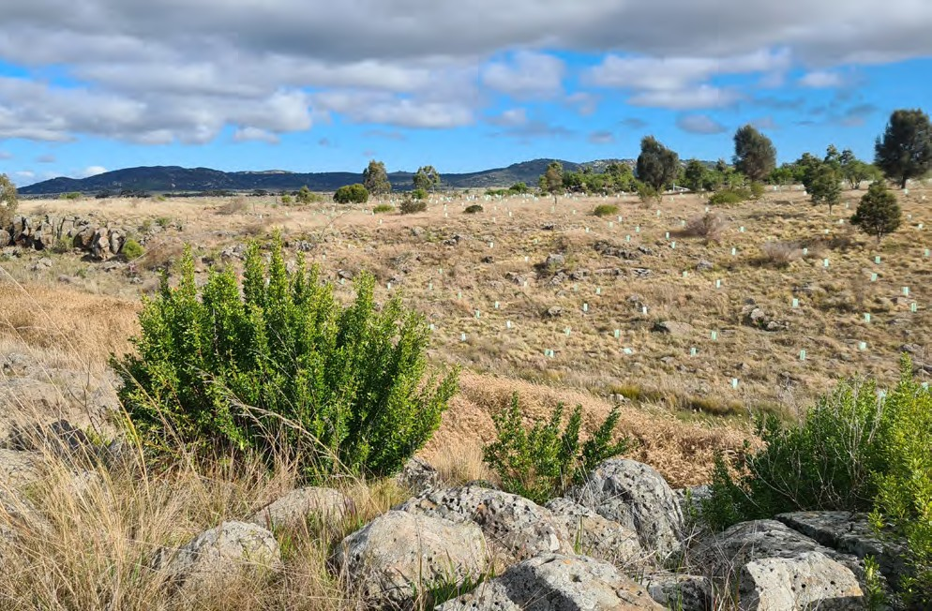
Correa - Glengowrie Source: Marcia Riederer

- VAGO 2020, Recommendation 1-4 in ‘Protecting Critically Endangered Grasslands’, Independent assurance report to Parliament 2019–20: 16.

MNES Conservation Outcomes

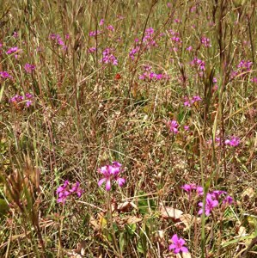
Natural Temperate Grassland

These 12 recommendations relate to each of the 12 MNES – the ecological communities, plants and animals that are protected by the MSA program.
MNES 1: Natural Temperate Grassland
Key insights and management implications for Natural Temperate Grassland
Of all the MNES, Natural Temperate Grassland associated with the Western Grassland Reserve has received the most attention from stakeholders48 – consequently a
large degree of resources has been directed toward monitoring Natural Temperate Grassland. (DELWP commenced monitoring Natural Temperate Grassland in 2013.)
One of the main issues around interpretation of the results for Natural Temperate Grassland under the current framework is that most of the KPIs are disaggregated by ‘states’ – and this is how they have traditionally been reported, each with separate baselines.
It is possible that KPIs for Natural Temperate Grassland could be organised by management unit (i.e. stratify results by parcel of land) to highlight variation in the different land use histories and management regimes across the landscape. Time since acquisition would seem an important variable, as this is the period within which DELWP has had the ability to have any direct management impact. This variable would provide a more robust baseline to assess change in grassland condition as a function of time since acquisition as additional land acquisition occurs. This may help to inform a clearer picture of whether interim management actions are required or have been effective if applied.

KPI 1: Hectares making transition between states | Status 2020-2022 | Reason for non-assessment | Trend | Data Confidence | Year that baseline was/will be set
Herb-rich grassland | Not assessed | Change in monitoring method |  | N/A | N/A
Themeda grassland | Not assessed | Change in monitoring method |  | N/A | N/A
C3 grassland | Not assessed | Change in monitoring method |  | N/A | N/A
Nutrient-enriched grassland | Not assessed | Change in monitoring method |  | N/A | N/A
De-rocked grassland | Not assessed | Change in monitoring method |  | N/A | N/A

Comments: KPI 1 compares the results from vegetation mapping completed at
five-yearly intervals. With respect to grassland state change, DELWP was unable to provide a formal assessment of KPI 1 in 2021, due to a recent change in its monitoring protocol leading to dataset incompatibility issues, therefore status, trend and data confidence assessments for KPI 1 are not presented here.

- DELWP Officer, personal communication, 20 July 2021.

Note that monitoring toward this KPI was not undertaken in 2020 due to COVID-19 restrictions. DELWP has indicated that the interpretation of KPI 1 is now complicated by the shift to the use of point-based field surveys. This new survey method was prompted by the recommendations of VAGO, covering the whole of the Western Grassland Reserve, and will offer a more repeatable means of assessing state change in future reports, according to DELWP.49 DELWP intended for this KPI to highlight changes brought about by dramatic changes in land use leading to wholescale degradation of grasslands on large scales (e.g. conversion to cropping, fertiliser application, heavy and ongoing grazing which impacts on Themeda).50 It was not intended to deal with incremental changes on a fine scale, with other KPIs being more appropriate for this.

KPI 2: Cover of native perennial forbs | Status 2020-2022 | Reason for non-assessment | Trend | Data Confidence | Year that baseline was/will be set
Herb-rich grassland | Met | N/A |  | High | 2019
Themeda grassland | Met | N/A |  | High | 2018
C3 grassland | Not assessed | Baseline not yet set |  | N/A | 2022
Nutrient-enriched grassland | Not met | N/A |  | High | 2017
De-rocked grassland | Not assessed | Baseline not yet set |  | N/A | 2023

Comments: KPI 2 measures the cover of the valuable and diverse native perennial forb component, which includes many rare species.51 This KPI was met in two states: Herb-rich grassland and Themeda grassland and the trend is stable. This KPI was not met in the Nutrient-enriched grassland state and the trend for this indicator is a pattern of deterioration. Where an assessment can be made for KPI 2, confidence in the data is high, with sufficient data collected for multiple plots over multiple years. The baseline has not yet been set for the other states because these states are not yet sufficiently protected – thus an assessment of status and trend cannot be made for these states. This KPI is assessed using a continuous improvement approach, where any increase over the baseline in a five-year reporting period will lead to the calculation of a new baseline for subsequent reporting periods.

- DELWP, internal document, provided 16 February 2022.
- DELWP, internal document, provided 16 February 2022.
- Stuwe J 1986, ‘An assessment of the conservation status of native grasslands on the western plains, Victoria and sites of botanical significance.’ Arthur Rylah Institute for Environmental Research Technical Report Series No. 48, Conservation Forests & Lands, Fisheries and Wildlife Service, Heidelberg, Victoria.

According to DELWP, the decline of forbs in Nutrient-enriched grassland is attributable to two sources:
  - new properties being acquired which have low forb cover (e.g., Argoona Rd),52 when added to the dataset, they cause an overall decrease in mean cover
  - increasing biomass levels after the cessation of grazing, causing the competitive exclusion of those native forbs which prosper under grazing. This loss is exacerbated by the failure of other forb species to recolonise ungrazed grasslands, due to their need for open space, combined with their rarity in the landscape and low dispersal ability.
DELWP suspects that rectifying this problem in Nutrient-enriched grassland will likely require:
  - improved interim management to ensure that newly protected properties are in relatively good condition
  - biomass control, via either a return to grazing regimes sufficient to provide space for the forbs, or the introduction of fire regimes, coupled with
  - specific efforts to re-introduce those forbs that are lacking.53

KPI 3: Richness of native perennial forbs | Status 2020-2022 | Reason for non-assessment | Trend | Data Confidence | Year that baseline was/will be set
Herb-rich grassland | Met | N/A |  | High | 2017
Themeda grassland | Met | N/A |  | High | 2018
C3 grassland | Not assessed | Baseline not yet set |  | N/A | 2022
Nutrient-enriched grassland | Met | N/A |  | High | 2017
De-rocked grassland | Not assessed | Baseline not yet set |  | N/A | Unclear

Comments: KPI 3 measures the richness of the native perennial forb component (explicitly at the scale of the 400 m2 plot). This KPI is assessed using a continuous improvement approach, where any increase over the baseline in a five-year reporting period will lead to the calculation of a new baseline for subsequent reporting periods. This KPI was met in the three states for which assessment is possible: Herb-rich grassland, Themeda grassland, and Nutrient-enriched grassland, with the trend being stable for all three states. The baseline has not yet been set for the other states because these states are not yet sufficiently protected. Where an assessment can be made for KPI 3, confidence in the data is high, with sufficient data collected for multiple plots over multiple years.

- DELWP, internal document, provided 16 February 2022.
- DELWP, internal document, provided 16 February 2022.

KPI 4: Cover of Kangaroo Grass | Status 2020-2022 | Reason for non-assessment | Trend | Data Confidence | Year that baseline was/will be set
Herb-rich grassland | Met | N/A |  | High | 2017
Themeda grassland | Met | N/A |  | High | 2017
C3 grassland | Not assessed | Baseline not yet set |  | N/A | Unclear
Nutrient-enriched grassland | Met | N/A |  | High | 2017
De-rocked grassland | Not assessed | Baseline not yet set |  | N/A | Unclear

Comments: KPI 4 measures the cover of Kangaroo Grass (Themeda triandra) which was the natural dominant of Natural Temperate Grassland and can be considered a foundational species that regulates nutrient dynamics and species competition in the community.54 For the most intact state (Herb-rich grassland), this KPI is assessed using a set baseline approach (rather than a continuous improvement approach), where the baseline remains at 29%. This reflects the fact that Kangaroo Grass is valuable but can become over-abundant.55 It is assumed that the intact Herb-rich grasslands have an acceptable level of Kangaroo Grass cover. For all other states, a continuous improvement approach will be taken, where any increase over the baseline in a five-year reporting period will lead to the calculation of a new baseline for subsequent reporting periods until a cover of 29% is reached, when the baseline will become fixed. However, the baseline has not yet been set for the other states because these states are not yet sufficiently protected. With respect to the maintenance of Kangaroo Grass cover, KPI 4 has been met for all states where it can be assessed (Herb-rich grassland, Themeda grassland, Nutrient-enriched grassland) and the trend is currently stable, although cover is increasing in states Herb-rich grassland and Themeda grassland. In the case of Themeda grassland, this appears likely to result in the raising of the benchmark in future years, in line with the continuous improvement approach. Where an assessment can be made for KPI 4, confidence in the data is high, with sufficient data collected for multiple plots and over multiple years.

- Prober SM and Lunt ID 2009. ‘Restoration of Themeda australis swards suppresses soil nitrate and enhances ecological resistance to invasion by exotic annuals.’ Biological Invasions 11, 171-181.
- Stuwe J 1986, ‘An assessment of the conservation status of native grasslands on the western plains, Victoria and sites of botanical significance.’ Arthur Rylah Institute for Environmental Research Technical Report Series No. 48, Conservation Forests & Lands, Fisheries and Wildlife Service, Heidelberg, Victoria.

KPI 5: Cover of any native perennial grass (ex. Kangaroo Grass) | Status 2020-2022 | Reason for non-assessment | Trend | Data Confidence | Year that baseline was/will be set
Herb-rich grassland | Met | N/A |  | High | 2013
Themeda grassland | Met | N/A |  | High | 2013
C3 grassland | Not assessed | Baseline not yet set |  | N/A | Unclear
Nutrient-enriched grassland | Met | N/A |  | High | 2013
De-rocked grassland | Not assessed | Baseline not yet set |  | N/A | Unclear

Comments: KPI 5 measures the cover of native perennial grasses (other than Kangaroo Grass). This KPI is assessed using a set baseline approach (rather than a continuous improvement approach), where the baseline remains at the value defined in the first monitoring period, reflecting the fact that moderate levels of native grass cover must be maintained, and that both loss of cover and over-growth may be problematic. This KPI was met in the three states for which assessment is possible: Herb-rich grassland, Themeda grassland and Nutrient-enriched grassland. The baseline has not yet been set for the other states because these states are not yet sufficiently protected. Where an assessment can be made for KPI 5, confidence in the data is high, with sufficient data collected for multiple plots over multiple years.
In state Nutrient-enriched grassland, the cover of natives is apparently decreasing and a breach of the baseline is possible over the next few years, according to DELWP.56 The likely explanation for this apparent decrease in native grass cover is attributable to two sources:
  - new properties being acquired which have lower native grass cover; when added to the dataset, they cause an overall decrease in the mean
  - an actual decrease at managed sites.57

- DELWP, internal document, provided 16 February 2022.
- DELWP, internal document, provided 16 February 2022.

KPI 6: Percentage of plots that have bare ground between 25 – 75% | Status 2020-2022 | Reason for non-assessment | Trend | Data Confidence | Year that baseline was/will be set
Herb-rich grassland | Met | N/A |  | High | N/A
Themeda grassland | Met | N/A |  | High | N/A
C3 grassland | Met | N/A |  | High | N/A
Nutrient-enriched grassland | Met | N/A |  | High | N/A
De-rocked grassland | Met | N/A |  | High | N/A

Comments: This KPI is a measure of habitat structural heterogeneity. It requires that Natural Temperate Grassland exists in a range of structural types each year (no single type is always preferred), to allow a range of animals to meet their habitat requirements. This KPI does not refer to a baseline. Rather, the KPI is met, or not, in each year. This KPI was met in 2017, 2018, 2019 and 2021 after having not been met in 2014, 2015 or 2016. Although the KPI was met in 2021, it came very close to being breached because biomass was high in many places. Where an assessment can be made for KPI 6, confidence in the data is high, with sufficient data collected for multiple plots and over multiple years.

KPI 7: Percentage cover of all perennial vegetation comprised of weeds | Status 2020-2022 | Reason for non-assessment | Trend | Data Confidence | Year that baseline was/will be set
Herb-rich grassland | Met | N/A |  | High | 2017
Themeda grassland | Met | N/A |  | High | 2017
C3 grassland | Not assessed | Baseline not yet set |  | N/A | Unclear
Nutrient-enriched grassland | Met | N/A |  | High | 2017
De-rocked grassland | Not assessed | Baseline not yet set |  | N/A | Unclear

Comments: KPI 7 measures the percent of all perennial vegetation cover that is comprised of weeds (introduced species). This KPI is assessed using a continuous improvement approach, where any increase over the baseline in a five-year reporting period will lead to the calculation of a new baseline for subsequent reporting periods. This KPI was met in Herb-rich grassland, Themeda grassland, and Nutrient-enriched grassland – the three states for which assessment is possible as the baseline is set. The baseline has not yet been set for the other states because these states are not yet sufficiently protected. Where an assessment can be made for KPI 7 confidence in the data is high, with sufficient data collected for multiple plots and over multiple years at several sites.

Weed cover appears to be increasing steadily in protected areas of Natural Temperate Grassland, and it appears very likely that this KPI will be breached within the next two to three years without substantially increased weed control.58 Currently, it is only the use of the five-year rolling average that has prevented the increase from registering as a breach of the baseline. The increase in weed levels measured in Nutrient- enriched grassland is attributable to two sources:
  - most of the change is the result of new properties being acquired which have very high weed levels (e.g. Argoona Rd), when added to the dataset, they cause an overall increase in the mean
  - an actual increase in weed cover at managed sites.59

Theme Natural Temperate Grassland

Recommendation

05
That DELWP:
- modifies the monitoring methods for Natural Temperate Grassland to organise by management unit as well as by state, and include ‘time since acquisition’ as a parameter
- enhances interpretation of results by adding an overall ’grassland quality’ metric to the KPI reporting suite, and
- addresses areas where measures indicate grassland condition is deteriorating.

- DELWP, internal document, provided 16 February 2022.
- DELWP, internal document, provided 16 February 2022.

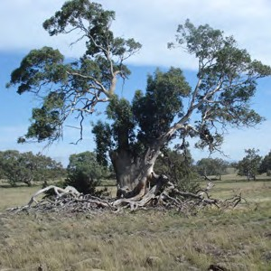
Grassy Eucalypt Woodland

MNES 2: Grassy Eucalypt Woodland

Key insights and management implications for Grassy Eucalypt Woodland

As 2021 was the first year under the MSA program that Grassy Eucalypt Woodland has been protected and was the first year that this community was able to be monitored, there is not enough data to establish baseline measures to report against the associated KPIs.

KPI 1: Hectares making transition between states | Status 2020-2022 | Reason for non-assessment | Trend | Data Confidence | Year that baseline was/will be set
Herb-rich grassland | Not assessed | Assessed every 5 years |  | N/A | N/A
Themeda grassland | Not assessed | Assessed every 5 years |  | N/A | N/A
C3 grassland | Not assessed | Assessed every 5 years |  | N/A | N/A
Nutrient-enriched grassland | Not assessed | Assessed every 5 years |  | N/A | N/A
De-rocked grassland | Not assessed | Assessed every 5 years |  | N/A | N/A

Comments: 2021 was the first year of data collection, at a single site. KPI 1 is assessed at five-yearly intervals, with the next assessment due in 2026. Status assessments are therefore not provided here, any trends are unclear and data confidence assessments are not applicable.

KPI 2: Cover of native perennial forbs | Status 2020-2022 | Reason for non-assessment | Trend | Data Confidence | Year that baseline was/will be set
Herb-rich grassland | Not assessed | Baseline not yet set |  | N/A | 2026
Themeda grassland | Not assessed | Baseline not yet set |  | N/A | 2026
C3 grassland | Not assessed | Baseline not yet set |  | N/A | 2026
Nutrient-enriched grassland | Not assessed | Baseline not yet set |  | N/A | 2026
De-rocked grassland | Not assessed | Baseline not yet set |  | N/A | 2026

Comments: 2021 was the first year of data collection, at a single site. Baselines are not yet set for KPI 2. Status assessments are therefore not provided here, any trends are unclear and data confidence assessments are not applicable.

KPI 3: Richness of native perennial forbs | Status 2020-2022 | Reason for non-assessment | Trend | Data Confidence | Year that baseline was/will be set
Herb-rich grassland | Not assessed | Baseline not yet set |  | N/A | 2026
Themeda grassland | Not assessed | Baseline not yet set |  | N/A | 2026
C3 grassland | Not assessed | Baseline not yet set |  | N/A | 2026
Nutrient-enriched grassland | Not assessed | Baseline not yet set |  | N/A | 2026
De-rocked grassland | Not assessed | Baseline not yet set |  | N/A | 2026

Comments: 2021 was the first year of data collection at a single site. Baselines are not yet set for KPI 3. Status assessments are therefore not provided here, any trends are unclear and data confidence assessments are not applicable.

KPI 4: Cover of native grass (Themeda triandra and Poa) | Status 2020-2022 | Reason for non-assessment | Trend | Data Confidence | Year that baseline was/will be set
Herb-rich grassland | Not assessed | Baseline not yet set |  | N/A | 2026
Themeda grassland | Not assessed | Baseline not yet set |  | N/A | 2026
C3 grassland | Not assessed | Baseline not yet set |  | N/A | 2026
Nutrient-enriched grassland | Not assessed | Baseline not yet set |  | N/A | 2026
De-rocked grassland | Not assessed | Baseline not yet set |  | N/A | 2026

Comments: 2021 was the first year of data collection at a single site. Baselines are not yet set for KPI 4. Status assessments are therefore not provided here, any trends are unclear and data confidence assessments are not applicable.

KPI 5: Structural heterogeneity | Status 2020-2022 | Reason for non-assessment | Trend | Data Confidence | Year that baseline was/will be set
Herb-rich grassland | Not assessed | Data not provided |  | N/A | N/A
Themeda grassland | Not assessed | Data not provided |  | N/A | N/A
C3 grassland | Not assessed | Data not provided |  | N/A | N/A
Nutrient-enriched grassland | Not assessed | Data not provided |  | N/A | N/A
De-rocked grassland | Not assessed | Data not provided |  | N/A | N/A

Comments: 2021 was the first year of data collection at a single site. Results data were not provided for KPI 5. Status assessments are therefore not provided here, any trends are unclear and data confidence assessments are not applicable.

KPI 6: Percent of plots between 25 – 75% with Eucalyptus recruits | Status 2020-2022 | Reason for non-assessment | Trend | Data Confidence | Year that baseline was/will be set
Herb-rich grassland | Not assessed | Data not provided |  | N/A | N/A
Themeda grassland | Not assessed | Data not provided |  | N/A | N/A
C3 grassland | Not assessed | Data not provided |  | N/A | N/A
Nutrient-enriched grassland | Not assessed | Data not provided |  | N/A | N/A
De-rocked grassland | Not assessed | Data not provided |  | N/A | N/A

Comments: 2021 was the first year of data collection at a single site. Results data were not provided for KPI 6. Status assessments are therefore not provided here, any trends are unclear and data confidence assessments are not applicable.

KPI 7: Percentage cover of all perennial vegetation comprised of weeds | Status 2020-2022 | Reason for non-assessment | Trend | Data Confidence | Year that baseline was/will be set
Herb-rich grassland | Not assessed | Baseline not yet set |  | N/A | 2026
Themeda grassland | Not assessed | Baseline not yet set |  | N/A | 2026
C3 grassland | Not assessed | Baseline not yet set |  | N/A | 2026
Nutrient-enriched grassland | Not assessed | Baseline not yet set |  | N/A | 2026
De-rocked grassland | Not assessed | Baseline not yet set |  | N/A | 2026

Comments: 2021 was the first year of data collection, at a single site. Baselines are not yet set for KPI 7. Status assessments are therefore not provided here, any trends are unclear and data confidence assessments are not applicable.

Theme Grassy Eucalypt Woodland

Recommendation

06
That DELWP:
- delivers the Grassy Eucalypt Woodland baseline by 2026 as planned and immediately adopts interim management arrangements to prevent deterioration in the condition of those areas most at risk
- changes the monitoring methods for the Grassy Eucalypt Woodland to be organised by management unit as well as by state, measure ‘time since acquisition’, and
- add an overarching ’grassland quality’ metric to the KPI reporting suite.

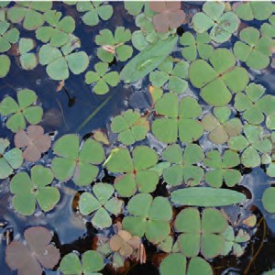
Seasonal Herbaceous Wetland

MNES 3: Seasonal Herbaceous Wetland

Key insights and management implications for Seasonal Herbaceous Wetland
Results indicate that native forb richness remains stable across all wetland sites. However, weeds would appear to be increasing across the same monitored sites, despite levels remaining within the 95% CI tolerance of the defined baseline in each case. Native perennial species remain stable, suggesting that weed growth is outstripping native growth. It is likely that more intensive weed control may have prevented this situation.60
DELWP has observed many species disappearing and reappearing. Data suggests that these fluctuations correlate mainly with wet hydrological phases and (to some extent) weed management 61 – therefore there may be potential management explanations
for the variability. Weed management has not been prioritised at these sites over the last few years, which could explain the increase in weed cover. Lack of weed control and recent restrictions to grazing in the surrounding Wetland Grassland Reserve is also a likely factor in the increase in weed cover. DELWP has indicated that previous weed control programs at the same wetland sites have been highly successful and relatively easy to implement given the small scale of the issue – therefore it would be advisable to prioritise the reinstatement of these measures, along with the appropriate funding for land managers.
Other management interventions to explore include:
- cease grazing – long-term grazing eventually strips many of the forbs out
- cease hydrological modification (including dams) in the catchment – dams within wetlands, or in wetland catchments, can delay filling, starving the wetlands of water
- supplementary planting of forbs, shrubs and sedges – to competitively disadvantage non-native species and directly increase species richness

the impact of different burning regimes
- targeted spot spraying – which is known to be an effective control of specific weeds and may be effectively implemented to support the persistence of the wetlands.62
Further, DELWP has focused on the monitoring of floristics in the design of KPIs for the wetlands because the community description’s condition thresholds under the national listing focus largely on vegetation. There is potential for monitoring of other correlates of wetland condition, including the presence of certain fauna including invertebrates, macroinvertebrates, birds and frogs.

- DELWP Officer, personal communication, 15 February 2022.
- DELWP Officer, personal communication, 15 February 2022.
- DELWP Officer, personal communication, 21 July 2021.

KPI 1: Richness of native perennial forbs during spring-summer | Status 2020-2022 | Reason for non-assessment | Trend | Data Confidence | Year that baseline was/will be set
Cobbledicks Rise | Met | N/A |  | High | 2018
One Tree Rise | Met | N/A |  | High | 2018
Windmill | Met | N/A |  | High | 2018

Comments: This KPI measures the richness of the native perennial forb component at the individual wetland scale. This KPI measures forb richness in every year, regardless of hydrological phase. Given this will include wet and dry years, this measure is expected to fluctuate over time. This KPI was met for all wetlands in 2020–2022, with levels of native perennial species remaining stable. Data confidence is high where it is able to be assessed.

KPI 2: Richness of all native forbs during drawdown | Status 2020-2022 | Reason for non-assessment | Trend | Data Confidence | Year that baseline was/will be set
Cobbledicks Rise | Not assessed | Lack of drawdown event |  | N/A | 2017
One Tree Rise | Not assessed | Lack of drawdown event |  | N/A | Unclear
Windmill | Not assessed | Lack of drawdown event |  | N/A | 2017

Comments: This KPI measures the richness of all native forbs, including both perennial and annual species, at the individual wetland scale. It is measured only at times when a given wetland is drawing down after filling, and the maximum expression of species richness is expected. This may only happen every few years, such that this KPI will remain unassessed in many years. This KPI is assessed against a baseline, set by
the first year of monitoring at drawdown, with a unique benchmark for each wetland. Since monitoring began, drawdown has only occurred in 2017, for Windmill Wetland and Cobbledicks Rise Wetland (One Tree Rise has a smaller catchment and did not fill in 2017). Drawdown did not occur during 2020–2022 so this KPI was not assessed this year.

KPI 3: Percentage cover of all perennial vegetation comprised of weeds during spring-summer | Status 2020-2022 | Reason for non-assessment | Trend | Data Confidence | Year that baseline was/will be set
Cobbledicks Rise | Met | N/A |  | High | 2018
One Tree Rise | Met | N/A |  | High | 2018
Windmill | Met | N/A |  | High | 2018

Comments: This KPI measures the percentage of all perennial vegetation cover that is comprised of weeds. This KPI is assessed against a baseline set by the first five years of monitoring. This KPI was met for all wetlands in 2020-2022, although the trend is deteriorating with exotic perennial species appearing to have increased steadily over the last few years. Confidence in the data is high where it is able to be assessed.

KPI 4: Percentage cover of all perennial vegetation comprised of weeds during drawdown | Status 2020-2022 | Reason for non-assessment | Trend | Data Confidence | Year that baseline was/will be set
Cobbledicks Rise | Not assessed | Lack of drawdown event |  | N/A | 2017
One Tree Rise | Not assessed | Lack of drawdown event |  | N/A | Unclear
Windmill | Not assessed | Lack of drawdown event |  | N/A | 2017

Comments: Like KPI 3, this KPI measures the percentage of all perennial vegetation cover that is comprised of weeds. In this case, the KPI only applies when a wetland is drawing down, having been filled. This KPI is assessed against a baseline, set by the first year of monitoring at drawdown, with a unique benchmark for each wetland. Since monitoring began, drawdown has only occurred in 2017, for Windmill Wetland and Cobbledicks Rise Wetland (One Tree Rise has a smaller catchment and did not fill in 2017). Drawdown did not occur during 2020–2022 so this KPI was not assessed in 2020–2022.

Theme Seasonal Herbaceous Wetland

Recommendation

07
That DELWP:
- increases weed control efforts and funding for land managers to protect Seasonal Herbaceous Wetland
- undertakes further research on the impacts of grazing, hydrological modification, and supplementary plantings of other native species, and
- broadens the KPI suite for future monitoring and reporting on wetland condition.

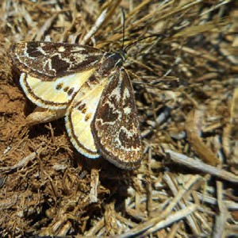
Golden Sun Moth

MNES 4: Golden Sun Moth

Key insights and management implications for the Golden Sun Moth

It is unclear if the apparent trend of a decline in Golden Sun Moth numbers represents a genuine population decline, is an issue of detectability or rather represents natural annual variability. Cover of vegetation inhibiting the moth’s reproductive behaviour is known to be an issue for both moth emergence and detection. DELWP has indicated that a recent lack of grazing in the moth’s known MSA extent, coupled with a relatively wet season, has led to a build-up of biomass.63 DELWP has indicated that many large areas of Golden Sun Moth habitat have also not had the optimal grazing and burning regimes applied to them in recent years.
An important covariate is the type of vegetation cover – the moths are presumed to eat C3 grasses, not Kangaroo Grass. It is for this reason that DELWP has previously reported the cover of different grass types.64 This has interesting implications for management – the moths tolerate grazed areas, but heavily grazed areas are not ideal. Kangaroo Grass-dominated ecosystems are viewed to be more desirable from a vegetation management perspective,65 but the moth preferences C3 grasses
– and this poses a potentially difficult management trade-off. DELWP’s Population Viability Analysis (PVA) modelling highlighted the importance of bare ground and C3 dominance grasses – and these outputs were incorporated into a structured decision- making exercise to assess the trade-off.
Weed control may be important to the Golden Sun Moth’s persistence; there is evidence of association with Chilean Needle Grass (Nassella neesiana) (Richter et al.) and with native C3 grasses i.e. Wallaby and Spear grasses (Rytidosperma spp. and Austrostipa spp.). A major assumption is that the main food plants for larvae of
the Golden Sun Moth are perennial C3 grasses, both native and exotic.66 While this is based on observations of moths in exotic grasslands (Brown et al. 2012),67 the extent to which they eat exotic grasses is unclear. Therefore, there are potentially negative impacts of weed control in areas with high levels of exotic C3 grasses such as Nassella trichotoma. DELWP has not yet undertaken studies assessing the relationship between biomass control regimes and persistence of the Golden Sun Moth – and there is potential to further explore this.
With additional Golden Sun Moth sites expected to come under MSA management over the next 18 months, DELWP indicates that some changes to the design may occur, and that comparison against a counterfactual control would assist to assess changes linked to MSA management.68

- DELWP Officer, personal communication, 15 February 2022.
- M Bruce, K Batpurev, D Bryant. S Sinclair and M Kohout 2020, ‘Melbourne Strategic Assessment: Ecological Outcomes Report 2014-15 to 2019-20.’ DELWP Heidelberg, Victoria.
- Sinclair SJ, Zamin T, Gibson-Roy P, Dorrough J, Wong N, Craigie V, Garrard GE and Moore JL 2019b, ‘A state-and-transition model to guide grassland management.’ Australian Journal of Botany 67, 437-453.
- Regan T. et al., Arthur Rylah Institute 2012, ‘Melbourne Strategic Assessment: Population Viability Analysis model for threatened species’.
- Brown, G., Tolsma, A. and McNabb, E., 2012. Ecological aspects of new populations of the threatened Golden sun moth ‘Synemon plana' on the Victorian Volcanic plains. Victorian Naturalist, The, 129(3), pp.77-85.
- DELWP Officer, personal communication, 15 February 2022.

KPI 1: Proportion of monitoring sites that are occupied | Status 2020-2022 | Reason for non-assessment | Trend | Data Confidence | Year that baseline was/will be set
All locations | Not met | N/A |  | Moderate | 2018

Comments: The Golden Sun Moth was detected at four of 11 plots (0.36) in the 2021–22 season. With the inclusion of this data, the upper 95% confidence interval (0.84) of the five-year mean has fallen below the baseline of 0.89, which may suggest an overall decline in population numbers. This is the first year that the KPI has been in breach of the baseline for Golden Sun Moth and occupancy is the lowest recorded in eight years of monitoring. This likely reflects a general decline in detections since the first three years of monitoring – and annual variation in detections appears to be increasing.
DELWP has noted69 that monitoring for the Golden Sun Moth started later this year and this may account for the lower apparent occupancy than in previous years. Monitoring data shows generally high grassland biomass levels (and correspondingly less bare ground) in 2021, compared with previous years.70 DELWP speculates that this factor may have had a detrimental effect on moth emergence/detectability, though this remains unclear.71

Theme Golden Sun Moth

Recommendation

08
That DELWP:
- considers changes to the monitoring regime of the Golden Sun Moth, and
- undertakes research into biomass control impacts.

- DELWP, internal document, provided 16 February 2022.
- DELWP Officer, personal communication, 15 February 2022.
- DELWP Officer, personal communication, 15 February 2022.

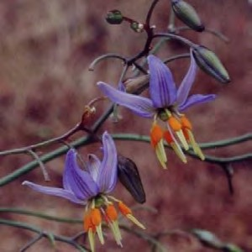
Matted Flax-lily

MNES 5: Matted Flax-lily

Key insights and management implications for the Matted Flax-lily

DELWP has funded genetic research for the species led by La Trobe University in 2021, which revealed the MSA population is genetically normal, with similar levels of genetic diversity compared to other populations. The research also explored the nature of clonality within the population’s genetics. DELWP accepts that there is some level of error in the counting of plants at low levels due to clonality.72 Periodic genetic sampling of future populations will be important to account for clonality.
Biomass control will be a necessary management intervention going forward for the species,73 as the species risks decline if it is shaded out. The preferred biomass reduction regime is the application of planned burning every seven to 10 years; the species responds negatively to grazing.74
DELWP is confident the species will persist in the medium-long term75 and indicates that if decline in the dataset is detected over time, they can readily rectify this, as there is ample tube stock for planting and the plants can be grown from a cutting of a rhizome. Response planning to manage potential species decline may be required given the current risk. Given the relative ease of intervention, supplementary planting may be undertaken to address any immediate declines, with opportunity to involve community.

KPI 1: Percentage of plants detected each year | Status 2020-2022 | Reason for non-assessment | Trend | Data Confidence | Year that baseline was/will be set
Kalkallo Common | Not assessed | Baseline not yet set |  | N/A | 2025
Mt Ridley | Not assessed | Baseline not yet set |  | N/A | 2022

Comments: In 2015, an initial database of known Matted Flax-lily locations (n=52) was compiled from field searches and the compilation of existing data from Hume City Council, Merri Creek Management Committee and Abzeco. Monitoring in these areas commenced in 2016. Each year during monitoring, new plants have been discovered. By 2019 there were 64 locations included in the database. It is not yet possible to state whether the KPI has been met, as the baseline has not yet been set. This KPI is assessed against a static benchmark which will be set in 2022 for Mt Ridley and 2025
for Kalkallo Common. Status assessments are therefore not provided here, any trends are unclear and data confidence assessments are not applicable.

Theme Matted Flax-lily

Recommendation

09
That DELWP schedules periodic genetic sampling of future populations of the Matted Flax-lily to ensure viability and develop a biomass control plan for the species.

- DELWP Officer, personal communication, 15 February 2022.
- DELWP Officer, personal communication, 15 February 2022. 74. DELWP Officer, personal communication, 15 February 2022.
- DELWP Officer, personal communication, 15 February 2022.

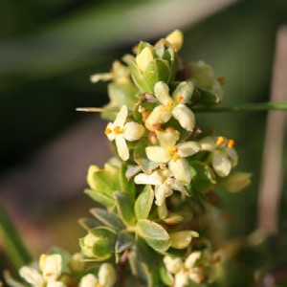
Spiny Rice-flower

MNES 6: Spiny Rice-flower

Key insights and management implications for the Spiny Rice-flower

DELWP consulted the official Pimelea Recovery Team in the design of the KPIs for this species. Of all the plant species under MSA management, it is the one that has had the most formal consultation.76 This species requires a lot of effort to monitor, with it taking longer to count compared with other species, according to DELWP.77
The Pimelea Recovery Team advised DELWP that Spiny Rice-flower recruits periodically, roughly every 10 years, and according to rainfall. DELWP used this information to determine the threshold for KPI 2: that once every 10 years there must be a high population of recruits. This KPI is unique in that it's not an aggregate – if
it’s achieved once within the 10-year period, it's achieved. Based on the design, it is unclear whether this KPI resets after it has been met or whether it is measured in blocks of 10 years. It is recommended that this is clarified. Further testing may be required to assess the adequacy of the 10-year window in capturing the variable recruitment dynamics.
Results in rates of recruitment for the Spiny Rice-flower are currently lower than expected over recent years. DELWP proposes to address this issue by observing if recruitment rates are enough to replace mortality rates within the population over time.
DELWP indicates that areas in which this species are found are in current need of a biomass control regime in the form of planned burning.78 DELWP report that to date, burns have been implemented well with positive outcomes.79 As the MSA program scales up, it will be important to maintain efforts to control biomass and manage the risk of degradation to current and new populations.
KPI 1: Population count | Status 2020-2022 | Reason for non-assessment | Trend | Data Confidence | Year that baseline was/will be set
Radio | Not assessed | Baseline not yet set |  | N/A | 2024
Truganina Cemetery | Not assessed | Baseline not yet set |  | N/A | 2024

Comments: The population counts (within clusters) in 2019 were 201 at Radio (in 4 clusters) and 965 at Truganina Cemetery (in 1 cluster). As 2019 was the first year of monitoring using this method, the baseline cannot yet be set. Status assessments are therefore not provided here, any trends are unclear and data confidence assessments are not applicable.

- DELWP Officer, personal communication, 15 February 2022.
- DELWP Officer, personal communication, 6 July 2021.
- DELWP Officer, personal communication, 15 February 2022.
- DELWP Officer, personal communication, 15 February 2022.

KPI 2: Number of recruits that form over 10% of the population over a 10-year period | Status 2020-2022 | Reason for non-assessment | Trend | Data Confidence | Year that baseline was/will be set
Radio | Not assessed | Baseline not yet set |  | N/A | 2024
Truganina Cemetery | Not assessed | Baseline not yet set |  | N/A | 2024

Comments: This KPI measures the recruitment potential of the population, to ensure that the conditions for recruitment are sustained (periodic bare ground, seed supply), not the survival rate of recruits, which are not monitored. (The overall population trajectory is covered by KPI 1.) The first year of monitoring using this method was 2019. The KPI will be first assessed after 10 years of monitoring, in 2029. Status assessments are therefore not provided here, any trends are unclear and data confidence assessments are not applicable.

Theme Spiny Rice-flower

Recommendation

10

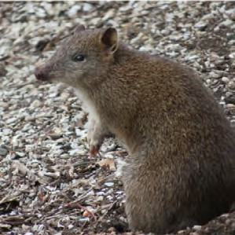
Southern Brown Bandicoot
That DELWP:
- clarifies the monitoring design
- assesses the adequacy of the current 10 year monitoring and reporting threshold, and
- develop a biomass control plan for the Spiny Rice-flower.

MNES 7: Southern Brown Bandicoot

Key insights and management implications for the Southern Brown Bandicoot

Southern Brown Bandicoot occupancy appears to vary by site, which suggests that they may have distinct habitat preferences relating to various pressures in the local environment. DELWP speculates that bandicoots prefer the artificial canal sites as the high vegetation cover in these areas offers protection from foxes, and the wet environment promotes insects and fungi, which they eat. Roadsides and bushland in the reserves are speculated to have, by comparison, less cover, and therefore the Southern Brown Bandicoot is potentially more vulnerable to predation by
foxes in these areas.80 Further insights into occupancy trends may inform sensitive management designs that address habitat preferences and species responses to management regimes (including planned burning, predator control and weed control), noting the importance of the artificial environment.

- Bryant, David, et al. 2018 "The occurrence of the Southern Brown Bandicoot Isoodon obesulus obesulus and its habitat on Chinaman Island, Western Port, Victoria." The Victorian Naturalist, vol. 135, no. 5, pp. 128.

Other data of relevance to Southern Brown Bandicoot occupancy relates to fox occupancy, with DELWP suggesting that foxes are everywhere within the Southern Brown Bandicoot’s range.81 Foxes pose the biggest threat to the bandicoot where habitat destruction is not present. Bandicoots appear to persist in the presence of foxes if there is enough cover.82 In previous years, DELWP has found an overlap of foxes and bandicoots at 30% of sites – and expert elicitation data fed into PVA modelling suggests the best action to support bandicoots is landscape-scale fox baiting. No landscape fox baiting is currently applied to control predation impacting on the Southern Brown Bandicoot. Other measures to explore include the extent of native vegetation, fire and planned burning.83
Western Port Biosphere, many academic institutes and community groups are currently collecting data for the Southern Brown Bandicoot. These other data sources external to the MSA may be useful for understanding explanatory trends around landscape- level occupancy. This may include leveraging citizen science capabilities to obtain more data informing a more complete picture of the population dynamics of Southern Brown Bandicoot with increasing urbanisation. DELWP may assist in addressing the gap in monitoring standards, through providing information on appropriate methods or tools for citizen science data to be included in the broader analyses and including a protocol that outlines the minimum requirement to meet the KPI objective for data to be used.

KPI 1: Proportion of monitoring sites that are occupied | Status 2020-2022 | Reason for non-assessment | Trend | Data Confidence | Year that baseline was/will be set
Southern Brown Bandicoot Management Area | Not assessed | Not monitored in 2020–2022 |  | N/A | 2019

Comments: The baseline for Southern Brown Bandicoot varies by habitat type; canal 76%, reserve 39% and road 35% of sites occupied. Bandicoot detections were spread out across the management area, with notable areas of non-detection in the south-western and north-eastern (north of the Princess Hwy) corners of the management area. The KPI will be assessed against these baselines in subsequent five-yearly surveys, with the next due in 2024. Status assessments are therefore not provided here, any trends are unclear and data confidence assessments are not applicable.

Theme Southern Brown Bandicoot

Recommendation

11
That DELWP undertakes research into habitat preferences and species responses to pressures and management regimes for the Southern Brown Bandicoot. This would include designing a protocol for leveraging citizen science and empowering partner organisations to contribute to reporting on the KPIs.

- DELWP Officer, personal communication, 29 February 2022.
- DELWP Officer, personal communication, 29 February 2022.
- DELWP Officer, personal communication, 29 February 2022.

Growling Grass Frog

MNES 8: Growling Grass Frog

Key insights and management implications for the Growling Grass Frog

The current KPI doesn’t rely on the actual status of frog populations – it is instead based on the modelled risk of extinction. There are some shortcomings to this method, because if the model incorrectly determines that risk is low then the outcome is met even if the population is in reality declining/extinct.84 There is an outstanding need to establish baseline monitoring for new corridors, with DELWP commencing this work in 2021 (outside this report’s data acquisition period).
Formal monitoring is being undertaken by professional ecologists and supplemented with data collected in citizen science programs and frog monitoring apps. This extra effort to monitor sites will not only help with data acquisition, but will assist in finding new sites, and may fill in some of the temporal gaps to improve the volume and quality of data. DELWP wishes to direct people's enthusiasm and effort to the MSA area.85 Uncertainty is reduced through citizen science data collection supplementing conventional monitoring.
Groundwater feed may not be able to be relied on in future. Inputs of pollutants of various kinds will contribute to declines in habitat quality, as will the introduction of new exotic species, notably predatory fish.86 Pressures of urbanisation are expected to impact the Growling Grass Frog and it is anticipated that these will likely get worse for the species, however experts are unclear to what extent. Some mitigations (applied at both the wetland design and management phases) are in place, but how successful these will be is also currently unclear. As such, there is uncertainty around what the impacts will be. Efforts should be prioritised to address uncertainty around management and potential threats to the Growling Grass Frog with increasing urbanisation to pre-emptively address the potential for population decline.
KPI 1: Modelled stochastic patch- occupancy estimate of extinction risk | Status 2020-2022 | Reason for non-assessment | Trend | Data Confidence | Year that baseline was/will be set
All locations | Not assessed | Not monitored in 2020–2022 |  | N/A | 2022

Comments: Growling Grass Frog has yet to be monitored as part of the MSA program as at the closure of this report’s data acquisition period (2 February 2022) and so there are no results to report at present. Status assessments are therefore not provided here, any trends are unclear and data confidence assessments are not applicable.

Theme Growling Grass Frog

Recommendation

12
That DELWP establishes baseline monitoring for new corridors for the Growling Grass Frog, evaluates threats and management responses, and encourages citizen science to supplement conventional monitoring.

- DELWP Officer, internal document, supplied 16 June 2022.
- DELWP Officer, personal communication, 29 July 2021.
- DELWP Officer, personal communication, 29 July 2021.

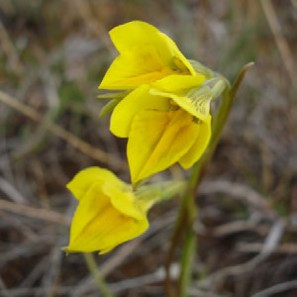
Small Golden Moths Orchid

MNES 9: Small Golden Moths Orchid

Key insights and management implications for the Small Golden Moths Orchid

Urgent action is required to secure the population of the Small Golden Moths Orchid to halt potential species decline and extinction.
It is unclear if, and how well, the species is persisting. The area containing the remnant grassland habitat of Small Golden Moths Orchid is not yet protected.87 Currently no direct interim management is being undertaken.
As this is the last known population of the Small Golden Moths Orchid,88 with the species having undergone a ‘catastrophic reduction in range and distribution’ in recent years,89 the species is considered extremely vulnerable to threats. Because of this, pressures such as subtle changes in biomass and rabbits may be problematic for the species.
KPI 1: Count of individuals emergent at least once over a five-year period | Status 2020–2022 | Reason for non-assessment | Trend | Data Confidence | Year that baseline was/will be set
Conservation Area 3 | Not assessed | Population not yet under MSA management |  | N/A | Unclear

Comments: As areas have yet to be protected, monitoring has not commenced on this species, therefore results are unable to be assessed. Status assessments are therefore not provided here, any trends are unclear and data confidence assessments are not applicable.

Theme Small Golden Moths Orchid

Recommendation

13
That DELWP urgently assess the impacts of biomass and pests on the Small Golden Moths Orchid.

- DELWP Officer, personal communication, 15 February 2022.
- DELWP Officer, personal communication, 15 February 2022.
- Backhouse, G; Lester, K 2010. "National Recovery Plan for the Small Golden Moths Orchid Diuris basaltica" (PDF). Australian Government Department of the Environment. Accessed 5 March 2022.

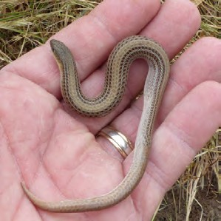
Striped Legless Lizard

MNES 10: Striped Legless Lizard

Key insights and management implications for the Striped Legless Lizard

Monitoring is undertaken under conditions that are presumed to provide the highest probability of detection, however, there remains the possibility that detections are affected by seasonal climatic conditions, e.g. rainfall or events such as fire. It may be possible to revisit the assumptions around detectability once more data is obtained.90 Overall, the species is viewed to be increasingly more common and widespread than was thought at the beginning of the program.91 However, habitat preferences for the species remain unclear. Some monitored sites in poorer condition have higher rates of detection, with other larger sites (assumed more suitable habitat) having much lower rates of detection. Further research is required to better understand the Striped Legless Lizard’s habitat preferences to inform appropriate and targeted management.
It is possible that the current KPI design for the Striped Legless Lizard is limited in its ability to reveal important information on species occupancy capturing the full geographic extent of the population, in part due to the non-random re-sampling
design and fixed number of monitoring sites. Monitoring is also limited in the design of the KPI without comparison to a baseline such that trends may be clearly assessed.
A change in design of the monitoring protocol to increase the number of sites monitored with random sampling may reveal trends in occupancy over time. Previous years’ data on detectability may inform the number of sites required to meaningfully detect change.

KPI 1: Proportion of monitoring sites that are occupied | Status 2020–2022 | Reason for non-assessment | Trend | Data Confidence | Year that baseline was/will be set
Mount Cottrell NCR | Met | Change in monitoring method |  | Low | N/A
Truganina South NCR | Met | Change in monitoring method |  | Low | N/A
Werribee River easement | Met | Change in monitoring method |  | Low | N/A
All other locations | Met | Change in monitoring method |  | Low | N/A

Comments: Striped Legless Lizard has been detected in all survey years after the establishment of the permanent plot in 2017 on Mount Cottrell NCR. At Truganina South NCR, Striped Legless Lizard was detected in 2019. This KPI has been met for the first five years at both locations. At the other locations the assessment of the KPI
began in 2021. Striped Legless Lizard was detected in 2021 at all permanent monitoring plots except at the Werribee River easement (it was last detected here in 2019). In
2021, 10 new locations were searched specifically for Striped Legless Lizard. No lizards were detected at these locations and, as such, they will not become permanent plots. Limitations with the current monitoring protocol and indicator design mean the dataset is currently biased to locations where the lizard has been previously detected – this makes the assessment of any trends unclear and confidence in the data is low.

- DELWP Officer, personal communication, 14 July 2021.
- DELWP Officer, personal communication, 14 July 2021.

Theme Striped Legless Lizard

Recommendation

14
That DELWP:
- redesigns the KPI and monitoring protocol for the Striped Legless Lizard, such that the measure for persistence is a randomly sampled measure for occupancy across all sites and accounts for new locations, and
- undertakes research to assess habitat preferences and population dynamics for the Striped Legless Lizard.

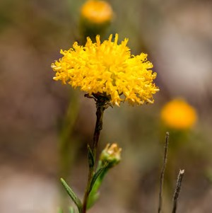
Button Wrinklewort

MNES 11: Button Wrinklewort

Key insights and management implications for the Button Wrinklewort

At Truganina Cemetery, adult plants are surviving at the anticipated rate.92 However, recruitment is failing for the Button Wrinklewort at Truganina Cemetery, and targeted research is required to determine why. It is speculated that rabbits may be eating the adult plants and creating a browsing pressure on the species, as occurring signs of rabbit occupation have greatly increased in recent years.93 It is thought that development in surrounding areas may be encouraging rabbits into the site. It is possible too, that invertebrates may be eating new recruits. Ongoing drought stress is also thought to be a factor in the failure of recruitment at the site.94 Further research is required to understand the causative factors underlying failure in population recruitment.
DELWP has evidence that the seed produced from the MSA Button Wrinklewort plants is highly germinable.95 The MSA program has contracted La Trobe University to produce plants from seed collected at Truganina, and this seed has germinated to produce healthy plants.96 These results would indicate that there is potential for management intervention to support population numbers; it may be possible to undertake planting into the population too, to overcome the recruitment issue. DELWP is intending to reintroduce these plants at several key sites including Truganina Cemetery and St Albans railway station.97 It is unclear when this will commence. Further research and experimental observation would be required to understand the effect of this kind of intervention on the long-term persistence of the population.

KPI 1: Population count | Status 2020–2022 | Reason for non-assessment | Trend | Data Confidence | Year that baseline was/will be set
Truganina Cemetery | Not met | N/A |  | Moderate | 2019

Comments: KPI 1 has been assessed as ‘not met’ in this reporting cycle. Results indicate that MSA population of Button Wrinklewort is slowly declining, largely due to the failure of new recruits to survive their first year and replace plants that are dying.98 DELWP does not know why recruitment is failing. An adequate number of plots have been sampled since 2019 to obtain a good level of data – however monitoring to date has only occurred at one site, meaning data confidence is moderate.

Theme Button Wrinklewort

Recommendation

15
That DELWP assesses the causes of recruitment failure for the Button Wrinklewort population – including research into germination – and develop a management plan for the species based on the findings.

- DELWP Officer, personal communication, 15 February 2022.
- DELWP Officer, personal communication, 15 February 2022.
- DELWP Officer, personal communication, 15 February 2022.
- DELWP Officer, personal communication, 15 February 2022.
- Department of Land, Water and Planning (DELWP) webpage, ‘Our progress at a glance – Protecting biodiversity in Melbourne’s growth areas – program highlights’, https://www.msa.vic.gov.au/our-progress-at-a-glance Accessed 26 February 2022.
- Department of Land, Water and Planning (DELWP) webpage, ‘Our progress at a glance – Protecting biodiversity in Melbourne’s growth areas – program highlights’, https://www.msa.vic.gov.au/our-progress-at-a-glance Accessed 26 February 2022.
- DELWP, internal document, provided 17 January 2022.

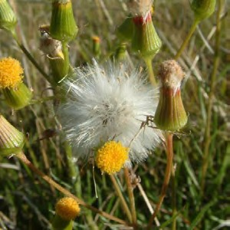
Large-fruit Groundsel

MNES 12: Large-fruit Groundsel

Key insights and management implications for the Large-fruit Groundsel

DELWP indicates that there is not enough data (in part due to lack of protected populations on MSA land) to conclude definitive insights on the species or management implications.99 Given the small numbers, the population remains vulnerable to external pressures. It is possible that the risk of decline could be mitigated through population augmentation via the planting of tube stock.100

KPI 1: Population count | Status 2020–2022 | Reason for non-assessment (if applicable) | Trend | Data Confidence | Year that baseline was/will be set
Conservation Area 5 | Not assessed | Population not yet under MSA management |  | N/A | Unclear
Little Raven | Not assessed | Baseline set in 2022 |  | N/A | 2022

Comments: The natural Large-fruit Groundsel population at Little Raven is small, and the number of plants recorded has declined slightly since its discovery (16 plants in 2017, 12 plants in 2021). The baseline for the population at Little Raven has been set this year. Status assessments are therefore not provided here, any trends are
unclear and data confidence assessments are not applicable. The larger population in Conservation Area 5 is not yet protected and remains unmonitored.

Theme Large-fruit Groundsel

Recommendation

16
That DELWP undertakes research into the benefits of population augmentation of the Large-fruit Groundsel via the planting of tube stock.

- DELWP Officer, personal communication, 15 February 2022. 100. DELWP Officer, personal communication, 15 February 2022.

Part 2: Scientific assessments

This section contains the KPI results in detail for all MNES. It presents data supplied by DELWP and Parks Victoria in relation to status and trend information against conservation outcomes for MNES defined in the 2015 MSA MRF and published in
the Victorian Government Gazette,101 with the data acquisition period for this report ending on 28 February 2022. The report also addresses issues and limitations to the current MRF in its assessment of the conservation outcomes, guided by an evaluation framework based around two key evaluation questions outlined below.
KEQ 1: Are the conservation outcomes for each MNES being met under the current definitions and performance indicators?
  - This assesses the status and trend reporting against MNES conservation outcomes KPIs defined under the current MSA MRF framework.
KEQ 2: Is the current framework for MSA monitoring and reporting on the conservation outcomes adequate?
  - This comprises an evaluation of the existing MSA MRF and program logic.

DELWP’s MSA Monitoring and Reporting Framework (MRF)
The 2015 MSA MRF contains the most current approved program logic for the program’s output and outcomes reporting.102 The outcomes refer to conservation outcomes for MNES under MSA management. The official MRF document has not been updated since 2015, however it is still referenced by DELWP as a document that ‘mandates […] annual data collection [and] that ecological outcomes be reported every five years
to provide the Australian Government and the public with the data required to judge whether Victoria is achieving its obligations under the MSA.’103
DELWP documents changes to the MRF – in relation to ecological monitoring of the conservation outcomes – in its September 2021 publication of the MSA Outcomes Report 2014–2020,104 with a section in each chapter detailing changes made to improve the MRF. These changes have yet to be reflected in an updated version of DELWP’s official MSA MRF document. To date, no formal external review or consultation process has occurred to inform changes to the monitoring framework, as DELWP has relied largely on internal expertise.
DELWP is the custodian of the data collected through ARI’s annual MSA ecological monitoring program. ARI has been undertaking annual data collection for the MSA ecological monitoring program since 2013, involving field surveys tailored to the characteristics of each species and community. This monitoring work preceded the publication of the MRF in 2015, as there was a period of trialling and developing field sampling techniques and methodologies.

- State Government of Victoria 2022, Victorian Government Gazette, Issue G4, ‘Melbourne Strategic Assessment (Environment Mitigation Levy) Act 2020 – Notice of the Conservation Outcomes’, http://www.gazette.vic.gov.au/gazette/Gazettes2022/GG2022G004.pdf Accessed 27 January 2022.
- DELWP 2015, ‘Monitoring and Reporting Framework – Melbourne Strategic Assessment’, East Melbourne, Victoria.
- Bruce M, Batpurev K, Bryant D, Sinclair S and Kohout M 2020, ‘Melbourne Strategic Assessment: Ecological Outcomes Report 2014-15 to 2019-20.’ DELWP, Heidelberg, Victoria.
- Bruce M, Batpurev K, Bryant D, Sinclair S and Kohout M 2020, ‘Melbourne Strategic Assessment: Ecological Outcomes Report 2014-15 to 2019-20.’ DELWP, Heidelberg, Victoria.

Monitoring data is used to measure progress towards the conservation outcomes KPIs, as detailed in the 2015 MRF and summarised in the MSA Outcomes Report 2014–2020. KPIs for species include measures relating to population counts, detection rates, recruitment and occupancy. KPIs for communities include measures relating
to plant species richness and cover of weed and native species, state change and spatial heterogeneity. It should be noted that the MSA Outcomes Report 2014–2020 did not present detailed analyses or interpretation of the monitoring results. Instead, it has offered a statement of whether each KPI was met and some brief qualitative discussion of trends.
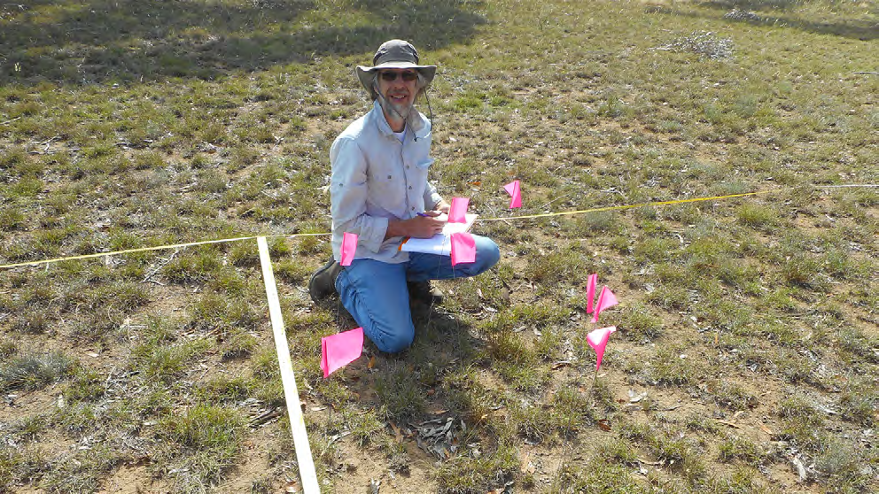
Figure 3: Annual monitoring being undertaken by DELWP staff at Truganina Cemetery Source: DELWP

Evaluation approach for KEQ 1: Are the conservation outcomes for each MNES being met under the current definitions and performance indicators?
This report presents DELWP’s methodology and results data for each MNES as provided to the Commissioner by DELWP, with updates to reflect data collected over the 2020–2022 monitoring period. Multiple DELWP documents exist, containing definitions of performance objectives and measures for the conservation outcomes
for MNES under MSA management. Current definitions of the conservation outcomes are presented in the Notice of the MSA Conservation Outcomes published in the Victorian Government Gazette and in DELWP’s 2015 MSA MRF. Current definitions of performance indicators associated with the conservation outcomes are contained within DELWP’s 2015 MSA MRF and Ecological Outcomes Report 2014–2020. There are discrepancies between the gazetted outcomes and the outcomes statements contained within the MRF, in terms of the language used to define the conservation outcomes. To avoid potential confusion, both the gazetted outcomes and MRF
outcomes definitions are presented in this report for each MNES. Associated outcomes KPIs have been obtained from the 2015 MSA MRF, as these were not included with the gazetted conservation outcomes.

It should also be noted that DELWP’s gazetted conservation outcomes statements include some that, technically by definition in DELWP’s MSA MRF, are MSA program ‘outputs’ performance measures, and as such will not be analysed in this report.
For assessing ecological status and trends, DELWP commissions ARI to develop, review and report on KPIs for each MNES. These KPIs sit beneath the outcome statements. These KPIs were designed by ARI to assess whether each outcome is being achieved. According to ARI, the choice of each KPI is determined by the form of the outcome, the ecological characteristics of the species or vegetation communities (mobility, detectability, temporal variation, etc.), the feasibility and cost of measurement,
and the spatial distribution of the species or vegetation community.105
For species, these KPIs may relate to abundance and/or occupancy. For vegetation communities, KPIs may relate to cover of selected plants, richness of plant species within selected groups, heterogeneity and/or proportion of community undergoing undesirable changes between states.106
Informal changes to the MRF have occurred since the official publication of this document in 2015. ARI detailed these in its MSA Outcomes Report 2014/15–2019/20. ARI has since made further informal updates to the monitoring protocol for 2020–2022 via an internal document,107 and these changes are documented in Appendix 2.

Targets, baselines and continual improvement
The following outlines the general design of targets, baselines and continual improvement approaches under the MSA MRF and has been extracted from the MSA Outcomes Report 2014–2020.108

‘For each MNES under MSA management, DELWP has created performance targets. These vary according to the characteristics of the species or community – however, there are several consistent themes:
  - most KPIs are assessed against a baseline, which sets the measure that the relevant attribute must remain above (for desirable attributes such as populations of threatened species) or below (for undesirable attributes such as weeds). In all such cases, the KPI is not met once the 95% confidence interval on the measure fails to meet the baseline.
  - all baseline values that are derived from means (for percentage cover and species counts) are rounded to the nearest whole number.

- Bruce M, Batpurev K, Bryant D, Sinclair S and Kohout M 2020, ‘Melbourne Strategic Assessment: Ecological Outcomes Report 2014-15 to 2019-20.’ DELWP, Heidelberg, Victoria.
- Bruce M, Batpurev K, Bryant D, Sinclair S and Kohout M 2020, ‘Melbourne Strategic Assessment: Ecological Outcomes Report 2014-15 to 2019-20.’ DELWP, Heidelberg, Victoria.
- DELWP, internal document, Accessed 6 February 2022.
- Bruce M, Batpurev K, Bryant D, Sinclair S and Kohout M 2020, ‘Melbourne Strategic Assessment: Ecological Outcomes Report 2014-15 to 2019-20.’ DELWP, Heidelberg, Victoria.

In most cases, baselines are set by the conditions at the commencement of monitoring. Given monitoring usually only commences when land comes under MSA management, this means that the target is to maintain or improve on what was present when MSA management commenced. In most of these cases, the baseline is calculated not from the first survey, but from the mean of the first five years of monitoring data. This approach is intended to dampen fluctuations between monitoring periods that are not related to management or long-term success (e.g. fluctuations in vegetation cover due to recent fires, or responses by animals to weather conditions).
A continuous improvement approach applies to some KPIs, which DELWP has designed to build on positive outcomes for MNES. In these cases, if the measured mean in a five-yearly reporting cycle is an improvement from the
baseline, the measured mean sets a new target for the next five-year reporting period. DELWP states that this approach is beneficial for measures where the most desirable outcome is always ‘complete removal’ (e.g. weeds) or ‘as high as possible’ (e.g. abundance of a listed species). For other KPIs, the baseline
is set and does not change, regardless of the results. Such set baselines are considered appropriate in cases where the attribute is desired at moderate levels. For example, it is desirable for the cover of Kangaroo Grass in Natural Temperate Grasslands to be maintained within a range, so a continuous improvement model is not appropriate.
There are exceptions to these general approaches, which are based on considerations of the ecology and survey techniques applicable to the measure in question. These are described and explained in the MRF.’

Stratification of reporting
The following outlines the MSA MRF’s approach to stratification of reporting and has been extracted from the MSA Outcomes Report 2014–2020.109
‘The ‘stratification of reporting’ refers to the way that the KPI results are reported on separately for different locations. This is intended to reveal whether progress is consistent or mixed, and whether different places under different management regimes are tracking differently.
For two of the three vegetation communities (Natural Temperate Grassland and Grassy Eucalypt Woodland), the KPIs are reported separately according to states. These are defined by a state-and-transition model (STM).110 STMs present alternative states of species assemblages (or profiles, groups) that
could occur at a given site. Which of these occurs depends on management and natural events at the site.

- Bruce M, Batpurev K, Bryant D, Sinclair S and Kohout M 2020, ‘Melbourne Strategic Assessment: Ecological Outcomes Report 2014-15 to 2019-20.’ DELWP, Heidelberg, Victoria.
- Sinclair SJ, Zamin T, Gibson-Roy P, Dorrough J, Wong N, Craigie V, Garrard GE and Moore JL (2019b) ‘A state-and-transition model to guide grassland management.’ Australian Journal of Botany 67, 437-453.

The assemblage may change from one state to another – it may undergo a desirable or undesirable transition if a threshold is crossed. Assigning a state to a site is effectively a shorthand summary of what has happened to that site, what its current ecological status is, what the possibilities are for the site for improvement and what management tools might be available.
The STM for Natural Temperate Grassland is described in Sinclair et al. (2019b).111 The STM for Grassy Eucalypt Woodland is unpublished and is not yet in use. States are not used for reporting on Seasonal Herbaceous Wetlands, because this community is reported on at discrete wetland sites.’

Other measures
Some additional parameters are monitored that do not contribute to the KPIs, such as weather and other environmental covariates. DELWP has not included these measures as KPIs as they are ‘highly labile, highly correlated to the KPIs, or because they have an uncertain relationship to the desired outcomes.’112 This data may assist in the interpretation of the KPIs in future, inform species and community models or reveal other changes of interest in the ecosystem. DELWP has not yet compiled the data for other measures for 2020–22 and as such they are not presented here.

Scope of application
The following outlines the scope of application of MSA monitoring undertaken under the MSA program and has been extracted from the MSA Outcomes Report 2014–2020.113

Geographic

‘Monitoring applies to all known natural populations of relevant species and vegetation communities on land within the MSA Conservation Areas described in the BCS, the Western Grassland Reserve, the Grassy Eucalypt Woodland Reserve, the Southern Brown Bandicoot management area and any other parcels of land acquired under the MSA. It is DELWP’s intention to monitor any newly discovered natural populations of EPBC-listed species on MSA managed land, and to evaluate their outcomes against the KPIs.’

Temporal

‘Monitoring commences at a given location only once that site is secured or the regional implementation program has commenced in that area (for Growling Grass Frog, and Southern Brown Bandicoot only). This approach was a basic assumption in the design and costing of the MSA. This has several implications.

- Sinclair SJ, Zamin T, Gibson-Roy P, Dorrough J, Wong N, Craigie V, Garrard GE and Moore JL (2019b) ‘A state-and-transition model to guide grassland management.’ Australian Journal of Botany 67, 437-453.
- Bruce M, Batpurev K, Bryant D, Sinclair S and Kohout M 2020, ‘Melbourne Strategic Assessment: Ecological Outcomes Report 2014-15 to 2019-20.’ DELWP, Heidelberg, Victoria.
- M Bruce, K Batpurev, D Bryant. S Sinclair and M Kohout 2020, ‘Melbourne Strategic Assessment: Ecological Outcomes Report 2014-15 to 2019-20.’ DELWP, Heidelberg, Victoria.

First, it means that the monitoring does not include counterfactuals that are not part of MSA management. This limits the ability to compare and evaluate MSA management against other management (including ‘no management’) scenarios.
Second, the progressive addition of sites means that the statistical power to detect changes or management effects will initially be low. For example, in 2019, only approximately 10% of the Natural Temperate Grassland designated for protection under the MSA program was being monitored, with conclusions unable to be drawn about the remaining 90%.
Third, it means that newly secured sites can influence the apparent progress towards the outcomes; not because of changes brought about by management, but simply due to their addition to the dataset. DELWP has designed KPIs to counter such effects. For example, some KPIs are assessed for a given site only from when it is secured, and some baselines are re-balanced to account for new sites.’

Treatment of species re-introductions, population augmentations and colonisation of restored habitats
The following outlines a rationale for the treatment of species reintroductions, population augmentations and colonisation of restored habitats under the MSA program and has been extracted from the MSA Outcomes Report 2014–2020.114

‘For several plant species, new populations may be created, or existing populations augmented, with the establishment of new individuals by seeding or planting. Button Wrinklewort and Large-fruit Groundsel are known to establish well from direct seeding. Both Matted Flax-lily and Spiny Rice-flower have been previously translocated from cleared sites to recipient sites, with a mixed record of success and failure. For the Growling Grass Frog, new wetlands will be created to compensate for losses due to development.115
It is important that the MRF deals appropriately with these situations.
To this end, DELWP has adopted the following principles (introduced in ARI’s MSA Outcomes Report 2014–2020, but not explicitly outlined in the MRF).
Any plants that are planted or translocated within an existing population are marked and monitored but only contribute to the KPI targets in the fifth year after their introduction, when they are assumed to be established within the population. DELWP states that this decision reflects the fact that planted
or translocated plants suffer high mortality rates.116 If they are counted before they are truly established, the population will be falsely inflated early on, then a decline will later be recorded which does not reflect the decline of the wild population.

- M Bruce, K Batpurev, D Bryant. S Sinclair and M Kohout 2020, ‘Melbourne Strategic Assessment: Ecological Outcomes Report 2014-15 to 2019-20.’ DELWP, Heidelberg, Victoria.
- DELWP 2017, ‘Growling Grass Frog Masterplan for Melbourne’s Growth Corridors. Melbourne Strategic Assessment.’, East Melbourne, Victoria.
- Godefroid S, Piazza C, Rossi G, Buord S, Stevens A-D, Aguraiuja R, Cowell C, Weekley CW, Vogg G, Iriondo JM, Johnson I, Dixon B, Gordon D, Magnanon S, Valentin B, Bjureke K, Koopman R, Vicens M, Virevaire M and Vanderborght T 2011, ‘How successful are plant species reintroductions?’ Biological Conservation 144, 672-682.

Any progeny resulting from direct seeding at monitored sites are counted as part of the monitored population and contribute to the KPI targets. According to DELWP, this recognises the fact that direct seeding is likely to be an important management action for some populations of some species. It also recognises that individuals emerging from direct sowing are often indistinguishable from those derived from wild seed, and that any plants which are detected by the monitoring protocols have gone through stringent selection as germinants and probably have a similar survival probability to wild plants.
Spatially discrete, new plant populations created away from wild populations are not assessed with relation to their KPIs. Instead, new populations are monitored and reported as ‘other measures’. The decision to exclude such populations from evaluation against KPIs considers the clearly defined commitment to protect assets under the MSA (not new assets), the unknown survival probabilities in new populations and the fact that most translocation projects are expected to be conducted under non-MSA projects with their own monitoring requirements. It is acknowledged that new populations are often valuable for the conservation of species and should be monitored, as they boost the numbers of individuals, provide insurance populations and may facilitate gene flow. Spatially discrete new populations created on MSA properties by non-MSA projects which are covered by their own monitoring programs are not monitored at all under the MSA (e.g. several translocations were undertaken under the Regional Rail Link project).
It is expected that new wetlands created for the Growling Grass Frog will be colonised from adjacent habitat. This newly created habitat will be monitored and will contribute towards KPI targets.’

Evaluation approach for KEQ 2: Is the current framework for MSA monitoring and reporting on the conservation outcomes adequate?
As monitoring is designed to uncover evidence required to enable an assessment of the conservation status and trajectory of MNES informing appropriate protection
measures, a robust monitoring program is recognised as an important component of threatened species management.117 A well designed MRF may help identify threats that are driving population decline, and hence help and prioritise management responses. It may also assess the efficacy and contribute to improvements of actions that aim to manage conservation outcomes.118
KEQ 2 provides the basis for a meta-evaluation assessing the adequacy of the existing MSA MRF. Based on an initial assessment, this report summarises findings and makes recommendations for improvement to the current MRF. The data collected
and findings gathered through interviews with DELWP and Parks Victoria were the primary inputs for an assessment of KEQ 2 in the current report. Results are stratified according to each MNES and a general summary is provided under the subheading Key insights, management implications and future focus.

- (Eds) Legge S, Robinson N, Lindenmayer D, Scheele B, Southwell D, Wintle B 2018, ‘Monitoring Threatened Species and Ecological Communities’, CSIRO publishing, Clayton, Victoria.
- (Eds) Legge S, Robinson N, Lindenmayer D, Scheele B, Southwell D, Wintle B 2018, ‘Monitoring Threatened Species and Ecological Communities’, CSIRO publishing, Clayton, Victoria.

The timeframes for delivery of this inaugural report have meant that external consultation was not within scope. As such, information informing the current assessment for KEQ 2 has been obtained through interviews with internal experts from DELWP and Parks Victoria, and may form the basis for future formal reviews (see Recommendation 1) of the MSA MRF, including addressing specific criteria such as:
  - Do the KPIs adequately address the objectives for MNES?
  - Are the methods clear enough to be reproduced?
  - What would true ex-MSA counterfactuals add in terms of inference?
  - Is the rate of expansion of the current monitoring program sufficient such that reasonable power will be achieved in reasonable time?
  - Is monitoring linked to learning and adaptive management?
  - Is the monitoring integrated with management?
  - Does the monitoring link to an understanding of threats?
  - Are there knowledge gaps that monitoring could help to address?

How to read results in Part 2 of this report
Results in Part 2 of this report are separated into chapters by MNES (i.e. by communities and species).

These MNES are:
Ecosystems: Natural Temperate Grassland, Grassy Eucalypt Woodland and Seasonal Herbaceous Wetland.
Threatened species: Golden Sun Moth, Matted Flax-lily, Spiny Rice-flower, Southern Brown Bandicoot, Growling Grass Frog, Small Golden Moths Orchid, Striped Legless Lizard, Button Wrinklewort and Large-fruit Groundsel.

For each of the 12 MNES, information will be provided on:
  - Background: Brief information on the species/community ecology, including status of EPBC listing
  - DELWP’s conservation commitments
  - KPIs assessed: For each MNES, there are one or more KPIs relating to KEQ 1. For each KPI there is a summary table at the beginning of the relevant section. This table is a quick guide to the status of a KPI for the current reporting period. It shows the relevant reporting unit (location, population or state) and indicates if the KPI was achieved, not achieved or not assessed. Reasons for it to not have been assessed include that the MNES is not currently protected (or too few locations are protected), too few years have elapsed for the KPI to be assessed (e.g. the baseline is not set) or the KPI is only assessed after a particular event which has not occurred in the relevant period (e.g. wetland flooding)
  - Monitored areas
  - Results: Progress (status, trend and data confidence) against existing KPIs and delivery targets defined under the MSA program’s MRF)

  - Results interpretation
  - Key insights and management implications.
Also included are charts or tables that show annual data relevant to the KPI. The most common of these is a chart showing the temporal trend in the indicator (shown as
a faded line), a baseline (shown as horizontal dashed line) and the relevant mean used for assessing performance against the KPIs (typically a five-year rolling mean) with 95% confidence intervals (Figure 4).
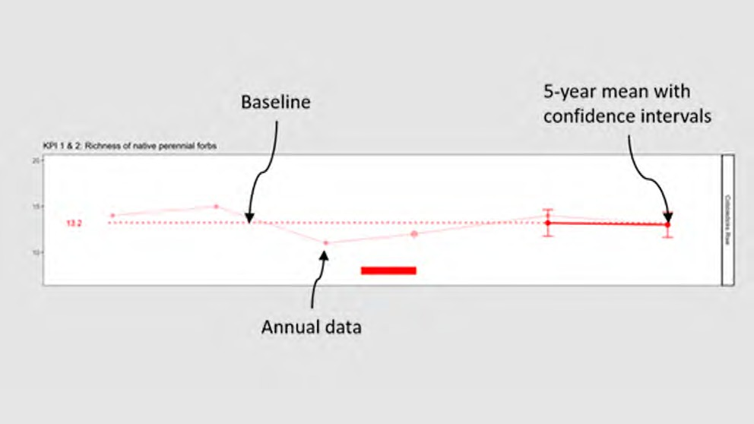
Figure 4: Example of a KPI indicator chart, in this case the KPI was recorded as achieved Source: DELWP

Data source
This report presents data supplied by DELWP, ARI and Parks Victoria in relation to status and trend information against conservation outcomes for MNES defined in the MRF and published in the Victorian Government Gazette,119 with the data acquisition period for this report ending on 28 February 2022.

Status 2020–2022
The status for each MNES conservation outcomes KPI is assessed as either ‘Met’, ‘Not met’ or ‘Not assessed’ according to the objective defined by the KPI. For each MNES under MSA management, DELWP has created performance targets that determine these statuses. Targets vary according to the characteristics of the species or community – however, there are several consistent themes:
  - most KPIs are assessed against a baseline, which sets the measure that the relevant attribute must remain above (for desirable attributes such as populations of threatened species) or below (for undesirable attributes such as weeds). In all such cases, the KPI is not met once the 95% confidence interval on the measure fails to meet the baseline.
  - all baseline values that are derived from means (for percentage cover and species counts) are rounded to the nearest whole number.

- State Government of Victoria 2022, Victorian Government Gazette, Issue G4, ‘Melbourne Strategic Assessment (Environment Mitigation Levy) Act 2020 – Notice of the Conservation Outcomes’, http://www.gazette.vic.gov.au/gazette/Gazettes2022/GG2022G004.pdf Accessed 27 January 2022.

In most cases, baselines are set by the conditions at the commencement of monitoring. This means that the target is to maintain or improve on what was present when MSA management commenced. In these cases, the baseline is calculated not from the first survey, but from the mean of the first five years of monitoring data. This approach is intended to dampen fluctuations between monitoring periods that are not related to management or long-term success (e.g., fluctuations in vegetation cover due to recent fires, or responses by animals to weather conditions).
A continuous improvement approach applies to some KPIs, which DELWP has designed to encourage positive outcomes (‘maintain gains’) for MNES. In these cases, if the measured mean in a five-yearly reporting cycle is an improvement from the baseline, the measured mean sets a new target for the next five-year reporting period. DELWP states that this approach is beneficial for measures where the most desirable outcome is always ‘complete removal’ (e.g., weeds) or ‘as high as possible’ (e.g. abundance of a listed species). For other KPIs, the baseline is set and does not change, regardless of the results. Such set baselines are considered appropriate in cases where the attribute is desired at moderate levels. For example, it is desirable for the cover of Kangaroo Grass in Natural Temperate Grasslands to be maintained within a range, so a continuous improvement model is not appropriate.
There are exceptions to these general approaches, which are based on considerations of the ecology and survey techniques applicable to the measure in question. These are described and explained in the MRF.
Many KPIs are currently unable to be assessed, the reasons for which are outlined below.

Reason for non-assessment
For many of the KPIs, an assessment was unable to be made, with reasons for this varying with each KPI. Reasons for non-assessments are defined below:
  - N/A (not applicable): The KPI was able to be assessed
  - Baseline not yet set: For many of the KPIs, not enough time has elapsed for the baseline to have been set as this occurs after the fifth year of monitoring once enough data has been collected. This means the baseline is set as the mean measure of five years of data for that KPI from the commencement of monitoring
  - Baseline set in 2022: For some of the KPIs, the baseline was set in 2022, meaning that not enough time has elapsed for the baseline to have been set
  - Change in monitoring method: DELWP indicates that some changes to the monitoring methods have been necessary over time as new information comes in, and knowledge of the species and systems improves. This has impacted the ability for an assessment to be made for some KPIs, as previous data collected according to outdated methodology is no longer valid
  - Data not provided: For some of the KPIs, data may have been collected but was not formally provided by DELWP for assessment

  - Lack of drawdown event: For some of the Seasonal Herbaceous Wetlands KPIs, data may only be collected after a drawdown event has occurred. An assessment has not been made due to lack of this event occurring in the defined reporting period
  - Not monitored in 2020–2022: Some KPIs were not monitored over 2020–2022, and therefore an assessment cannot be made for this period
  - Population not yet under MSA management: Some areas earmarked for monitoring of MNES KPIs are not yet under MSA management (due to land not yet being acquired), and therefore remain unassessed.

Trend
The trend summary presents an overall analysis of the trend assessments for each KPI. The trend identifies whether the status of the indicator is deteriorating, improving or remaining stable. The legend for trend in the report card reads as follows:

Improving
Stable

Deteriorating
Unclear

Data confidence
Data confidence reflects on knowledge gaps and data limitations when assessing the status and trend of each KPI. The legend for data quality in the report card is:
  - N/A (not applicable): A KPI data confidence assessment has not been made, because status and trend assessments have not been made for this indicator.
  - Insufficient evidence: There is negligible evidence (that is, suitable data and/or thresholds) and no status and trend assessments can be made.
  - Low: An assessment can be made, but there is only minimal evidence to guide the assessment.
  - Moderate: Limited evidence or limited consensus.
  - High: Adequate high-quality evidence and high level of consensus.

Year that baseline was/will be set
In many cases, the baselines for KPIs have not yet been set, the reasons for which may include:
  - a lack of data for the baselines to be set under the current definitions. For some KPIs, the baseline is calculated not from the first survey, but from the mean of the first five years of monitoring data. In such instances, not enough time has elapsed for the baseline to be calculated
  - monitoring has not yet commenced due to lack of protection of monitored areas
  - the KPI is not measured against a baseline.

MNES 1: Natural Temperate Grassland

Background

Natural Temperate Grassland of the Victorian Volcanic Plain (hereafter Natural Temperate Grassland) is a vegetation community occurring on heavy soils on basalt terrain, dominated by one or more native tussock-forming grasses. This community also contains a variety of native herbs (notably daisies – family Asteraceae) which may occasionally be dominant. Sparse or absent tree cover is also characteristic of this community.120
This community formerly covered much of the Victorian Volcanic Plain (apart from forested areas in the far west and south, and isolated woodlands and wetlands elsewhere). It is now restricted to small, scattered remnants throughout its former range, with a concentration of remnants immediately west of Melbourne.121
EPBC listing: Critically Endangered
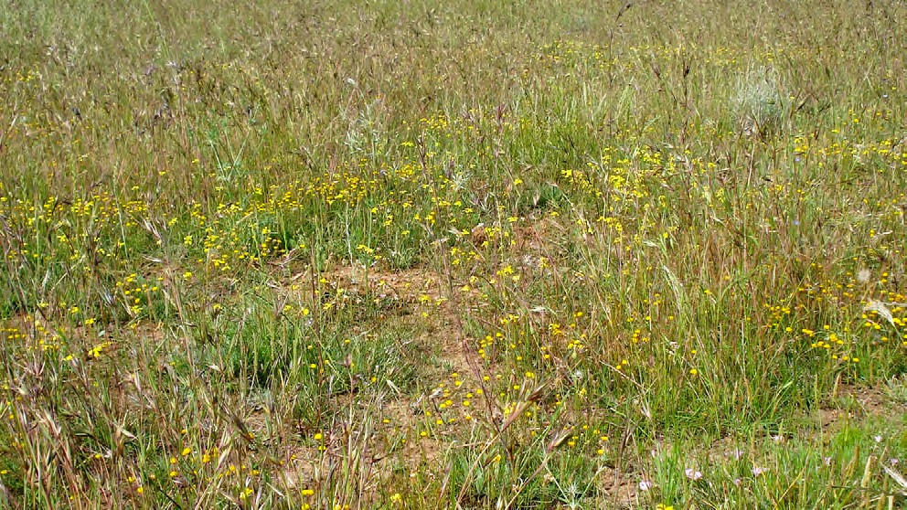
Figure 5: Natural Temperate Grassland in the Western Grassland Reserve Source: DELWP

- Department of Sustainability, Environment, Water, Population and Communities (DSEWPAC) 2011, ‘Nationally Threatened Ecological Communities of the Victorian Volcanic Plain: Natural Temperate Grassland & Grassy Eucalypt Woodland. A guide to the identification, assessment and management of nationally threatened ecological communities Environment Protection and Biodiversity Conservation Act 1999.’ Department of Sustainability, Environment, Water, Population and Communities. Canberra, ACT.
- Department of Sustainability, Environment, Water, Population and Communities (DSEWPAC) 2011, ‘Nationally Threatened Ecological Communities of the Victorian Volcanic Plain: Natural Temperate Grassland & Grassy Eucalypt Woodland. A guide to the identification, assessment and management of nationally threatened ecological communities Environment Protection and Biodiversity Conservation Act 1999.’ Department of Sustainability, Environment, Water, Population and Communities. Canberra, ACT.

DELWP’s conservation commitment

DELWP published the following statements as conservation outcomes for the Natural Temperate Grassland by notice in the Victorian Government Gazette:
‘The creation of the 15,000-ha Western Grassland Reserve (nature conservation reserve or National Park protection) located outside the UGB to Melbourne’s west, protecting native grasslands.’
‘The permanent protection of native grasslands in conservation areas identified in the BCS and the Conservation Areas Declaration.’
‘Improved composition, structure, quality and ecological function of protected native grasslands.’

DELWP’s MSA MRF also summarises the conservation outcomes for the Natural Temperate Grassland as a single goal statement: ‘the composition, structure and function of Natural Temperate Grassland of the Victorian Volcanic Plains improves within the program area’.

KPIs assessed
Progress towards this outcome is measured using seven KPIs:
- The area (ha) making an unfavourable transition between states must be zero (defined by an STM).
- The cover of native perennial forbs must remain above a baseline. The baseline is different for each state. It is defined by the cover observed in the first five years of monitoring for each state and fixed at a new elevated level if exceeded.
- The richness of native perennial forbs must remain above a baseline. The baseline is different for each state. It is defined by the richness observed in the first five years of monitoring for each state and fixed at a new elevated level if exceeded.
- The cover of Kangaroo Grass (Themeda triandra) must remain above a baseline. The baseline is different for each state. It is defined by the first five years of monitoring for each state and fixed at a new elevated level if it is exceeded, until it reaches 29% where it remains fixed.
- The cover of native perennial grass (excluding Themeda triandra) must remain above a baseline. The baseline is different for each state and is set permanently by the cover observed in the first five years of monitoring for each state.
- Every year, between 5–30% (inclusive) of randomly located plots must have bare ground cover of 25–75% (inclusive).
- The cover of perennial weeds must remain below a baseline. The baseline is different for each state. It is defined by the richness observed in the first five years of monitoring for each state and fixed at a new lowered level if weeds are reduced below the baseline.

For KPIs 2, 3, 4, 5 and 7, each state has a separate baseline, which applies across all patches of that state. For each state, that baseline is calculated using the data collected in the first five years after the first acquisition of a substantial representation of that state (i.e. three different patches of vegetation in that state, spread over three different management units).

MNES | 1. Natural Temperate Grassland
Commonwealth approved 2015 MSA MRF single outcome statement | The composition, structure and function of Natural Temperate Grassland improves.
2014–2020 Ecological Outcomes Report single outcome statement | The composition, structure and function of Natural Temperate Grassland of the Victorian Volcanic Plain improves.
Conservation Outcomes published in the Victorian Government Gazette – Issue G4, 27 January 2022 | The creation of the 15,000-ha Western Grassland Reserve (nature conservation reserve or National Park protection) located outside the UGB to Melbourne’s west, protecting native grasslands.  The permanent protection of native grasslands in conservation areas identified in the BCS and the Conservation Areas Declaration.  Improved composition, structure, quality and ecological function of protected native grasslands.

Monitored areas

Natural Temperate Grassland is only monitored on properties protected under the MSA, including both the Western Grassland Reserve and other smaller conservation areas within the UGB. The KPIs report on trends aggregated across all reserved land; not by specific reserve or paddock, however the data can be interrogated for specific areas if necessary.

Properties are gradually being protected by the MSA program, meaning the area under monitoring increases year- on-year. DELWP has indicated the number of plots will increase over time, and the ability to detect changes and infer relationships between management and ecological outcomes will increase. The current monitoring program is approximately 17% of the scale of the monitoring program expected in the final years of the MSA, when all properties are protected (in terms of area monitored and number of sampling plots).
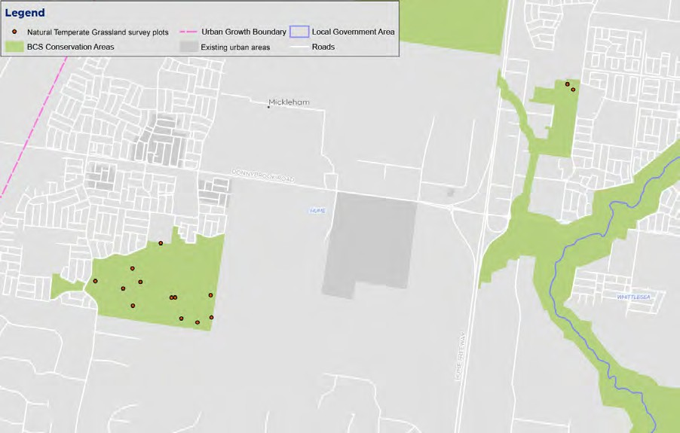
Figure 6: Map of Natural Temperate Grassland monitoring locations (north) Source: DELWP

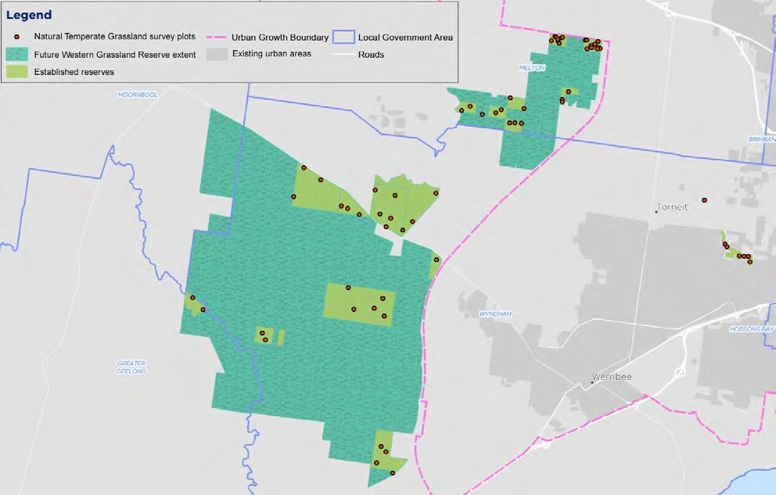
Figure 7: Map of Natural Temperate Grassland monitoring locations (west) Source: DELWP

Results

KP1: Hectares making transition between states

KPI 1: Hectares making transition between states | Status 2020-2022 | Reason for non-assessment | Trend | Data Confidence | Year that baseline was/will be set
Herb-rich grassland | Not assessed | Change in monitoring method |  | N/A | N/A
Themeda grassland | Not assessed | Change in monitoring method |  | N/A | N/A
C3 grassland | Not assessed | Change in monitoring method |  | N/A | N/A
Nutrient-enriched grassland | Not assessed | Change in monitoring method |  | N/A | N/A
De-rocked grassland | Not assessed | Change in monitoring method |  | N/A | N/A

This KPI compares the results from vegetation mapping completed at five-yearly intervals (with the first interval having concluded in 2020, covering all areas protected and mapped by 2016 – an arbitrary commencement date when several properties were protected). It refers to states defined by the Natural Temperate Grassland state-and-transition model (STM),122 where some states are more desirable than others. The KPI is designed to ensure that any transitions between states are positive transitions, and that negative transitions are avoided.

- Sinclair SJ, Zamin T, Gibson-Roy P, Dorrough J, Wong N, Craigie V, Garrard GE and Moore JL 2019b, ‘A state-and-transition model to guide grassland management.’ Australian Journal of Botany 67, 437-453.

KPI 2: Cover of native perennial forbs

KPI 2: Cover of native perennial forbs | Status 2020-2022 | Reason for non-assessment | Trend | Data Confidence | Year that baseline was/will be set
Herb-rich grassland | Met | N/A |  | High | 2019
Themeda grassland | Met | N/A |  | High | 2018
C3 grassland | Not assessed | Baseline not yet set |  | N/A | 2022
Nutrient-enriched grassland | Not met | N/A |  | High | 2017
De-rocked grassland | Not assessed | Baseline not yet set |  | N/A | 2023

This KPI measures the cover of the valuable and diverse native perennial forb component, which includes many rare species.123 The point intercept plots (permanent and re-allocated) provide an estimate of the cover of native perennial herbs in each state in each year. Forb cover is relatively low across all states.
This KPI was met in two states: Herb-rich grassland and Themeda grassland. This KPI was not met in the Nutrient-enriched grassland state. The baseline has not yet been set for the other states because these states are not yet sufficiently protected – thus an assessment cannot be made for these states.
This KPI is assessed using a continuous improvement approach, where any increase over the baseline in a five-year reporting period will lead to the calculation of a new baseline for subsequent reporting periods.
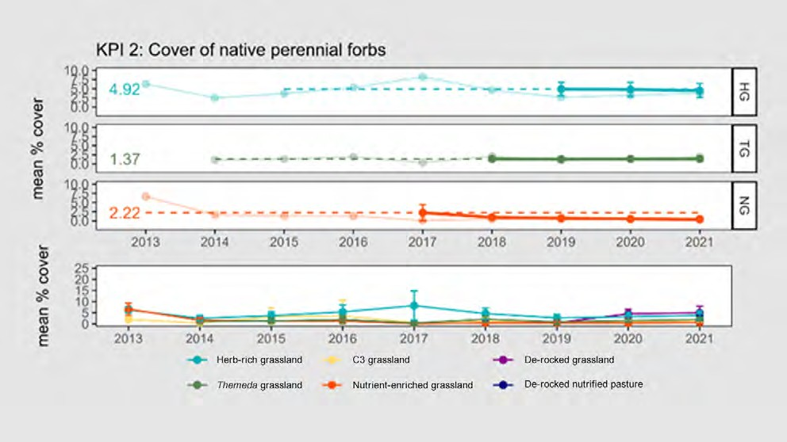
Figure 8: Cover of native perennial forbs in Natural Temperate Grassland, displayed by state. The error bars represent 95% confidence intervals. The baselines are shown for those states which have had baselines set.
Source: DELWP

- Stuwe J 1986, ‘An assessment of the conservation status of native grasslands on the western plains, Victoria and sites of botanical significance.’ ARI Technical Report Series No. 48, Conservation Forests & Lands, Fisheries and Wildlife Service, Heidelberg, Victoria.

KPI 3: Richness of native perennial forbs

KPI 3: Richness of native perennial forbs | Status 2020-2022 | Reason for non-assessment | Trend | Data Confidence | Year that baseline was/will be set
Herb-rich grassland | Met | N/A |  | High | 2017
Themeda grassland | Met | N/A |  | High | 2018
C3 grassland | Not assessed | Baseline not yet set |  | N/A | 2022
Nutrient-enriched grassland | Met | N/A |  | High | 2017
De-rocked grassland | Not assessed | Baseline not yet set |  | N/A | Unclear

This KPI measures the richness of the native perennial forb component (explicitly at the scale of the 400 m2 plot). The point intercept plots (permanent and re-allocated) provide an estimate of the richness of native perennial herbs per plot, in each state, in each year. It is notable that imperfect detectability of sparse or cryptic species (due to seasonal conditions and human error) inevitably leads to fluctuations in the data. This KPI is assessed using a continuous improvement approach, where any increase over the baseline in a five-year reporting period will lead to the calculation of a new baseline for subsequent reporting periods.
This KPI was met in the three states for which assessment is possible: Herb-rich grassland, Themeda grassland and Nutrient-enriched grassland. The baseline has not yet been set for the other states because these states are not yet sufficiently protected.
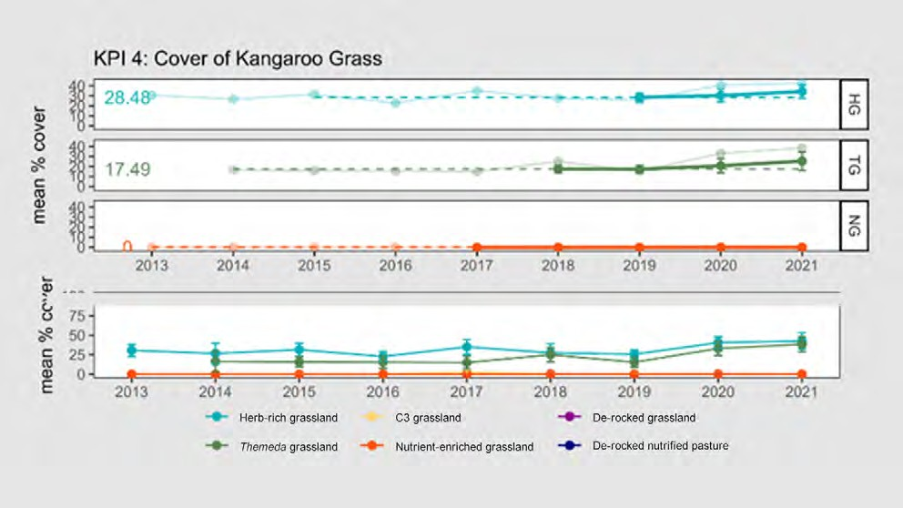
Figure 9: Richness of native perennial forbs in Natural Temperate Grassland, displayed by state. The error bars represent 95% confidence intervals. The upper panel shows the annual data (faint line), five-year rolling mean (heavy line) and the baseline (dashed line) for those states which have had baselines set. The lower panel shows the annual data for all states. Source: DELWP

KPI 4: Cover of Kangaroo Grass (Themeda triandra)

KPI 4: Cover of Kangaroo Grass | Status 2020-2022 | Reason for non-assessment | Trend | Data Confidence | Year that baseline was/will be set
Herb-rich grassland | Met | N/A |  | High | 2017
Themeda grassland | Met | N/A |  | High | 2017
C3 grassland | Not assessed | Baseline not yet set |  | N/A | Unclear
Nutrient-enriched grassland | Met | N/A |  | High | 2017
De-rocked grassland | Not assessed | Baseline not yet set |  | N/A | Unclear

This KPI measures the cover of Kangaroo Grass (Themeda triandra), which was the natural dominant of Natural Temperate Grassland and is considered a foundational species that regulates nutrient dynamics and species competition in the community.124 The point intercept plots (permanent and re-allocated) provide an estimate of the cover of this species in each state in each year.
For the most intact state (Herb-rich grassland), this KPI is assessed using a set baseline approach (rather than a continuous improvement approach), where the baseline remains at 29%. This reflects the fact that Kangaroo Grass is valuable but can become over-abundant.125 It is assumed that the intact Herb-rich grasslands have an acceptable level of Kangaroo Grass cover.
For all other states, a continuous improvement approach will be taken, where any increase over the baseline in a five-year reporting period will lead to the calculation of a new baseline for subsequent reporting periods until a cover of 29% is reached, when the baseline will become fixed.
The baseline has not yet been set for the other states because these states are not yet sufficiently protected.
Figure 10: Cover of Kangaroo Grass (Themeda triandra), displayed by state. The error bars represent 95% confidence intervals. The upper panel shows the annual data (faint line), five-year rolling mean (heavy line) and the baseline (dashed line) for those states which have had baselines set. The lower panel shows the annual data for all states. Source: DELWP

- Prober SM and Lunt ID 2009. ‘Restoration of Themeda australis swards suppresses soil nitrate and enhances ecological resistance to invasion by exotic annuals.’ Biological Invasions 11, 171-181.
- Stuwe J 1986, ‘An assessment of the conservation status of native grasslands on the western plains, Victoria and sites of botanical significance.’ ARI Technical Report Series No. 48, Conservation Forests & Lands, Fisheries and Wildlife Service, Heidelberg, Victoria.

KPI 5: Cover of any native perennial grasses (excluding Kangaroo Grass)

KPI 5: Cover of any native perennial grass (ex. Kangaroo Grass) | Status 2020-2022 | Reason for non-assessment | Trend | Data Confidence | Year that baseline was/will be set
Herb-rich grassland | Met | N/A |  | High | 2013
Themeda grassland | Met | N/A |  | High | 2013
C3 grassland | Not assessed | Baseline not yet set |  | N/A | Unclear
Nutrient-enriched grassland | Met | N/A |  | High | 2013
De-rocked grassland | Not assessed | Baseline not yet set |  | N/A | Unclear

This KPI measures the cover of native perennial grasses (other than Kangaroo Grass, which was dealt with in the preceding KPI). The point intercept plots (permanent and re-allocated) provide an estimate of the cover of these species in each state in each year.
This KPI is assessed using a set baseline approach (rather than a continuous improvement approach), where the baseline remains at the value defined in the first monitoring period, reflecting the fact that moderate levels of native grass cover must be maintained, and that both loss of cover and over-growth may be problematic.
This KPI was met in the three states for which assessment is possible as the baselines are set: Herb-rich grassland, Themeda grassland and Nutrient-enriched grassland.
The baseline has not yet been set for the other states because these states are not yet sufficiently protected.
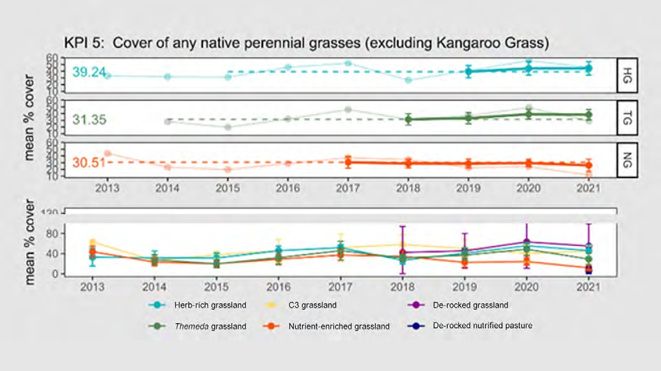
Figure 11: Cover of perennial native grasses (excluding Themeda triandra) in Natural Temperate Grassland, displayed by state. The error bars represent 95% confidence intervals. The upper panel shows the annual data (faint line), five-year rolling mean (heavy line) and the baseline (dashed line) for those states which have had baselines set. The lower panel shows the annual data for all states. Source: DELWP

KPI 6: Percentage of plots that have bare ground cover between 25–75%

KPI 6: Percentage of plots that have bare ground between 25–75% | Status 2020-2022 | Reason for non-assessment | Trend | Data Confidence | Year that baseline was/will be set
Herb-rich grassland | Met | N/A |  | High | N/A
Themeda grassland | Met | N/A |  | High | N/A
C3 grassland | Met | N/A |  | High | N/A
Nutrient-enriched grassland | Met | N/A |  | High | N/A
De-rocked grassland | Met | N/A |  | High | N/A

This KPI is a measure of habitat structural heterogeneity. It requires that Natural Temperate Grassland exists in a range of structural types each year (no single type is always preferred), to allow a range of animals to meet their habitat requirements. The KPI requires a certain percentage (5–30%) of plots to fall within a bare ground cover category (25–75% bare ground), and consequently requires a proportion to fall outside that category. Rapid plots provide the data for this KPI. Only plots that sample Natural Temperate Grassland (as mapped in the inventory report) contribute
to the assessment of KPI 6. Individual 10 m radius plots that appear not to be Natural Temperate Grassland are included if they fall within mapped Natural Temperate Grassland.
This KPI does not refer to a baseline. Rather, the KPI is met or not in each year.
Table 2 shows performance against this KPI over multiple years. It records the numbers of plots that fell into different bare ground categories, along with a measure of what percentage of plots fall within the range specified by the KPI. It shows that this KPI was met in 2017, 2018, 2019 and 2021 after having not been met in 2014, 2015 or 2016.

Table 2: The distribution of all plots according to bare ground categories. All figures are numbers of rapid plots. Source: DELWP

Year | 0–24%  bare ground | 25–75%  bare ground | 76–100%  bare ground | Total number of plots | Percentage of plots with 25–75% bare ground cover | KPI met?
2013 | No rapid plots were implemented in 2013.
2014 | 45 | 1 | 1 | 47 | 2% | No
2015 | 37 | 31 | 1 | 69 | 45% | No
2016 | 57 | 36 | 0 | 93 | 39% | No
2017 | 113 | 11 | 0 | 124 | 9% | Yes
2018 | 139 | 21 | 0 | 160 | 13% | Yes
2019 | 154 | 67 | 3 | 224 | 30% | Yes
2020 | N/A | N/A | N/A | N/A | N/A | N/A
2021 | 1717 | 117 | 0 | 1834 | 0 | Yes

KPI 7: Percentage cover of all perennial vegetation comprised of weeds

KPI 7: Percentage cover of all perennial vegetation comprised of weeds | Status 2020-2022 | Reason for non-assessment | Trend | Data Confidence | Year that baseline was/will be set
Herb-rich grassland | Met | N/A |  | High | 2017
Themeda grassland | Met | N/A |  | High | 2017
C3 grassland | Not assessed | Baseline not yet set |  | N/A | Unclear
Nutrient-enriched grassland | Met | N/A |  | High | 2017
De-rocked grassland | Not assessed | Baseline not yet set |  | N/A | Unclear

This KPI measures the percentage of all perennial vegetation cover that is comprised of weeds (introduced species). Weeds are considered undesirable.126 The point intercept data from the permanent and re-randomised plots provide the relevant data in each state in each year. This KPI is assessed using a continuous improvement approach, where any increase over the baseline in a five-year reporting period will lead to the calculation of a new baseline for subsequent reporting periods.
This KPI was met in Herb-rich grassland, Themeda grassland (TG) and Nutrient-enriched grassland – the three states for which assessment is possible as the baseline is set.
The baseline has not yet been set for the other states because these states are not yet sufficiently protected.
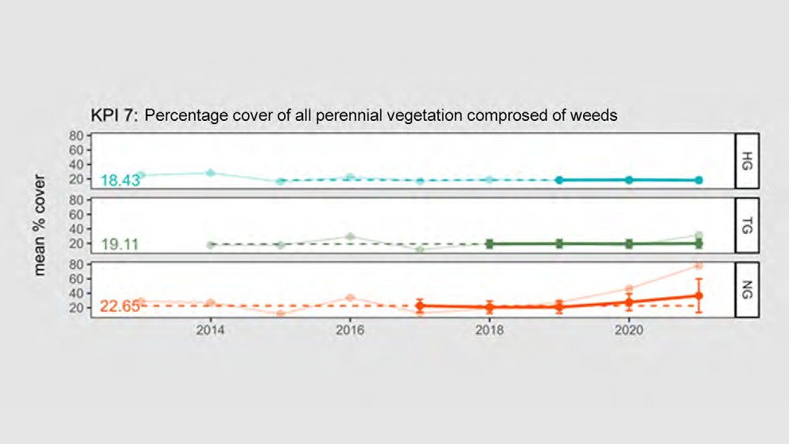
Figure 12: Percentage cover of all perennial vegetation comprised of weeds. The error bars represent 95% confidence intervals. The upper panel shows the annual data from permanent and re-allocated plots (faint line), five-year rolling mean (heavy line), and the baseline (dashed line) for those states which have had baselines set. Source: DELWP

- Sinclair SJ, Griffioen P, Duncan DH, Millett-Riley JE and White MD 2015, ‘Quantifying ecosystem quality by modelling multi-attribute expert opinion.’ Ecological Applications 25, 1463-1477.

Results interpretation
Results for Natural Temperate Grassland are varied where KPIs can be assessed. For the most intact grasslands (states Herb-rich grassland and Themeda grassland’), which are relatively rare in the landscape, all KPIs have been met and the condition of the grassland is being maintained. For more degraded grasslands (e.g. state Nutrified Grassland), weed levels have increased in recent years and native forbs have declined, which is cause for concern even though the KPIs have not been breached to date.127

KPI 1 – state change
With respect to grassland state change, DELWP was unable to provide a formal assessment of KPI 1 in 2021, due to a recent change in its monitoring protocol leading to dataset incompatibility issues. Note this KPI was not assessed in 2020 due to COVID-19 lockdowns and restrictions. Despite this, DELWP suspects that no, or very
little, negative state change has occurred at each site, given that it is aware of no cases of large-scale conversion to cropping, fertiliser application or other such detrimental applications within the WGR.128 DELWP has observed one site undergoing a small positive state change likely due to dedicated restoration efforts in November 2016.
DELWP has indicated that the interpretation of KPI 1 is now complicated by the shift from the use of subjective polygon-based data to the use of point-based field surveys recording the covers of important plant groups within a 10 m radius at a grid of points separated by 80 m. DELWP applies the state key129 to each point, as an estimate of which state was likely to exist at or around that location. This new survey method
was prompted by the recommendations of VAGO, covering the whole of the Western Grassland Reserve and will offer a more repeatable means of assessing state change in future reports, according to DELWP.130
In future years, this KPI will be assessed by comparing state change across all points (>10,000 points). Given the small size of the areas assessed (10 m radius), DELWP has indicated that one would expect some error and inaccuracies in the data, because states are designed to apply to management units and may have variation within them (i.e. some small points within a given management unit will not qualify for that state). For this reason, DELWP plans to define and apply a tolerance for negative state
change, both spatially (the number of points within a mapped state that were different) and on the cover data (a certain deviation from the threshold in the state key).131 DELWP will adjust this tolerance to match states that were mapped in the same year as the point data (where no functional state change was possible, and all error must be due to spatial heterogeneity and observer error). Field surveys are recommended to validate point-based data to determine the appropriate level of tolerance. With the tolerances applied, ‘genuine’ state changes will only be recognised where clusters of points show similar changes in unison (i.e. spatial tolerance of variegation); and changes will be recognised with some tolerance in cover threshold, to account for observer error, location error and inter-annual variation in weed cover (i.e. cover error tolerance).

- DELWP Officer, personal communication, 9 February 2022. 128. DELWP, internal document, provided 16 February 2022.
- Sinclair SJ, Zamin T, Gibson-Roy P, Dorrough J, Wong N, Craigie V, Garrard GE and Moore JL 2019b. ‘A state-and-transition model to guide grassland management.’ Australian Journal of Botany 67, 437-453.
- DELWP, internal document, provided 16 February 2022.
- DELWP Officer, personal communication, 9 February 2022.

DELWP intended for this KPI to highlight changes brought about by dramatic changes in land use leading to wholescale degradation of grasslands on large scales (e.g. conversion to cropping, fertiliser application, heavy and ongoing grazing which impacts on Themeda).132 It was not intended to deal with incremental changes on a fine scale, with other KPIs being more appropriate for this.

KPI 2 – cover of native forbs
With respect to the maintenance of native forb cover, KPI 2 has been met for two states: Herb-rich grassland and Themeda grassland; and not met for one state, Nutrient-enriched grassland. According to DELWP, the decline of forbs in Nutrient-enriched grassland may be attributable to two sources: 1) new properties being acquired which have low forb cover (e.g. Argoona Rd).133 When added to the dataset, they cause an overall decrease in mean cover (despite DELWP’s approach to ‘dampen’ this effect) and 2) increasing biomass levels after the cessation of grazing, causing the competitive exclusion of those native forbs which prosper under grazing (e.g. Atriplex semibaccata). This loss is exacerbated by the failure of other forb species to recolonise ungrazed grasslands, due to their need for open space, combined with their rarity in the landscape and low dispersal ability.
DELWP suspects that rectifying this problem in state Nutrient-enriched grassland will likely require:
  - improved interim management to ensure that newly protected properties are in relatively good condition
  - biomass control, via either a return to grazing regimes sufficient to provide space for the forbs or the introduction of fire regimes, coupled with
  - specific efforts to re-introduce those forbs that are lacking.134

KPI 3 – maintenance of native forb richness
With respect to native forb richness, KPI 3 has been met in the three states for which assessment is possible: Herb-rich grassland, Themeda grassland, and Nutrient- enriched grassland. The baseline has not yet been set for the other states because these states are not yet sufficiently protected. It is suspected the same factors noted for KPI 2 are relevant to KPI 3.

KPI 4 – maintenance of Kangaroo Grass cover
With respect to the maintenance of Kangaroo Grass cover, KPI 4 has been met for all states where it can be assessed Herb-rich grassland, Themeda grassland and Nutrient-enriched grassland. DELWP has indicated that the persistence of Kangaroo
Grass in sites where it occurs is currently not a major issue.135 The species appears to be increasing slightly in cover in states Herb-rich grassland and Themeda grassland. Kangaroo Grass is effectively absent in all other states, with the baseline set at 0% for Nutrient-enriched grassland, and likely to be set at 0% for the other states in coming years. This will mean that this KPI is never breached in these states, however efforts to increase Kangaroo Grass cover in these states could be accelerated, hopefully leading to non-zero benchmarks in future.

- DELWP, internal document, provided 16 February 2022. 133. DELWP, internal document, provided 16 February 2022. 134. DELWP, internal document, provided 16 February 2022. 135. DELWP, internal document, provided 16 February 2022.

KPI 5 – maintenance of other native grasses
With respect to the maintenance of other native grasses, KPI 5 has been met in all three states where it has been assessed (Herb-rich grassland, Themeda grassland and Nutrient-enriched grassland). In state Nutrient-enriched grassland the cover of natives is apparently decreasing, and a breach of the baseline may not be surprising over the next few years, according to DELWP.136 The explanation for this apparent decrease in native grass cover may be attributable to two sources:
  - new properties being acquired which have lower native grass cover. When added to the dataset, they cause an overall decrease in the mean (despite our approach
to dampen this effect, above, this effect is still present)
  - an actual potential decrease at managed sites resulting from weed invasion and lack of biomass management.137

KPI 6 – biomass heterogeneity across the reserve
With respect to biomass heterogeneity across the reserve, KPI 6 was met in 2021. It was also met in 2017, 2018 and 2019 (not measured in 2020). It was not met in 2014,
2015 or 2016. In 2021, 6% of plots had bare ground cover of 5–25%. This is within the target range (5 –30% of plots), but very close to the lower limit. This means that 2021 came very close to breaching the KPI because biomass was high in many places.

KPI 7 – perennial weed cover
With respect to perennial weed cover, KPI 7 has been met in all three states where it is assessed (Herb-rich grassland, Themeda grassland and Nutrient-enriched grassland). Weed cover appears to be increasing steadily in protected areas of Nutrient-enriched grassland, and it appears very likely that this KPI will be breached within the next two to three years without substantially increased weed control.138 Currently, it is only the use of the five-year rolling average that has prevented the increase from registering as a breach of the baseline. The ‘increase’ in weed levels measured in Nutrient-enriched grassland is likely attributable to two sources:
  - new properties being acquired which have very high weed levels (e.g. Argoona Rd). When added to the dataset, they cause an overall increase in the mean (despite DELWP’s approach to dampen this effect, above, this effect is still present)
  - an actual increase in weed cover at managed sites. The former source represents a combination of ‘luck’, in the order that properties are acquired, combined with a possible worsening of private land sites as time goes by. The later source is likely attributable to MSA management.139

136. DELWP, internal document, provided 16 February 2022.
137. DELWP, internal document, provided 16 February 2022. 138. DELWP, internal document, provided 16 February 2022. 139. DELWP, internal document, provided 16 February 2022.

Key insights and management implications
Natural Temperate Grassland is a complex ecosystem – and DELWP indicates it has been difficult to design monitoring protocols that properly capture the dynamics of the system, with not a single variable appropriate to detect and measure change.140 The KPIs described above provide good indications of Natural Temperate Grassland change, but they address separate aspects of the community. No single KPI is a direct and all-encompassing measure of the composition, structure and function for the community, which is the way improvement is framed in DELWP’s conservation outcomes statement.
DELWP partially addresses this, having developed an overall Natural Temperate Grassland quality metric, and is determined using the algorithm described in Sinclair et al.141 This metric has previously been reported on by DELWP as an ‘other measure’.142 The quality algorithm combines eight measurable on-ground variables into a single value. These eight variables correspond closely with the KPI variables.
The algorithm makes sense of changes among the multiple KPIs, by providing a single quality score between 100 (a ‘pristine’ site) and zero (where no value remains). The score is calculated from all permanent and re-allocated point-intercept plots in each year and reported by state. Having this metric included as a KPI may assist in interpretation of results for Natural Temperate Grassland, given the complexity of this.
For Natural Temperate Grassland, KPIs are reported according to a ‘state-and- transition’ model,143 where some states are more desirable than others. Much of Natural Temperate Grassland earmarked for MSA management falls within the Western Grassland Reserve. The KPI ‘Hectares making transition between states’ was designed to ensure that any transitions between states are positive transitions, and that negative transitions are avoided. However, many areas within the Western Grassland Reserve are acquired in poor condition and as such much of the focus is on weed management and protection of higher quality areas from weed encroachment. DELWP has indicated that restoration to improve grassland condition has not been a realistic or feasible objective, therefore one wouldn’t expect to see much state transition (positive or negative) in these areas over time.144
Of all the MNES, Natural Temperate Grassland associated with the Western Grassland Reserve has received the most attention from stakeholders, according to DELWP145
– consequently a large degree of resources has been directed toward monitoring Natural Temperate Grassland (DELWP commenced monitoring Natural Temperate Grassland in 2013).
Many of the MSA species are not technically independent, as many cohabit in Natural Temperate Grassland. These complex ecosystem dynamics may make it difficult to tease out causative relationships between management interventions and species responses.

- DELWP, internal document, provided 16 February 2022.
- Sinclair SJ, Griffioen P, Duncan DH, Millett-Riley JE and White MD 2015, ‘Quantifying ecosystem quality by modelling multi-attribute expert opinion.’ Ecological Applications 25, 1463-1477.
- M Bruce, K Batpurev, D Bryant. S Sinclair and M Kohout 2020, ‘Melbourne Strategic Assessment: Ecological Outcomes Report 2014-15 to 2019-20.’ Department of Environment, Land, Water and Planning, Heidelberg, Victoria.
- Sinclair SJ, Zamin T, Gibson-Roy P, Dorrough J, Wong N, Craigie V, Garrard GE and Moore JL 2019b. ‘A state-and-transition model to guide grassland management.’ Australian Journal of Botany 67, 437-453.
- DELWP Officer, personal communication, 20 July 2021.
- DELWP Officer, personal communication, 20 July 2021.

One of the main issues around interpretation of the results for Natural Temperate Grassland under the current framework is that most of the KPIs are disaggregated by states – and this is how they have traditionally been reported on, each with separate baselines. Previously, results have been summarised across all states where a single outcome is reported for each KPI – such as ‘met’ (in all states), ‘not met’ (in all states) or ‘partially met’ (where the KPI is met across some states but unassessed in others). It is unclear how one would summarise across all the states in each KPI category, if, for example, one state is performing badly and one is doing well. The design of this KPI may be amended to account for this potential issue to clarify results in such a scenario.
KPIs for Natural Temperate Grassland could be organised by management unit as well as by states (i.e. stratify results by parcel of land). State monitoring may highlight variation in the different land use histories, while monitoring by parcel may reveal information on the efficacy of management regimes across the landscape. Time
since acquisition would seem an important variable, as this is the period within which DELWP has had the ability to have any direct management impact. This gets lost in DELWP’s attempt to ‘dampen’ the effect of the addition of new properties. It would be good to be able to explore variation in grassland condition as a function of time since acquisition. This may help to inform a clearer picture of whether interim management actions are required or have been effective if applied.
Further, the introduction of counterfactual controls in the form of monitored areas on private land – outside the MSA managed areas – in conjunction with data from remote sensing across all tenures would improve an understanding of the efficacy of interim land management.

MNES 2: Grassy Eucalypt Woodland

Background

‘Grassy Eucalypt Woodland of the Victorian Volcanic Plain’ (hereafter Grassy Eucalypt Woodland) is an ecological community listed as Critically Endangered under the EPBC Act.146 This community is characterised by eucalypt woodlands with a grassy understorey, described in detail in the Commonwealth listing advice.147 Grassy Eucalypt Woodland of the Victorian Volcanic Plain represents occurrences of grassy eucalypt woodlands located south of the Great Dividing Range, and are specifically limited to the extensive Quaternary basalt plain of south-western Victoria.148
EPBC listing status: Critically endangered
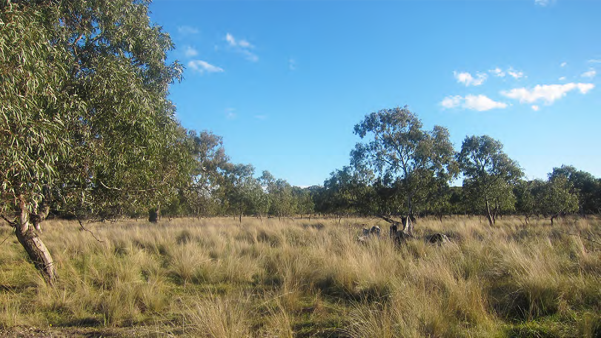
Figure 13: Grassy Eucalypt Woodland of the Victorian Volcanic Plain Source: DELWP

- Department of the Environment 2022. ‘Grassy Eucalypt Woodland of the Victorian Volcanic Plain in Community and Species Profile and Threats Database’, Department of the Environment, Canberra. Available from: http://www.environment.gov.au/cgi-bin/sprat/public/ sprat.pl Accessed 10 February 2022.
- TSSC 2008, ‘Advice to the Minister for the Environment, Heritage and the Arts from the Threatened Species Scientific Committee (the Committee) on Amendment to the list of Threatened Ecological Communities under the Environment Protection and Biodiversity Conservation Act 1999 (EPBC Act): Natural Temperate Grassland of the Victorian Volcanic Plain.’ Threatened Species Scientific Committee. Canberra, ACT.
- TSSC 2008, ‘Advice to the Minister for the Environment, Heritage and the Arts from the Threatened Species Scientific Committee (the Committee) on Amendment to the list of Threatened Ecological Communities under the Environment Protection and Biodiversity Conservation Act 1999 (EPBC Act): Natural Temperate Grassland of the Victorian Volcanic Plain.’ Threatened Species Scientific Committee. Canberra, ACT.

DELWP’s conservation commitments
DELWP published the following statements as conservation outcomes for the Grassy Eucalypt Woodland by notice in the Victorian Government Gazette:
‘The creation of the 1,200 ha Grassy Eucalypt Woodland Protected Area outside the UGB, south-west of Whittlesea, protecting Grassy Eucalypt Woodland.’
‘The permanent protection of 341 ha of Grassy Eucalypt Woodland:
- in conservation areas identified in the BCS and the Conservation Areas Declaration
- on land secured as part of the Grassy Eucalypt Woodland Protected Area that is in addition to the 1,200 ha.’
‘Improved composition, structure, quality, and ecological function of protected Grassy Eucalypt Woodland.’

- DELWP 2015, ‘Monitoring and Reporting Framework – Melbourne Strategic Assessment’, East Melbourne, Victoria.
DELWP’s MSA MRF also summarises the conservation outcomes for the Grassy Eucalypt Woodland as a single goal statement: ‘the composition, structure and function of Grassy Eucalypt Woodland of the Victorian Volcanic Plain improves in all areas where it is protected’.149

KPIs assessed
Progress towards this goal is measured using seven KPIs:
- The area (ha) making an unfavourable transition between states must be zero – defined by a state-and-transition model (STM), currently unpublished.
- The cover of native perennial forbs must remain above a baseline. The baseline is different for each state. It is defined by the cover observed in the first five years of monitoring for each state and fixed at a new elevated level if exceeded.
- The richness of native perennial forbs must remain above a baseline. The baseline is different for each state. It is defined by the richness observed in the first five years of monitoring for each state and fixed at a new elevated level if exceeded.
- The cover of ‘target grass species’ (Kangaroo Grass (Themeda triandra), Common Tussock Grass (Poa labillardierei) and/or Soft Spear-grass (Austrostipa mollis)) must remain above a baseline. The baseline is different for each state. It is defined by the first five years of monitoring for each state and fixed at a new elevated level if it is exceeded, until it reaches 29%, where it remains fixed.
- Every year, the relative abundance of four woodland structural types must be appropriately represented across the entire reserve network (Multi-layered vegetation, Open treeless vegetation, Park-like vegetation and Vigorous regeneration; which must be in certain proportions by area).
- Every year, between 25–75% of all plots must support some Eucalyptus recruits.
- The cover of perennial weeds must remain below a baseline. The baseline is different for each state. It is defined by the richness observed in the first five years of monitoring for each state and fixed at a new lowered level if weeds are reduced below the baseline.

KPIs are assessed in the following five grassland states: Herb-rich grassland, Themeda
grassland, C3 grassland, Nutrient-enriched grassland, and De-rocked grassland.

MNES | 2. Grassy Eucalypt Woodland
Commonwealth approved 2015 MSA MRF single outcome statement | The composition, structure and function of Grassy Eucalypt Woodland improves.
2014–2020 Ecological Outcomes Report single outcome statement | The composition, structure and function of Grassy Eucalypt Woodland of the Victorian Volcanic Plain improves.
Conservation Outcomes published in the Victorian Government Gazette – Issue G4, 27 January 2022 | The creation of the 1,200 ha Grassy Eucalypt Woodland Protected Area outside the UGB, south-west of Whittlesea, protecting Grassy Eucalypt Woodland.  The permanent protection of 341 ha of Grassy Eucalypt Woodland:  - in conservation areas identified in the BCS and the Conservation Areas Declaration  - on land secured as part of the Grassy Eucalypt Woodland Protected Area that is in addition to the 1,200 ha. Improved composition, structure, quality, and ecological function of protected Grassy Eucalypt Woodland.

Monitored areas
Grassy Eucalypt Woodland is only monitored on properties protected under the MSA. Currently this only covers The Mount Ridley Woodland Reserve (Conservation Area 26), which was first monitored in 2021. Twelve plots were implemented.
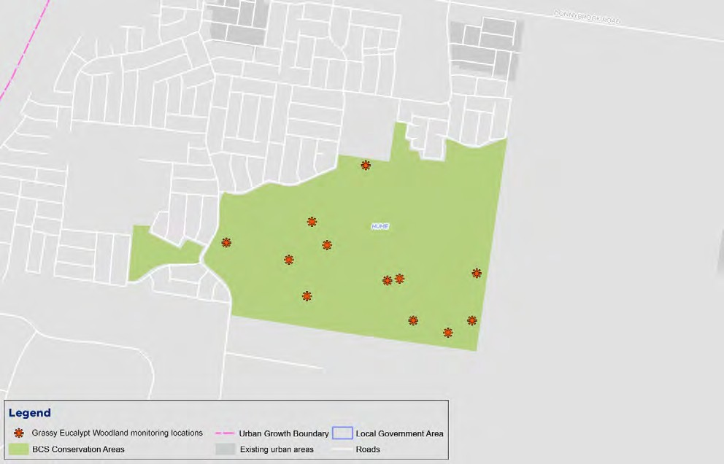
Figure 14: Map of monitored locations of Grassy Eucalypt Woodland Source: DELWP

Results

KP1: Hectares making transition between states

KPI 1: Hectares making transition between states | Status 2020-2022 | Reason for non-assessment | Trend | Data Confidence | Year that baseline was/will be set
Herb-rich grassland | Not assessed | Assessed every 5 years |  | N/A | N/A
Themeda grassland | Not assessed | Assessed every 5 years |  | N/A | N/A
C3 grassland | Not assessed | Assessed every 5 years |  | N/A | N/A
Nutrient-enriched grassland | Not assessed | Assessed every 5 years |  | N/A | N/A
De-rocked grassland | Not assessed | Assessed every 5 years |  | N/A | N/A

KP2: Cover of native perennial forbs

KPI 2: Cover of native perennial forbs | Status 2020-2022 | Reason for non-assessment | Trend | Data Confidence | Year that baseline was/will be set
Herb-rich grassland | Not assessed | Baseline not yet set |  | N/A | 2026
Themeda grassland | Not assessed | Baseline not yet set |  | N/A | 2026
C3 grassland | Not assessed | Baseline not yet set |  | N/A | 2026
Nutrient-enriched grassland | Not assessed | Baseline not yet set |  | N/A | 2026
De-rocked grassland | Not assessed | Baseline not yet set |  | N/A | 2026

KP3: Richness of native perennial forbs

KPI 3: Richness of native perennial forbs | Status 2020-2022 | Reason for non-assessment | Trend | Data Confidence | Year that baseline was/will be set
Herb-rich grassland | Not assessed | Baseline not yet set |  | N/A | 2026
Themeda grassland | Not assessed | Baseline not yet set |  | N/A | 2026
C3 grassland | Not assessed | Baseline not yet set |  | N/A | 2026
Nutrient-enriched grassland | Not assessed | Baseline not yet set |  | N/A | 2026
De-rocked grassland | Not assessed | Baseline not yet set |  | N/A | 2026

KP4: Cover of native grass (Themeda triandra and Poa)

KPI 4: Cover of native grass (Themeda triandra and Poa) | Status 2020-2022 | Reason for non-assessment | Trend | Data Confidence | Year that baseline was/will be set
Herb-rich grassland | Not assessed | Baseline not yet set |  | N/A | 2026
Themeda grassland | Not assessed | Baseline not yet set |  | N/A | 2026
C3 grassland | Not assessed | Baseline not yet set |  | N/A | 2026
Nutrient-enriched grassland | Not assessed | Baseline not yet set |  | N/A | 2026
De-rocked grassland | Not assessed | Baseline not yet set |  | N/A | 2026

KPI 5: Structural heterogeneity

KPI 5: Structural heterogeneity | Status 2020-2022 | Reason for non-assessment | Trend | Data Confidence | Year that baseline was/will be set
Herb-rich grassland | Not assessed | Data not provided |  | N/A | N/A
Themeda grassland | Not assessed | Data not provided |  | N/A | N/A
C3 grassland | Not assessed | Data not provided |  | N/A | N/A
Nutrient-enriched grassland | Not assessed | Data not provided |  | N/A | N/A
De-rocked grassland | Not assessed | Data not provided |  | N/A | N/A

KPI 6: Percentage of plots between 25–75% with Eucalyptus recruits

KPI 6: Percent of plots between 25 – 75% with Eucalyptus recruits | Status 2020-2022 | Reason for non-assessment | Trend | Data Confidence | Year that baseline was/will be set
Herb-rich grassland | Not assessed | Data not provided |  | N/A | N/A
Themeda grassland | Not assessed | Data not provided |  | N/A | N/A
C3 grassland | Not assessed | Data not provided |  | N/A | N/A
Nutrient-enriched grassland | Not assessed | Data not provided |  | N/A | N/A
De-rocked grassland | Not assessed | Data not provided |  | N/A | N/A

KPI 7: Percentage cover of all perennial vegetation comprised of weeds

KPI 7: Percentage cover of all perennial vegetation comprised of weeds | Status 2020-2022 | Reason for non-assessment | Trend | Data Confidence | Year that baseline was/will be set
Herb-rich grassland | Not assessed | Baseline not yet set |  | N/A | 2026
Themeda grassland | Not assessed | Baseline not yet set |  | N/A | 2026
C3 grassland | Not assessed | Baseline not yet set |  | N/A | 2026
Nutrient-enriched grassland | Not assessed | Baseline not yet set |  | N/A | 2026
De-rocked grassland | Not assessed | Baseline not yet set |  | N/A | 2026

Results interpretation
2021 was the first year of data collection, at a single site. Baselines are not yet set for KPIs 1, 2, 3, 4 and 7 – these will be set in the fifth year after the commencement of monitoring. For KPIs 5 and 6, results data were not provided. No trends are apparent yet.

Key insights and management implications
As 2021 was the first year under the MSA program that Grassy Eucalypt have been protected and was the first year that this community was able to be monitored, there is not enough data to establish a baseline measure to report against the associated KPIs.
DELWP has undertaken some encouraging recent work in partnership with Traditional Owners; the Strategy for establishing a Grassy Eucalypt Woodland Protected Area150 was released by DELWP in June 2021, which outlines an approach to the protection
of this area with the help of Trust for Nature, Hume City Council and informed by Traditional Owner knowledge and values. The strategy details high-level objectives for management that were co-developed with Traditional Owners. DELWP applied a multi- tenure approach to land protection through either Crown land reserves or negotiated on-title land management agreements on private land. A 4.9-ha reserve containing Grassy Eucalypt Woodland was secured in 2021 and monitoring has now commenced in this area. However Traditional Owners were not included in the design of associated KPIs.
As for Natural Temperate Grassland, it is possible that KPIs for Grassy Eucalypt Woodland could be organised by management unit as well as by states (i.e. stratify results by parcel of land). State monitoring may highlight variation in the different land use histories, while monitoring by parcel may reveal information on the efficacy of
and management regimes across the landscape. Time since acquisition would seem an important variable, as this is the period within which DELWP has had the ability to have any direct management impact. This gets lost in DELWP’s attempt to dampen the effect of the addition of new properties. It would be good to be able to explore variation in grassland condition as a function of time since acquisition. This may help to inform a clearer picture of whether interim management actions are required or have been effective if applied.
Further (and as for all MNES monitored under the MSA program), the introduction of counterfactual controls in the form of monitored areas on private land – outside the MSA sphere of influence – in conjunction with data from remote sensing across all tenures would improve an understanding of the efficacy of interim land management.

  - DELWP 2021, ‘Strategy for establishing a Grassy Eucalypt Woodland Protected Area – Melbourne Strategic Assessment’, East Melbourne, Victoria.

MNES 3: Seasonal Herbaceous Wetlands

Background

Seasonal Herbaceous Wetlands of the Temperate Lowland Plains (hereafter Seasonal Herbaceous Wetlands) are a class of wetlands listed as Critically Endangered under the EPBC Act.151 These wetlands occur on fertile clay soils and are inundated after rains but may remain dry for long periods. Vegetation occurring in the wetlands is typically low and open, composed mostly of grasses, sedges, herbs and ferns. This community was formerly scattered in large and small patches across the lowland plains of south-eastern Australia – however, it is now restricted to small, scattered remnants throughout its former range.152

EPBC listing status: Critically Endangered
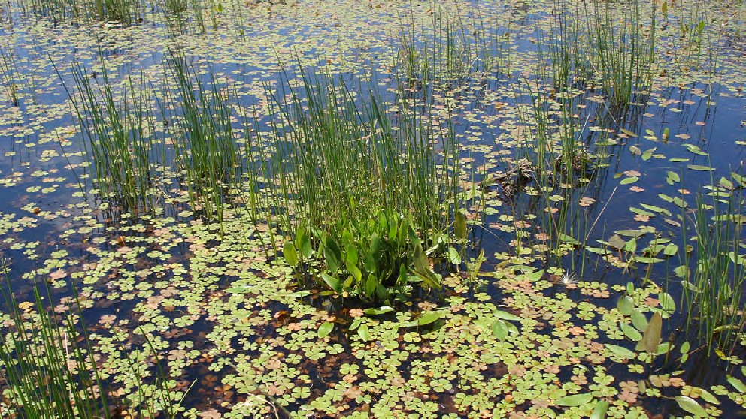
Figure 15: Example of Seasonal Herbaceous Wetlands after filling Source: DELWP

  - TSSC 2012, ‘Advice to the Minister for the Environment, Heritage and the Arts from the Threatened Species Scientific Committee (the Committee) on Amendment to the list of Threatened Ecological Communities under the Environment Protection and Biodiversity Conservation Act 1999 (EPBC Act): Seasonal Herbaceous Wetlands of the Temperate Lowland Plains.’ Threatened Species Scientific Committee. Canberra, ACT.
  - TSSC 2012, ‘Advice to the Minister for the Environment, Heritage and the Arts from the Threatened Species Scientific Committee (the Committee) on Amendment to the list of Threatened Ecological Communities under the Environment Protection and Biodiversity Conservation Act 1999 (EPBC Act): Seasonal Herbaceous Wetlands of the Temperate Lowland Plains.’ Threatened Species Scientific Committee. Canberra, ACT.

DELWP’s conservation commitments
DELWP published the following statements as conservation outcomes for Seasonal Herbaceous Wetlands by notice in the Victorian Government Gazette:
‘The permanent protection of Seasonal Herbaceous Wetlands in:
- the Western Grassland Reserve
- the conservation areas identified in the BCS and the Conservation Areas Declaration.’
‘Improved composition, structure, quality and ecological function of protected Seasonal Herbaceous Wetlands that are greater than three hectare (sic) in size.’

KPIs assessed
DELWP’s MSA MRF also summarises the conservation outcome for Seasonal Herbaceous Wetlands as a single goal statement: ‘the composition, structure and function of Seasonal Herbaceous Wetlands of the Temperate Lowland Plains improves in all areas where it is protected’.153
Four KPIs have been designed by DELWP to measure progress towards this goal:
- Richness of native perennial forbs during spring/summer must remain above the baseline, set as the mean of the first five years of monitoring.
- Richness of all native forbs during drawdown must remain above the baseline, set as the mean of the first five years of monitoring.
- Percentage of all perennial vegetation (during spring-summer) composed of weeds must remain below the baseline (set by the first year of monitoring for the wetland).
- Percentage of all perennial vegetation (during drawdown) composed of weeds must remain below the baseline (set by the first year of monitoring for the wetland).
KPIs 1 and 2 are assessed using a continuous improvement approach, where any increase over the baseline in any wetland in a five-year reporting period will lead to the calculation of a new baseline for that wetland for subsequent reporting periods.
KPIs 3 and 4 are assessed using a continuous improvement approach, where any decrease below the baseline in any wetland in a five-year reporting period will lead to the calculation of a new baseline for that wetland for subsequent reporting periods.

- DELWP 2015, ‘Monitoring and Reporting Framework – Melbourne Strategic Assessment’, East Melbourne, Victoria.

MNES | 3. Seasonal Herbaceous Wetlands
Commonwealth approved 2015 MSA MRF single outcome statement | The composition, structure and function of Seasonal Herbaceous Wetlands (freshwater) improves.
2014–2020 Ecological Outcomes Report single outcome statement | The composition, structure and function of Seasonal Herbaceous Wetlands of the Temperate Lowland Plains improves.
Conservation Outcomes published in the Victorian Government Gazette – Issue G4, 27 January 2022 | The permanent protection of Seasonal Herbaceous Wetlands (freshwater) in:  - the Western Grassland Reserve  - the conservation areas identified in the BCS and the Conservation Areas Declaration  Improved composition, structure, quality, and ecological function of protected Seasonal Herbaceous Wetlands (freshwater) that are greater than three ha in size

Monitored areas
Seasonal Herbaceous Wetlands are monitored as discrete wetlands. Each wetland is reported separately. All Seasonal Herbaceous Wetlands sites exceeding 3 ha in area are monitored.
The first parcels of land supporting Seasonal Herbaceous Wetlands were acquired in 2012. These areas contained three wetlands greater than 3 ha. As of 2019, no further examples of Seasonal Herbaceous Wetlands have been protected which meet this criterion. All monitored wetlands are in the Western Grassland Reserve. They are:
- Cobbledicks Rise Wetland (5.1 ha, part of the Cobbledicks cluster noted in DEPI (2013b)154
- One Tree Rise Wetland (3.1 ha)
- Windmill Wetland (4.3 ha, part of the Cobbledicks cluster noted in DEPI (2013b)155
- Monitoring commenced for all three sites in 2014. Their locations are shown in Figure 16.

- DEPI 2013b, ‘The impact of Melbourne’s growth on ‘seasonal herbaceous wetlands of the temperate lowland plains’. DEPI, East Melbourne.
- DEPI 2013b, ‘The impact of Melbourne’s growth on ‘seasonal herbaceous wetlands of the temperate lowland plains’. DEPI, East Melbourne.

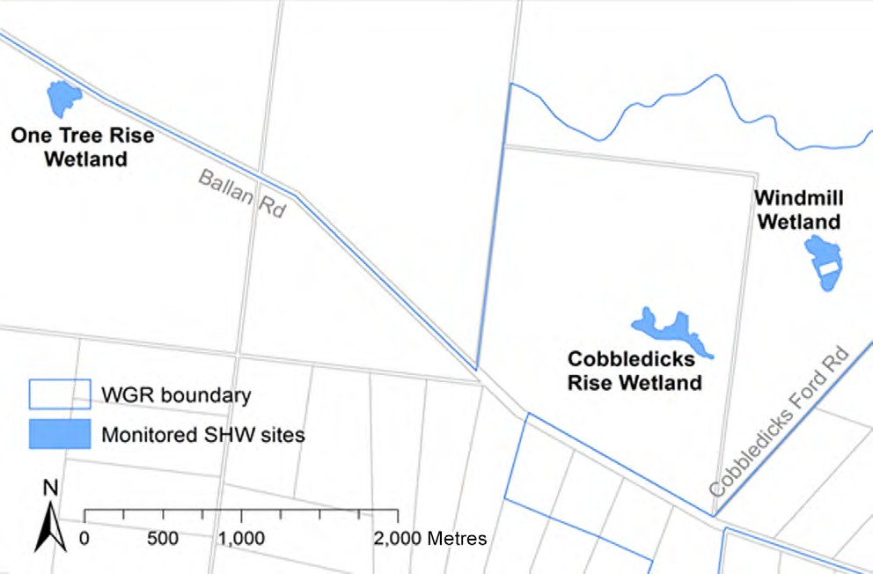
Figure 16: The locations of the subject wetlands within the protected Western Grassland Reserve Source: DELWP

Results

KPI 1: Richness of native perennial forbs during spring-summer

KPI 1: Richness of native perennial forbs during spring-summer | Status 2020-2022 | Reason for non-assessment | Trend | Data Confidence | Year that baseline was/will be set
Cobbledicks Rise | Met | N/A |  | High | 2018
One Tree Rise | Met | N/A |  | High | 2018
Windmill | Met | N/A |  | High | 2018

This KPI measures the richness of the valuable native perennial forb component (explicitly at the individual wetland scale). This KPI measures forb richness in every year, regardless of hydrological phase. Given this will include wet and dry years, this measure is expected to fluctuate over time. This KPI was met for all wetlands in 2020–2022.

KPI 2: Richness of all native forbs during drawdown

KPI 2: Richness of all native forbs during drawdown | Status 2020-2022 | Reason for non-assessment | Trend | Data Confidence | Year that baseline was/will be set
Cobbledicks Rise | Not assessed | Lack of drawdown event |  | N/A | 2017
One Tree Rise | Not assessed | Lack of drawdown event |  | N/A | Unclear
Windmill | Not assessed | Lack of drawdown event |  | N/A | 2017

This KPI measures the richness of all native forbs, including both perennial and annual species (explicitly at the individual wetland scale). It is measured only at times when a given wetland is drawing down after filling, and the maximum expression of species richness is expected. This may only happen every few years, such that this KPI will remain unassessed in many years.
This KPI is assessed against a baseline, set by the first year of monitoring at drawdown, with a unique benchmark for each wetland. Since monitoring began, drawdown has only occurred in 2017, for Windmill Wetland and Cobbledicks Rise Wetland (One Tree Rise has a smaller catchment and did not fill in 2017). This occurred during the normal spring-summer monitoring period, so a single monitoring event covered KPIs 1 and 2. Drawdown did not occur during 2020–2022 so this KPI was not assessed this year.
For Cobbledicks Rise Wetland, the count of native forbs at drawdown in 2017 was 12 species. All were perennial, so this value is identical to that measured for KPI 1 (which only assesses perennial forb species). For Windmill Wetland, the count of native forbs at drawdown in 2017 was 17 species. Three were annual, so that this count is higher than KPI 1 measured at the same time for this wetland.
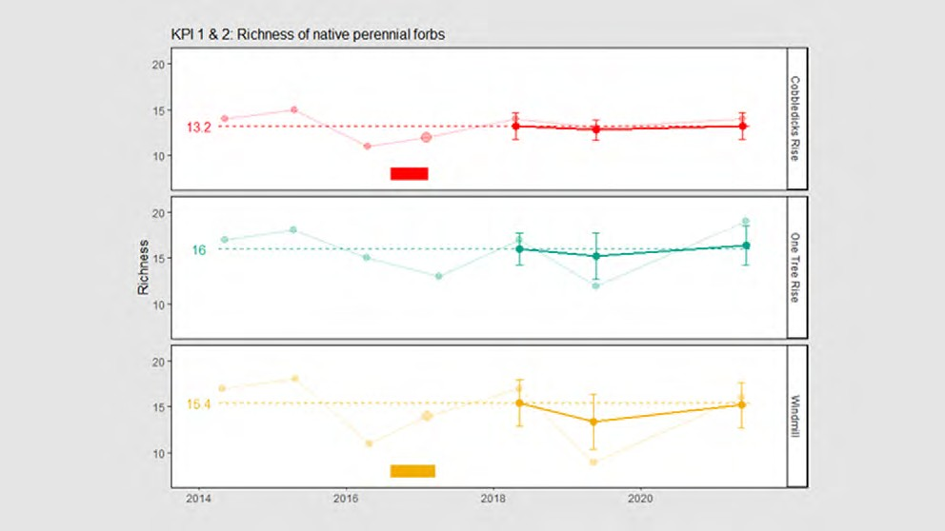
Figure 17: The richness of native forbs for each wetland. The solid lines show the five-year rolling mean (± 95% CI) and the faded lines show the annual data. The dashed line is the baseline, calculated after the first five years of monitoring. Larger points indicate that the wetland was monitored during drawdown in that year. The horizontal bars indicate the period over which each wetland was full. The location of the points on the x-axis indicates the date of sampling, with a sampling year (i.e. the axis marks) beginning on September 1
Source: DELWP

KPI 3: Percentage cover of all perennial vegetation comprised of weeds during spring-summer

KPI 3: Percentage cover of all perennial vegetation comprised of weeds during spring-summer | Status 2020-2022 | Reason for non-assessment | Trend | Data Confidence | Year that baseline was/will be set
Cobbledicks Rise | Met | N/A |  | High | 2018
One Tree Rise | Met | N/A |  | High | 2018
Windmill | Met | N/A |  | High | 2018

This KPI measures the percentage of all perennial vegetation cover that is comprised of weeds (introduced species). Weeds are considered undesirable as they are in grasslands. This KPI is assessed against a baseline set by the first five years of monitoring. This KPI was met for all wetlands in 2020–2022.

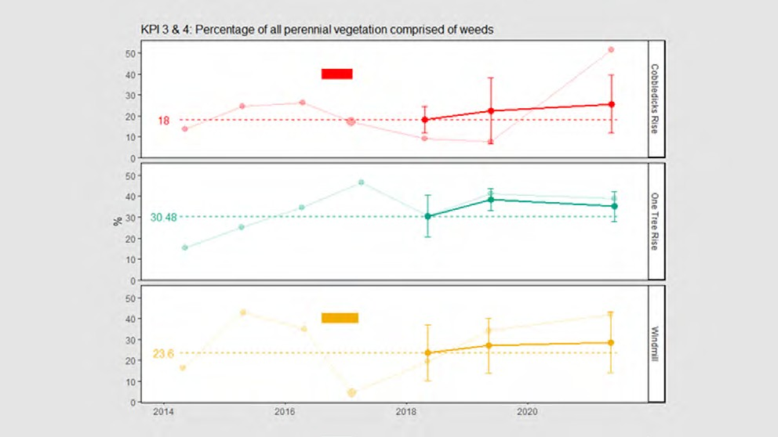
Figure 18: The percentage of all perennial vegetation comprised of weeds for each wetland. The solid lines show the five-year rolling average (± 95% CI) and the faded lines show the annual data. The dashed line is the baseline, calculated after the first five years of monitoring. Larger points indicate wetland was monitored during drawdown in that year. The horizontal bars indicate the period over which a wetland was considered filled. The location of the points on the x-axis indicates the date of sampling, with a sampling year (i.e. the axis marks) beginning on September 1 Source: DELWP

KPI 4: Percentage cover of all perennial vegetation comprised of weeds during drawdown

KPI 4: Percentage cover of all perennial vegetation comprised of weeds during drawdown | Status 2020-2022 | Reason for non-assessment | Trend | Data Confidence | Year that baseline was/will be set
Cobbledicks Rise | Not assessed | Lack of drawdown event |  | N/A | 2017
One Tree Rise | Not assessed | Lack of drawdown event |  | N/A | Unclear
Windmill | Not assessed | Lack of drawdown event |  | N/A | 2017

Like KPI 3, this KPI measures the percentage of all perennial vegetation cover that is comprised of weeds (introduced species). In this case, the KPI only applies when a wetland is drawing down, having been filled.
This KPI is assessed against a baseline, set by the first year of monitoring at drawdown, with a unique benchmark for each wetland. Since monitoring began, drawdown has only occurred in 2017, for Windmill Wetland and Cobbledicks Rise Wetland (One Tree Rise has a smaller catchment and did not fill in 2017). This occurred during the normal spring-summer monitoring period, so a single monitoring event covered KPIs 3 and 4, and the data for KPI 3 also cover KPI 4. Drawdown has not occurred and so this KPI was not assessed in 2020–2022.
The baseline for Cobbledicks Rise Wetland is set at 17%, for Windmill Wetland it is set at 5%. These values are shown as large points on Figure 18.

Results interpretation
Results indicate that native forb richness remains stable across all wetland sites. However, weeds would appear to be increasing across the same monitored sites, despite levels remaining within the 95% CI tolerance of the defined baseline in each case.
It should be noted that this ecosystem was not monitored in 2020 due to the impacts of COVID-19.
None of the monitored wetlands filled in 2021 (and neither in 2020); however, One Tree Rise held a few centimetres of water in its centre, which was just enough to allow some aquatic species to be detectable.156
Results for this community convey a wide degree of variation, as the appearance of vegetation within this system is often very dynamic due to its rapid wetting and drying cycles. Large fluctuations in vegetation cover sometimes occur year-to-year.
Exotic perennial species have increased steadily over the last few years.157 Each wetland has experienced invasion from a different mix of weed species (in
descending order of cover: Windmill: Helminthotheca echioides, Galenia pubescens, Nassella trichotoma, Cynara cardunculus; Cobbledicks Rise: Hypochaeris radicata, Helminthotheca echioides, Cynara cardunculus, Nassella trichotoma; One Tree Rise: Galenia pubescens, Phalaris aquatica, Helminthotheca echioides).
Native perennial species remain stable, suggesting that weed growth is outstripping native growth. It is likely that more intensive weed control may have prevented this situation.158 It is likely that the increase in weed cover has been exacerbated by two successive and relatively wet years that have caused rapid growth but no substantial inundation which would likely drown the weeds. Inundation does not appear to kill the weed seed bank.
The native forbs which persist in the wetlands are doing well. They remain as abundant and as rich as they were when first monitored in 2014.
According to the definition in the listing advice, based on the presence of indicator herb species, Windmill and Cobbledicks Rise qualify as ‘high quality sites’. One Tree Rise does not (which has been the case most years since monitoring began).

- DELWP, internal document, provided 7 February 2022.
- DELWP, internal document, provided 7 February 2022.
- DELWP Officer, personal communication, 15 February 2022.

New sites are expected to be coming into MSA management over the next few years, with inventory survey work having already commenced on one of the new ones this spring.
The overall outlook for the wetlands is stable, according to DELWP, with this confidence in part due to the knowledge of these wetland vegetation communities as being highly resilient to short- to medium-term droughts.159

Key insights and management implications
DELWP’s monitoring and reporting protocol for the Seasonal Herbaceous Wetlands would appear scientifically robust and informed by available research. The KPIs appear to be adequate for capturing variation in the current system and providing an appropriate measure of its trajectory. However, linkages between KPIs and management outputs remain unclear.
Due to seasonal variability and the ephemeral nature of the wetlands, assigning measures that indicate a change in wetland condition is difficult. Further, wetland species are highly resilient, with some having the ability to survive in dry periods for several years before re-emerging.160 According to DELWP, the monitoring protocol was challenging to develop, due to there being ‘no single obvious thing to measure’, and due to this community being highly dynamic – changing from one state in a wet season to ‘virtually bare ground’ in a dry season.161
The four KPIs for Seasonal Herbaceous Wetlands are technically two KPIs measured across two scenarios. It is DELWP’s intention to monitor the wetlands annually, however sites can only be monitored at their full expression after they’ve been filled and they’re in a state of drawing down – as it is at this point that most vegetation and flowering plants appear and are able to be detected. A drawdown event is rare, having only occurred twice in eight years since MSA monitoring commenced. These communities are likely to go approximately seven to eight years (based roughly on current data) without drawing down, which limits DELWP’s ability to monitor them and gather sufficient data. This will only become more challenging, with experts
postulating that filling events will get further and further apart with increasing climate change.162 Therefore it may be worth undertaking actions to ensure that monitoring design is robust and sensitive enough to factor in change over time. It is possible that methods may be adapted to accommodate for future change with potential to impact on the dynamics of the system.
DELWP previously monitored other smaller wetlands to obtain data that fed into their predictive model for the wetlands. ARI indicates the model is highly variable and is not currently in use.163
The increase in weeds may have implications for the persistence of native forbs, though DELWP is uncertain about the extent to which this is a problem for the wetland community. With respect to the count of native forbs – some are detectable all the time when it's very dry and some species are cryptic and go underground. DELWP has observed lots of species disappearing and reappearing, and it is possible that the variation observed may be explained by the issue of detectability.

- DELWP Officer, personal communication, 15 February 2022. 160. DELWP Officer, personal communication, 15 February 2022.
161. DELWP Officer, personal communication, 21 July 2021.
162. DELWP Officer, personal communication, 21 July 2021. 163. DELWP Officer, personal communication, 21 July 2021.

However, data would suggest that these fluctuations correlate mainly with wet hydrological phases and (to some extent) with weed management 164 – therefore there may be potential management explanations for the variability. Weed management has not been prioritised at these sites over the last few years which likely explains the increase in weed cover. Lack of weed control and recent restrictions to grazing in the surrounding Wetland Grassland Reserve is also a likely factor in the increase in weed cover. DELWP has indicated that previous weed control programs at the same wetland sites have been highly successful, and relatively easy to implement given the small scale of the issue – therefore it would be advisable to prioritise the reinstatement of these measures along with the appropriate funding for land managers.
Other management explanations to explore include the removal of grazing (long- term grazing eventually strips many of the forbs out) and hydrological modification including dams in the catchment (dams within wetlands or in wetland catchments can delay filling, starving the wetlands of water); the supplementary planting of forbs, shrubs and sedges (to competitively disadvantage non-native species and directly
increase species richness, once established); and the impact of different burning regimes.
To support outcomes for Seasonal Herbaceous Wetland, efforts may be made to restore land to a more diverse and native state, including supplementary planting and reintroduction of native co-habitants where it is possible to do so and with environmental constraints in mind. DELWP has indicated that it may be possible to undertake some level of supplementary planting of the rarer species, as well as other restoration actions including reintroducing other species known to naturally occur in and support this ecosystem, including redgums and lignums.165 Targeted spot spraying is known to be an effective control of specific weeds and may be effectively implemented to support the persistence of the wetlands.166
It may be worth noting that if too many weed species (greater than 50%) and woody species (greater than 10%) are present in a wetland community, it no longer
constitutes a wetland under the Commonwealth listing’s definition of this community167
– which is a potential limitation as these variables experience annual fluctuations.
Further, DELWP has focused on the monitoring of floristics in the design of KPIs for the wetlands because the community description’s condition thresholds under the national listing focus largely on vegetation. There is potential for monitoring of other correlates of wetland condition, including the presence of certain fauna including invertebrates, macroinvertebrates, birds and frogs.
Wetlands are not technically part of the MSA offset equation,168 and not part of specific funding agreements (from levies). One of the main reasons the community was listed is due to the threat from cropping. The community was listed after the MSA agreement was signed off in 2012. The Commonwealth asked DELWP to do an assessment of impacts of urban development and was satisfied that the existing MSA program extent captured the extent of this community sufficiently.169

- DELWP Officer, personal communication, 15 February 2022.
- DELWP Officer, personal communication, 21 July 2021.
- DELWP Officer, personal communication, 21 July 2021.
- TSSC 2012, ‘Advice to the Minister for the Environment, Heritage and the Arts from the Threatened Species Scientific Committee (the Committee) on Amendment to the list of Threatened Ecological Communities under the Environment Protection and Biodiversity Conservation Act 1999 (EPBC Act): Seasonal Herbaceous Wetlands of the Temperate Lowland Plains.’ Threatened Species Scientific Committee. Canberra, ACT.
- DELWP Officer, personal communication, 6 October 2021.
- DELWP Officer, personal communication, 6 October 2021.

MNES 4: Golden Sun Moth

Background

Golden Sun Moth (Synemon plana) is a day flying moth with a wingspan of about 3 cm. Golden Sun Moth is found in Victoria, South Australia and New South Wales. In Victoria it is found extensively on the Victorian Volcanic Plain, including the Werribee Keilor plains to the west of Melbourne.170
EPBC listing status: Critically Endangered
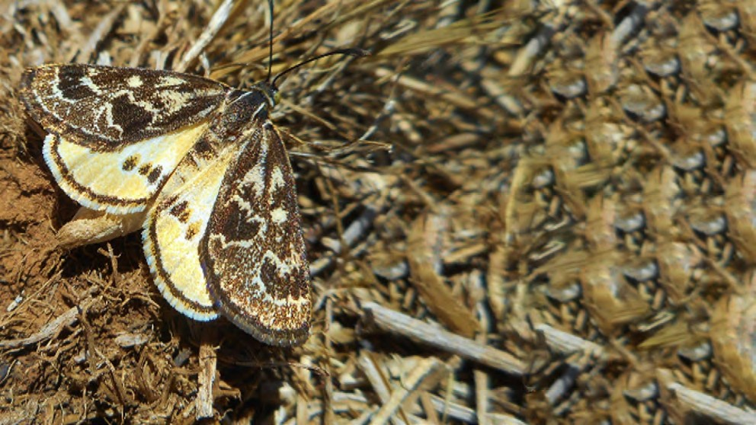
Figure 19: Male Golden Sun Moth in the Western Grassland Reserve Source: DELWP

DELWP’s conservation commitment
DELWP published the following statements as conservation outcomes for the Golden Sun Moth by notice in the Victorian Government Gazette:
‘Permanent protection of occupied habitat for Golden Sun Moth with viable populations, as defined by Population Viability Analysis (PVA) models. The amount of habitat required outside the UGB to meet this target, over and above the conservation areas within the UGB and the Western Grassland Reserve, is 680 ha.’
‘Golden Sun Moth populations in the Western Grassland Reserve are sustained in the long-term. Sustained means that the five-year mean proportion of sites occupied remains above the baseline.’
‘Golden Sun Moth populations in the conservation areas identified in the BCS and the Conservation Areas Declaration, and those outside the UGB are sustained in the long-term. Sustained means that the five-year mean proportion of sites occupied remains above the baseline.’
‘Golden Sun Moth populations in the Grassy Eucalypt Woodland Protected Area are sustained in the long-term. Sustained means that the five-year mean proportion of sites occupied remains above the baseline.’

- Brown G, Tolsma A, and McNabb E 2012, ‘Ecological aspects of new populations of the threatened Golden sun moth Synemon plana on the Victorian Volcanic Plains.’ The Victorian Naturalist 129, 77-85.

DELWP’s MSA MRF also summarises the conservation outcomes for the Golden Sun Moth as a single goal statement: ‘the Golden Sun Moth persists’.

KPIs assessed
DELWP measures progress towards this goal using the following KPI:
  - The five-year mean proportion of monitoring sites occupied must remain above a baseline set by the first five years of survey.
The baseline for this KPI is static at 89% of sites occupied, calculated as the mean of the first five years of data for all sites monitored within the first five years.

MNES | 4. Golden Sun Moth
Commonwealth approved 2015 MSA MRF single outcome statement | Golden Sun Moth persists.
2014–2020 Ecological Outcomes Report single outcome statement | Golden Sun Moth persists.
Conservation Outcomes published in the Victorian Government Gazette – Issue G4, 27 January 2022 | The permanent protection of occupied habitat for Golden Sun Moth in:  - the Western Grassland Reserve  - the conservation areas identified in the BCS and the Conservation Areas Declaration  - 680 ha of conservation areas identified outside the UGB that can include land within the Grassy Eucalypt Woodland Protected Area (where occupied habitat is found).  Golden Sun Moth populations in the Western Grassland Reserve are sustained in the long-term. Sustained means that the five-year mean proportion of sites occupied remains above the baseline.  Golden Sun Moth populations in the conservation areas identified in the BCS and the Conservation Areas Declaration, and those outside the UGB are sustained in the long-term. Sustained means that the five- year mean proportion of sites occupied remains above the baseline.  Golden Sun Moth populations in the Grassy Eucalypt Woodland Protected Area are sustained in the long-term. Sustained means that the five-year mean proportion of sites occupied remains above the baseline.

Monitored areas

Golden Sun Moth occurs in numerous conservation areas within the MSA area.171 Monitoring currently occurs at 11 permanent plots at these locations:

- Truganina South Nature Conservation Reserve (NCR)
- Western Grassland Reserve, Mount Cottrell NCR (eastern half)
- Western Grassland Reserve, One Tree East (Paddock 1 and Paddock 2)
- Western Grassland Reserve, Wilsons Block (Wilsons North and Wilsons South)
- Western Grassland Reserve, Radio Block.
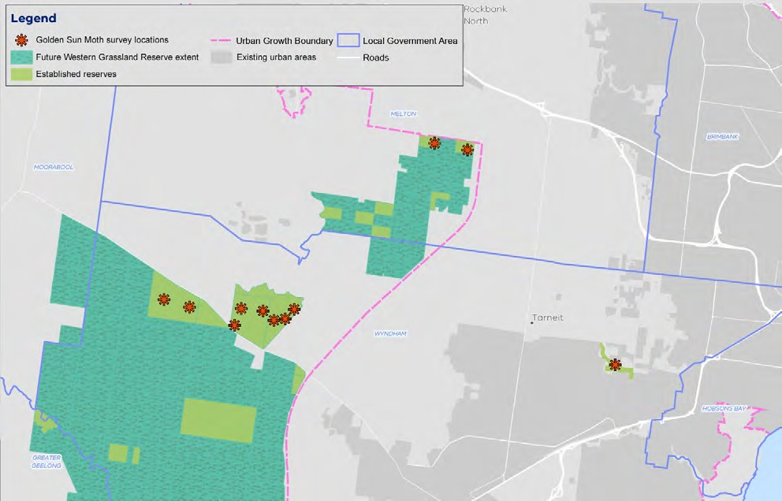
Figure 20: Map of monitored areas for the Golden Sun Moth Source: DELWP

Results

KPI 1: Proportion of monitoring sites that are occupied

KPI 1: Proportion of monitoring sites that are occupied | Status 2020-2022 | Reason for non-assessment | Trend | Data Confidence | Year that baseline was/will be set
All locations | Not met | N/A |  | Moderate | 2018

- DELWP 2015, ‘Monitoring and Reporting Framework – Melbourne Strategic Assessment’, East Melbourne, Victoria.

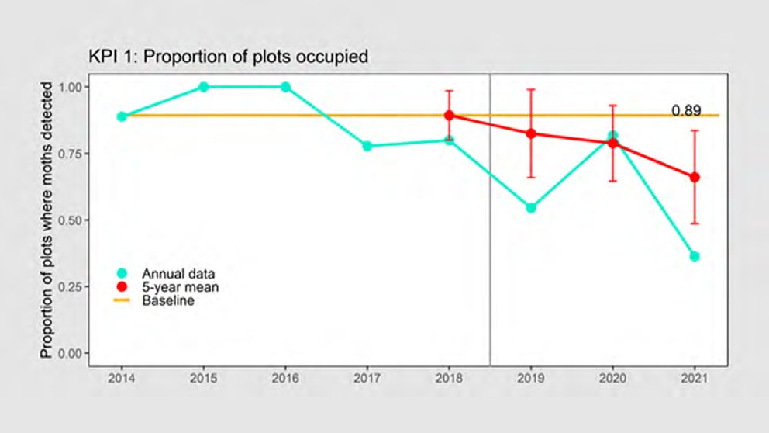
Figure 21: The proportion of plots in which Golden Sun Moth was detected. The five-year mean is shown in red with error bars depicting 95% confidence intervals. The baseline, set after the first five years, is shown as an orange line. Source: DELWP

Results interpretation
The Golden Sun Moth was detected at four of 11 plots (0.36) in the 2021/22 season. With the inclusion of this data, the upper 95% confidence interval (0.84) of the five-year mean has fallen below the baseline of 0.89, which may suggest an overall decline in population numbers.
This is the first year that the KPI has been in breach of the baseline for Golden Sun Moth and occupancy is the lowest recorded in eight years of monitoring. This likely reflects a general decline in detections since the first three years of monitoring.
DELWP has noted172 that monitoring for the Golden Sun Moth started later this year (in January 2022) than in previous years (typically November or December) due to suboptimal weather conditions for moth flying (detection relies on this behaviour) during that period. This may account for the lower apparent occupancy than in previous years. In general, it is expected that the addition of new locations may add noise to the data, but this is somewhat controlled for by taking the five-year mean as the measure for the baseline. Further, as no new monitoring locations were added this year, this cannot explain the variation.
Factors thought to influence Golden Sun Moth flying behaviour – such as temperature, wind speed and cloud cover – were not significantly different this year compared to previous years.173
Monitoring data show generally high grassland biomass levels (and correspondingly less bare ground) in 2021, compared with previous years.174 DELWP speculates that this factor may have had a detrimental effect on moth emergence/detectability but are unable to conclusively demonstrate this from the data they had collected.175

- DELWP, internal document, provided 16 February 2022.
- DELWP, internal document, provided 16 February 2022.
- DELWP Officer, personal communication, 15 February 2022.
- DELWP Officer, personal communication, 15 February 2022.

The spring of 2021 was relatively wet and humid – this may also have had a detrimental effect on moth emergence, however there is no evidence to support this idea.

Key insights and management implications
It is unclear if the apparent trend of a decline in Golden Sun Moth numbers represents a genuine population decline, is an issue of detectability, or rather represents natural annual variability. DELWP indicates results are somewhat a cause for concern but
not an immediate issue176 – despite the sharp decrease in numbers between 2020 and 2021 – and is hopeful that the result can be explained by seasonal weather patterns as more data is collected over time.
Cover of vegetation inhibiting the moth’s reproductive behaviour is known to be an issue for both moth emergence and detection, and DELWP has indicated that a recent lack of grazing in the moth’s known MSA extent, coupled with a relatively wet season, has led to a build-up of biomass.177 DELWP has indicated that many large areas of Golden Sun Moth habitat have also not had the optimal grazing and burning regimes applied to them in recent years.
Although unlikely, it is possible that detectability in the current monitoring methodology may not be fully capturing the population dynamics and trajectory of the species.
DELWP is currently using the standard method for monitoring of this species, in accordance with scientific literature. They have in previous years, however, trialled other ways of monitoring the species (to see if it could obtain better estimates of some parameters for PVA modelling) that could have provided alternate measures of
species persistence, including surveys of larvae and the trapping of moths using tents. These methods failed to be reliable – even in years where there was relatively good detectability – and were subsequently abandoned.
Local environmental covariates may help to explain some of the variation in the data. For example, grassland data does indicate that biomass has been high this year.
As DELWP has remarked that it’s been an unusual spring (wet and humid), it would potentially be worth analysing the effects of certain weather variables to build a more comprehensive understanding of the dynamics at play.178 DELWP commissioned
research on this topic three years ago looking at moth emergence and its relationship with vegetation structures. Preliminary results for this were inconclusive.
Another important covariate is the type of vegetation cover – the moths are presumed to eat C3 grasses, not Kangaroo Grass. It is for this reason that DELWP has previously reported the cover of different grass types.179 This has interesting implications for management – the moths tolerate grazed areas, but heavy grazing is not ideal.
Kangaroo Grass-dominated ecosystems are viewed to be more desirable from a vegetation management perspective,180 but the moth preferences C3 grasses – and this poses a potentially difficult management trade-off. DELWP’s PVA modelling highlighted the importance of bare ground and C3 dominance grasses – and these outputs were incorporated into a structured decision-making exercise to assess the trade-off. The exercise revealed that the status quo scenario for the management of the Golden Sun Moth is currently near-best in terms of optimising outcomes for the species.

- DELWP Officer, personal communication, 15 February 2022.
- DELWP Officer, personal communication, 15 February 2022.
- DELWP Officer, personal communication, 15 February 2022.
- M Bruce, K Batpurev, D Bryant. S Sinclair and M Kohout 2020, ‘Melbourne Strategic Assessment: Ecological Outcomes Report 2014-15 to 2019-20.’ DELWP, Heidelberg, Victoria.
- Sinclair SJ, Zamin T, Gibson-Roy P, Dorrough J, Wong N, Craigie V, Garrard GE and Moore JL 2019b, ‘A state-and-transition model to guide grassland management.’ Australian Journal of Botany 67, 437-453.

Weed control may be important to the Golden Sun Moth’s persistence; there is evidence of association with Chilean Needle Grass (Nassella neesiana) (Richter et al.) and with native C3 grasses i.e. Wallaby and Spear grasses (Rytidosperma spp. & Austrostipa spp.). A major assumption is that the main food plants for larvae of the Golden Sun Moth are perennial C3 grasses, both native and exotic.181 While this is based on observations of moths in exotic grasslands (Brown et al. 2012),182 the extent to which they eat exotic grasses is unclear. Therefore, there are potentially negative impacts
of weed control in areas with high levels of exotic C3 grasses such as Nassella trichotoma. DELWP has not yet looked at studies assessing the relationship between biomass control regimes and persistence of the Golden Sun Moth – and there is potential to further explore this.
With additional Golden Sun Moth sites expected to come under MSA management over the next 18 months, DELWP indicates that some changes to the design may occur, and that comparison against a counterfactual control would assist to assess changes linked to MSA management.183
New plots being added over time could be explaining some of the variation. Acquisitions have been slow and limited the data, causing large fluctuations over time. As the five- year rolling mean is technically not independent from the baseline, therefore there is no way of calculating error bars with annual data. Therefore what is presented is, in fact, the error around the five-year mean.
It has been difficult for DELWP to implement appropriate management responses for this species.184 DELWP has only had access to parcels on the public land estate where there is limited data for the Golden Sun Moth, with monitoring only commencing
in an area when land becomes available to manage under the MSA program.185 Nevertheless, the Golden Sun Moth is assumed to be quite widespread and common in non-MSA areas where it is known to occur.

- Regan T. et al., Arthur Rylah Institute 2012, ‘Melbourne Strategic Assessment: Population Viability Analysis model for threatened species’
- Brown, G., Tolsma, A. and McNabb, E., 2012. Ecological aspects of new populations of the threatened Golden sun moth 'Synemon plana' on the Victorian Volcanic plains. The Victorian Naturalist, 129(3), pp.77-85.
- DELWP Officer, personal communication, 15 February 2022.
- DELWP Officer, personal communication, 15 February 2022.
- DELWP Officer, personal communication, 15 February 2022.

MNES 5: Matted Flax-lily

Background

Matted Flax-lily (Dianella amoena) is a perennial lily that forms mats often exceeding
~5 m in diameter. It has linear grey-green leaves and produces blue or violet star-shaped flowers, followed by purple berries.186 It retreats underground during dry periods, making detection problematic. Matted Flax-lily is scattered across Victoria, with a few recently discovered populations in the Canberra region.
EPBC listing status: Endangered
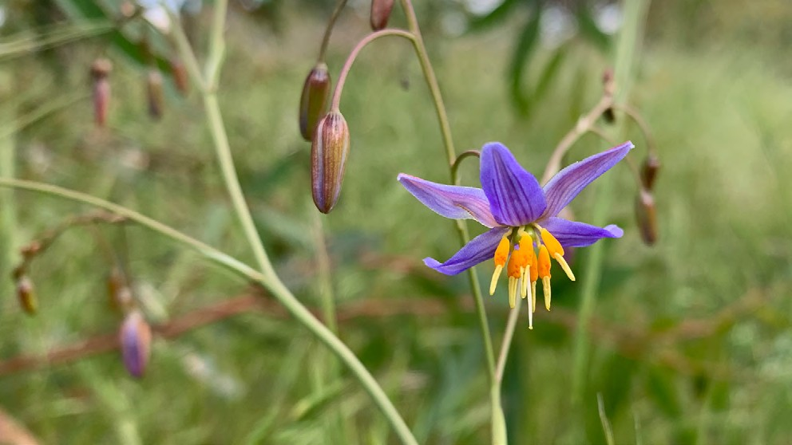
Figure 22: A flowering Matted Flax-lily Source: DELWP
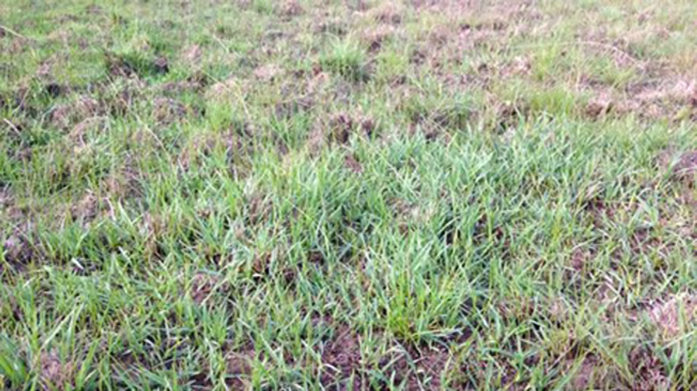
Figure 23: A clump of Matted Flax-lily (foreground) Source: DELWP

- Carr GW and Horsfall PF 1995, ‘Studies in Phormiaceae (Liliaceae) 1: New species and combinations in Dianella Lam.’ Ex Juss. Muelleria 8, 365-378.

DELWP’s conservation commitment
DELWP published the following statements as conservation outcomes for the Matted Flax-lily by notice in the Victorian Government Gazette:
‘The permanent protection of occupied habitat for Matted Flax-lily in:
- the conservation areas identified in the Biodiversity Conservation Strategy (BCS) and the Conservation Areas Declaration
- 529 ha of conservation areas identified outside the UGB that can include land within the Grassy Eucalypt Woodland Protected Area (where occupied habitat is found).’
‘Matted Flax-lily populations in the conservation areas identified in the BCS and the Conservation Areas Declaration, and those outside the UGB are sustained in the long-term. Sustained means that the five year mean detection rate of previously known plants remains above the baseline.’
‘Matted Flax-lily populations in the Grassy Eucalypt Woodland Protected Area are sustained in the long-term. Sustained means that the five-year mean detection rate of previously known plants remains above the baseline.’

DELWP’s MSA MRF also summarises the conservation outcomes for the Matted Flax- lily as a single goal statement: ‘no substantial negative change to the population of Matted Flax-lily within the program area’.

KPIs assessed
Progress towards this goal is measured using a single KPI:
1. Annual detection rate of known plants, which must remain above a baseline, set in the first five years of monitoring.
Note this target is different from that included in the published MRF. The MRF will be updated as explained below.
The baseline detection rate will be set from the Kalkallo Common population in 2022, the fifth year of sampling. Currently, the mean detection rate is 0.92 (from the first four years of monitoring only).

MNES | 5. Matted Flax-lily
Commonwealth approved 2015 MSA MRF single outcome statement | No substantial negative change to populations of Matted Flax-lily.
2014–2020 Ecological Outcomes Report single outcome statement | Matted Flax-lily persists.
Conservation Outcomes published in the Victorian Government Gazette – Issue G4, 27 January 2022 | The permanent protection of occupied habitat for Matted Flax-lily in:  - the conservation areas identified in the BCS and the Conservation Areas Declaration  - 529 ha of conservation areas identified outside the UGB that can include land within the Grassy Eucalypt Woodland Protected Area (where occupied habitat is found).  Matted Flax-lily populations in the conservation areas identified in the BCS and the Conservation Areas Declaration, and those outside the UGB are sustained in the long-term. Sustained means that the five- year mean detection rate of previously known plants remains above the baseline.  Matted Flax-lily populations in the Grassy Eucalypt Woodland Protected Area are sustained in the long-term. Sustained means that the five-year mean detection rate of previously known plants remains above the baseline

Monitored areas
Matted Flax-lily is known to occur in at least seven separate conservation areas within the MSA program area.187 Only one of these sites has so far come under management within the MSA program before 2021, Conservation Area 24, the Kalkallo Common Grassland. This site has been monitored under the MSA since 2016, following a site inventory to locate known plants in 2015. It was not monitored in 2020 due to COVID-19.
At Kalkallo Common Grassland, Matted Flax-lily plants have been translocated into the stony rises. These translocations pre-date the MSA, and these plants have been monitored under a different project, funded separately from the MSA. These plants are not included in MSA monitoring, although it is acknowledged that they form part of the Matted Flax-lily population in functional terms (i.e. they likely contribute pollen and seeds to the population).
A second population of at least 58 clumps has since been protected at Mount Ridley and will be monitored from 2021. In 2021 the site was searched and 58 plants found.

- DELWP 2015, ‘Monitoring and Reporting Framework – Melbourne Strategic Assessment’, East Melbourne, Victoria.

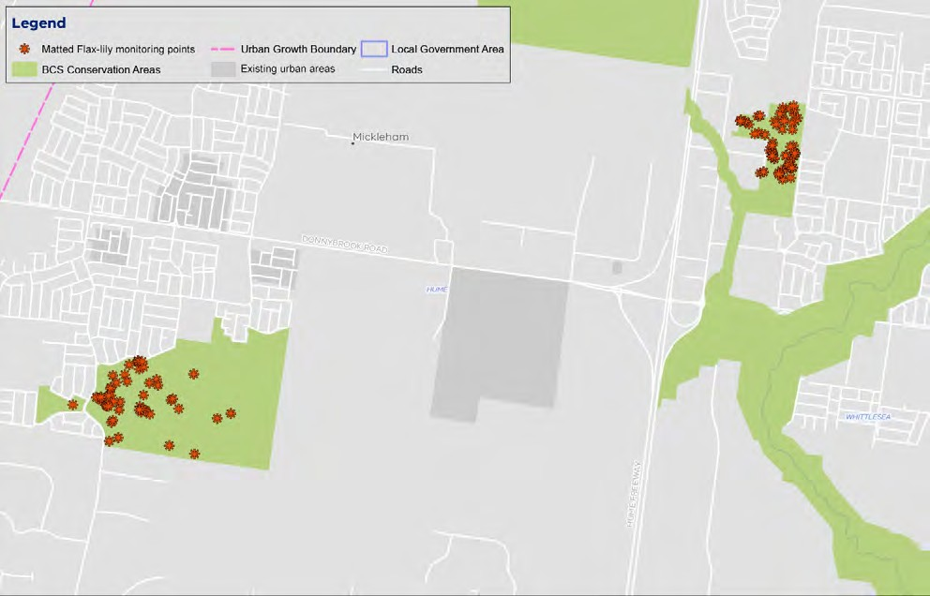
Figure 24: Map of monitored locations for the Matted Flax-lily Source: DELWP

Results: KPI

KPI 1: Percentage of plants detected each year

KPI 1: Percentage of plants detected each year | Status 2020-2022 | Reason for non-assessment | Trend | Data Confidence | Year that baseline was/will be set
Kalkallo Common | Not assessed | Baseline not yet set |  | N/A | 2025
Mt Ridley | Not assessed | Baseline not yet set |  | N/A | 2022

In 2015, an initial database of known Matted Flax-lily locations (n=52) was compiled from field searches and the compilation of existing data from Hume City Council, Merri Creek Management Committee and Abzeco. Monitoring in these areas commenced
in 2016. Each year during monitoring, new plants have been discovered, until by 2019 there are 64 locations included in the database.
It is not yet possible to state whether the KPI has been met, as the baseline has not yet been set. This KPI is assessed against a static benchmark, which will be set in 2022 for Mt Ridley and 2025 for Kalkallo Common.

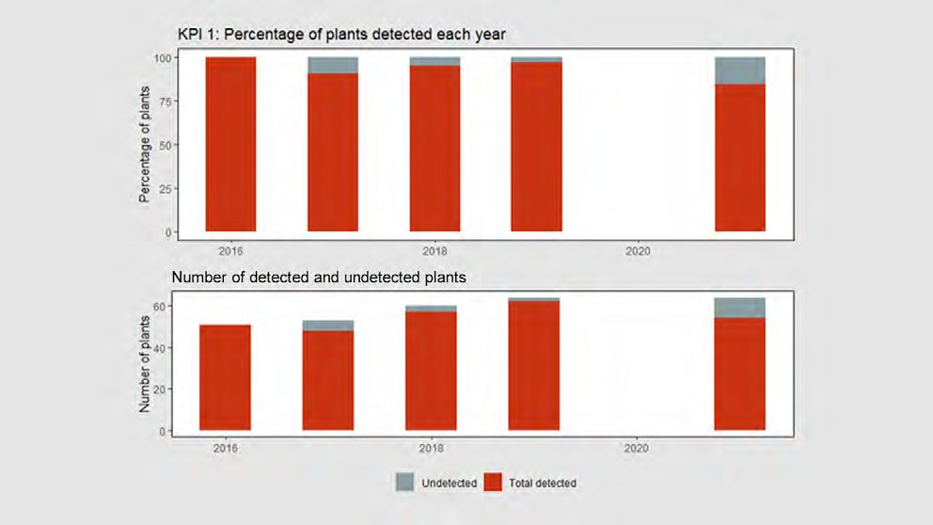
Figure 25: Matted Flax-lily plants detected in the first four years of monitoring at Kalkallo Common, expressed as a percentage of the total number of plants known in each year. Year 1 (2016) shows 100% detection by definition. Source: DELWP

Results interpretation
Baseline results would indicate that the population of Matted Flax-lily at Kalkallo Common (65 clumps in 2021) is ‘apparently stable, or nearly so’, according to DELWP,188 with the current trajectory indicating no trends of concern. Because individual plants are accounted for with georeferenced data, DELWP reports these results with a high level of confidence.189
Three plants that were not detected in 2021 are located near graves in Donnybrook Cemetery (within Conservation Area 24), in areas which are now mown regularly to <2 cm.

Key insights and management implications
At the commencement of the MSA program, only a small amount of data on the Matted Flax-lily was available to guide management or monitoring. As such, DELWP’s assumptions about how things would work and how they worked out in practice
with respect to the monitoring of this species, have changed over time.190 Monitoring protocol now includes an annual broader formal search for new plants. This last occurred in 2019, but not in 2020 due to COVID-19 lockdowns and restrictions. Detected and undetected proportion of plants is now measured, and newly detected plants are added to the existing dataset. In this way, the denominator grows every year.191
Expert elicitation data collected for PVA models suggest that Matted Flax-lily is long lived and hardy. An individual forms a clump, with shoots emerging from an
underground rootstock. These clumps may measure from 20 cm to >10 m in diameter. The species rarely produces observable young plants.

- DELWP Officer, personal communication, 15 February 2022.
- DELWP Officer, personal communication, 6 July 2021. 190. DELWP Officer, personal communication, 6 July 2021.
- DELWP Officer, personal communication, 6 July 2021.

Matted Flax-lily is somewhat unique compared with the other flora species under MSA management, in terms of monitoring. Matted Flax-lily often loses its foliage and retreats underground in summer and autumn but may retain foliage if conditions remain moist. This means that plants are unreliably detectable, and that a healthy plant may remain undetected when searched one year and be clearly present the next. Sites with this species are very large, but have a sparse and patchy distribution, with detection described as ‘like finding needle in a haystack’.192 Consequently, this is reflected in historical records – with new data on plants (not a recruit) appearing with the discovery of new plants that have been there undetected for quite some time.
Detectability is also thought to be affected by the length of surrounding grass. In wet years, the grass may be long, and Matted Flax-lily more difficult to see even if it has emerged. This was the case in 2021, with the season being wetter than average.
It is unclear how many years of non-detection should be taken as evidence of death. DELWP’s current data indicate that many plants have gone undetected for two years, before being found again in the third. Two plants have been undetected for three years and have not yet been found again. It remains to be seen whether these plants are in fact dead or if they will be detected again in future. DELWP believes that a rule defining the temporal pattern of non-detection accounting for actual plant deaths will emerge as more data is collected in the coming years.
DELWP has funded genetic research for the species led by La Trobe University in 2021, which revealed the MSA population is genetically ‘normal’, with similar levels of genetic diversity compared to other populations. The research also explored the
nature of clonality within the population’s genetics – specifically, if the genetic makeup of a clump of plants comprises one individual (a clump of genetic clones) or multiple individuals, and how this may impact the number of individuals found in a clump.
Results of this research indicate that it is not possible to differentiate. The research also uncovered that three plants forming a clump within the current MSA population were genetic clones, and DELWP has adjusted its dataset to account for this (three plants become one plant). DELWP accepts that there is some level of error in the counting of plants, at low levels, due to clonality.193 Periodic genetic sampling of future populations will be important to account for clonality.
Biomass control will be a necessary management intervention going forward for the species,194 as the species risks decline if it is shaded out. The preferred biomass reduction regime is the application of planned burning every seven to 10 years; the species responds negatively to grazing.195
DELWP is confident the species will persist in the medium-long term.196 DELWP indicates that if declines are detected in the dataset over time, they would be easy to rectify,
as there is ample tube stock for planting, and the plants can be grown from a cutting of a rhizome. Response planning to manage potential species decline may be required given the current risk. Given the ease of intervention, supplementary planting may be
undertaken to address any immediate declines, with opportunity to involve community.

- DELWP Officer, personal communication, 6 July 2021.
- DELWP Officer, personal communication, 15 February 2022.
- DELWP Officer, personal communication, 15 February 2022.
- DELWP Officer, personal communication, 15 February 2022.
- DELWP Officer, personal communication, 15 February 2022.

MNES 6: Spiny Rice-flower

Background

Spiny Rice-flower (Pimelea spinescens subsp. Spinescens) is a small shrub, growing up to 30 cm high. It is endemic to Victoria, occurring on the volcanic plains, in the Wimmera and the northern plains.197

EPBC listing status: Critically Endangered
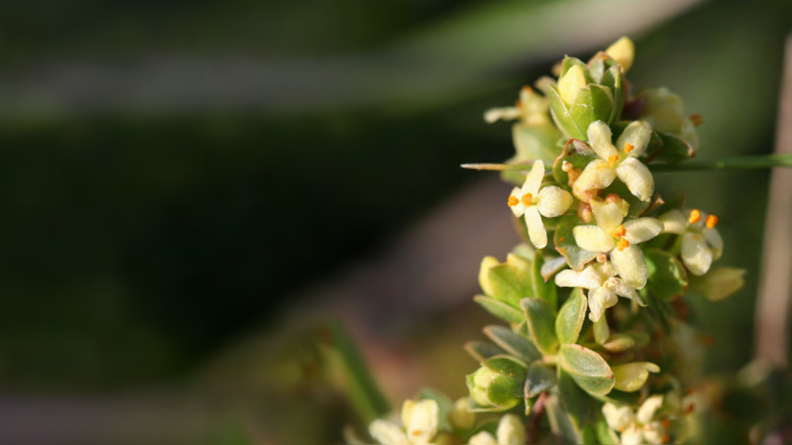
Figure 26: Spiny Rice-flower Source: DELWP

DELWP’s conservation commitment
DELWP published the following statements as conservation outcomes for the Spiny Rice-flower by notice in the Victorian Government Gazette:
‘The permanent protection of occupied habitat for Spiny Rice-flower in: the Western Grassland Reserve the conservation areas identified in the BCS and the Conservation Areas Declaration 394 ha of conservation areas identified outside the UGB that can include land within the Grassy Eucalypt Woodland Protected Area (where occupied habitat is found).’
‘Spiny Rice-flower populations in the Western Grassland Reserve are sustained in the long-term. Sustained means that the recruits forming more than 10% of the population in each location at least once in the previous 10 years and the five-year mean population count remain above the baseline.’
‘Spiny Rice-flower populations in the conservation areas identified in the BCS and the Conservation Areas Declaration, and those outside the UGB are sustained in the long-term. Sustained means that recruits forming more than 10% of the population in each conservation area at least once in the previous 10 years and the five- year mean population count remain above the baseline.’

- James EA, Jordan R 2014, ‘Limited structure and widespread diversity suggest potential buffers to genetic erosion in a threatened grassland shrub Pimelea spinescens (Thymelaeaceae).’ Conservation Genetics 15, 305-317.

DELWP’s MSA MRF also summarises the conservation outcomes for the Spiny Rice-flower as a single goal statement: ‘no substantial negative change to the population of Spiny Rice-flower and the population is self-sustaining within the program area’.

KPIs assessed
Progress towards this goal is measured using two KPIs:
  - The five-year mean population density, measured in sample plots, which must remain above a baseline set by the first five years of survey.
  - The occurrence of recruits, which must form over 10% of the MSA-wide population in at least one of the previous 10 years.
DELWP has recommended that KPI 1 is changed, so that ‘density’ is replaced with ‘count’ (as for Button Wrinklewort and Large-fruit Groundsel). The data presented here refer to the updated KPI.
KPI 1 is assessed using a continuous improvement approach, where any increase over the baseline in a five-year reporting period will lead to the calculation of a new baseline for subsequent reporting periods.
KPI 2 is assessed against a static baseline (10% of population, one in 10 years).
The baseline has not yet been set for either KPI in any of the monitored areas and is due to be set in 2024.

MNES | 6. Spiny Rice-flower
Commonwealth approved 2015 MSA MRF single outcome statement | No substantial negative change to populations of Spiny Rice-flower, and populations are self-sustaining.
2014–2020 Ecological Outcomes Report single outcome statement | No substantial negative change to the population of Spiny Rice-flower, and the population is self-sustaining.
Conservation Outcomes published in the Victorian Government Gazette – Issue G4, 27 January 2022 | The permanent protection of occupied habitat for Spiny Rice-flower in:  - the Western Grassland Reserve  - the conservation areas identified in the BCS and the Conservation Areas Declaration  - 394 ha of conservation areas identified outside the UGB that can include land within the Grassy Eucalypt Woodland Protected Area (where occupied habitat is found)  Spiny Rice-flower populations in the Western Grassland Reserve are sustained in the long-term. Sustained means that the recruits forming more than 10% of the population in each location at least once in the previous ten years and the five-year mean population count remain above the baseline.  Spiny Rice-flower populations in the conservation areas identified in the BCS and the Conservation Areas Declaration, and those outside the UGB are sustained in the long-term. Sustained means that recruits forming more than 10% of the population in each conservation area at least once in the previous ten years and the five-year mean population count remain above the baseline.

Monitored areas
Spiny Rice-flower occurs naturally in numerous conservation areas within the program area. Only four of these sites have so far come under management within the MSA program:
- Truganina Cemetery Grassland (Conservation Area 10)
- Western Grassland Reserve, Mount Cottrell NCR
- Western Grassland Reserve, Magpie block
- Western Grassland Reserve, Radio block.
Spiny Rice-flower is currently only monitored at two of these locations: Truganina Cemetery (monitored as one large cluster) and Radio property, Western Grassland Reserve (monitored in four discrete clusters).
A translocated population has been established on Mount Cottrell NCR, but it is monitored by another project and is not part of the MSA program.
It is anticipated that many more populations will be acquired and monitored in future. Due to the constraints of the COVID-19 pandemic, this species was not monitored in 2020.
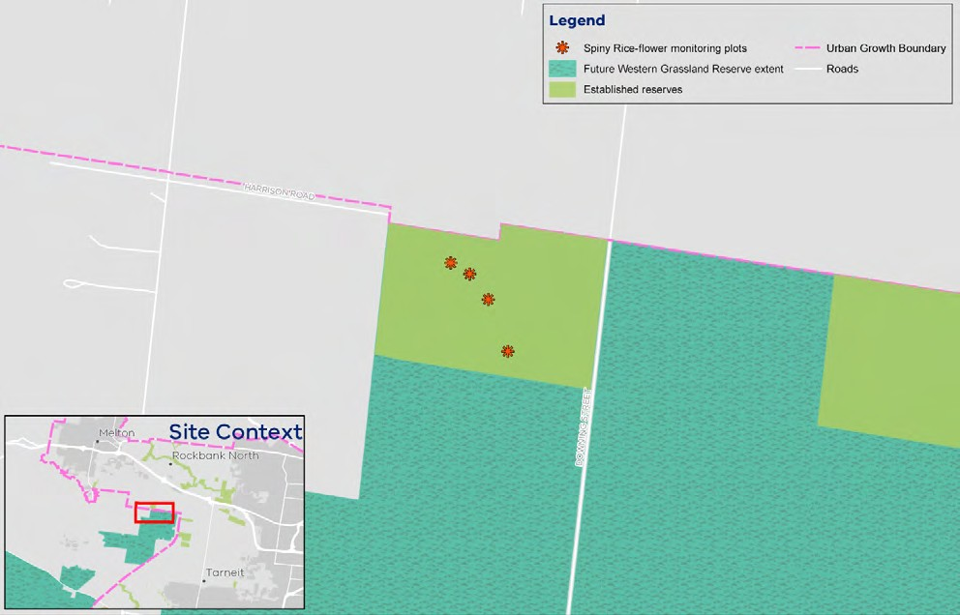
Figure 27: Map of monitored locations of Spiny Rice-flower Source: DELWP

Results

KPI 1: Population count

KPI 1: Population count | Status 2020-2022 | Reason for non-assessment | Trend | Data Confidence | Year that baseline was/will be set
Radio | Not assessed | Baseline not yet set |  | N/A | 2024
Truganina Cemetery | Not assessed | Baseline not yet set |  | N/A | 2024

The population counts (within clusters) in 2019 were 201 at Radio (in 4 clusters) and 965 at Truganina Cemetery (in 1 cluster). As 2019 was the first year of monitoring using this method the baseline cannot yet be set.
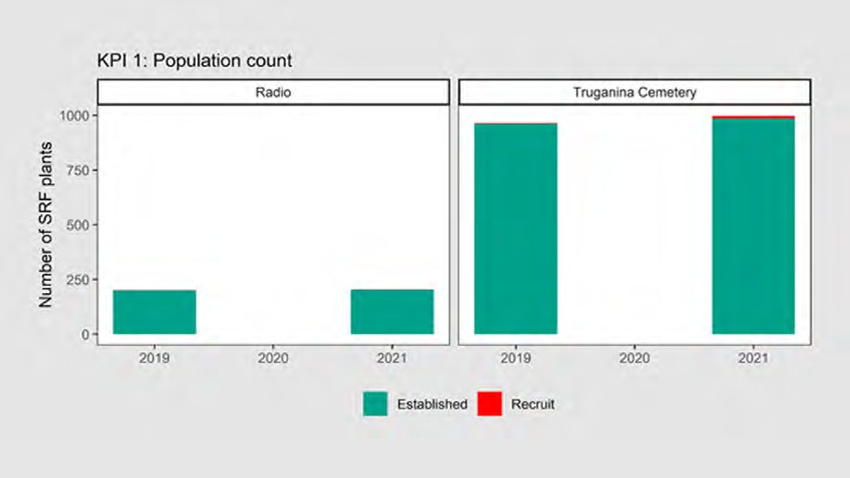
Figure 28: Population count of Spiny Rice-flower at Radio and Truganina Cemetery in 2019 and 2021 (not monitored in 2020) Source: DELWP

KPI 2: Number of years that recruits form over 10% of the population over a 10-year period

KPI 2: Number of recruits that form over 10% of the population over a 10-year period | Status 2020-2022 | Reason for non-assessment | Trend | Data Confidence | Year that baseline was/will be set
Radio | Not assessed | Baseline not yet set |  | N/A | 2024
Truganina Cemetery | Not assessed | Baseline not yet set |  | N/A | 2024

This KPI measures the proportion of plants that are new recruits to a population. It is expected that recruits form more than 10% of each population at least once every 10 years. This KPI is intended to measure rates of recruitment of the population, to ensure that the conditions for recruitment are sustained (periodic bare ground, seed supply), rather than measuring the fate of recruits, which is not specifically reported on. (The overall population trajectory is intended to be covered by KPI 1.) Figure 29 shows examples of Spiny Rice-flower recruits.

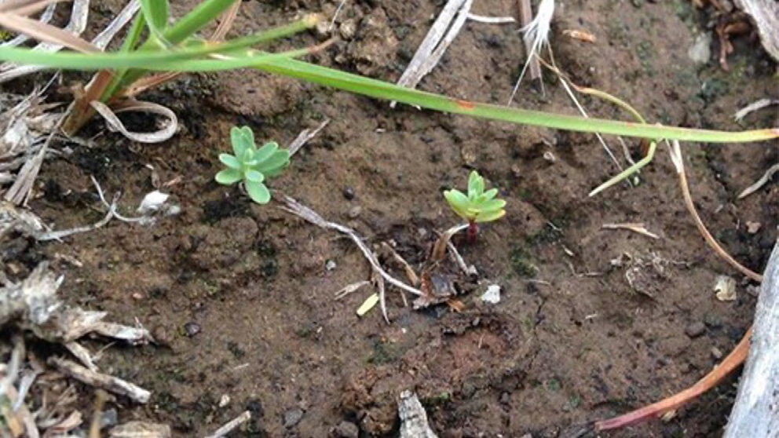
Figure 29: Two Spiny Rice-flower recruits, Truganina Cemetery Source: DELWP

Table 3 shows the percentage of recruits recorded across all currently monitored sites. The first year of monitoring using this method was 2019. The KPI will be first assessed after 10 years of monitoring, in 2029.

Table 3: Percentage of population formed by recruits. The numbers in brackets show the total numbers of recruits and the total number of plants in the sample plots for that population. Source: DELWP

Site | Percentage of population formed by recruits
 | 2019 | 2020 | 2021
Truganina Cemetery | (4/965) | N/A | (0/998)
Radio (WGR) | (0/202) | N/A | (0/204)

Results interpretation
Preliminary results indicate that Spiny Rice-flower populations are stable, with low mortality of adult plants and despite a low level of recruitment. After two years of monitoring, no year has yet seen recruits make up more than 2% of plants. Generally, stability is expected for this species in the long term, according to DELWP, if some recruitment is observed.
Nine hundred and sixty-five plants were recorded at Truganina Cemetery in 2019 and 998 plants in 2020. Two hundred and two plants were recorded at ‘Radio’ in 2019, 204 in 2021. The slight increase in plants between 2019 and 2021 is mostly due to new discoveries of previously undetected adult plants, rather than new recruits (n=12 at Truganina, 0 at Radio).
Spiny Rice-flower is believed to be a long-lived species (possibly >100 years). According to DELWP, the Recovery Team has indicated it would be expected that a recruitment ‘pulse’ (an upturn event) would be experienced every 10 or so years.

Given 2021 was a very wet spring, with mild humid conditions, DELWP had expected to see a recruitment pulse event in that year. The lack of an observed pulse may be of concern, according to DELWP, but this is not certain, and DELWP awaits advice from the Recovery Team.

Key insights and management implications
DELWP consulted the official Pimelea Recovery Team in the design of the KPIs for this species. Of all the plant species under MSA management, it is the one that has had the most formal consultation.198
This species requires a lot of effort to monitor, with it taking longer to count compared with other species, according to DELWP.199
DELWP indicates that initial monitoring of this species was not adequate with respect to the original KPI measuring population density.200 It was assumed that the population of plants had two habits (relating to plant spatial arrangement): either a big population in a small area; or a few individual scattered plants. DELWP committed to monitoring the population, making sure the individuals were still there each year. DELWP subsequently discovered a large population which had clusters as well as scatters of plants and has since redesigned the monitoring protocol.
When DELWP implemented its original monitoring protocol, it sampled only 1% to 2% of the actual population in the plot.201 This was due to the size of the plots in their existing monitoring protocol being too small to cover the patterning of the population; 5 m plots didn't adequately cover the distribution and therefore the full population wasn’t being captured. Plots have now been increased to 20 x 20 m, and every plant within them is marked using X-Y coordinates (which are linked to grassland data) and sampled each year as part of a census. This allows DELWP to locate the cluster in subsequent years, as well as providing opportunity to analyse spatial trends in the data. Scattered plants are now de-emphasised under the new monitoring protocol and are numerically of no consequence to the results. Consequently, DELWP reset the monitoring program under the new protocol in 2018, with the exclusion of previous years’ data (collected under the previous protocol).
The Pimelea Recovery Team advised DELWP that Spiny Rice-flower recruits periodically, roughly every 10 years, and according to rainfall. DELWP used this information to determine the threshold for KPI 2: that once every 10 years there must be a high population of recruits. This KPI is unique in that it's not an aggregate – if it’s achieved once within the 10-year period, it's achieved. Based on the design it is unclear whether this KPI resets after it had been met or whether it measured in blocks of 10 years
– it is recommended this is clarified. Further testing may be required to assess the adequacy of the 10-year window in capturing the variable recruitment dynamics.

- DELWP Officer, personal communication, 15 February 2022.
- DELWP Officer, personal communication, 6 July 2021.
- DELWP Officer, personal communication, 6 July 2021.
- DELWP Officer, personal communication, 6 July 2021.

DELWP also indicates that it is concerned about results in rates of recruitment for the Spiny Rice-flower, as it expected to see more recruitment over the last couple of years. DELWP is hoping to address this issue by observing if recruitment rates are enough to replace mortality rates within the population over time. It is expected that more data will reveal that it’s a very ‘slow-moving species’. 202
A data-driven PVA model for this species exists, which is calibrated with annual monitoring data. With respect to management requirements specific to this species, the Spiny Rice-flower does not respond well to grazing – however, this is not an issue because it is not currently being managed on private land. The Spiny Rice- flower is intolerant of shade and humidity. Biomass control is important to this species, with planned burning being the main tool for management with respect to this. DELWP indicates that areas in which this species are found are in current need of a biomass control regime in the form of planned burning.203 Burns to date have been implemented well with positive outcomes, according to DELWP.204 As the MSA program scales up, it will be important to maintain efforts to control biomass and manage the risk of degradation to current and new populations.

- DELWP Officer, personal communication, 15 February 2022.
- DELWP Officer, personal communication, 15 February 2022.
- DELWP Officer, personal communication, 15 February 2022.

MNES 7: Southern Brown Bandicoot

Background

The Southern Brown Bandicoot (eastern) (Isoodon obesulus subsp. obesulus) is a marsupial in the family Peramelidae. Males are generally larger than females.205 The sub-species is found in Victoria, New South Wales and South Australia. In Victoria it is primarily in coastal and foothill regions south-east of Melbourne, with isolated populations in western Victoria.206
EBPC listing status: Endangered
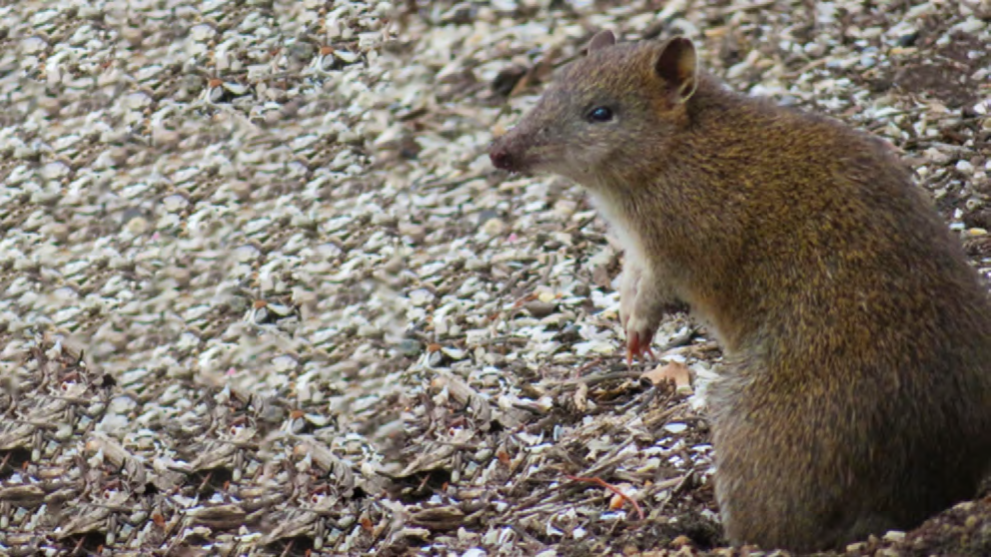
Figure 30: Southern Brown Bandicoot Source: DELWP

DELWP’s conservation commitment
DELWP published the following statements as conservation outcomes for the Southern Brown Bandicoot by notice in the Victorian Government Gazette:
‘Functioning and sustainable Southern Brown Bandicoot populations within the Southern Brown Bandicoot management area with connectivity between populations. Sustainable populations means that the proportion of sites occupied (measured via camera trap surveys taken every five years) remains above the baseline.’
‘The protection and enhancement of all Southern Brown Bandicoot populations within the Southern Brown Bandicoot management area.’

- Menkhorst PWS 1990, ‘Distribution and conservation status of bandicoots in Victoria.’ In: JH Seebeck, PR Brown, RL Wallis and CM Kemper (eds.) Bandicoots and Bilbies, Surrey Beatty & Sons Pty Ltd, Chipping Norton, pp. 51-50.
- Brown GW and Main ML 2010, ‘National Recovery Plan for the Southern Brown Bandicoot Isoodon obesulus’ Department of Sustainability and Environment, Victoria.

DELWP’s MSA MRF also summarises the conservation outcomes for the Southern Brown Bandicoot as a single goal statement: ‘Southern Brown Bandicoot persists within the Southern Brown Bandicoot management area.’
Persistence is assessed by the degree of occupancy of Southern Brown Bandicoots as estimated by remote camera surveys, spread across 100 sites within the management area.

KPIs assessed
Progress towards this goal is measured using a single KPI:
1. The five-year mean proportion of monitoring sites occupied must remain above a modelled baseline estimate of occupancy (calculated using data from the first survey).
Note the KPI as stated above is unofficial and has been modified from the KPI provided in the 2015 MSA MRF to reflect changes to DELWP’s methodology.207

MNES | 7. Southern Brown Bandicoot
Commonwealth approved 2015 MSA MRF single outcome statement | Southern Brown Bandicoot persists.
2014–2020 Ecological Outcomes Report single outcome statement | Southern Brown Bandicoot persists.
Conservation Outcomes published in the Victorian Government Gazette – Issue G4, 27 January 2022 | Functioning and sustainable Southern Brown Bandicoot populations within the Southern Brown Bandicoot management area with connectivity between populations. Sustainable populations means that the proportion of sites occupied (measured via camera trap surveys taken every five years) remains above the baseline.  The protection and enhancement of all Southern Brown Bandicoot populations within the Southern Brown Bandicoot management area.

Monitored areas
Southern Brown Bandicoot is monitored on public land throughout the Southern Brown Bandicoot Management Area.208 The management area (Figure 31) covers 59,549 ha to the south-east of Melbourne, primarily outside the UGB. Previous research has shown that despite this landscape being heavily modified, bandicoot populations persist.209,210 Monitoring is undertaken every five years. The first year of monitoring was 2018, the next monitoring is due in autumn 2023.
The baseline is the proportion of sites occupied as estimated by an occupancy model. It was set during the first monitoring period (2018) and it is split into three habitat types; canal 0.76, reserve 0.39 and road 0.35 of sites occupied.

- DELWP 2015, ‘Monitoring and Reporting Framework – Melbourne Strategic Assessment’, East Melbourne, Victoria.
- DEPI 2014, ‘Sub-regional Species Strategy for the Southern Brown Bandicoot.’ East Melbourne.
- Bryant D, Sinclair S, Geary W, Bruce M and Millen C 2018, ‘The occurrence of the Southern Brown Bandicoot Isoodon obesulus and its habitat on Chinaman Island, Western Port, Victoria.’ The Victorian Naturalist 135, 128-138.
- Maclagan SJ, Coates T and Ritchie EG 2018, ‘Don’t judge habitat on its novelty: Assessing the value of novel habitats for an endangered mammal in a peri-urban landscape.’ Biological Conservation 223, 11-18).

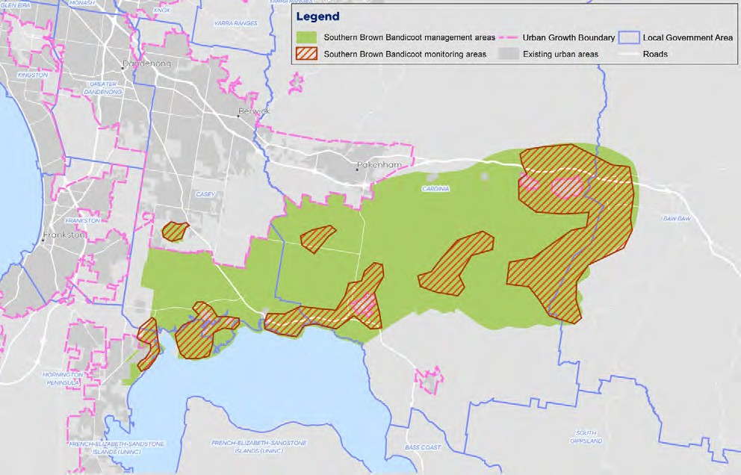
Figure 31: Map of Southern Brown Bandicoot management area Source: DELWP

Results

KPI 1: Proportion of monitored sites that are occupied

KPI 1: Proportion of monitoring sites that are occupied | Status 2020-2022 | Reason for non-assessment | Trend | Data Confidence | Year that baseline was/will be set
Southern Brown Bandicoot Management Area | Not assessed | Not monitored in 2020–2022 |  | N/A | 2019

The baseline for Southern Brown Bandicoot was calculated from the first survey, using the model to estimate occupancy from the data. The best supported model had occupancy dependent on habitat type and detection dependent on survey month.
There was no evidence that this model fitted poorly. The baseline for Southern Brown Bandicoot therefore varies by habitat type; canal 76%, reserve 39% and road 35% of sites occupied (Figure 32). The KPI will be assessed against these baselines in subsequent five-yearly surveys, with the next due in 2024. Bandicoot detections were spread out across the management area, with notable areas of non-detection in the south-western and north-eastern (north of the Princes Highway) corners of the management area.

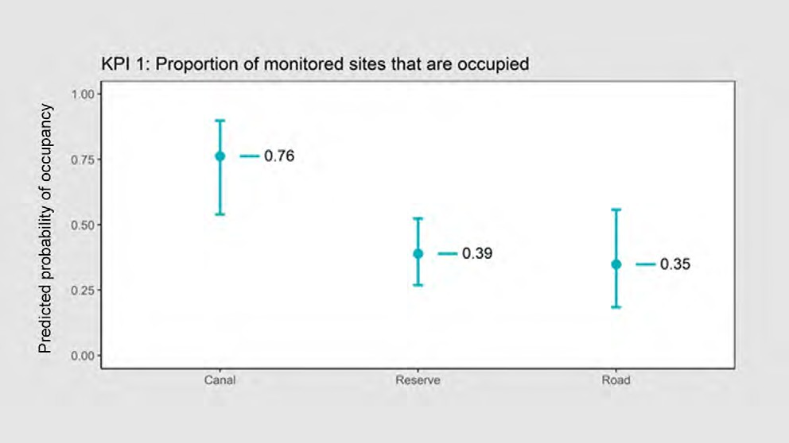
Figure 32: The modelled proportion of sites occupied by Southern Brown Bandicoot and the detection probability for Southern Brown Bandicoot. Error bars are 95% confidence intervals. The horizontal lines show the baseline for each habitat type Source: DELWP

Results interpretation

Occupancy results for Southern Brown Bandicoot vary by habitat type, with 76% of sites predicted to be occupied at the canal, 39% within the reserve and 35% of sites along the road.

Bandicoot detections were spread out across the management area, with notable areas of non-detection in the south-western and north-eastern (north of the Princes Highway) corners of the management area.
Detection probability appears to be influenced by survey month, being lower during February compared with the other months. Nevertheless, DELWP has demonstrated that 26 days was more than sufficient to achieve a cumulative detection probability (the probability of detection of at least one individual given the site is occupied) of over 0.99, which was achieved after 20 days for all deployment periods.
Data was not obtained from two (out of 100) sites due to a fire. These two sites will be monitored in subsequent years. Currently no information on population trends is available, as the next round of monitoring contributing to an assessment of the KPI will occur in 2023.

Key insights and management implications
Southern Brown Bandicoot is monitored every five years at permanently referenced sites, while every other MNES under the MSA program MRF is monitored annually. DELWP has indicated that the Southern Brown Bandicoot is expensive and difficult to monitor (the camera-based design is the most cost-effective) and currently Southern Brown Bandicoot doesn't have as much funding as the other species.211 DELWP has indicated that five-yearly monitoring intervals were selected as a balance between the ability to detect change and the cost of undertaking monitoring.212 However, annual monitoring may be necessary to capture population trends given the species’ short generation time.213
DELWP’s MSA program is limited in its ability to directly influence management of the Southern Brown Bandicoot, as the reserve system spans across multiple land tenures, and its habitat only covers a small area within the UGB. However, early PVA modelling suggested management across the landscape to optimise outcomes for the species. Currently, no new reserves are being created for the Southern Brown Bandicoot but work is being undertaken to create habitat corridors to support the species. The success of this work relies on populations in existing reserve areas moving to establish new populations.214
It is apparent that a contraction of the Southern Brown Bandicoot’s range has occurred over time. Southern Brown Bandicoot used to be found in Langwarrin flora and fauna reserve but is now no longer detected here. Southern Brown Bandicoot was also surveyed both west and south of the modelled habitat extent, on the Mornington Peninsula down around Bass Strait and in the reserve in Mount Martha – but were not found. This makes the MSA area locally important. Experts are not sure why this range contraction has occurred, although they speculate that it is likely due to a combination of habitat loss and predation. There exist some captive breeding programs for the Southern Brown Bandicoot, so it may be possible to analyse
the existing population’s genetics and undertake experimental reintroductions of individuals to bolster the genetic health of the population. However, experts warn that due to the landscape being largely unregulated, this approach would risk a high rate of failure due to predation, and some smaller scale reintroductions have made little difference to overall population numbers.215 DELWP is reassured that where it does find the Southern Brown Bandicoot at sites within the current extent, it is generally detecting relatively high levels of occupancy which would indicate adequate carrying capacity for the species.216

- DELWP Officer, personal communication, 15 July 2021.
- DELWP Officer, personal communication, 15 July 2021.
- DELWP Officer, personal communication, 29 February 2022.
- DELWP Officer, personal communication, 15 July 2021.
- DELWP Officer, personal communication, 15 July 2021.
- DELWP Officer, personal communication, 29 February 2022.

Southern Brown Bandicoot occupancy appears to vary by site, which suggests that they may have distinct habitat preferences relating to various pressures in the local environment. DELWP speculates that Southern Brown Bandicoots prefer the artificial canal sites as the high vegetation cover in these areas offers protection from foxes and the wet environment promotes insects and fungi, which they eat. Roadsides and bushland in the reserves are speculated to have, by comparison, less cover, and therefore the Southern Brown Bandicoot is potentially more vulnerable to predation by foxes in these areas.217 Further insights into occupancy trends may inform sensitive management designs that address habitat preferences and species responses to management regimes (including planned burning, predator control and weed control), noting the importance of the artificial environment.
Other data of relevance to Southern Brown Bandicoot occupancy relates to fox occupancy, with DELWP suggesting that they are everywhere within the Southern Brown Bandicoot’s range.218 Foxes pose the biggest threat to the bandicoot where habitat destruction isn't present. Bandicoots appear to persist in the presence of foxes if there is enough cover. In previous years, DELWP has found an overlap of foxes and bandicoots at 30% of sites – and expert elicitation data fed into PVA modelling suggests the best action to support bandicoots is landscape-scale fox baiting. No landscape fox baiting is currently applied to control for levels of predation impacting on Southern Brown Bandicoot. Other measures to explore include the extent of native vegetation, fire and planned burning.219
Western Port Biosphere, many academic institutes and community groups are currently collecting data for the Southern Brown Bandicoot. These other data sources external to the MSA may be useful for understanding explanatory trends around landscape- level occupancy. It is possible that the current Southern Brown Bandicoot may leverage citizen science capabilities to obtain more data informing a more complete picture of the population dynamics of the Southern Brown Bandicoot with increasing urbanisation. DELWP may assist in setting the standard for monitoring, through providing information on appropriate methods or tools. A protocol may be designed outlining the minimum requirement to meet the KPI objective for the data
to be included in the broader analyses.

- Bryant, David, et al. 2018 "The occurrence of the Southern Brown Bandicoot Isoodon obesulus obesulus and its habitat on Chinaman Island, Western Port, Victoria." The Victorian Naturalist, vol. 135, no. 5, pp. 128.
- DELWP Officer, personal communication, 29 February 2022.
- DELWP Officer, personal communication, 29 February 2022.

MNES 8: Growling Grass Frog

Background

Growling Grass Frog (Litoria raniformis) is a large, semi-aquatic member of the bell frog group.220 It was formerly distributed widely across lowland south-eastern Australia, including in most regions of Victoria (excluding the Mallee and alpine regions).221
EPBC listing status: Vulnerable
Figure 33: Growling Grass Frog Source: DELWP

DELWP’s conservation commitment
DELWP published the following statements as conservation outcomes for the Growling Grass Frog by notice in the Victorian Government Gazette:
‘Functioning and sustainable populations of Growling Grass Frog within and adjacent to the UGB with connectivity between populations. Sustainable populations is defined as a reduction in extinction risk to low (using DELWP’s Growling Grass Frog Masterplan model).’
‘Protection and enhancement of important populations of Growling Grass Frog, as identified in the BCS and the Conservation Areas Declaration under section 11 of the MSA Act.’

- Barker J, Grigg G and Tyler MJ 1995, ‘A Field Guide to Australian Frogs.’ Surrey Beatty, Chipping Norton, NSW.
- Heard GW, McCarthy MA, Scroggie MP, Baumgartner JB and Parris KM 2013, ‘A Bayesian model of metapopulation viability, with application to an endangered amphibian.’ Diversity and Distribution. 19, 555–566.

DELWP’s MSA MRF also summarises the conservation outcomes for the Growling Grass Frog as a single goal statement: ‘Growling Grass Frog persists within the MSA area.’

KPIs assessed
Progress towards this goal is measured using a single KPI:
1. Projected risk of extinction for each Conservation Area, estimated using a stochastic patch-occupancy model for Growling Grass Frog metapopulations.

MNES | 8. Growling Grass Frog
Commonwealth approved 2015 MSA MRF single outcome statement | Growling Grass Frog persists.
2014–2020 Ecological Outcomes Report single outcome statement | Growling Grass Frog persists.
Conservation Outcomes published in the Victorian Government Gazette – Issue G4, 27 January 2022 | Functioning and sustainable Growling Grass Frog populations within the UGB with connectivity between populations. Sustainable populations means that there is a reduction in extinction risk to low in the long-term (using the modelling that supports DELWP’s Growling Grass Frog masterplan).  The protection and enhancement of important Growling Grass Frog populations in the conservation areas identified in the BCS and the Conservation Areas Declaration.

Monitored areas
Growling Grass Frog is known from several locations in the MSA area. Most of these areas are yet to be protected and monitoring commenced in 2021, outside the audit’s data acquisition period. These data sets will be included in future reports. Other projects have monitored some MSA populations in the past and that data is available to augment future MSA data.

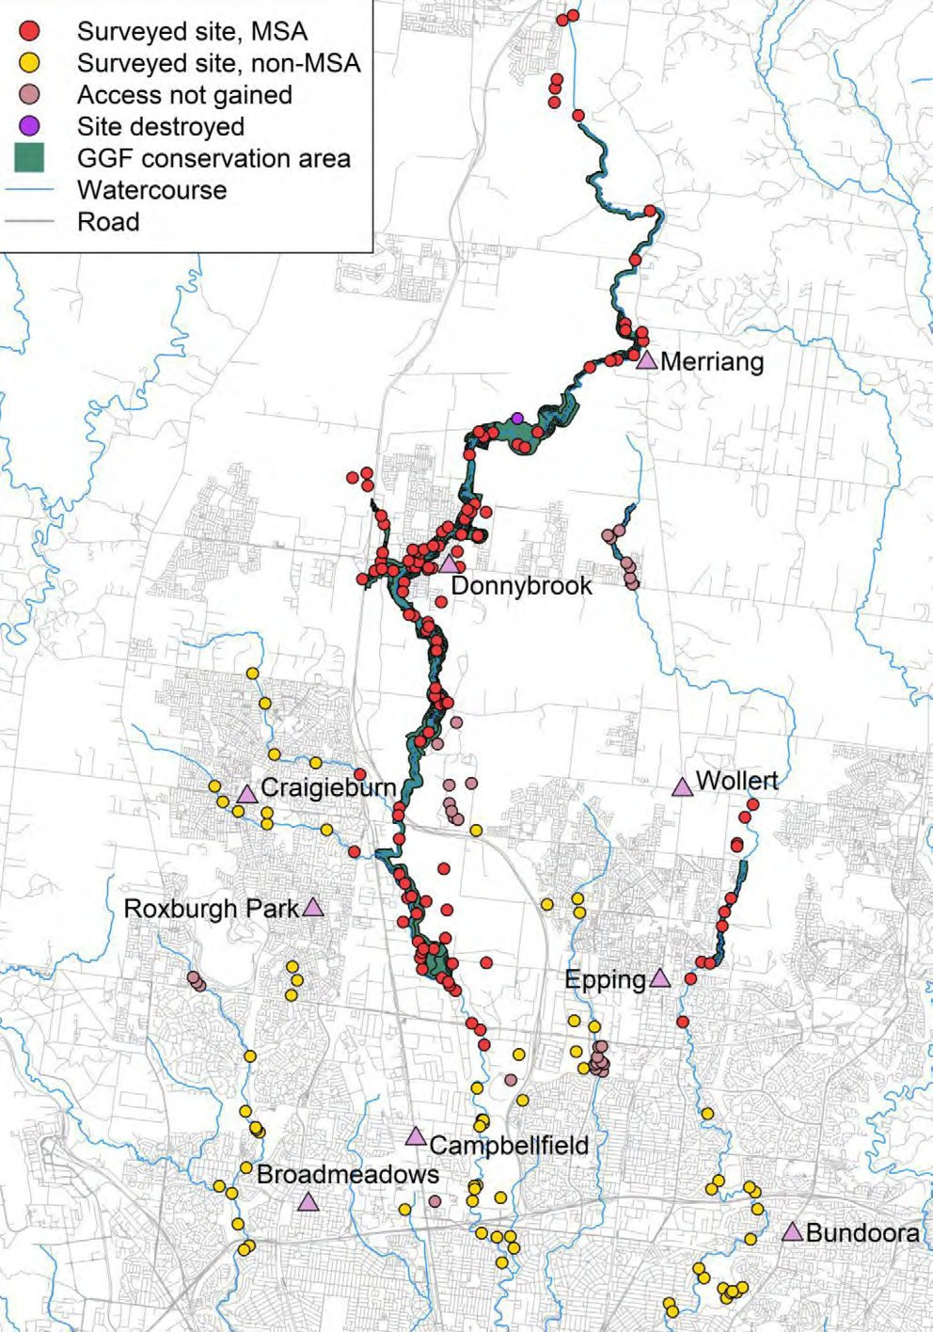
Figure 34: Known Growling Grass Frog areas under MSA management Source: DELWP

Results
Monitoring commenced in 2022 outside of the audit’s data acquisition period; as such there are no results to report at present. These data sets will be included in future reports.

KPI 1: Modelled stochastic patch-occupancy estimate of extinction risk

KPI 1: Modelled stochastic patch- occupancy estimate of extinction risk | Status 2020-2022 | Reason for non-assessment | Trend | Data Confidence | Year that baseline was/will be set
All locations | Not assessed | Not monitored in 2020–2022 |  | N/A | 2022

Key insights and management implications
The Growling Grass Frog was federally listed largely due to loss of habitat from development.222 Other reasons included widespread historic declines unrelated to urban development, likely as a consequence of chytrid fungus epidemics.223 There has been a focus on retention of habitat along stream drainage lines in MSA zones; developers pay compensation for loss of habitat and these funds are redirected into retention and creation of new habitats along the corridors. DELWP has created a decision tool for working out where best to intervene and determine the allocation of resources in the construction of new wetlands.
A long-standing Growling Grass Frog research project around the Merri Creek corridor has been undertaking monitoring for over 20 years. DELWP indicates it is well placed to keep monitoring and understanding what's happening here over time224 – which will inform a broader understanding of the species’ responses.
To date no new sites have been monitored, so the baseline state of the system is set by data from the Merri Creek catchment. Interim sampling in the MSA wetlands has been occurring. Currently, there is no established baseline for the new wetlands; the first round of monitoring in 2022 will be setting this baseline on a site-by-site basis.
There remains a need to monitor outcomes for the species against a tangible management goal. Uncertainty exists around the efficacy of current and proposed management, and previous artificial wetland designs have failed to support the species.225

- Department of the Environment 2022, ‘Litoria raniformis in Species Profile and Threats Database’, Department of the Environment, Canberra, https://www.environment.gov.au/sprat Accessed 8 September 2021.
- DELWP Officer, internal document, supplied 16 June 2022.
- DELWP Officer, personal communication, 29 July 2021.
- DELWP Officer, personal communication, 29 July 2021.

Interpretation of the conservation outcomes for the Growling Grass Frog remains a challenge. There are two main things DELWP is using to assist with interpretation:
- PVA models to estimate frog extinction risks under different urban development scenarios. The PVA model was built on long-term stochastic patch occupancy models (SPOM), based on existing Merri Creek data. This will be an important plank, and DELWP will continue to build and update those models to enable future planning for the species. DELWP indicates that the models will need a lot of refinement, especially given that the creation of artificial wetlands (as well as urban development) is fundamentally changing the system through radical hydrology
and water quality changes.226 Ecological processes in an urban metapopulation are different to those in a rural one; the rules and parameters that govern extinction risk in the semi-rural landscape will need to change as landscapes are urbanised. DELWP has some initial ideas for this measure but hasn’t fully quantified this yet. DELWP indicates that direct reporting on outcomes would be superior to reporting on modelled predictions.227 Most of the data on which the model relies is based on rural or semi-urbanised systems.
- Measures of wetland occupancy i.e. the number of wetlands that have frogs in them. Reporting on the number of occupied wetlands is the useful and cost-effective approach to monitoring this species.228 DELWP indicates using direct measures
of wetland occupancy to report on outcomes would be superior to reporting on modelled predictions.229 Most of the data on which the model relies is based on rural or semi-urbanised systems. As ecological processes in an urban metapopulation are different to those in a rural one, the model’s rules and parameters will need to change as the catchment is urbanised, according to DELWP.230
The current KPI doesn’t rely on the actual status of frog populations – it is instead based on the modelled risk of extinction. There are some shortcomings to this method, because if the model incorrectly determines that risk is low then the outcome is met even if the population is in reality declining/extinct.231 There is an outstanding need to establish baseline monitoring for new corridors, with DELWP commencing this work in 2022 (outside this report’s data acquisition period).
Formal monitoring is being undertaken by professional ecologists and supplemented with data collected in citizen science programs and using frog monitoring apps. This extra effort to monitor sites will not only help with data acquisition, but will assist in finding new sites, and may fill in some of the temporal gaps to improve the volume and quality of data. DELWP wishes to direct people's enthusiasm and effort to the MSA area.232 Uncertainty is reduced through data collection via citizen science – both the master plan and citizen science are funded by MSA partly, but also linked into the Victorian Nature Festival.
Other variables that may be assessed to explain the changes over time include water quality, salinity, temperature and vegetation structure. It is expected that these will change over time as urbanisation occurs.233

- DELWP Officer, personal communication, 29 July 2021.
- DELWP Officer, personal communication, 29 July 2021.
- DELWP Officer, personal communication, 29 July 2021.
- DELWP Officer, internal document, supplied 16 June 2022.
- DELWP Officer, internal document, supplied 16 June 2022.
- DELWP Officer, internal document, supplied 16 June 2022.
- DELWP Officer, personal communication, 29 July 2021.
- DELWP Officer, personal communication, 29 July 2021.

Many of the streams within the MSA Growling Grass Frog catchment are strongly seasonal, with the frogs using the artificial areas (non-naturally occurring water bodies and dams) as breeding sites. Off-stream habitat also exists around the catchments. Flash floods in catchments – which disrupts the ability of frogs to use instream habitat – will disrupt water quality due to run-off from roads and changes in salinity are expected because of this. To some extent these are fed by groundwater, raising the salinity slightly – and it is known this is good for reducing chytrid fungus (a major threat to the species).234 A recharge of aquifers is expected to go down
over time, resulting in salinity going down over time, impacting on the fungus.235
Groundwater feed may not be able to be relied on in future. Inputs of pollutants
of various kinds will contribute to declines in habitat quality, as will the introduction of new exotic species, notably predatory fish.236 Current and past research has identified many of these risks and how to mitigate them in practice.237,238
DELWP describes its management approach as effectively trying to design artificial habitats in urban environments to functionally substitute for natural habitats over the long term.239 Pressures of urbanisation are expected to impact Growling Grass Frog and it is anticipated that these will likely get worse for the species, however experts are unclear to what extent. Some mitigations (applied at both the wetland design and management phases) are in place, but how successful these will be is also currently unclear. As such, there is uncertainty around what the impacts will be. Efforts should be prioritised to address uncertainty around management and potential threats to the Growling Grass Frog with increasing urbanisation to pre-emptively address the potential for population decline.
There currently exist no thresholds of impact for Growling Grass Frog occupancy to define success or failure for this species under MSA management. With Growling Grass Frog, there is a view among some experts that indicators are likely to go down; that the number of occupied sites will go down even if management interventions are applied. DELWP is wanting to focus on understanding how interventions will impact on the system but has doubts around whether management options exist to
prevent declines.240 DELWP indicates it is well placed to collect data to inform an understanding of the cause of likely declines – however, it is more pessimistic about whether it will have the management tools to intervene if declines are realised.241 Much of these corridors remains in private hands, making it challenging for DELWP to intervene. Further, there are competing land uses in these corridors, therefore limiting DELWP’s capacity to implement broader level catchment management.

- Lips, Karen & Brem, Forrest & Brenes, Roberto & Reeve, John & Alford, Ross & Voyles, Jamie & Carey, Cynthia & Livo, Lauren & Pessier, Allan & Collins, James, 2006. ‘From The Cover: Emerging infectious disease and the loss of biodiversity in a Neotropical amphibian community.’ Proceedings of the National Academy of Sciences of the United States of America. 103. 3165-70.
- DELWP Officer, personal communication, 29 July 2021.
- DELWP Officer, personal communication, 29 July 2021.
- Heard GW, Scroggie MP, Clemann N, Ramsey DS, 2014. ‘Wetland characteristics influence disease risk for a threatened amphibian.’ Ecol Appl; 24(4):650-62.
- Heard GW, Thomas CD, Hodgson JA, Scroggie MP, Ramsey DSL, Clemann N, 2015. ‘Refugia and connectivity sustain amphibian metapopulations afflicted by disease.’ Ecology Letters; 18(8): 853-863.
- DELWP Officer, personal communication, 29 July 2021.
- DELWP Officer, personal communication, 29 July 2021.
- DELWP Officer, personal communication, 29 July 2021.

MNES 9: Small Golden Moths Orchid

Background

Small Golden Moths Orchid (Diuris basaltica) is a perennial orchid growing to 15 cm tall, with a single stem supporting one or two small yellow flowers. It retreats to an underground tuber each year in summer and at other times when conditions are unfavourable. It is endemic to the Keilor and Werribee Plains.242
EPBC listing status: Endangered
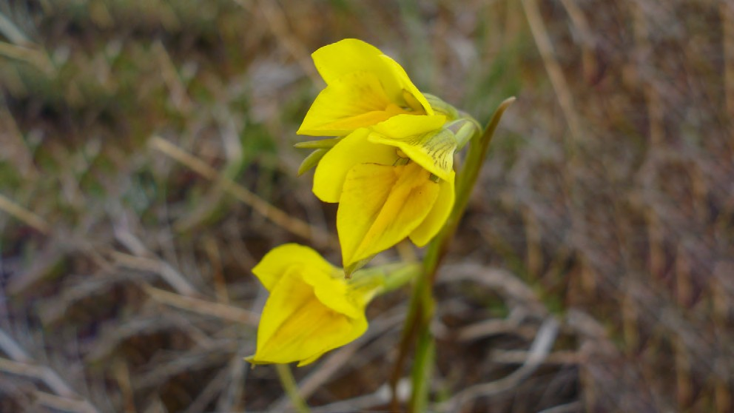
Figure 35: Small Golden Moths Orchid Source: DELWP

DELWP’s conservation commitment
DELWP published the following statements as conservation outcomes for the Small Golden Moths Orchid by notice in the Victorian Government Gazette:
No substantial negative change to the known population of Small Golden Moths Orchid within the UGB in conservation area 3. No substantial negative change means that the count of individuals emergent at least once over a five-year period remains above 90% of the baseline.

DELWP’s MSA MRF also summarises the conservation outcomes for the Small Golden Moths Orchid as a single goal statement: ‘no substantial negative change to the population of Small Golden Moths Orchid.’

- Barker J, Grigg G and Tyler MJ 1995, ‘A Field Guide to Australian Frogs.’ Surrey Beatty, Chipping Norton, NSW.

KPIs assessed
Progress towards this goal is measured using a single KPI:
1. Count of individuals emergent at least once over a five-year period.

MNES | 9. Small Golden Moths Orchid
Commonwealth approved 2015 MSA MRF single outcome statement | No substantial negative change to populations of Small Golden Moths Orchid.
2014–2020 Ecological Outcomes Report single outcome statement | No substantial negative change to Small Golden Moths Orchid.
Conservation Outcomes published in the Victorian Government Gazette – Issue G4, 27 January 2022 | No substantial negative change to the known population of Small Golden Moths Orchid within the UGB in conservation area 3. No substantial negative change means that the count of individuals emergent at least once over a five-year period remains above 90% of the baseline.

Monitored areas
The Small Golden Moths Orchid is known from only one location in the MSA area, in Conservation Area 3. This area has not yet been protected and no monitoring has occurred. The species is not dealt with further here.
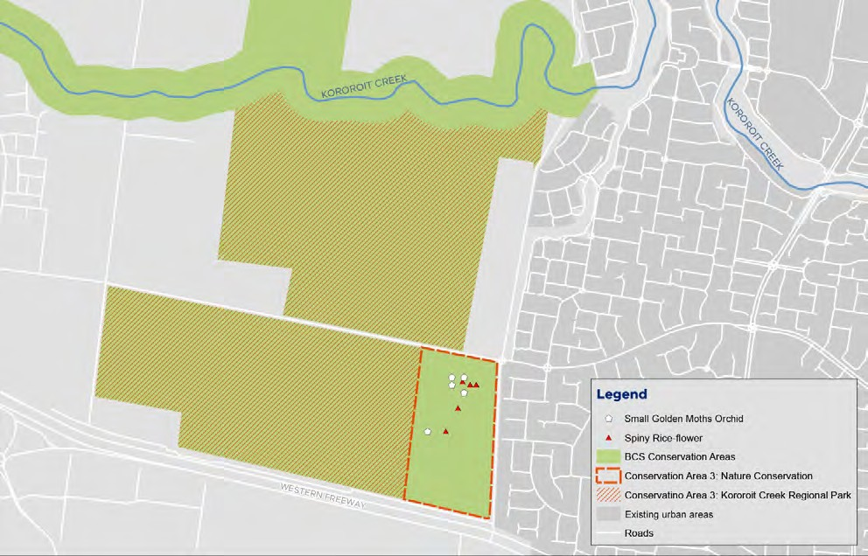
Figure 36: Map of Conservation Area 3 Source: DELWP

Results
As areas have yet to be protected, monitoring has not commenced on this species, therefore results are unable to be assessed.

KPI 1: Count of individuals emergent at least once over a five-year period | Status 2020–2022 | Reason for non-assessment | Trend | Data Confidence | Year that baseline was/will be set
Conservation Area 3 | Not assessed | Population not yet under MSA management |  | N/A | Unclear

Results interpretation
As results are currently unable to be assessed, an interpretation of results is not provided here.

Key insights and management implications
It is unclear if and how well the species is persisting. The MSA program has been unable to secure the area containing the remnant grassland habitat of Small Golden Moths Orchid and currently no interim management is being undertaken.243

As this is the last known population of the Small Golden Moths Orchid,244 with the species having undergone a ‘catastrophic reduction in range and distribution’ in recent years,245 the species is considered extremely vulnerable to threats. Because of this, pressures such as subtle changes in biomass and rabbits may be problematic for the species.
Urgent action is required to understand potential threats to the population of the Small Golden Moths Orchid to halt potential species decline and extinction.

- DELWP Officer, personal communication, 15 February 2022.
- DELWP Officer, personal communication, 15 February 2022.
- Backhouse, G; Lester, K 2010. "National Recovery Plan for the Small Golden Moths Orchid Diuris basaltica" (PDF). Australian Government Department of the Environment. Accessed 5 March 2022.

MNES 10: Striped Legless Lizard

Background

Striped Legless Lizard (Delma impar) is a flap-footed lizard lacking forelimbs and with its hind limbs reduced to small flaps.246 The species is found in the ACT, Victoria, New South Wales and South Australia. The Victorian range has contracted south, with significant populations in the western suburbs of Melbourne.247
EPBC listing status: Vulnerable
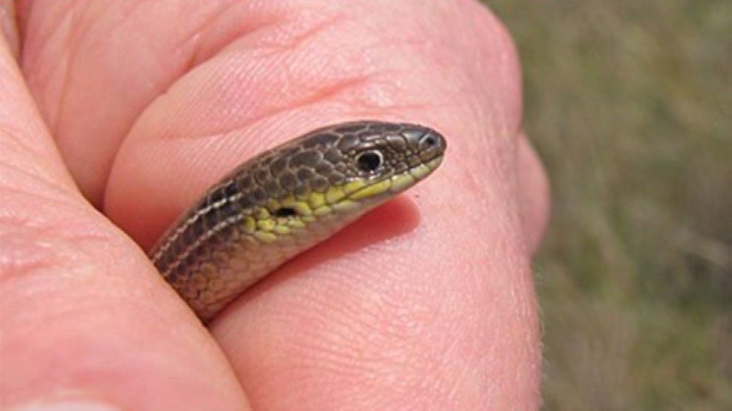
Figure 37: Striped Legless Lizard within the Western Grassland Reserve Source: DELWP

DELWP’s conservation commitment
DELWP published the following statements as conservation outcomes for the Striped Legless Lizard by notice in the Victorian Government Gazette:
No substantial negative change to the known population of Small Golden Moths Orchid within the UGB in conservation area 3. No substantial negative change means that the count of individuals emergent at least once over a five-year period remains above 90% of the baseline.

DELWP’s MSA MRF also summarises the conservation outcomes for the Striped Legless Lizard as a single goal statement: ‘the Striped Legless Lizard persists.’

- Wilson SK and Swan G 2010, ‘A Complete Guide to the Reptiles of Australia.’ New Holland Publishers (Australia) Pty Ltd, Chatswood.
- O'Shea MB 2005, ‘Methods for Assessment and Techniques for Management of Striped Legless Lizard Delma impar Populations in South- eastern Australia.’ Ph.D. thesis, Victoria University, St. Albans, Victoria.

KPIs assessed
Progress towards this goal is measured using a single KPI:
1. Evidence of Striped Legless Lizard is detected at least once in every five-year period at 100% of permanent monitoring plots (i.e. plots which have previously yielded detections).
There is no baseline for this KPI.

MNES | 10. Striped Legless Lizard
Commonwealth approved 2015 MSA MRF single outcome statement | Striped Legless Lizard persists.
2014–2020 Ecological Outcomes Report single outcome statement | Striped Legless Lizard persists.
Conservation Outcomes published in the Victorian Government Gazette – Issue G4, 27 January 2022 | Striped Legless Lizard populations are sustained in the long-term across the known distribution of this species in the Western Grassland Reserve and the conservation areas identified in the BCS and the Conservation Areas Declaration. Sustained means that evidence of Striped Legless Lizard is detected once in every five-year period at each of the permanent monitoring plots.

Monitored areas
The KPI for Striped Legless Lizard relates to the Western Grassland Reserve and Truganina South NCR. Currently two permanent monitoring locations have been established, at Mount Cottrell NCR.
The population at Truganina South NCR was not monitored in 2018; the decision to make this a permanent location was made in 2019.
No populations were monitored in 2020 due to COVID-19 restrictions.
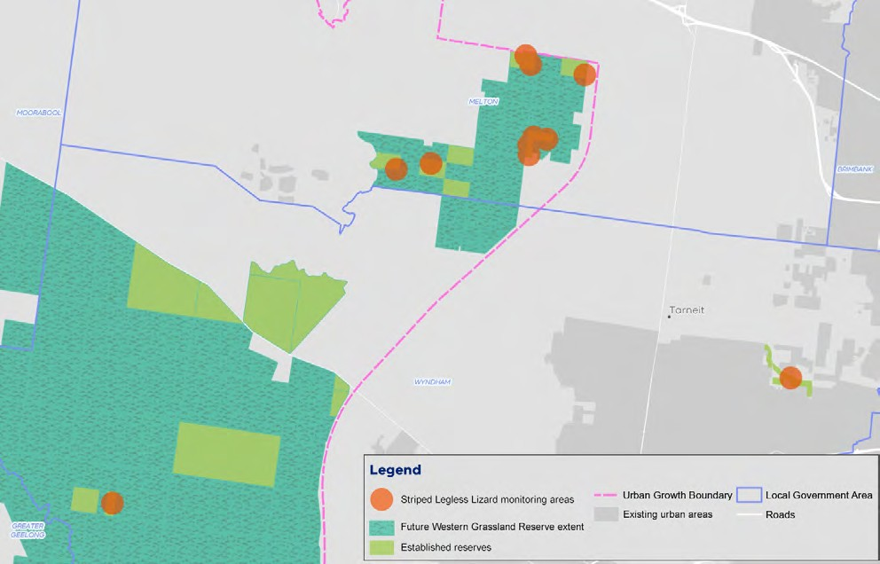
Figure 38: Map of monitored areas for Striped Legless Lizard Source: DELWP

Results

KPI 1: Proportion of monitoring sites that are occupied

KPI 1: Proportion of monitoring sites that are occupied | Status 2020–2022 | Reason for non-assessment | Trend | Data Confidence | Year that baseline was/will be set
Mount Cottrell NCR | Met | Change in monitoring method |  | Low | N/A
Truganina South NCR | Met | Change in monitoring method |  | Low | N/A
Werribee River easement | Met | Change in monitoring method |  | Low | N/A
All other locations | Met | Change in monitoring method |  | Low | N/A

Striped Legless Lizard has been detected in all survey years after the establishment of the permanent plot in 2017 on Mount Cottrell NCR. At Truganina South NCR, Striped Legless Lizard was detected in 2019. This KPI has been met for the first five years at both locations (Table 4). At the other locations the assessment of the KPI began in 2021.

Table 4: Detections of Striped Legless Lizard at permanent monitoring plots (phase 3) by year Source: DELWP

Location | 2016 | 2017 | 2018 | 2019 | 2020 | 2021
Mount Cottrell NCR | Yes* | Yes | Yes | Yes | N/A | Yes
Truganina South NCR | N/A | Yes* | N/A^ | Yes | N/A | Yes
Basalt | N/A | N/A | N/A | Yes* | N/A | Yes
Werribee River easement | N/A | N/A | N/A | Yes* | N/A | No
Little Pony | N/A | N/A | N/A | Yes* | N/A | Yes
Caboose 1 | N/A | N/A | N/A | Yes* | N/A | Yes
Caboose 2 | N/A | N/A | N/A | Yes* | N/A | Yes
Olive 1 | N/A | N/A | N/A | Yes* | N/A | Yes
Olive 2 | N/A | N/A | N/A | Yes* | N/A | Yes
Radio 1 | N/A | N/A | N/A | Yes* | N/A | Yes
Radio 2 | N/A | N/A | N/A | Yes* | N/A | Yes
*Indicates first year of detection as part of phase 1 or 2 survey. ^The decision to include Truganina South NCR as part of monitoring was taken in 2019, therefore surveys for were not conducted as per the MRF in 2018. Note monitoring did not occur in 2020 due to COVID-19 restrictions.

Results interpretation
Striped Legless Lizard was detected in 2021 at all permanent monitoring plots except at the Werribee River easement (it was last detected here in 2019).
In 2021, 10 new locations were searched specifically for Striped Legless Lizard. No lizards were detected at these locations and, as such, they will not become permanent plots.
Recent new detections have been predominantly in the northern section of the Western Grassland Reserve.

Key insights and management implications
It is possible that the current KPI design for the Striped Legless Lizard is limited in its ability to reveal important information on species occupancy capturing the full
geographic extent of the population, in part due to the non-random re-sampling design and fixed number of monitoring sites. Monitoring is also limited in the design of the KPI without comparison to a baseline such that trends may be clearly assessed. A change in design of the monitoring protocol to increase the number of sites monitored with random sampling may reveal trends in occupancy over time. Previous years’ data on detectability may inform the number of sites required to meaningfully detect change.
The Striped Legless Lizard is cryptic – initial MSA monitoring efforts struggled to consistently find the species and it remained unclear for some time exactly where search efforts should be located.248
Historically, the MSA program hasn’t had enough acquired reserve to establish permanent monitoring plots for this species.
The species was thought to have a high probability of non-detection.249 A relationship with time of survey (temperature-dependent) and rates of detectability has been previously observed.
Current methods include an inventory search for Striped Legless Lizard at known sites, followed with a more intense search and establishment of monitoring points at locations where individuals are found.
Detections do not equal abundance; data is recorded on the number of detections at each location and multiple detections may constitute one or several individuals.
Monitoring is undertaken under conditions that are presumed to provide the highest probability of detection, however, there remains the possibility that detections are affected by seasonal climatic conditions, e.g. rainfall or events such as fire. It may be possible to revisit the assumptions around detectability once more data is obtained.250
Overall, the species is viewed as increasingly more common and widespread than was thought at the beginning of the program.251 However, habitat preferences for the species remain unclear. Some monitored sites in poorer condition have higher rates of detection, with other larger sites (assumed more suitable habitat) having much lower rates of detection. Further research is required to better understand the Striped Legless Lizard’s habitat preferences to inform appropriate and targeted management.

- DELWP Officer, personal communication, 14 July 2021.
- DELWP Officer, personal communication, 14 July 2021.
- DELWP Officer, personal communication, 14 July 2021.
- DELWP Officer, personal communication, 14 July 2021.

MNES 11: Button Wrinklewort

Background

Button Wrinklewort (Rutidosis leptorhynchoides) is a small perennial daisy that produces multiple flowering stems with yellow flower heads. It occurs in grasslands and grassy woodlands, in areas free from intense competition from other plants. It is distributed across south-western Victoria, around Melbourne and in the Canberra region.252
EPBC listing status: Endangered
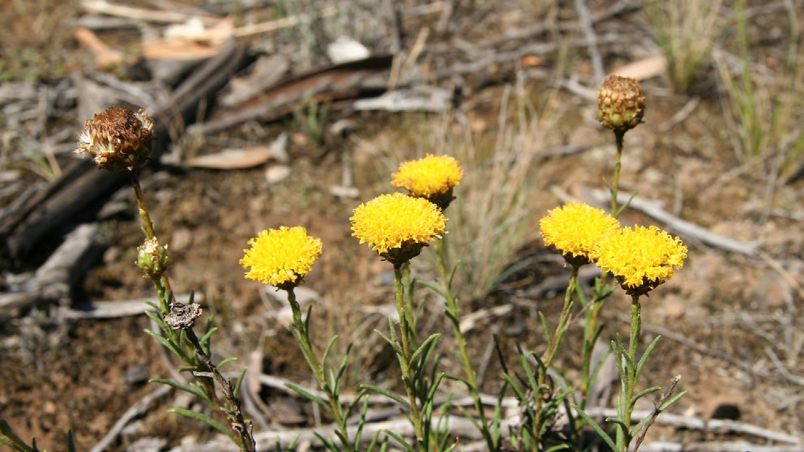
Figure 39: Button Wrinklewort Source: DELWP

DELWP’s conservation commitment
DELWP published the following statements as conservation outcome for the Button Wrinklewort by notice in the Victorian Government Gazette:
‘No substantial negative change to the known population of Button Wrinklewort within the UGB in conservation area 10. No substantial negative change means that the count of individuals emergent at least once over a five-year period remains above 90% of the baseline.’

DELWP’s MSA MRF also summarises the conservation outcome for the Button Wrinklewort as a single goal statement: ‘no substantial negative change to the population of Button Wrinklewort within the MSA program area’.

- Office of Environment and Heritage NSW (OEH) 2012, ‘National Recovery Plan for Button Wrinklewort Rutidosis leptorrhynchoides,’ Hurstville, NSW.

KPIs assessed
DELWP measures progress towards this goal using a single KPI:
1. The five-year mean population count must remain above a baseline set by the first five years of counts.
The baseline for this species is the mean population count over the first five years of monitoring. This was set in 2019, at 617. Given this KPI is assessed using a total
population count, no uncertainty is quantified, meaning that the actual count in every year must remain above the baseline for the target to be met (not the 95% CI as with many other KPIs).
This KPI will be assessed using a continuous improvement approach, where any increase over the baseline in a five-year reporting period will lead to the calculation of a new baseline for subsequent reporting periods.

MNES | 11. Button Wrinklewort
Commonwealth approved 2015 MSA MRF single outcome statement | No substantial negative change to populations of Button Wrinklewort.
2014–2020 Ecological Outcomes Report single outcome statement | No substantial negative change to populations of Button Wrinklewort.
Conservation Outcomes published in the Victorian Government Gazette – Issue G4, 27 January 2022 | No substantial negative change to the known population of Button Wrinklewort within the UGB in conservation area 10. No substantial negative change means that the count of individuals emergent at least once over a five-year period remains above 90% of the baseline.

Monitored areas
Button Wrinklewort occurs naturally at only one location within the MSA area, the Truganina Cemetery Grassland (Conservation Area 10). Here, the entire population is contained within an area measuring 90 x 70 m. This site has been monitored under the MSA since 2015, however no monitoring took place in 2020 due to COVID-19 restrictions.
Button Wrinklewort has also been planted at two further locations, in 2020. These are currently being monitored and – in line with the MRF – will be assessed for their contribution to the KPI when they have survived five years.

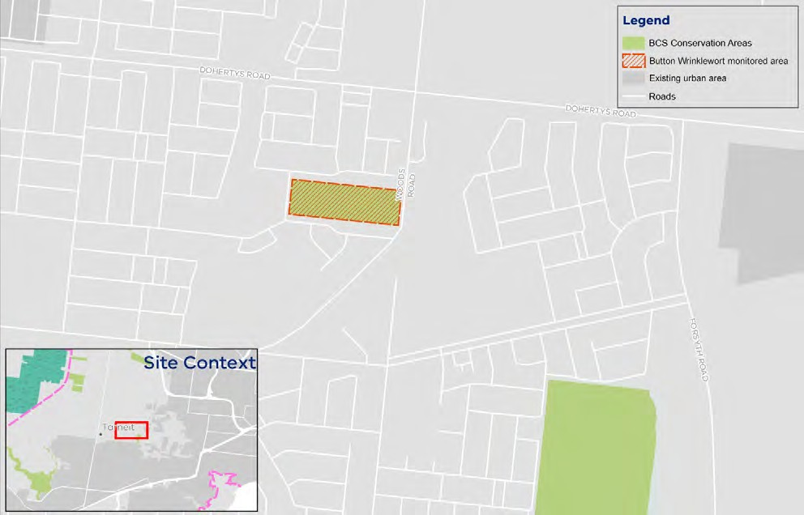
Figure 40: Map of monitored areas for Button Wrinklewort Source: DELWP

Results: KPI

KPI 1: Population count

KPI 1: Population count | Status 2020–2022 | Reason for non-assessment | Trend | Data Confidence | Year that baseline was/will be set
Truganina Cemetery | Not met | N/A |  | Moderate | 2019

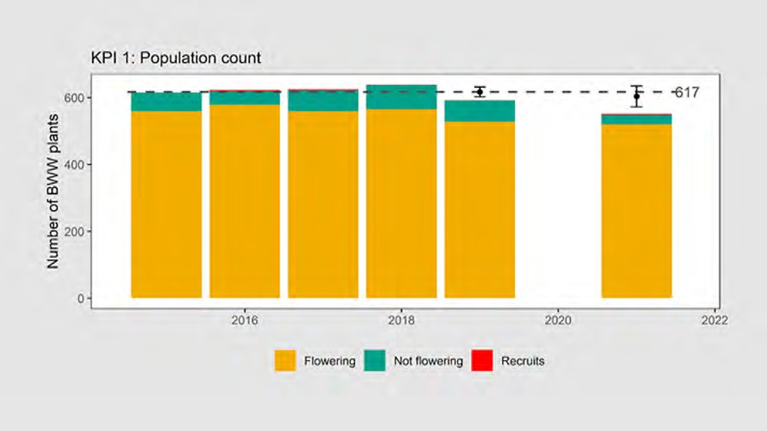
Figure 41: Population count of Button Wrinklewort at Truganina Cemetery, 2015–2021. The dashed line shows the baseline calculated after the first five years of monitoring (n=617). Source: DELWP

Results interpretation
Results indicate that MSA population of Button Winklewort is slowly declining, largely due to the failure of new recruits to survive their first year and replace plants that are dying.253 DELWP does not know why recruitment is failing.
Button Wrinklewort was monitored at Truganina Cemetery by La Trobe University from 2004 until 2012, providing a valuable longer-term context for the data reported here.254 These data revealed a population that declined from 1,072 plants in 2004 to 472 plants in 2012. The number of Button Wrinklewort plants recorded at Truganina Cemetery increased very slightly from 2015 to 2018 (from 591 to 638) but declined to 593 in 2019. In each year, most plants have been reproductive (between 89% and 93%). Very few recruits have been recorded in any year (between zero and four individuals, with only nine across all years). DELWP has highlighted that the decline from over 600 plants (measured between 2015 and 2018) down to 548 plants in 2021 represents a real decline – and is not primarily an issue of detectability or sampling error.255 This knowledge is based on the frequent recording of dead plants at locations where they have previously been recorded alive.
Based on the location of dead plants, DELWP has identified two observed sources of mortality between 2018 and 2021:256
- direct mortality from an ecological burn implemented in early 2019. Fires are considered necessary for grassland management. DELWP has stated that some mortality from fire is normal, expected and acceptable in a population and does not necessarily imply that a given fire was inappropriate or badly implemented.
- direct mortality caused by rabbits undermining and killing plants. Rabbit numbers are not currently monitored in Truganina Cemetery, however anecdotal observations of their droppings and diggings suggest a substantial increase in numbers since 2019. DELWP hypothesises this may be due to construction works forcing rabbits to occupy the cemetery, although this idea remains untested.
It is difficult to attribute each plant death to either fire or rabbits with the available information, so DELWP is unable to quantify the relative magnitudes of these effects.257 There are likely to be other sources of mortality, such as trampling, drought stress, competition from grass, or senescence from old age (likely due to a build-up of old stem bases weakening the base of the plant).258 Further, these sources of mortality are all likely to interact (i.e. rabbit browsing and digging is likely to be more harmful after fire), so that many deaths will be influenced by multiple factors.259
The observed levels of mortality are not necessarily excessive on their own, according to DELWP.260 However, DELWP indicates that in a healthy population, rates of mortality should be balanced or exceeded by rates of recruitment, at least every few years.261 Recruitment has been very low at Truganina Cemetery since at least 2015 (0-4 recruits per year) and this has not kept pace with the rate of mortality.

- DELWP, internal document, provided 17 January 2022.
- Prof. John Morgan, La Trobe University, unpublished data.
- DELWP, internal document, provided 17 January 2022.
- DELWP, internal document, provided 17 January 2022.
- DELWP, internal document, provided 17 January 2022.
- DELWP, internal document, provided 17 January 2022.
- DELWP, internal document, provided 17 January 2022.
- DELWP, internal document, provided 17 January 2022.
- DELWP, internal document, provided 17 January 2022.

Key insights and management implications
It seems clear that recruitment is failing for the Button Wrinklewort at Truganina Cemetery and targeted research is required to determine why this is. This lack of recruitment may become an issue for the long-term viability of the population;
however, this is currently unclear given the limited amount of data available. Issues of detectability are unlikely to be majorly impacting monitoring results, due to the species being visible all year round – it doesn't go below ground and therefore is relatively easy to observe.
DELWP observed that other Button Wrinklewort populations have regular recruitment at higher levels,262 suggesting that recruitment failure at Truganina Cemetery is a significant and isolated problem. For example, in 2021, DELWP observed 63 recruits in a recently planted population of 620 plants (i.e. of similar size to Truganina Cemetery), growing only a few kilometres away from Truganina Cemetery.
At Truganina Cemetery, adult plants are surviving at the anticipated rate.263 It is speculated that rabbits may be eating the adult plants and creating a browsing pressure on the species, as signs of rabbit occupation have greatly increased in recent years.264 It is thought that development in surrounding areas may be encouraging rabbits into the site. It is possible too, that invertebrates may be eating new recruits. Ongoing drought stress is also thought to be a factor in a failure of recruitment at the site.265 Further research is required to understand the causative factors underlying failure in population recruitment.
Recent studies (not supported financially by MSA but supported via in-kind contribution) indicate that reductions in seed production due to pollinator limitation is perhaps a minor contributing factor, but not a major problem at Truganina.266
DELWP has evidence that the seed produced from the MSA Button Wrinklewort plants is highly germinable.267 The MSA program has contracted La Trobe University to produce plants from seed collected at Truganina and this seed has germinated
to produce healthy plants (~85% of seed has resulted in a plant potted up to a 6”

- DELWPOfficer, personal communication, 15 February 2022.
- DELWPOfficer, personal communication, 15 February 2022.
- DELWPOfficer, personal communication, 15 February 2022.
- DELWPOfficer, personal communication, 15 February 2022.
- Courtice, B., Hoebee, S. E., Sinclair, S., & Morgan, J. W. 2020, ‘Local population density affects pollinator visitation in the endangered grassland daisy Rutidosis leptorhynchoides (Asteraceae).’ Australian Journal of Botany 67(8) 638-648.
- DELWPOfficer, personal communication, 15 February 2022.
- Rodger, Y. S., Pavlova, A., Sinclair, S., Pickup, M., & Sunnucks, P. 2021, ‘Evolutionary history and genetic connectivity across highly fragmented populations of an endangered daisy.’ Heredity, 126(5), 846-858.
- DELWP webpage, ‘Our progress at a glance – Protecting biodiversity in Melbourne’s growth areas – program highlights’, https://www.msa.vic.gov.au/ our-progress-at-a-glance Accessed 26 February 2022.
- DELWP webpage, ‘Our progress at a glance – Protecting biodiversity in Melbourne’s growth areas – program highlights’, https://www.msa.vic.gov.au/ our-progress-at-a-glance Accessed 26 February 2022.
pot). These results would indicate that there is potential for management intervention to support population numbers; it may be possible to undertake planting into the population too, to overcome the recruitment issue. Further research and experimental observation would be required to understand the effect of this kind of intervention on the long-term persistence of the population.
Further, recent research (supported financially by MSA) would suggest that the Truganina population is in good genetic health and it is unlikely that inbreeding or other genetic problems are suppressing recruitment – however, this is a real danger for the near future as numbers continue to decline.268
It is possible that seed collection is relatively high at Truganina, given there are few sources for growers to access close to Melbourne. This may be having an impact on seed fall and be a factor in poor recruitment rates. It is also possible that seed predators are eating seeds and that young plants are being eaten, possibly by slugs or mites.
To help boost population numbers, DELWP has highlighted that it is working with
La Trobe University to collect and grow plants from wild Button Wrinklewort seed.269 DELWP is intending to reintroduce these plants at several key sites, including Truganina Cemetery and St Albans railway station.270

MNES 12: Large-fruit Groundsel

Background

Large-fruit Groundsel (Senecio macrocarpus) is a perennial daisy growing to about 40 cm high, with grey foliage and yellow flower heads.271, 272 It occurs in grassy woodlands and grasslands, in places free from intense competition from other plants. It is distributed widely across south-eastern Australia.
EPBC listing status: Vulnerable
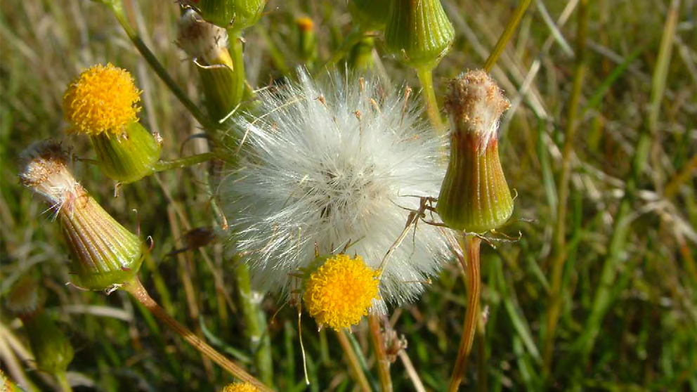
Figure 42: Large-fruit Groundsel Source: DELWP

DELWP’s conservation commitment
DELWP published the following statement as the conservation outcome for the Large- fruit Groundsel by notice in the Victorian Government Gazette:
‘No substantial negative change to known populations of Large-fruit Groundsel within the UGB (including but not limited to conservation area 5). No substantial negative change means that the five-year mean population count remains above the baseline.’

DELWP’s MSA MRF also summarises the conservation outcomes for the Large-fruit Groundsel as a single goal statement: ‘no substantial negative change to the population of Large-fruit Groundsel within the program area’.

- Belcher RO (1983) New Australian species of Erechthitoid Senecio (Asteraceae). Muelleria 5, 119-122; Hills A, Boekel R 1996, ‘Action statement No. 68. Large-fruit groundsel Senecio macrocarpus.’ Department of Natural Resources and Environment, Victoria.
- Walsh NG 1999, ‘Senecio. In: Walsh NG and Entwisle TJ (Eds.) Flora of Victoria vol 4: Dicotyledons Cornaceae to Asteraceae.’ Inkata Press, Melbourne.

KPIs assessed
Progress towards this goal is measured using a single KPI:
1. The five-year mean population count, which must remain above a baseline set by the first five years of counts.
This KPI will be assessed using a continuous improvement approach, where any increase over the baseline in a five-year reporting period will lead to the calculation of a new baseline for subsequent reporting periods.

MNES | 12. Large-fruit Groundsel
Commonwealth approved 2015 MSA MRF single outcome statement | No substantial negative change to populations of Large-fruit Groundsel.
2014–2020 Ecological Outcomes Report single outcome statement | No substantial negative change to populations of Large-fruit Groundsel.
Conservation Outcomes published in the Victorian Government Gazette – Issue G4, 27 January 2022 | No substantial negative change to known populations of Large-fruit Groundsel within the UGB (including but not limited to conservation area 5). No substantial negative change means that the five-year mean population count remains above the baseline.

Monitored areas
In 2015, when the MRF was written, only one naturally occurring population of Large-fruit Groundsel was known (in Conservation Area 5). This area has not yet been protected under the MSA and has not been the subject of monitoring.
In 2017, a small, previously unknown wild population was discovered on a parcel of land in the Western Grassland Reserve, known as Little Raven. Monitoring of this population commenced in 2017.
There are also three introduced populations in the MSA area, which are considered under other measures:
In 2012, a population was established on One Tree East. This population was previously reported on as an ‘other measure’. It is now extinct.
In 2012, a small population was established at Mount Cottrell NCR.273 This population was previously also reported on as an ‘other measure’. As of 2021, it numbers only two individuals.
A translocated population occurs on Little Raven. This population is monitored under a different project and is not reported on here.
The baseline for this species in the main population in CA5 has not been set, as this site remains unprotected.
The baseline for the small population at Little Raven was set in 2021, at 13 plants.

- DELWP 2015, ‘Monitoring and Reporting Framework – Melbourne Strategic Assessment’, East Melbourne, Victoria.

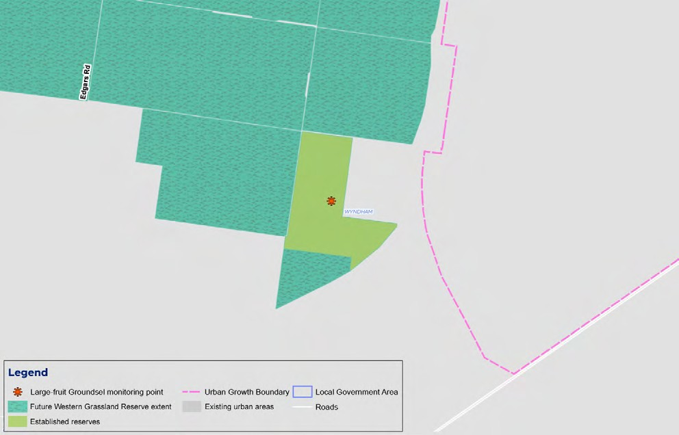
Figure 43: Map of monitored areas for Large-fruit Groundsel Source: DELWP

Results: KPI

KPI 1: Population count

KPI 1: Population count | Status 2020–2022 | Reason for non-assessment (if applicable) | Trend | Data Confidence | Year that baseline was/will be set
Conservation Area 5 | Not assessed | Population not yet under MSA management |  | N/A | Unclear
Little Raven | Not assessed | Baseline set in 2022 |  | N/A | 2022

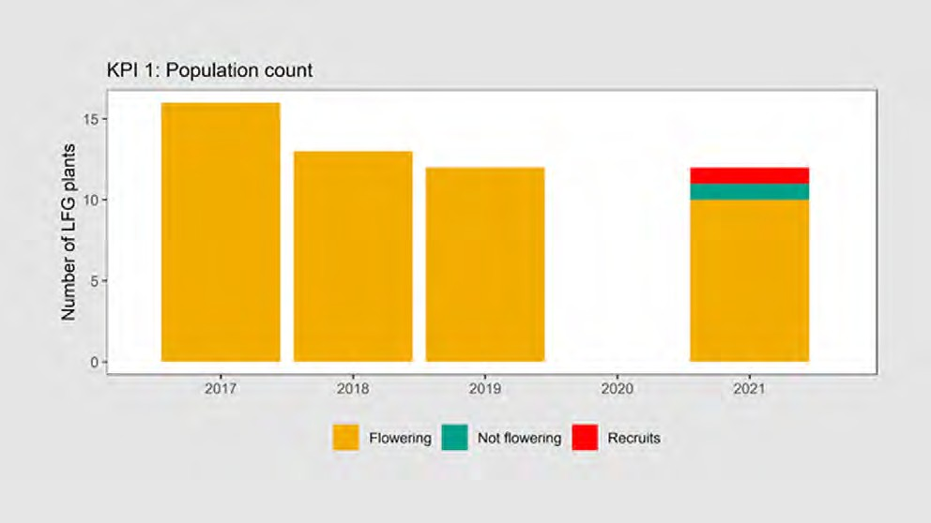
Figure 44: Population count Large-fruit Groundsel at Little Raven, 2017–2021 Source: DELWP

Results summary
The natural Large-fruit Groundsel population at Little Raven is small and the number of plants recorded has declined slightly since its discovery (16 plants in 2017, 12 plants in 2021). The baseline for the population at Little Raven has been set this year, so no assessment against the KPIs is able to be made. The larger population in Conservation Area 5 is not yet protected and remains unmonitored.

Key insights and management implications
Large-fruit Groundsel disperses widely (wind dispersal) and it can produce viable seeds from selfing, meaning that new populations can be founded by one or a few individuals.274 The population discovered in 2016–17 at Little Raven appeared on recently burnt ground and may have dispersed relatively recently from a nearby population on the railway line.275
Of the 16 plants detected originally, five have died and two appeared to be senescing. One recruit appeared in 2021. The cause of this apparent decline is unknown.276
This species’ lifespan is approximately 10 years. It is dispersed widely through wind, preferring to colonise recently burnt areas.277 It germinates readily from seed when conditions are favourable, in wet years and with enough open ground free from competition.278
DELWP indicates that there is not enough data (in part due to lack of protected populations on MSA land) to glean any definitive insights on the species or its management implications.279 Given the small numbers, the population remains vulnerable to external pressures. It is possible that the risk of decline could be potentially mitigated through population augmentation via the planting of tube stock.280

- DELWP, internal document, provided 21 January 2022.
- DELWP, internal document, provided 21 January 2022.
- DELWP, internal document, provided 21 January 2022.
- Ahrens, C. W., & James, E. A. 2015. ‘Range-wide genetic analysis reveals limited structure and suggests asexual patterns in the rare forb Senecio macrocarpus.’ Biological Journal of the Linnean Society, 115(2), 256-269.
- DELWP, internal document, provided 21 January 2022.
- DELWP Officer, personal communication, 15 February 2022.
- DELWP Officer, personal communication, 15 February 2022.

Appendix 1 – Historical and legislative context

Introduction

The Commissioner for Environmental Sustainability has been tasked with preparing biennial reports on the implementation of MSA conservation outcomes. The Commissioner’s function is stipulated under the CES Act as: ‘8(b) conduct, once every 2 years, strategic audits of, and prepare reports on, the implementation of – (ii) the MSA conservation outcomes by the Secretary to the Department of Environment, Land, Water and Planning (DELWP).’281

Background on the Melbourne Strategic Assessment (MSA) program
To accommodate Melbourne’s future population growth and urban expansion, four growth areas were planned to cover 60,000 ha under the Victorian government MSA program Delivering Melbourne’s Newest Sustainable Communities. 282 These growth areas included several state and nationally listed biodiversity values which triggered requirements to address potential impacts on these species and communities under proposed plans.
DELWP opted to undertake a strategic assessment,283 based on the assumption that it would provide biodiversity gains and cost efficiencies over time. A strategic assessment was intended to enable a consolidated approach to impact assessment, preventing multiple smaller impacts from ‘falling through the cracks’.284 This involved a streamlined regulatory assessment and approvals process under Commonwealth law, involving:
- a strategic assessment of all biodiversity values within a set area
- the creation of a set of requirements that defined which areas were to be avoided (those that are too important to be lost), and which areas could be removed or offset, through combining Commonwealth EPBC Act requirements and Victorian Native Vegetation Clearing requirements.

- State Government of Victoria 2003, ‘Commissioner for Environmental Sustainability Act 2003’, Melbourne, Victoria.
- DEPI 2009, ‘Delivering Melbourne’s Newest Sustainable Communities: Program Report’, East Melbourne, Victoria.
- DEPI 2009, ‘Delivering Melbourne’s Newest Sustainable Communities: Strategic Impact Assessment Report’, East Melbourne, Victoria.
- DEPI 2013, ‘Biodiversity Conservation Strategy for Melbourne’s Growth Corridors’, East Melbourne, Victoria.

DELWP is obligated to fulfill the requirements of the Commonwealth-approved MSA program285 and Biodiversity Conservation Strategy286 (BCS). These requirements are based on timestamped native vegetation datasets and values assessments performed in the original 2010 strategic assessment, and include:
- defined areas (as defined by the BCS) of high biodiversity value in which environmental impacts must be avoided (not be developed on)
- defined areas in which environmental impacts are minimised through close regulation during precinct structure planning
- defined areas of low biodiversity value that can be cleared and offset
- the application of consolidated levy fees which developers pay the Victorian Government. The Government uses this revenue to buy and manage land on developers’ behalf.
The MSA program’s strategic biodiversity offsetting program was established to ensure NNL was achieved for biodiversity throughout implementation of Growth Area Framework Plans. Major offsets under the MSA program include the establishment of:
- A 15,000 ha Western Grassland Reserve near Werribee
- A 1,200 ha Grassy Eucalypt Woodland protected area near Whittlesea
- 4,000 ha of reserve, across 36 Conservation Areas, within new suburbs inside the UGB.
The MSA program’s scope also included objectives and actions to enable protection of areas supporting functioning and sustainable populations of the Growling Grass Frog and the Southern Brown Bandicoot, among several other important biodiversity values.
Under the MSA program, the Victorian government committed to establishing a Natural Temperate Grassland reserve as an offset by 2022, via acquisition through use of a PAO. A PAO is a planning mechanism that is used by the government to earmark areas for protection through planning scheme amendments on Crown land. The government also committed to establishing a Grassy Eucalypt Woodland reserve as an offset by 2020.
Natural Temperate Grassland used to be widespread across the Victorian Volcanic Plain, in the state’s south-west. While these grasslands once covered over a third of the state, they are now small and fragmented. They are considered two of Victoria’s most important and biodiverse ecological communities.
In June 2008 and June 2009, the Australian Government listed Natural Temperate Grassland and Grassy Eucalypt Woodland respectively as critically endangered under the Environment Protection and Biodiversity Conservation Act 1999 (EPBC Act).

The MSA program’s conservation commitments
Along with the MSA Program Report, DELWP’s MSA Biodiversity Conservation Strategy (BCS)287 and Sub Regional Species Strategies were the initial documents approved by the Commonwealth Government to define conservation objectives for MNES under MSA management.

- DEPI 2009, ‘Delivering Melbourne’s Newest Sustainable Communities: Program Report’, East Melbourne, Victoria.
- DEPI 2013, ‘Biodiversity Conservation Strategy for Melbourne’s Growth Corridors’, East Melbourne, Victoria.
- DEPI 2013, ‘Biodiversity Conservation Strategy for Melbourne’s Growth Corridors’, East Melbourne, Victoria.

The requirement to prepare the BCS arose from the Program Report, which committed to: ‘An overarching Biodiversity Conservation Strategy […] for each of the expanded growth corridors.’288 This strategy was intended to inform the preparation of the Growth Area Framework Plans (and subsequent Precinct Structure Plans) and to provide high-level guidance for practitioners. It outlines how the areas of biodiversity value (State and Commonwealth) within the growth areas will be managed and how outcomes for MNES will be delivered.
According to DELWP,289 the purpose of the BCS is to:
- inform and guide the preparation of Growth Area Framework Plans and subsequent Precinct Structure Plans
- outline how the conservation outcomes for matters of national environmental significance in the program report will be achieved spatially within the growth corridors and how impacts on these matters will be mitigated
- identify the land within the growth corridors that is required to be protected due to the sub-regional species strategies and the prescriptions for matters of national environmental significance
- identify how areas set aside for conservation will be managed
- outline how mitigation measures will be implemented. These conservation measures aim to comprise:
- the protection and management of land of high biodiversity value within defined conservation areas and areas outside the UGB
- requirements to provide offsets for removal of native vegetation and threatened species habitat on land not required for conservation and suitable for urban development
- requirements to salvage and translocate certain threatened species prior to removal of habitat on land not required for conservation and suitable for urban development.
The BCS aims to apply the requirements of the MNES prescriptions and the Native Vegetation Management Framework290 strategically, at a growth corridor level,
to identify conservation areas and to remove the need to protect additional land resulting from these requirements at the precinct structure planning stage, or other development approval stages.291

MSA Conservation Outcomes for MNES under Victorian legislation
The MSA program’s implementation of its conservation outcomes has been brought under Victorian regulation through introduction of the Melbourne Strategic Assessment Act 2020. The Conservation Outcomes are formally defined by notice in
the Victorian Government Gazette (Part 6, section 93 of the MSA Act)292 and set out a range of measures to limit and offset the impacts of urban development on threatened species and ecological communities listed as MNES in the growth areas of Melbourne.

- DEPI 2009, ‘Delivering Melbourne’s Newest Sustainable Communities: Program Report’, East Melbourne, Victoria.
- DELWP Officer, personal communication, 23 August 2021.
- Department of Sustainability and Environment (DSE) 2011, ‘Native Vegetation Management – A Framework for Action’, Melbourne, Victoria.
- DEPI 2013, ‘Biodiversity Conservation Strategy for Melbourne’s Growth Corridors’, East Melbourne, Victoria.
- State Government of Victoria 2022, Victorian Government Gazette, Issue G4, ‘Melbourne Strategic Assessment (Environment Mitigation Levy) Act 2020 – Notice of the Conservation Outcomes’, http://www.gazette.vic.gov.au/gazette/Gazettes2022/GG2022G004.pdf Accessed 27 January 2022.

The Commonwealth approved 2015 MSA Monitoring and Reporting Framework293 (MRF) formally defined outcomes for MNES – and DELWP has subsequently structured these using as a simple two-tier objectives hierarchy,294 with a single overarching desired outcome for each species and community, each with associated KPIs.
The following single outcome statements, one for each species or community, form the basis of the KPIs:
- The composition, structure and function of Natural Temperate Grassland of the Victorian Volcanic Plain improves
- The composition, structure and function of Grassy Eucalypt Woodland of the Victorian Volcanic Plain improves
- The composition, structure and function of Seasonal Herbaceous Wetlands of the Temperate Lowland Plains improves
- No substantial negative change to populations of Button Wrinklewort
- No substantial negative change to populations of Large-fruit Groundsel
- No substantial negative change to Small Golden Moths Orchid
- Matted Flax-lily persists
- No substantial negative change to the population of Spiny Rice-flower, and the population is self-sustaining
- Golden Sun Moth persists
- Growling Grass Frog persists
- Southern Brown Bandicoot persists
- Striped Legless Lizard persists.
DELWP treats each of these as independent outcomes, all of which must be achieved for the MSA to be fulfilling its obligations.295 They have not been afforded different levels of importance or integrated into any system which permits trade-offs between them.296

Reporting challenges for the inaugural MSA report by the Commissioner
This Strategic Audit of the Implementation of MSA Conservation Outcomes 2022 Report presents data supplied by DELWP and Parks Victoria in relation to status and trend information against conservation outcomes for MNES defined in the MRF and published in the Victorian Government Gazette, 297 covering the reporting period 1 July 2020 to 30 June 2022. This report also addresses issues and limitations in the current MRF regarding its assessment of the conservation outcomes.
A significant number of MNES cannot be fully assessed in this first reporting period for multiple reasons including lack of data and the baseline for the KPI not being set.

- DELWP 2015, ‘Monitoring and Reporting Framework – Melbourne Strategic Assessment’, East Melbourne, Victoria.
- Biggs HC, and Rogers KH 2003, ‘An adaptive system to link science, monitoring, and management in practice. In The Kruger Experience: Ecology and Management of Savanna Heterogeneity’ du Toit JT, Rogers KH, and Biggs HC, eds. Washington, D.C.: Island Press, 59–80.
- Bruce M, Batpurev K, Bryant D, Sinclair S and Kohout M 2020, ‘Melbourne Strategic Assessment: Ecological Outcomes Report 2014-15 to 2019-20.’ Department of Environment, Land, Water and Planning, Heidelberg, Victoria.
- Bruce M, Batpurev K, Bryant D, Sinclair S and Kohout M 2020, ‘Melbourne Strategic Assessment: Ecological Outcomes Report 2014-15 to 2019-20.’ Department of Environment, Land, Water and Planning, Heidelberg, Victoria.
- State Government of Victoria 2022, Victorian Government Gazette, Issue G4, ‘Melbourne Strategic Assessment (Environment Mitigation Levy) Act 2020 – Notice of the Conservation Outcomes’, http://www.gazette.vic.gov.au/gazette/Gazettes2022/GG2022G004.pdf Accessed 27 January 2022.

Tables 6 to 8 demonstrate the status of MNES at 30 June 2022.
Current definitions of the conservation outcomes and performance indicators are presented in the Notice of the MSA Conservation Outcomes published in the Victorian Government Gazette and DELWP’s MSA Ecological Outcomes Report 2014–2020.
It should be noted that DELWP’s gazetted conservation outcomes statements include some that, technically by definition in DELWP’s MSA MRF, are MSA program outputs performance measures and, as such, will not be analysed in this report. There are also discrepancies between the gazetted outcomes and the outcomes statements contained within the MRF, in terms of the language used to define the conservation outcomes. To avoid potential confusion, both the gazetted outcomes and MRF outcomes definitions are presented in this report for each MNES. Associated KPIs have been obtained from the 2015 MSA MRF, as these were not included with the gazetted conservation outcomes
Informal changes to the MRF have been proposed since the official publication of this document in 2015. ARI detailed these in their MSA Outcomes Report 2014–2020. ARI has since proposed further informal updates to the monitoring protocol for 2020–2022 via an internal document,298 and these changes are documented in Appendix 2.

Table 5: Monitoring timeframes

MNES  Number | MNES name | KPI  number | KPI type | Location | First year of MSA monitoring  /year that monitoring is expected to commence | Year that baseline was/ will be set
1 | Natural Temperate Grassland | 1 | States | Herb-rich grassland | 2013 | N/A
1 | Natural Temperate Grassland | 1 | States | Themeda grassland | 2013 | N/A
1 | Natural Temperate Grassland | 1 | States | C3 grassland | 2013 | N/A
1 | Natural Temperate Grassland | 1 | States | Nutrient-enriched grassland | 2013 | N/A
1 | Natural Temperate Grassland | 1 | States | De-rocked grassland | 2013 | N/A
1 | Natural Temperate Grassland | 2 | Forb cover | Herb-rich grassland | 2013 | 2019
1 | Natural Temperate Grassland | 2 | Forb cover | Themeda grassland | 2014 | 2018
1 | Natural Temperate Grassland | 2 | Forb cover | C3 grassland | 2013 | 2022
1 | Natural Temperate Grassland | 2 | Forb cover | Nutrient-enriched grassland | 2013 | 2017
1 | Natural Temperate Grassland | 2 | Forb cover | De-rocked grassland | 2019 | 2023
1 | Natural Temperate Grassland | 3 | Forb richness | Herb-rich grassland | 2013 | 2017
1 | Natural Temperate Grassland | 3 | Forb richness | Themeda grassland | 2014 | 2018
1 | Natural Temperate Grassland | 3 | Forb richness | C3 grassland | 2013 | 2022

- DELWP, internal document, Accessed 6 February 2022.

MNES  Number | MNES name | KPI  number | KPI type | Location | First year of MSA monitoring  /year that monitoring is expected to commence | Year that baseline was/ will be set
1 | Natural Temperate Grassland | 3 | Forb richness | Nutrient-enriched grassland | 2013 | 2017
1 | Natural Temperate Grassland | 3 | Forb richness | De-rocked grassland | N/A | Unclear
1 | Natural Temperate Grassland | 4 | Themeda | Herb-rich grassland | 2013 | 2017
1 | Natural Temperate Grassland | 4 | Themeda | Themeda grassland | 2013 | 2017
1 | Natural Temperate Grassland | 4 | Themeda | C3 grassland | N/A | Unclear
1 | Natural Temperate Grassland | 4 | Themeda | Nutrient-enriched grassland | 2013 | 2017
1 | Natural Temperate Grassland | 4 | Themeda | De-rocked grassland | N/A | Unclear
1 | Natural Temperate Grassland | 5 | Perennial grass cover (excluding Themeda) | Herb-rich grassland | 2013 | 2013
1 | Natural Temperate Grassland | 5 | Perennial grass cover (excluding Themeda | Themeda grassland | 2013 | 2013
1 | Natural Temperate Grassland | 5 | Perennial grass cover (excluding Themeda) | C3 grassland | N/A | Unclear
1 | Natural Temperate Grassland | 5 | Perennial grass cover (excluding Themeda) | Nutrient-enriched grassland | 2013 | 2013
1 | Natural Temperate Grassland | 5 | Perennial grass cover (excluding Themeda) | De-rocked grassland | N/A | Unclear
1 | Natural Temperate Grassland | 6 | Structural heterogeneity | Herb-rich grassland | 2013 | N/A
1 | Natural Temperate Grassland | 6 | Structural heterogeneity | Themeda grassland | 2013 | N/A
1 | Natural Temperate Grassland | 6 | Structural heterogeneity | C3 grassland | 2013 | N/A
1 | Natural Temperate Grassland | 6 | Structural heterogeneity | Nutrient-enriched grassland | 2013 | N/A
1 | Natural Temperate Grassland | 6 | Structural heterogeneity | De-rocked grassland | 2013 | N/A
1 | Natural Temperate Grassland | 7 | Weeds | Herb-rich grassland | 2013 | 2017
1 | Natural Temperate Grassland | 7 | Weeds | Themeda grassland | 2013 | 2017
1 | Natural Temperate Grassland | 7 | Weeds | C3 grassland | N/A | Unclear
1 | Natural Temperate Grassland | 7 | Weeds | Nutrient-enriched grassland | 2013 | 2017
1 | Natural Temperate Grassland | 7 | Weeds | De-rocked grassland | N/A | Unclear
2 | Grassy Eucalypt Woodland | 1 | States | Herb-rich grassland | 2022 | N/A
2 | Grassy Eucalypt Woodland | 1 | States | Themeda grassland | 2022 | N/A
2 | Grassy Eucalypt Woodland | 1 | States | C3 grassland | 2022 | N/A
2 | Grassy Eucalypt Woodland | 1 | States | Nutrient-enriched grassland | 2022 | N/A
2 | Grassy Eucalypt Woodland | 1 | States | De-rocked grassland | 2022 | N/A

MNES  Number | MNES name | KPI  number | KPI type | Location | First year of MSA monitoring  /year that monitoring is expected to commence | Year that baseline was/ will be set
2 | Grassy Eucalypt Woodland | 2 | Forb cover | Herb-rich grassland | 2022 | 2026
2 | Grassy Eucalypt Woodland | 2 | Forb cover | Themeda grassland | 2022 | 2026
2 | Grassy Eucalypt Woodland | 2 | Forb cover | C3 grassland | 2022 | 2026
2 | Grassy Eucalypt Woodland | 2 | Forb cover | Nutrient-enriched grassland | 2022 | 2026
2 | Grassy Eucalypt Woodland | 2 | Forb cover | De-rocked grassland | 2022 | 2026
2 | Grassy Eucalypt Woodland | 3 | Forb richness | Herb-rich grassland | 2022 | 2026
2 | Grassy Eucalypt Woodland | 3 | Forb richness | Themeda grassland | 2022 | 2026
2 | Grassy Eucalypt Woodland | 3 | Forb richness | C3 grassland | 2022 | 2026
2 | Grassy Eucalypt Woodland | 3 | Forb richness | Nutrient-enriched grassland | 2022 | 2026
2 | Grassy Eucalypt Woodland | 3 | Forb richness | De-rocked grassland | 2022 | 2026
2 | Grassy Eucalypt Woodland | 4 | Themeda, Poa cover | Herb-rich grassland | 2022 | 2026
2 | Grassy Eucalypt Woodland | 4 | Themeda, Poa cover | Themeda grassland | 2022 | 2026
2 | Grassy Eucalypt Woodland | 4 | Themeda, Poa cover | C3 grassland | 2022 | 2026
2 | Grassy Eucalypt Woodland | 4 | Themeda, Poa cover | Nutrient-enriched grassland | 2022 | 2026
2 | Grassy Eucalypt Woodland | 4 | Themeda, Poa cover | De-rocked grassland | 2022 | 2026
2 | Grassy Eucalypt Woodland | 5 | Structural heterogeneity | Herb-rich grassland | 2022 | N/A
2 | Grassy Eucalypt Woodland | 5 | Structural heterogeneity | Themeda grassland | 2022 | N/A
2 | Grassy Eucalypt Woodland | 5 | Structural heterogeneity | C3 grassland | 2022 | N/A
2 | Grassy Eucalypt Woodland | 5 | Structural heterogeneity | Nutrient-enriched grassland | 2022 | N/A
2 | Grassy Eucalypt Woodland | 5 | Structural heterogeneity | De-rocked grassland | 2022 | N/A
2 | Grassy Eucalypt Woodland | 6 | Recruits | Herb-rich grassland | 2022 | N/A
2 | Grassy Eucalypt Woodland | 6 | Recruits | Themeda grassland | 2022 | N/A
2 | Grassy Eucalypt Woodland | 6 | Recruits | C3 grassland | 2022 | N/A
2 | Grassy Eucalypt Woodland | 6 | Recruits | Nutrient-enriched grassland | 2022 | N/A
2 | Grassy Eucalypt Woodland | 6 | Recruits | De-rocked grassland | 2022 | N/A
2 | Grassy Eucalypt Woodland | 7 | Weeds | Herb-rich grassland | 2022 | 2026
2 | Grassy Eucalypt Woodland | 7 | Weeds | Themeda grassland | 2022 | 2026

MNES  Number | MNES name | KPI  number | KPI type | Location | First year of MSA monitoring  /year that monitoring is expected to commence | Year that baseline was/ will be set
2 | Grassy Eucalypt Woodland | 7 | Weeds | C3 grassland | 2022 | 2026
2 | Grassy Eucalypt Woodland | 7 | Weeds | Nutrient-enriched grassland | 2022 | 2026
2 | Grassy Eucalypt Woodland | 7 | Weeds | De-rocked grassland | 2022 | 2026
3 | Seasonal Herbaceous Wetlands | 1 | Forb-richness spring- summer | Western Grassland Reserve, Cobbledicks Rise | 2014 | 2018
3 | Seasonal Herbaceous Wetlands | 1 | Forb-richness spring- summer | Western Grassland Reserve, Windmill Rise | 2014 | 2018
3 | Seasonal Herbaceous Wetlands | 1 | Forb-richness spring- summer | Western Grassland Reserve, One Tree Rise | 2014 | 2018
3 | Seasonal Herbaceous Wetlands | 2 | Forb richness drawdown | Western Grassland Reserve, Cobbledicks Rise | 2017 | 2017
3 | Seasonal Herbaceous Wetlands | 2 | Forb richness drawdown | Western Grassland Reserve, Windmill Rise | 2017 | 2017
3 | Seasonal Herbaceous Wetlands | 2 | Forb richness drawdown | Western Grassland Reserve, One Tree Rise | N/A | N/A
3 | Seasonal Herbaceous Wetlands | 3 | Weeds spring- summer | Western Grassland Reserve, Cobbledicks Rise | 2014 | 2018
3 | Seasonal Herbaceous Wetlands | 3 | Weeds spring- summer | Western Grassland Reserve, Windmill Rise | 2014 | 2018
3 | Seasonal Herbaceous Wetlands | 3 | Weeds spring- summer | Western Grassland Reserve, One Tree Rise | 2014 | 2018
3 | Seasonal Herbaceous Wetlands | 4 | Weeds drawdown | Western Grassland Reserve, Cobbledicks Rise | 2017 | 2017
3 | Seasonal Herbaceous Wetlands | 4 | Weeds drawdown | Western Grassland Reserve, Windmill Rise | 2017 | 2017
3 | Seasonal Herbaceous Wetlands | 4 | Weeds drawdown | Western Grassland Reserve, One Tree Rise | N/A | N/A
4 | Golden Sun Moth | 1 | Occupancy | All locations | 2014 | 2018
5 | Matted Flax-lily | 1 | Count | Mt Ridley | 2021 | 2025
5 | Matted Flax-lily | 1 | Count | Kalkallo Common | 2016 | 2022
6 | Spiny Rice-flower | 1 | Count | Truganina Cemetery Grassland (Conservation Area 10) | 2019 | 2024
6 | Spiny Rice-flower | 1 | Count | Western Grassland Reserve, Radio block | 2019 | 2024
6 | Spiny Rice-flower | 2 | Recruits | Truganina Cemetery Grassland (Conservation Area 10) | 2019 | 2024

MNES  Number | MNES name | KPI  number | KPI type | Location | First year of MSA monitoring  /year that monitoring is expected to commence | Year that baseline was/ will be set
6 | Spiny Rice-flower | 2 | Recruits | Western Grassland Reserve, Radio block | 2019 | 2024
7 | Southern Brown Bandicoot | 1 | Occupancy | Southern Brown Bandicoot Management Area, canal | 2019 | 2019
7 | Southern Brown Bandicoot | 1 | Occupancy | Southern Brown Bandicoot Management Area, reserve | 2019 | 2019
7 | Southern Brown Bandicoot | 1 | Occupancy | Southern Brown Bandicoot Management Area, road | 2019 | 2019
8 | Growling Grass Frog | 1 | Risk | All locations | 2022 | 2022
9 | Small Golden Moths Orchid | 1 | Count | Conservation Area 3 | N/A | N/A
10 | Striped Legless Lizard | 1 | Occupancy | Mount Cottrell NCR | 2016 | N/A
10 | Striped Legless Lizard | 1 | Occupancy | Truganina South NCR | 2019 | N/A
10 | Striped Legless Lizard | 1 | Occupancy | Werribee River easement | 2019 | N/A
10 | Striped Legless Lizard | 1 | Occupancy | Western Grassland Reserve (all other locations) | 2019 | N/A
11 | Button Wrinklewort | 1 | Count | Truganina Cemetery Grassland (Conservation Area 10) | 2015 | 2019
12 | Large-fruit Groundsel | 1 | Count | Conservation Area 5 | N/A | Unclear
12 | Large-fruit Groundsel | 1 | Count | Little Raven | 2017 | 2021

Source: Compiled by the Victorian Commissioner for Environmental Sustainability with data sourced from DELWP

Table 6: KPIs met as at 28 February 2022

MNES  number | MNES name | KPI  number | KPI type | Location | Threshold of impact (negative) | Outcome at 28 Feb 2022
1 | Natural Temperate Grassland | 2 | Forb cover | Herb-rich grassland | KPI measure 95% confidence interval falls below the baseline (this is assumed, although hasn't been explicitly stated) | Met
1 | Natural Temperate Grassland | 2 | Forb cover | Themeda grassland | KPI measure 95% confidence interval falls below the baseline (this is assumed, although hasn't been explicitly stated) | Met
1 | Natural Temperate Grassland | 3 | Forb richness | Herb-rich grassland | KPI measure 95% confidence interval falls below the baseline (this is assumed, although hasn't been explicitly stated) | Met
1 | Natural Temperate Grassland | 3 | Forb richness | Themeda grassland | KPI measure 95% confidence interval falls below the baseline (this is assumed, although hasn't been explicitly stated) | Met
1 | Natural Temperate Grassland | 3 | Forb richness | Nutrient-enriched grassland | KPI measure 95% confidence interval falls below the baseline (this is assumed, although hasn't been explicitly stated) | Met
1 | Natural Temperate Grassland | 4 | Themeda | Herb-rich grassland | KPI measure 95% confidence interval falls below the baseline (this is assumed, although hasn't been explicitly stated) | Met
1 | Natural Temperate Grassland | 4 | Themeda | Themeda grassland | KPI measure 95% confidence interval falls below the baseline (this is assumed, although hasn't been explicitly stated) | Met
1 | Natural Temperate Grassland | 4 | Themeda | Nutrient-enriched grassland | KPI measure 95% confidence interval falls below the baseline (this is assumed, although hasn't been explicitly stated) | Met
1 | Natural Temperate Grassland | 5 | Perennial grass cover (excluding Themeda) | Themeda grassland | KPI measure 95% confidence interval falls below the baseline (this is assumed, although hasn't been explicitly stated) | Met
1 | Natural Temperate Grassland | 5 | Perennial grass cover (excluding Themeda) | Nutrient-enriched grassland | KPI measure 95% confidence interval falls below the baseline (this is assumed, although hasn't been explicitly stated) | Met
1 | Natural Temperate Grassland | 6 | Structural heterogeneity | Herb-rich grassland | Percentage cover falls outside the 25–75% range | Met
1 | Natural Temperate Grassland | 6 | Structural heterogeneity | Themeda grassland | Percentage cover falls outside the 25–75% range | Met
1 | Natural Temperate Grassland | 6 | Structural heterogeneity | C3 grassland | Percentage cover falls outside the 25–75% range | Met
1 | Natural Temperate Grassland | 6 | Structural heterogeneity | Nutrient-enriched grassland | Percentage cover falls outside the 25–75% range | Met
1 | Natural Temperate Grassland | 6 | Structural heterogeneity | De-rocked grassland | Percentage cover falls outside the 25–75% range | Met
1 | Natural Temperate Grassland | 7 | Perennial Weeds | Herb-rich grassland | KPI measure 95% confidence interval falls above the baseline (this is assumed, although hasn't been explicitly stated) | Met

MNES  number | MNES name | KPI  number | KPI type | Location | Threshold of impact (negative) | Outcome at 28 Feb 2022
1 | Natural Temperate Grassland | 7 | Weeds | Themeda grassland | KPI measure 95% confidence interval falls above the baseline (this is assumed, although hasn't been explicitly stated) | Met
1 | Natural Temperate Grassland | 7 | Weeds | Nutrient-enriched grassland | KPI measure 95% confidence interval falls above the baseline (this is assumed, although hasn't been explicitly stated) | Met
3 | Seasonal Herbaceous Wetlands | 1 | Forb-richness spring- summer | Western Grassland Reserve, Cobbledicks Rise | KPI measure 95% confidence interval falls below the baseline | Met
3 | Seasonal Herbaceous Wetlands | 1 | Forb-richness spring- summer | Western Grassland Reserve, Windmill Rise | KPI measure 95% confidence interval falls below the baseline | Met
3 | Seasonal Herbaceous Wetlands | 1 | Forb-richness spring- summer | Western Grassland Reserve, One Tree Rise | KPI measure 95% confidence interval falls below the baseline | Met
3 | Seasonal Herbaceous Wetlands | 3 | Weeds spring- summer | Western Grassland Reserve, Cobbledicks Rise | KPI measure 95% confidence interval falls above the baseline | Met
3 | Seasonal Herbaceous Wetlands | 3 | Weeds spring- summer | Western Grassland Reserve, Windmill Rise | KPI measure 95% confidence interval falls above the baseline | Met
3 | Seasonal Herbaceous Wetlands | 3 | Weeds spring- summer | Western Grassland Reserve, One Tree Rise | KPI measure 95% confidence interval falls above the baseline | Met
10 | Striped Legless Lizard | 1 | Occupancy | Mount Cottrell NCR | Is not detected at least once in every five-year period at 100% of permanent monitoring plots | Met
10 | Striped Legless Lizard | 1 | Occupancy | Truganina South NCR | Is not detected at least once in every five-year period at 100% of permanent monitoring plots | Met
10 | Striped Legless Lizard | 1 | Occupancy | Western Grassland Reserve (all other locations) | Is not detected at least once in every five-year period at 100% of permanent monitoring plots | Met
10 | Striped Legless Lizard | 1 | Occupancy | Werribee River easement | Is not detected at least once in every five-year period at 100% of permanent monitoring plots | Met

SOURCE: Compiled by the Victorian Commissioner for Environmental Sustainability with data sourced from DELWP

Table 7: KPIs not met as at 28 February 2022

MNES  number | MNES name | KPI  number | KPI type | Location | Threshold of impact (negative) | Outcome at 28 Feb 2022
1 | Natural Temperate Grassland | 2 | Forb cover | Nutrient-enriched grassland | KPI measure 95% confidence interval falls below the baseline (this is assumed, although hasn't been explicitly stated) | Not met
4 | Golden Sun Moth | 1 | Occupancy | All locations | KPI measure 95% confidence interval falls below the baseline | Not met
11 | Button Wrinklewort | 1 | Count | Truganina Cemetery Grassland (Conservation Area 10) | KPI measure falls below the baseline | Not met
SOURCE: Compiled by the Victorian Commissioner for Environmental Sustainability with data sourced from DELWP

Table 8: KPIs not assessed as at 28 February 2022

MNES  number | MNES name | KPI  number | KPI type | Location | Threshold of impact (negative) | Outcome at 28 Feb 2022
1 | Natural Temperate Grassland | 1 | States | Herb-rich grassland | See Sinclair et al. 2019b paper for method on evaluation of "positive, neutral or negative" transitions | Not assessed
1 | Natural Temperate Grassland | 1 | States | Themeda grassland | See Sinclair et al. 2019b paper for method on evaluation of "positive, neutral or negative" transitions | Not assessed
1 | Natural Temperate Grassland | 1 | States | C3 grassland | See Sinclair et al. 2019b paper for method on evaluation of "positive, neutral or negative" transitions | Not assessed
1 | Natural Temperate Grassland | 1 | States | Nutrient-enriched grassland | See Sinclair et al. 2019b paper for method on evaluation of "positive, neutral or negative" transitions | Not assessed
1 | Natural Temperate Grassland | 1 | States | De-rocked grassland | See Sinclair et al. 2019b paper for method on evaluation of "positive, neutral or negative" transitions | Not assessed
1 | Natural Temperate Grassland | 2 | Forb cover | C3 grassland | KPI measure 95% confidence interval falls below the baseline (this is assumed, although hasn't been explicitly stated) | Not assessed
1 | Natural Temperate Grassland | 2 | Forb cover | De-rocked grassland | KPI measure 95% confidence interval falls below the baseline (this is assumed, although hasn't been explicitly stated) | Not assessed
1 | Natural Temperate Grassland | 3 | Forb richness | C3 grassland | KPI measure 95% confidence interval falls below the baseline (this is assumed, although hasn't been explicitly stated) | Not assessed

MNES  number | MNES name | KPI  number | KPI type | Location | Threshold of impact (negative) | Outcome at 28 Feb 2022
1 | Natural Temperate Grassland | 3 | Forb richness | De-rocked grassland | KPI measure 95% confidence interval falls below the baseline (this is assumed, although hasn't been explicitly stated) | Not assessed
1 | Natural Temperate Grassland | 4 | Themeda | C3 grassland | KPI measure 95% confidence interval falls below the baseline (this is assumed, although hasn't been explicitly stated) | Not assessed
1 | Natural Temperate Grassland | 4 | Themeda | De-rocked grassland | KPI measure 95% confidence interval falls below the baseline (this is assumed, although hasn't been explicitly stated) | Not assessed
1 | Natural Temperate Grassland | 5 | Perennial grass cover (excluding Themeda) | C3 grassland | KPI measure 95% confidence interval falls below the baseline (this is assumed, although hasn't been explicitly stated) | Not assessed
1 | Natural Temperate Grassland | 5 | Perennial grass cover (excluding Themeda) | De-rocked grassland | KPI measure 95% confidence interval falls below the baseline (this is assumed, although hasn't been explicitly stated) | Not assessed
1 | Natural Temperate Grassland | 7 | Weeds | C3 grassland | KPI measure 95% confidence interval falls above the baseline (this is assumed, although hasn't been explicitly stated) | Not assessed
1 | Natural Temperate Grassland | 7 | Weeds | De-rocked grassland | KPI measure 95% confidence interval falls above the baseline (this is assumed, although hasn't been explicitly stated) | Not assessed
2 | Grassy Eucalypt Woodland | 1 | States | Herb-rich grassland | See Sinclair et al. 2019b paper for method on evaluation of "positive, neutral or negative" transitions | Not assessed
2 | Grassy Eucalypt Woodland | 1 | States | Themeda grassland | See Sinclair et al. 2019b paper for method on evaluation of "positive, neutral or negative" transitions | Not assessed
2 | Grassy Eucalypt Woodland | 1 | States | C3 grassland | See Sinclair et al. 2019b paper for method on evaluation of "positive, neutral or negative" transitions | Not assessed
2 | Grassy Eucalypt Woodland | 1 | States | Nutrient-enriched grassland | See Sinclair et al. 2019b paper for method on evaluation of "positive, neutral or negative" transitions | Not assessed
2 | Grassy Eucalypt Woodland | 1 | States | De-rocked grassland | See Sinclair et al. 2019b paper for method on evaluation of "positive, neutral or negative" transitions | Not assessed
2 | Grassy Eucalypt Woodland | 2 | Forb cover | Herb-rich grassland | KPI measure 95% confidence interval falls below the baseline (this is assumed, although hasn't been explicitly stated) | Not assessed
2 | Grassy Eucalypt Woodland | 2 | Forb cover | Themeda grassland | KPI measure 95% confidence interval falls below the baseline (this is assumed, although hasn't been explicitly stated) | Not assessed

MNES  number | MNES name | KPI  number | KPI type | Location | Threshold of impact (negative) | Outcome at 28 Feb 2022
2 | Grassy Eucalypt Woodland | 2 | Forb cover | C3 grassland | KPI measure 95% confidence interval falls below the baseline (this is assumed, although hasn't been explicitly stated) | Not assessed
2 | Grassy Eucalypt Woodland | 2 | Forb cover | Nutrient-enriched grassland | KPI measure 95% confidence interval falls below the baseline (this is assumed, although hasn't been explicitly stated) | Not assessed
2 | Grassy Eucalypt Woodland | 2 | Forb cover | De-rocked grassland | KPI measure 95% confidence interval falls below the baseline (this is assumed, although hasn't been explicitly stated) | Not assessed
2 | Grassy Eucalypt Woodland | 3 | Forb richness | Herb-rich grassland | KPI measure 95% confidence interval falls below the baseline (this is assumed, although hasn't been explicitly stated) | Not assessed
2 | Grassy Eucalypt Woodland | 3 | Forb richness | Themeda grassland | KPI measure 95% confidence interval falls below the baseline (this is assumed, although hasn't been explicitly stated) | Not assessed
2 | Grassy Eucalypt Woodland | 3 | Forb richness | C3 grassland | KPI measure 95% confidence interval falls below the baseline (this is assumed, although hasn't been explicitly stated) | Not assessed
2 | Grassy Eucalypt Woodland | 3 | Forb richness | Nutrient-enriched grassland | KPI measure 95% confidence interval falls below the baseline (this is assumed, although hasn't been explicitly stated) | Not assessed
2 | Grassy Eucalypt Woodland | 3 | Forb richness | De-rocked grassland | KPI measure 95% confidence interval falls below the baseline (this is assumed, although hasn't been explicitly stated) | Not assessed
2 | Grassy Eucalypt Woodland | 4 | Themeda, Poa cover | Herb-rich grassland | KPI measure 95% confidence interval falls below the baseline (this is assumed, although hasn't been explicitly stated) | Not assessed
2 | Grassy Eucalypt Woodland | 4 | Themeda, Poa cover | Themeda grassland | KPI measure 95% confidence interval falls below the baseline (this is assumed, although hasn't been explicitly stated) | Not assessed
2 | Grassy Eucalypt Woodland | 4 | Themeda, Poa cover | C3 grassland | KPI measure 95% confidence interval falls below the baseline (this is assumed, although hasn't been explicitly stated) | Not assessed
2 | Grassy Eucalypt Woodland | 4 | Themeda, Poa cover | Nutrient-enriched grassland | KPI measure 95% confidence interval falls below the baseline (this is assumed, although hasn't been explicitly stated) | Not assessed
2 | Grassy Eucalypt Woodland | 4 | Themeda, Poa cover | De-rocked grassland | KPI measure 95% confidence interval falls below the baseline (this is assumed, although hasn't been explicitly stated) | Not assessed
2 | Grassy Eucalypt Woodland | 5 | Structural heterogeneity | Herb-rich grassland | Percentage cover falls outside the 25–75% range | Not assessed
2 | Grassy Eucalypt Woodland | 5 | Structural heterogeneity | Themeda grassland | Percentage cover falls outside the 25–75% range | Not assessed

MNES  number | MNES name | KPI  number | KPI type | Location | Threshold of impact (negative) | Outcome at 28 Feb 2022
2 | Grassy Eucalypt Woodland | 5 | Structural heterogeneity | C3 grassland | Percentage cover falls outside the 25–75% range | Not assessed
2 | Grassy Eucalypt Woodland | 5 | Structural heterogeneity | Nutrient-enriched grassland | Percentage cover falls outside the 25–75% range | Not assessed
2 | Grassy Eucalypt Woodland | 5 | Structural heterogeneity | De-rocked grassland | Percentage cover falls outside the 25–75% range | Not assessed
2 | Grassy Eucalypt Woodland | 6 | Recruits | Herb-rich grassland | "Some" level of recruits falls outside the 25–75% range | Not assessed
2 | Grassy Eucalypt Woodland | 6 | Recruits | Themeda grassland | "Some" level of recruits falls outside the 25–75% range | Not assessed
2 | Grassy Eucalypt Woodland | 6 | Recruits | C3 grassland | "Some" level of recruits falls outside the 25–75% range | Not assessed
2 | Grassy Eucalypt Woodland | 6 | Recruits | Nutrient-enriched grassland | "Some" level of recruits falls outside the 25–75% range | Not assessed
2 | Grassy Eucalypt Woodland | 6 | Recruits | De-rocked grassland | "Some" level of recruits falls outside the 25–75% range | Not assessed
2 | Grassy Eucalypt Woodland | 7 | Weeds | Herb-rich grassland | KPI measure 95% confidence interval falls above the baseline (this is assumed, although hasn't been explicitly stated) | Not assessed
2 | Grassy Eucalypt Woodland | 7 | Weeds | Themeda grassland | KPI measure 95% confidence interval falls above the baseline (this is assumed, although hasn't been explicitly stated) | Not assessed
2 | Grassy Eucalypt Woodland | 7 | Weeds | C3 grassland | KPI measure 95% confidence interval falls above the baseline (this is assumed, although hasn't been explicitly stated) | Not assessed
2 | Grassy Eucalypt Woodland | 7 | Weeds | Nutrient-enriched grassland | KPI measure 95% confidence interval falls above the baseline (this is assumed, although hasn't been explicitly stated) | Not assessed
2 | Grassy Eucalypt Woodland | 7 | Weeds | De-rocked grassland | KPI measure 95% confidence interval falls above the baseline (this is assumed, although hasn't been explicitly stated) | Not assessed
3 | Seasonal Herbaceous Wetlands | 2 | Forb richness drawdown | Western Grassland Reserve, Cobbledicks Rise | KPI measure 95% confidence interval falls below the baseline | Not assessed
3 | Seasonal Herbaceous Wetlands | 2 | Forb richness drawdown | Western Grassland Reserve, Windmill Rise | KPI measure 95% confidence interval falls below the baseline | Not assessed
3 | Seasonal Herbaceous Wetlands | 2 | Forb richness drawdown | Western Grassland Reserve, One Tree Rise | KPI measure 95% confidence interval falls below the baseline | Not assessed
3 | Seasonal Herbaceous Wetlands | 4 | Weeds drawdown | Western Grassland Reserve, Cobbledicks Rise | KPI measure 95% confidence interval falls above the baseline | Not assessed
3 | Seasonal Herbaceous Wetlands | 4 | Weeds drawdown | Western Grassland Reserve, Windmill Rise | KPI measure 95% confidence interval falls above the baseline | Not assessed

r
MNES  number | MNES name | KPI  number | KPI type | Location | Threshold of impact (negative) | Outcome at 28 Feb 2022
3 | Seasonal Herbaceous Wetlands | 4 | Weeds drawdown | Western Grassland Reserve, One Tree Rise | KPI measure 95% confidence interval falls above the baseline | Not assessed
5 | Matted Flax-lily | 1 | Count | Mt Ridley | KPI measure 95% confidence interval falls below the baseline | Not assessed
5 | Matted Flax-lily | 1 | Count | Kalkallo Common | KPI measure 95% confidence interval falls below the baseline | Not assessed
6 | Spiny Rice-flower | 1 | Count | Truganina Cemetery Grassland (Conservation Area 10) | KPI measure falls below the baseline | Not assessed
6 | Spiny Rice-flower | 1 | Count | Western Grassland Reserve, Radio block | KPI measure falls below the baseline | Not assessed
6 | Spiny Rice-flower | 2 | Recruits | Truganina Cemetery Grassland (Conservation Area 10) | % recruits is below 10% of the MSA-wide population in at least one of the previous 10 years | Not assessed
6 | Spiny Rice-flower | 2 | SOURCE:  Recruits | Compiled by the Victorian Commissione  Western Grassland Reserve, Radio block | for Environmental Sustainability with dat  % recruits is below 10% of the MSA-wide population in at least one of the previous 10 years | a sourced from DELWP  Not assessed
7 | Southern Brown Bandicoot | 1 | Occupancy | Southern Brown Bandicoot Management Area, canal | KPI measure 95% confidence interval falls below the baseline | Not assessed
7 | Southern Brown Bandicoot | 1 | Occupancy | Southern Brown Bandicoot Management Area, reserve | KPI measure 95% confidence interval falls below the baseline | Not assessed
7 | Southern Brown Bandicoot | 1 | Occupancy | Southern Brown Bandicoot Management Area, road | KPI measure 95% confidence interval falls below the baseline | Not assessed
8 | Growling Grass Frog | 1 | Risk | All locations | KPI measure 95% confidence interval falls below the baseline | Not assessed
9 | Small Golden Moths Orchid | 1 | Count | Conservation Area 3 | KPI measure 90% confidence interval falls below the baseline | Not assessed
12 | Large-fruit Groundsel | 1 | Count | Conservation Area 5 | KPI measure falls below the baseline | Not assessed
12 | Large-fruit Groundsel | 1 | Count | Little Raven | KPI measure falls below the baseline | Not assessed

SOURCE: Compiled by the Victorian Commissioner for Environmental Sustainability with data sourced from DELWP

Regulatory environment

The MSA program aligns State and Federal biodiversity regulation under one program, aiming to ensure that urban development within Melbourne’s growth areas complies with all biodiversity requirements in a streamlined way.

Many historical planning and regulatory changes have enabled the current MSA program,299 as outlined in Figure 45 (on the next page).

- DELWP Officer, personal communication, 23 August 2021.

Urban planning and regulation

1980
- Regulation of development standardised
- Vic Planning and Environment Act introduced

1990

2000

2010
- All urban development actions associated with MSA growth corridor plans approved
- Melbourne Strategic Assessment Program Report approved
- Urban expansion coordinated
- Urban Growth Boundary introduced under the P&E Act
- Melbourne 2030 – planning for sustainable growth (2002) released

- Urban demand and supply planned
- Population growth was projected until 2030
- First urban boundary expansion
- Growth Areas Authority created (now Victorian Planning Authority)
- Victorian Government's urban development program plan
- Delivering Melbourne's newest sustainable communities released

- Plan Melbourne released

2020

Biodiversity planning and regulation

1980

1990
- Broadscale clearing ended
- Planning permit required under the Planning & Environment Act 1987 (P&E Act) to clear native vegetation

2000
- Offsetting rules introduced
- Commonwealth Environment Protection & Biodiversity Conservation Act introduced
- Vic. Native Vegetation Management Framework introduced under the P&E Act

- Measuring losses and gains
- Ecological Vegetation Classes are benchmarked for assessments
- EVC extent and quality is projected with computer modelling
- Mathematical methods for measuring losses and gains are set
- Victorian offset market opens for trading

2010
- Biodiversity Conservation Strategy approved by the Minister for Environment
- Seasonal Herbaceous Wetlands listed as critically endangered MNES under EPBC Act
- MSA formal ecological monitoring program commences
- MSA Act introduced into Victorian legislation
- MSA program delivery (2008 to present)
- Natural Temperate Grasslands listed as critically endangered MNES under EPBC Act

- Grassy Eucalypt Woodlands listed as critically endangered MNES under EPBC Act

2020

Figure 45: Timeline of regulatory changes enabling the MSA program Source: DELWP

The role of the Commonwealth
The Commonwealth Government has overall responsibility for ensuring that only actions that have been approved by the Federal Minister for the Environment are undertaken under the MSA program, and that all actions are consistent with the program. The Federal Government, represented by the Federal Minister for the Environment, has had an approval role at various stages of the program planning. During the implementation stage of the program the Commonwealth Government has played a limited role.300

Strategic inquiries and audits
This report is likely to contain interlinkages with other environmental legislative, policy and process reviews with potential to inform MSA program outcomes at a strategic level, including:
- The 2014 Senate Inquiry Environmental Offsets301
- The 2019 VAGO audit: Protecting Critically Endangered Grasslands302
- Parliamentary Review of the EPBC Act 2020303
- Parliamentary Inquiry into Ecosystem Decline in Victoria 2021304
- The 2021 VAGO audit: Protecting Victoria’s Biodiversity305

VAGO audit: Protecting Critically Endangered Grasslands
In 2019, the VAGO undertook an audit ‘Protecting Critically Endangered Grasslands’ focusing on the MSA program’s implementation with respect to its commitments to protect Natural Temperate Grasslands and Grassy Eucalypt Woodlands. VAGO’s objective was to determine whether the management of native vegetation clearing was protecting state and nationally significant native vegetation in the extended UGB areas.
As part of the 2019 audit, VAGO assessed:
- progress made toward establishing the Natural Temperate Grassland and Grassy Eucalypt Woodland reserves
- monitoring, evaluation and reporting processes by DELWP and its predecessors to support the delivery of these commitments
- program governance and risk management practices.
VAGO made seven recommendations to the Department of Land, Water and Planning (DELWP) considering the audit’s findings and DELWP responded to each recommendation with agreed actions toward improvements to the MSA program. The CES acknowledges the significant research and analysis undertaken by VAGO and others in recent years and references this work where relevant.

- DELWP Officer, personal communication, 8 September 2021.
- Commonwealth Government of Australia, The Senate, Environment and Communications References Committee, 2014, ‘Inquiry into Environmental offsets: Report’, Canberra, Australia.
- Victorian Auditor‐General’s Office 2020, ‘Protecting Critically Endangered Grasslands’, Independent assurance report to Parliament 2019–20: 16.
- Commonwealth Government of Australia, Department of Environment 2020, ‘Final Report of the Independent Review of the Environment Protection and Biodiversity Conservation Act 1999 (EPBC Act)’, Canberra, Australia.
- Parliament of Victoria, Legislative Council, Environment and Planning Committee 2021, ‘Inquiry into ecosystem decline in Victoria’, Melbourne, Australia.
- VAGO 2021, ‘Protecting Victoria's Biodiversity’, Independent assurance report to Parliament 2021–22:07.

The MSA Act and the role of the Commissioner for Environmental Sustainability
The Melbourne Strategic Assessment (Environment Levy Mitigation) Act 2020 306 (MSA Act) took effect in July 2020 and establishes a new Victorian legislative framework for the existing MSA program. The Act imposes a levy to fund regulatory measures designed to mitigate impacts on biodiversity caused by the development of land in Melbourne's growth corridors. The MSA Act also defines a role for the Commissioner
for Environmental Sustainability to report on the implementation of MSA conservation outcomes every two years.
The MSA conservation outcomes set out a range of measures to limit and offset the impacts of urban development on threatened species and ecological communities listed as MNES in the growth areas of Melbourne. These conservation outcomes are to be formally defined by the Victorian Minister for Energy, Environment and Climate Change, by notice in the government gazette (Part 6, section 93 of the MSA Act).
A key role of the Commissioner is to provide independent and objective scientific reporting to inform and provide assurance to policymakers, scientists and the Victorian public on the implementation of the MSA program’s conservation outcomes. This role is supported by the MSA Act 2020 and the Commissioner for Environmental Sustainability Act 2003. Reporting on the implementation of the MSA Conservation Outcomes sits within the Commissioner’s broader program to make environmental reporting more efficient and effectual.
As stated in the Commissioner’s Framework for the Victorian State of the Environment 2023 Report, Science for Sustainable Development, the long-term goal of environmental reporting is to maintain a healthy environment. Since 2014, building a stronger scientific evidence base and developing recommendations to improve environmental outcomes has been a key focus of the Commissioner’s work with partners and collaborators across the community, government and industry. The Commissioner has advocated for the important role of science and investment by government, in developing the tools and capabilities that we need to adequately protect, manage and restore Victoria’s environment.307
The Commissioner produces a suite of reports – including the State of the Environment, State of the Marine and Coastal Environment Report, and State of the Yarra and Its Parklands. These reports provided independent and evidence-based assessments
of the condition of Victoria’s natural environment, with recommendations focusing on developing solutions and achieving improvements for ecologically sustainable development in Victoria.

- State Government of Victoria 2020, ‘Melbourne Strategic Assessment (Environment Levy Mitigation) Act 2020’, Melbourne, Victoria.
- Commissioner for Environmental Sustainability Victoria 2020, ‘Framework for the Victorian State of the Environment 2023 Report: Science for Sustainable Development’, Melbourne, Victoria.

Appendix 2 – Summary of MNES monitoring methods and changes to MRF since 2015

Monitoring methods are presented for MNES below and each include a section documenting changes to the MRF since 2015. These are extracts from official documents that describe the ecological monitoring protocols for each MNES as indicated – either the MSA 2015 MRF,308 the 2015 Technical Protocols for Program Outcomes document,309 and the Outcomes Report 2014–2020.310

MNES 1: Natural Temperate Grassland
The following is an extract from the Outcomes Report 2014–2020.311
Three sampling methods are employed to monitor NTG, each described below.

State mapping
This method addresses the following KPI:
1. Hectares making transition between states
Every new parcel of land is inspected upon acquisition, and any Natural Temperate Grassland is mapped according to the method described in the Conservation Area Inventory Guidelines (DELWP 2015b)312 and assigned to a state using the Natural Temperate Grassland STM and the accompanying state key (Sinclair et al. 2019b). Every property is remapped periodically, and any changes in state are recorded. These changes are reported on in five-year blocks and any changes are evaluated as being positive, neutral or negative, according to Sinclair et al.313 The first five-year period for reporting has been identified as 2015–2020.

Intensive point intercept plots
This sampling method addresses the following KPIs:
- Cover of perennial native herbs
- Diversity of perennial native herbs
- Cover of Kangaroo Grass (Themeda triandra)
- Cover of any native perennial grass (excluding Themeda triandra)
- Cover of perennial weeds.
The plots are stratified across the states, with a higher density of plots in the more intact states which are rarer in the MSA area and more highly valued (Herb-rich grassland, Themeda grassland), and a lower density in the less intact states which are

- DELWP 2015, ‘Monitoring and Reporting Framework – Melbourne Strategic Assessment’, East Melbourne, Victoria.
- DELWP 2015c, ‘Technical Protocols for Program Outcomes. Melbourne Strategic Assessment’, East Melbourne, Victoria.
- Bruce M, Batpurev K, Bryant D, Sinclair S and Kohout M 2020, ‘Melbourne Strategic Assessment: Ecological Outcomes Report 2014-15 to 2019-20.’ DELWP, Heidelberg, Victoria.
- Bruce M, Batpurev K, Bryant D, Sinclair S and Kohout M 2020, ‘Melbourne Strategic Assessment: Ecological Outcomes Report 2014-15 to 2019-20.’ DELWP, Heidelberg, Victoria.
- DELWP 2015b, ‘Conservation Area Inventory Guidelines. Melbourne Strategic Assessment’, East Melbourne, Victoria.
- Sinclair SJ, Zamin T, Gibson-Roy P, Dorrough J, Wong N, Craigie V, Garrard GE and Moore JL 2019, ‘A state-and-transition model to guide grassland management.’ Australian Journal of Botany 67, 437-453.

more widespread (C3 grassland, Nutrient-enriched Grassland, De-rocked grassland) (The MRF provides density guidelines, and Table 1 shows the plot allocations by state).
Approximately 75% of the plots in each state are permanent (and marked) and 25% re- allocated annually (and not marked). This mix of plots was selected to gain the benefits of learning about change with repeat measures (permanent plots), and to partly
avoid the danger of biasing management towards the plot locations.314,315,316 Table 9 summarises how the plots have been deployed over multiple years of sampling as new properties have been protected, and new plots introduced and re-randomised.
Within the stratification by state the plots are located randomly, with the exception that additional permanent plots are located on Spiny Rice-flower clusters (See Spiny Rice-flower section). All such Spiny Rice-flower plots fall in Herb-rich grassland, such that this state experiences some bias towards sites occupied by Spiny Rice-flower. In 2019, three of 14 permanent plots are allocated to Spiny Rice-flower clusters.
Each plot is a square 400 m2 in area (20 x 20 m), aligned north-south. Within each plot, five 20 m lines are laid out across the plot, running east-west (at 2, 6, 10, 14 and 18
m along the north-south axis). Each line defines a set of 50 sampling points, located 40 cm apart, such that the plot contains 250 sampling points. At each point, a narrow pin is held vertically and any vascular plant species, exposed rock, detached plant litter, bare ground or moss intersecting the pin is recorded. Every item or species is
recorded only once per pin, but multiple items are recorded at a single point (including multiple plant species, rock and plants), meaning that when the values for all plants are summed, the total cover may exceed 100%. Every data point for plant species is recorded as ‘basal area’ (a point where the plant contacts the ground; i.e. a stem- or tiller-base), or aerial cover (a point where any other plant part touches the pin). The total cover for any species is the sum of basal and aerial cover.
After the point intercept measurements are completed, an unstructured three-minute search of the plot is undertaken by a single experienced botanist, to record all native perennial forb species not detected by pointing. Native perennial forbs are defined
in the MRF as any native perennial species not in the families Poaceae, Juncaceae or
Cyperaceae (DELWP 2015a).317
Figure 46 shows an example of a point intercept plot in NTG.
Soil samples are taken from all permanent plots when they are newly established, and every five years thereafter.
Intensive point intercept plots were first established in 2013, before the MRF was drafted. The monitoring methods were slightly different in 2013 to the following years, such that some measures cannot be served by the data from 2013.

Rapid plots
This sampling method addresses the following KPI:
- Percentage of plots that have bare ground cover between 25–75%
It also provides data to characterise the grassland habitat of Golden Sun Moth and Striped Legless Lizard (see next page).

- DELWP 2015, ‘Monitoring and Reporting Framework – Melbourne Strategic Assessment’, East Melbourne, Victoria.
- Vos P, Meelis E and Ter Keurs WJ 2000, ‘A framework for the design of ecological monitoring programs as a tool for environmental and nature management.’ Environmental monitoring and assessment 61, 317-344.
- Lindenmayer DB, Zammit C, Attwood SJ, Burns E, Shepherd CL, Kay G and Wood J 2012. ‘A novel and cost-effective monitoring approach for outcomes in an Australian biodiversity conservation incentive program.’ PLoS One 7, e50872.
- DELWP 2015b, ‘Conservation Area Inventory Guidelines. Melbourne Strategic Assessment’, East Melbourne, Victoria.

Numerous small ‘rapid plots’ are randomly positioned across the protected area of Natural Temperate Grassland without stratification by state. The MRF does not
specify the density of such plots, but this has been gradually raised from one plot per
18.3 ha in 2014 (51 plots) to 1 plot per 7 ha in 2018 (145 plots). Table 5 summarises how the rapid plots have been deployed over multiple years of sampling, as new properties have been protected and new plots introduced. Each rapid plot is a square 1 m2 in area. Within each plot, visual estimates are made of the cover of the following important elements:
- Themeda triandra
- Native forbs (as defined in DELWP 2015a)318
- C4 native grasses
- C3 native grasses
- Exotic perennial monocots
- Exotic perennial dicots
- Exotic annual dicots
- Exotic annual monocots
- Bare ground
- Litter
- Exposed rock.
The biomass assessment method of Schultz et al. (2017)319 is also applied at each plot. This data is used to characterise habitat for Golden Sun Moth.
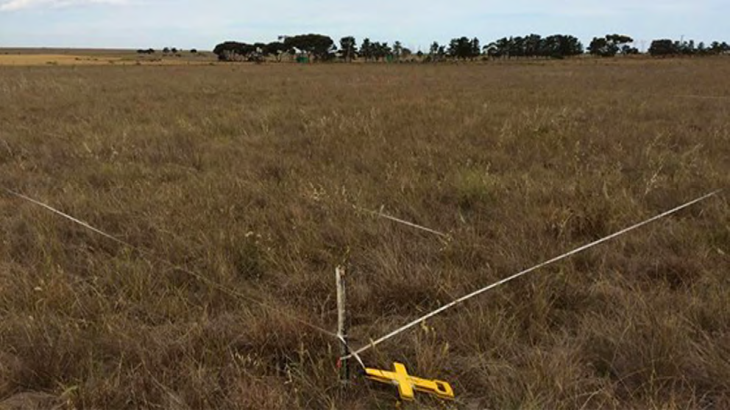
Figure 46: A point-intercept plot used to sample Natural Temperate Grassland Source: DELWP

- DELWP 2015b, ‘Conservation Area Inventory Guidelines. Melbourne Strategic Assessment’, East Melbourne, Victoria.
- Schultz N, Keatley M, Antos M, Wong N, Moxham C, Farmilo B and Morgan JW 2017, ‘The golf ball method for rapid assessment of grassland structure.’ Ecological Management & Restoration 18, 134-140.

Table 9: Sampling intensity for Natural Temperate Grassland, showing how the different plot types have been dispersed across the states in different years. Source: DELWP

Plot type (and state) | Number of plots
 | 2013 | 2014 | 2015 | 2016 | 2017 | 2018 | 2019 | 2020 | 2021
Rapid plots (1 m2) | - | 47 | 69 | 93 | 124 | 145 | 224 | - | -
Rapid plots (Grid based, 10 m radius) | - | - | - | - | - | - | - | - | 11,513
All point intercept plots | 16 | 23 | 32 | 33 | 32 | 36 | 53 | 53 (69) | 67 (83)
Permanent point intercept plots | 10 | 18 | 24 | 24 | 24 | 27 | 39 | 41 (57) | 67 (83)
Herb-rich grassland (HG) | 5 | 7 | 10 | 10 | 10 | 10 | 14 | 16 | 19
Themeda grassland (TG) | 0 | 3 | 5 | 5 | 5 | 8 | 11 | 10 | 13
C3 grassland (C3G) | 0 | 2 | 3 | 3 | 3 | 3 | 5 | 5 | 13
Nutrient-enriched grassland (NG) | 5 | 6 | 6 | 6 | 6 | 6 | 6 | 7 | 12
De-rocked grassland (DG) | 0 | 0 | 0 | 0 | 0 | 3 | 3 | 3 | 5
De-rocked nutrient-enriched pasture (DNP) | 0 | 0 | 0 | 0 | 0 | 0 | 0 | 0 | 5
Re-allocated point-intercept plots | 6 | 5 | 8 | 9 | 8 | 9 | 14 | 12 | -
Herb-rich grassland (HG) | 3 | 2 | 4 | 4 | 3 | 1 | 6 | 3 | -
Themeda grassland (TG) | 0 | 1 | 1 | 2 | 1 | 4 | 5 | 5 | -
C3 grassland (C3G) | 1 | 0 | 0 | 0 | 1 | 1 | 0 | 1 | -
Nutrient-enriched grassland (NG) | 2 | 2 | 3 | 3 | 3 | 3 | 3 | 3 | -
De-rocked grassland (DG) | 0 | 0 | 0 | 0 | 0 | 0 | 0 | 0 | -
De-rocked nutrient-enriched pasture (DNP) | 0 | 0 | 0 | 0 | 0 | 0 | 0 | 0 | -

Changes to the MRF
The following changes have been adopted since the MRF was published in 2015.
- All KPIs have been numbered, 1 to 7.
- The formulation of baselines and targets was clarified to clearly indicate which KPIs are assessed against static baselines, and which are assessed using a continual improvement model.
- A new state has been introduced: Restored Grassland (RG), to describe sites that have been resown or replanted. This was foreshadowed in Sinclair et al. (2019).
- Clarification has been provided to explain that grassland states are only reported on when a ‘substantial representation’ of the state is protected. This means that the process of defining the baseline (years 1-5) only commences when this level of protection is achieved. This is to ensure that no baseline is set from a small or
unrepresentative portion of the state, potentially leading to bias. The start dates for

state assessment are as follows: HG: 2015 (plots on Mount Cottrell NCR, Truganina Cemetery and Magpie); TG: 2014 (plots on Wilsons North, Wilsons South and One Tree); C3G 2018 (plots on Mount Cottrell NCR, Little Raven and Basalt); NG: 2013 (Plots on Wilsons North, Wilsons South and One Tree); DG: 2021 (plots on Truganina South NCR, Skylark, Lomandra); DNP: 2021 (plots on Far River, Chain-of-ponds, Rock Correa); R: Not yet achieved.
- All references to native herbs have been changed to native forbs, in line with accepted usage.
- In KPI 3, the term diversity has been changed to richness, in line with accepted usage.
- In KPI 6, it has been clarified that the bare ground cover range includes the value 25.0 (not 24.9) and 75.0 (not 75.1).
- The measurement of KPI 7 has been changed so that it includes all plots and is calculated in the same way as other KPIs which measure vegetation cover. The baseline for KPI 7 is now set after the first five years and reported by state. This KPI will be assessed using a continuous improvement approach, whereby the baseline will be updated after five years if an improvement has occurred. The trend in perennial weeds is presented as another measure (Other measure 9).
- The baseline for KPI’s 2, 3, 4 and 5 is the grand mean (i.e. the mean of the mean of each year) of the plots by state for the first five years in 20 x 20 m plots – only permanent and re-randomised plots are used.
- All reference to flora and fauna inventories has been removed. Inventories are instead completed as part of the management preparations for individual parcels, as once- off activities, and not as part of the five-yearly reporting under the MRF. They are lengthy and would be a distraction in the five-yearly reporting against KPIs.
- The other measure that tracks the covers of C3 and C4 grasses has been changed to report simple cover measures for each, rather than a combined proportional measure.
- The stipulation that monitoring of kangaroo abundance and pest animal abundance is to commence in the Western Grassland Reserve only when a large aggregation of parcels is protected (>5000 ha of connected land). In the smaller Conservation Areas these animals may be monitored on a case-by-case basis, if they are perceived to be problematic.
The following additional changes were implemented in 2021, specifically in response to the audit of the MSA conducted by VAGO (2020), which recommended further emphasis on mapping and monitoring weeds:
- Point intercept plots are positioned to sample all protected areas/states, including those which are not Natural Temperate Grassland. State DNP was previously excluded from reporting since it is not strictly Natural Temperate Grassland. Now it is monitored, but not assessed for the KPIs (it is included as an other measure).
- The rapid plot method has been replaced by a new rapid plot method, with the following changes:
  - The variables that are visually estimated at each plot have been changed slightly.
  - These variables are estimated over a 10 m radius (314 m2), rather than within a 1 m frame. This ensures that much more land area is included in sampling and solves the issue of some plots sampling un-representative vegetation

due to their small size in patchy vegetation. There is no requirement to physically mark these plots, a visual estimate of 10 m should be sufficient.
  - The plots are placed on a permanent 240 m square grid covering the whole WGR (previously plots were randomly repositioned each year). This almost retains the plot density used previously to assess KPI 6 (recommended 1 plot per 5.8 ha, previously 1 plot per 5 ha), but allows repeat estimates to be taken which can be used as input data for the Natural Temperate Grassland ecosystem model. Sampling on this grid occurs annually, to serve KPI 6.
  - All reserved land is covered by these surveys, and as much private land as can be accessed, in partnership with Local Government. The inclusion of private land addresses the VAGO Recommendation 2. Only plots that fall on reserved land serve KPI 6.
  - Plots are sampled whether the vegetation qualifies as Natural Temperate Grassland or not. This ensures that weed issues on non-Natural Temperate Grassland land are detected. Only plots that sample Natural Temperate Grassland (as mapped in the inventory report) contribute to the assessment of KPI 6. Individual 10 m radius plots that appear not to be Natural Temperate Grassland are included if they fall within mapped Natural Temperate Grassland.
  - In the first year a property is available for sampling, position plots on a higher-density 80 m square grid (positioned to also sample the 240 m grid, above). When 10 m radius plots are used on an 80 m grid, ~5% of the landscape is within a plot. Each plot can be assigned to a state from its cover data, allowing the state and weed mapping (see above) to be derived from this plot data (guided by the plot data in combination with the visible boundaries on aerial imagery).
  - At least once every five years, ensure that each property is sampled at high density (80 m grid). This ensures that no sizeable area of land goes unobserved for more than five years and allows the spatial capture of most large-scale weed issues and many weed control campaigns.
  - Undertake discretionary sampling at high density (80 or 40 m grid) wherever managers deem finer-scale cover information to be useful. For example, experimental weed control actions may warrant fine-scale data to be collected over several successive years.
  - Align all sampling grids with the pixels used by the Sentinel-2 satellite, which operates under the Copernicus Programme of the European Space Agency. This satellite provides regular data for fixed 10 x 10 m pixels across the relevant region, 10 m apart. This alignment will allow all rapid plot data to be used as training data to inform algorithms for the remote detection of weeds and native plant cover.
- Abandon the use of golf ball plots for Natural Temperate Grassland. Amend the MRF to include the golf ball assessment under the protocols for Striped Legless Lizard and Golden Sun Moth, where the resultant data are used.

MNES 2: Grassy Eucalypt Woodland

The following is an extract from the 2015 Technical Protocols for Program Outcomes document.320
Background
The plot design for GEW is similar to that for NTG, but takes into account the tree layer, which is patterned at a relatively large scale (the average mature Eucalyptus camaldulensis canopy is ~20 m wide locally). A mixture of permanently marked and annually re-allocated plots will be employed (to manage the trade-off noted below, under ‘Supporting Information’). It is expected that 75% of the plots in each state will be permanent, and 25% will be re-allocated annually; however, this allocation may be altered if required. Several scales of plot are used.

Intensive point-intercept plots (20 x 20 m)
This sampling method addresses the following KPIs:
- Cover of native perennial herbs in GEW states
- Diversity of native perennial herbs in GEW states
- Cover of target grass species in GEW states
- Cover of perennial weeds in GEW states.
Sampling will be repeated every year in spring (1 September–30 November).
Each plot will be a square 400 m2 in area (20 x 20 m). The plots will be aligned with the points of the compass (north, south, east, west), and those plots which are permanently marked with a short metal peg at the north-west corner.
Five 20 m lines will be laid out across the plot (meeting the sides at 2, 6, 10, 14, 18 m). These lines will each define a set of 50 sampling points, located 40 cm apart. In total, the plot will contain 250 sampling points.
At each point, a narrow metal pin will be held vertically, and any vascular plant species, exposed rock, detached plant litter, bare ground or moss intersecting the pin recorded. Multiple items may be recorded at a single point (including multiple plant species, rock and plants), meaning that when the values for all plants are summed, the total cover may exceed 100%. Every data point for plant species will be recorded as basal area (a point where the plant contacts the ground; a stem or tiller), or ‘cover’ (a point where any plant part touches the pin, including leaves held away from the base of the plant). Every basal point also contributes to cover (i.e. basal area is a subset of cover).
After the point intercept measurements are complete, an unstructured 3-minute search of the plot will be undertaken, to record all native herb and shrub species. Native herbs and shrubs are defined as any native species not in the families Poaceae, Juncaceae or Cyperaceae. Species of ambiguous native or exotic status will be ignored.

- DELWP 2015c, ‘Technical Protocols for Program Outcomes. Melbourne Strategic Assessment’, East Melbourne, Victoria.

Intensive plots will be allocated randomly (some permanent, some re-allocated), and stratified according to state. The stratification will also require that one or more plots fall within populations of Matted Flax-lily, see below. We do not yet know the spatial distribution of the states, so the stratification cannot be tabulated (c.f. grassland).
Conservation Areas outside the major GEW Reserve will be sampled by at least two plots, with an extra plot added for every 50 ha of woodland vegetation (50–100 ha: 3 plots, 100–150 ha: 4 plots, etc.). Half will be annually re-allocated (at least one of each kind in each relevant area).

Larger vegetation structure plots (50 x 50 m)
Large 50 x 50 m plots will be employed for woodland structure measurements, addressing the following KPIs:
- Percentage of plots in different woodland structure categories
- Percentage of plots with Eucalypt recruits.
The larger plots will each be centred on a 20 x 20 m plot (described above), extending 15 m out each side and marked with a short, permanent peg at each corner.
All trees >1.3 m tall (breast height) within the plot will be counted and assigned to size classes based on their diameter at breast height (dbh) (<5 cm (saplings), 5–60 cm (small trunks), >60 cm (large trunks)). Eucalyptus stems will be distinguished from stems of other groups (wattles, woody weeds).
The presence or absence of Eucalyptus seedlings <1.3 m high will be recorded.
Canopy photographs will be taken vertically at breast height to allow automated measurement of canopy cover (the mean of four photographs per plot, each taken from a 1 m high tripod located on the corners of the smaller plot). Canopy thus does not include cover below breast height.
Each plot will be assigned to one of three landscape positions, on the basis of subjective field observations:
- Undulating Plains
- Gilgai Plains
- Stony Rises.
Each plot will be assigned to one of four woodland structural types, as shown in Table 10: Plots which do not conform to any listed structural type are physically possible but are known to be exceedingly rare. Any such plots should be ignored when assessing the structural KPI (i.e. atypical plots are considered neither desirable nor undesirable in the structural mix).

Table 10: Definitions of woodland structural types Source: DELWP

Structural type | Saplings / shrubs per plot | Trunks per plot | Canopy cover
Multi-layered vegetation | 10 – 200 | >0 | >1
Open vegetation | <10 | 0 | <1
Park-like vegetation | <10 | >0 | >1
Vigorous regeneration | >200 | any number | any number

Changes to the MRF

No changes have been adopted for Grassy Eucalypt Woodland since the MRF was published in 2015.

MNES 3: Seasonal Herbaceous Wetland
The following is an extract from the Outcomes Report 2014–2020.321 Timing of sampling
The monitoring protocol322 requires that the timing of Seasonal Herbaceous Wetlands monitoring is governed by two temporal considerations. These result in two parallel lines of reporting for Seasonal Herbaceous Wetlands:
On drawdown: Wetlands must be assessed each time they draw down after filling, regardless of the date (but only once per year). Filling is here taken to be when most of the wetland area (>50%) meets the definition of ‘full’ given by Casanova and Powling (2014),323 that water reaches a depth of 10 cm. Filling does not occur every year.
Annual: Wetlands must be assessed every year between September and December, regardless of their hydrological status. If the drawdown sampling happens to coincide with this period, only a single round of monitoring is required to cover both on drawdown and annual sampling.
At each sampling, the hydrological phase of the wetlands is recorded, using a conceptual model adapted from Bayes and Cook (2015)324 which categorises wetland dynamics into the following five categories:
First fill: Water present, meets definition of ‘full’. Aquatic plants growing but leaves not yet at the water surface. Non-aquatic species present but many drowning. Much decomposing material in the water. Aquatic fauna not yet conspicuous.
Full: Water present, meets definition of ‘full’. Aquatic plants abundant, many emergent and flowering species are prominent on the surface and most are flowering. Aquatic fauna can be abundant (e.g. Shield shrimp, Water Boatmen, frogs).

- Bruce M, Batpurev K, Bryant D, Sinclair S and Kohout M 2020, ‘Melbourne Strategic Assessment: Ecological Outcomes Report 2014-15 to 2019-20.’ DELWP, Heidelberg, Victoria.
- DELWP 2015, ‘Monitoring and Reporting Framework – Melbourne Strategic Assessment’, East Melbourne, Victoria.
- Casanova MT and Powling IJ 2014, ‘What makes a swamp swampy? Water regime and the botany of endangered wetlands in western Victoria.’ Australian Journal of Botany 62, 469-480.
- Bayes E & Cook D 2015, ‘Seasonal Herbaceous Wetlands. Identification and Management Handbook.’ Goulburn Broken Catchment Management Authority.

Drawing down: Puddles and mud present, has recently been full, but no longer meets definition of full. Aquatic and dampland species remain prominent, many seeding.
Annual or geophyte plants prominent. Aquatic fauna often present.
Empty: No water. Soil cracks closed. Aquatic species retreated underground, dampland and semi-aquatic species abundant. Perennial native grasses, rushes and sedges actively growing. Terrestrial ruderals may be common. Aquatic fauna virtually absent.
Dry: No water. Bare ground prominent. Soil cracks evident. Aquatic species retreated underground. Damp-land forbs low cover and stunted. Perennial grasses, sedges and rushes remain prominent, but often inactive. Terrestrial ruderals may be common.
It is acknowledged that some degree of subjectivity is involved with the assignment of a phase at the time of sampling. A diagram depicting the hydrological phases of the wetlands is shown in Figure 47.
Deep drying and soil cracking
Empty
(no/little water, Soil moist)
Rain
Dry
(no water, soil dry)
Evaporation, drying
Rain
Exceptional rain
Drawing-down
(>50% of area : >10cm deep)
First Fill
(>50% of area : >10cm deep)
Rain
Evaporation, drying
Full
(>50% of area : >10cm deep)
Decomposition and Filling response
Rain
Figure 47: Hydrological phases of the Seasonal Herbaceous Wetlands Source: DELWP

Sampling with point intercept plots
Parallel line transects 25 metres apart are set up at fixed locations, to cross the majority of each Seasonal Herbaceous Wetlands area. Along each transect, a 1 x 1 m plot is sampled every 10 metres, provided the location falls within the Seasonal Herbaceous Wetlands (which is irregularly shaped and patchy). If it does not fall within the Seasonal Herbaceous Wetlands, that potential sampling location is ignored and the next sampled. Thus, the transects are of varying length for different wetlands and have gaps where no Seasonal Herbaceous Wetlands are sampled.
Within each 1 x 1 m plot, a wired frame is used to define nine points (spaced on a grid at 10, 50, 90 cm). At every point, the identity of the vegetation (by group) intercepting the points is recorded, in the following categories:
- Persistent perennial native grasses
- Opportunistically growing native grasses
- Perennial native tussock-forming sedges and rushes (Cyperaceae or Juncaceae)

- Perennial native rhizomatous sedges
- Perennial native forbs (aquatic)
- Perennial native forbs (damp-land dependent)
- Perennial native forbs (terrestrial or ruderal)
- Annual native forbs
- Perennial dryland exotic species
- Perennial aquatic exotic species
- Annual and biennial exotic species
- Water
- Bare ground, stones or mud.
Multiple categories are recorded at some points where multiple species overlapped at the point. This data is used to derive cover estimates for each category and hence the percentage of perennial cover that is exotic, as required to address the KPIs. The data are also used to inform the ecosystem model for Seasonal Herbaceous Wetlands.
An example of a plot used in sampling a wetland is shown in Figure 48.

Assessing the diversity of native forbs
All native forbs species encountered during the point-intercept sampling are recorded. One observer spends an additional 20 min/ha actively searching for forb species over the full extent of each wetland.

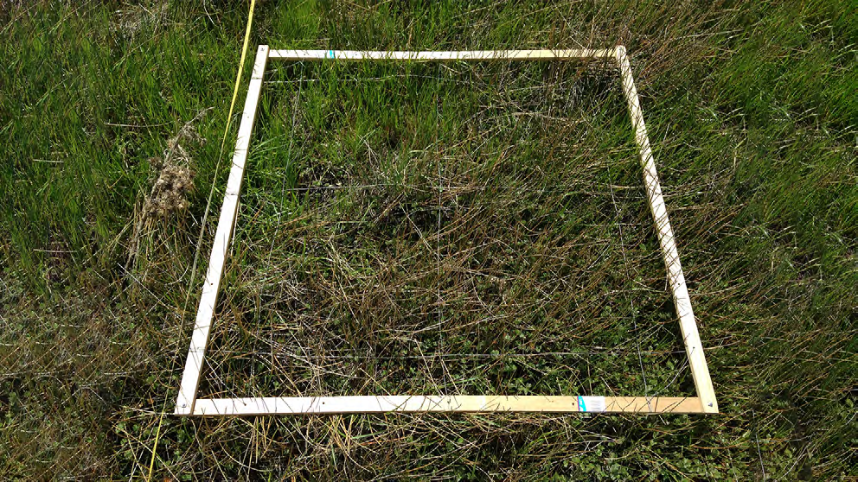
Figure 48: The small plot used to sample Seasonal Herbaceous Wetland, lying alongside the tape measure that defines the transect Source: DELWP

Changes to the MRF
The following changes have been adopted since the MRF was published in 2015.
- All references to native herbs have been changed to native forbs, in line with accepted usage.
- The term diversity has been changed to richness in KPIs 1 and 2, in line with accepted usage.
- All KPIs have now been numbered.
- The formulation of baselines and targets was clarified to clearly indicate that all KPIs are assessed using a continual improvement model.
- The clarification has been added that if a wetland is divided into multiple management units (e.g. by a fence), then these may be reported as separate wetlands, even
if they are each under 3 ha. Distinguishing wetlands with different management is important for modelling and adaptive management. This situation has not yet occurred; currently all wetlands are single management units.
- Filling is now defined in the methods section; this was left undefined in the MRF.
- It is now clearly stipulated that the hydrological phase must be noted at time of monitoring, with a full definition of each phase added to the methods.
- It has been clarified that for KPIs 3 and 4, the baseline is set for a given wetland after the first five years of monitoring, not after one year.
- The phrasing of KPIs 3 and 4 has been altered slightly to match the phrasing of the equivalent KPIs for Natural Temperate Grassland.

MNES 4: Golden Sun Moth
The following is an extract from the Outcomes Report 2014–2020.325

KPI 1: Detection of moths
To stratify Golden Sun Moth surveys, the Western Grassland Reserve is divided into 250 ha grids. Within each grid a 400 x 400 m plot is randomly allocated within Natural Temperate Grassland (excluding the states De-rocked grassland, De-rocked nutrient- enriched pasture, which are assumed to be inappropriate habitat for Golden Sun Moth). This plot allocation has resulted in 11 permanent plots being established in the existing protected area, as of 2019. Additional plots will be established in new areas as they are protected.

- Bruce M, Batpurev K, Bryant D, Sinclair S and Kohout M 2020, ‘Melbourne Strategic Assessment: Ecological Outcomes Report 2014-15 to 2019-20.’ DELWP, Heidelberg, Victoria.

Surveys are undertaken between November and January in each year, with each plot surveyed once per year. In each plot 21 transects are established (20 m apart) and these transects are walked noting the time to first detection, the total number of moths detected and the total survey time. If all transects are walked with no moth detection the species is recorded as absent from that plot). In cases where the shape of the grassland does not allow a plot to fit, transects are arranged 20 m apart that adequately sample the site (e.g. Truganina South NCR, in this case all native grassland was surveyed via transects 20 m apart). As far as practical, surveys are undertaken during conditions thought to maximise the probability of detection (between 11 am and 3 pm, ambient temperature 20-35⁰C, cloud cover <50% and light winds).
The baseline is the mean proportion of the number of plots occupied over the first five years of monitoring. This was set in 2018 as 0.89.

Changes to the MRF
The following changes have been adopted since the MRF was published in 2015.
- The Other measures have been amended to include an estimate of Golden Sun Moth abundance taken from counts of individuals in each plot. This requires a change
in the monitoring protocol such that each plot is fully covered, and all detected individuals are recorded. This is now reported as Other measure 6: number of moths per plot.
- The formulation of the baselines and targets has been clarified to make it clear that the KPI is assessed against a static baseline.
- The requirement for other measures to report the cover of all weeds has been removed as this measure includes exotic C3 grasses that might provide habitat for Golden Sun Moth, hence this may be a misleading measure.
- The other measures (Other measure 5) have been amended to include an estimate of biomass as determined by the “golf ball method”, using the Natural Temperate Grassland rapid plots located within the relevant management unit.
- The requirement for other measures to report the dominant grass in each plot has been removed, and instead the cover of C3 and C4 grasses is reported as other measure 4.
- The recommended survey conditions have been changed such that the recommended cloud cover is up to 50%.
- It is now specified that the other measure of wind direction is reported as the modal (most common) direction recorded at the time of survey for each plot.

MNES 5: Matted Flax-lily
The following is an extract from the Outcomes Report 2014-2020.326

KPI: Detection of plants
A database of the locations of known individuals is maintained and these locations are checked every year. Individuals are recorded as alive, visibly dead, or absent above ground.
Every five years, all relevant areas are searched for new plants. Any new plants found during these area searches or by chance during other field work, are added to the database and checked in all subsequent years.
In each year, as new plants are found, the cumulative count of known plants increases. Each year, all plant locations then known are checked and a percentage of plants detected is calculated. The value used to monitor Matted Flax-lily is the percentage
of known plants found in each year. The baseline is the arithmetic mean of these percentages in years two to five (year one is omitted because it is necessarily 100%).
Occasionally, it can be difficult to determine whether clumps of Matted Flax-lily represent a single large individual or several individuals growing nearby. This cannot be definitively addressed without genetic analysis. For practical purposes, any clumps of Matted Flax-lily separated by more than 75 cm are here considered to be separate individuals.

Changes to the MRF
The following changes have been adopted since the MRF was published in 2015.
- MRF (DELWP 2015a) suggested that the raw counts of plants detected each year are reported, and that the baseline is formed from the mean of the counts in the first five years. This approach has proven problematic due to the steady discovery of new plants (due to the large sites, the intermittent appearance of plants above ground, and the relatively low detectability of this species). If the baseline is set from the first five years alone, it will be set at a relatively low count, which would be easy to achieve in future years, even if the species was declining. To counter this effect, the MRF has been amended to reflect the monitoring and reporting approach described above.
- It has been clarified that a single baseline (set from Kalkallo Common) will be applied to all populations. This assumes all populations have a similar detection rate. This can be tested, by examining how often surviving plants have gone undetected in intervening years. If rates differ significantly between populations, the baselines can be reviewed and applied population-by-population.
- The formulation of the baseline and target was clarified to clearly indicate that the KPI is assessed using a static baseline (the quantity being the proportion of detection).

- Bruce M, Batpurev K, Bryant D, Sinclair S and Kohout M 2020, ‘Melbourne Strategic Assessment: Ecological Outcomes Report 2014-15 to 2019-20.’ DEWLP, Heidelberg, Victoria.

- The methods have been amended to make it clear that any clumps of Matted Flax- lily separated by more than 75 cm should be considered separate individuals. The only exception to this rule is where genetic analysis is used to determine which clumps are clones or distinct individuals. Genetic analysis was undertaken for most known plants in 2019–20, and several adjustments were made to the data. For example, two pairs (four plants) of apparently separate plants were combined (two plants), despite being separated by >75 cm.
- The methods now ensure that other measures include counts of the number of inflorescences, buds, flower heads and fruits per plant, to support the parameterisation of PVA models. Such data should be collected at least once every five years.

MNES 6: Spiny Rice-flower
The following is an extract from the Outcomes Report 2014-2020.327 Population census
Spatial structure of monitoring
Spiny Rice-flower plants occur in varying spatial arrangements; in clusters of varying extent and density (sometimes numbering hundreds of plants and covering hundreds of m2) and as isolated small clumps or lone individuals. To ensure that monitoring effort is focused efficiently on the main centres of population, monitoring is divided into two tiers:
- Clusters of plants are monitored every year and contribute to the assessment of KPIs. A cluster is any group of 10 or more plants, where all plants are within 10 m of another plant in the same cluster. An individual plant must be at least 10 cm from another plant, otherwise it is not counted as a plant (Spiny-Rice Flower can have multiple stems growing from ground level).
- Scattered plants are monitored every five years and are reported every five years as an ‘other measure’. These are defined as any plants outside clusters.
It is estimated that >95% of all plants are within clusters, so that the KPI is adequately addressed by the measurement of clusters only. The previous monitoring method described in the MRF covered a far lower percentage of plants and has been replaced for that reason.
KPIs are reported by site. Some sites may have several clusters and many scattered plants.
Population counts in clusters
Spiny Rice-flower is monitored at any time of year, but optimally in winter when it is flowering. A full count is undertaken for each cluster, with the location of every plant recorded as X, Y coordinates on a permanently marked grid. The coordinates from previous years may be used to aid plant searches in subsequent years.
Recruits are identified and recorded (plants not recorded in prior years and with no evidence of previous years’ growth).

- Bruce M, Batpurev K, Bryant D, Sinclair S and Kohout M 2020, ‘Melbourne Strategic Assessment: Ecological Outcomes Report 2014-15 to 2019–20.’ DELWP, Heidelberg, Victoria.

Currently, only two MSA properties support clusters of plants:
- Truganina Cemetery Grassland (Conservation Area 10)
- Western Grassland Reserve, Radio block.
Counts of scattered plants
The location of isolated plants is recorded and they are revisited every five years to determine if they remain (next visit due in 2023). Currently this method is used to record plants on three sites: Mount Cottrell Nature Conservation Reserve, Radio and Magpie, all in the Western Grassland Reserve. Any additional scattered plants located over time are simply added to the total reported.

Vegetation measures
Several habitat parameters relevant to the recruitment and persistence of Spiny Rice- flower are reported for each population: bare ground, cover of all weeds, biomass (cover of all plants), reported per site; and vegetation species composition, reported as the top five most abundant species across all plots (DELWP 2015a). These vegetation measures are all derived from 20 x 20 m point intercept plots undertaken as part of the monitoring for Natural Temperate Grassland. A single plot is located within each cluster. It is assumed that these plots adequately represent the vegetation supporting the populations.

Changes to the MRF
No changes have been adopted since the MRF was published in 2015.

MNES 7: Southern Brown Bandicoot
The following is an extract from the Outcomes Report 2014-2020.328

Site selection
A GIS layer was created to define likely bandicoot habitat within the management area defined in (DEPI 2014),329 by combining:
- the area predicted to have a >56% likelihood of Southern Brown Bandicoot occurrence by the DELWP habitat distribution model and recent (post 2000) Victorian Biodiversity Atlas records of Southern Brown Bandicoot buffered by 150 m
- One hundred sampling locations were randomly positioned within the resulting area with the constraint that all sites must be separated by at least 500 m. This minimum distance was chosen to limit the likelihood of an individual bandicoot being detected across multiple sites.

- Bruce M, Batpurev K, Bryant D, Sinclair S and Kohout M 2020, ‘Melbourne Strategic Assessment: Ecological Outcomes Report 2014-15 to 2019-20.’ DELWP, Heidelberg, Victoria.
- DEPI 2014, ‘Sub-regional Species Strategy for the Southern Brown Bandicoot.’ East Melbourne, Victoria.

- These randomly generated sites were examined initially on aerial photographs and then in the field, to ensure:
  - the security of cameras at the site
  - the presence of native vegetation (e.g. not in the middle of a paddock)
  - the presence of sufficiently homogenous habitat to allow two cameras to be installed 50 m apart
  - site access was safe and permissible (permission was arranged with private landholders where necessary).
In cases where a randomly generated site did not meet these criteria, the site was moved to a new location within 150 m of the randomised sites. In a minority of cases no nearby site could be found and entirely new sites were created in the field, based on drive-by assessments of habitat not guided by the randomised points.

Camera setup
Cameras were deployed in four separate periods with one deployment per site in 2019 (February, March/April, May or June/July). Two cameras were deployed at each site, each a different model (Reconyx HP2X Hyperfire 2 Professional Covert IR and Reconyx HC 600). Cameras were deployed between February and July 2019 in four separate deployments. All cameras were deployed for a minimum of 26 days.
Cameras were attached to the nearest suitable tree, approximately 0.5 m from the ground (using a cable lock to prevent theft). Cameras were pointed at a bait station, located
~2.5 m from the camera (the exact distance and angle is determined by the camera’s detection field, dependent on the camera model and noted in the manufacturer’s instructions). Bait was secured in an inaccessible plastic container. It consisted of a 5:1:2 mixture of rolled oats, golden syrup and peanut butter with 20 ml/kg of truffle oil. To minimise false triggers due to air movement and temperature fluctuation, cameras were directed south and downslope, where possible. The area between the camera and bait station and 1 m behind the bait station was cleared of vegetation and debris.
All cameras were pre-programmed as follows: five pictures per trigger, Rapidfire, NO Delay, Sensitivity HIGH, DAY & NIGHT. PIR TYPE for HP2X cameras was set to HF Legacy so as the motion detector would function the same as that of the Reconyx HC 600 cameras.
Although the cameras were deployed at 100 sites, only 98 sites yielded data for analysis in 2019; a wildfire in March 2019 (Bunyip complex) destroyed both cameras at two sites and no data could be recovered. These sites should remain as part of the monitoring program in future years. One camera was stolen, but this site was still included in the analysis because the other camera at this site operated without incident.

Data analysis
For Southern Brown Bandicoot, the occupancy is estimated using an occupancy model.330 Occupancy modelling also provides an estimate of uncertainty (expressed as confidence intervals) which is used to assess whether the KPI has been met.

- MacKenzie DI, Nichols JD, Royle JA, Pollock, KH and Bailey L (Eds.) 2005, ‘Occupancy Estimation and Modelling: Inferring Patterns and Dynamics of Species Occurrence.’ Academic Press, Cambridge, Massachusetts.

All animals captured on photos were identified by staff experienced in small mammal identification. All photos capturing Southern Brown Bandicoot were tagged to be included in occupancy analysis. Two parameters are estimated in this analysis, the probability of occupancy (the probability of the true presence at a site) and the probability of detection (the probability of detecting a species if it is present at a site). This type of modelling accounts for imperfect detection (where the probability of detection is <1). This approach is commonly used to analyse data obtained from remote camera surveys.331
Detection histories were compiled in R using the package camtrapR.332 Data from both cameras at a site were combined to produce a single daily detection history for each site. For each 24-hour period (midnight to midnight) at each site data was coded as either 1 (Southern Brown Bandicoot detected) or 0 (Southern Brown Bandicoot not detected). Detection histories were produced for 26 consecutive days as this was the minimum amount of time that at least one camera operated per site.
Occupancy analysis was conducted in R using the package unmarked.333 The probability of occupancy and detection was computed for a single season334 using the “occu” function. Several co-variates were tested for their impact on occupancy and detection (Table 11) The co-variates were habitat type (roadside, reserve or canal side), vegetation type (‘Eucalypt-dominated woodland’ or ‘Treeless scrub and heathland’) and survey month (February, March/April, May or June/July). The best supported model was chosen as having the lowest Akaike information criterion (AIC) value,335 using the “modSel” function.

Table 11: Details of occupancy model covariates and the AIC values for each model. Models with a lower AIC are considered to have more support. The column ΔAIC shows the difference in AIC from the best supported model (model 11, highlighted in bold). Source: DELWP

Model number | Occupancy | Detection | AIC | ΔAIC
1 | No covariates | No covariates | 1523.6 | 33.6
2 | Habitat type | No covariates | 1517.3 | 27.3
3 | Vegetation type | No covariates | 1525.0 | 35.0
4 | No covariates | Habitat type | 1504.3 | 14.3
5 | No covariates | Survey month | 1496.3 | 6.3
6 | No covariates | Vegetation type | 1524.8 | 34.8
7 | Habitat type | Habitat type | 1498.1 | 8.1
8 | Vegetation type | Vegetation type | 1526.2 | 36.2
9 | Vegetation type | Habitat type | 1505.7 | 15.7
10 | Vegetation type | Survey month | 1497.7 | 7.7
11 | Habitat type | Survey month | 1490.0 | 0.0
12 | Habitat type | Vegetation type | 1518.5 | 28.5

- Meek P, Flemming P, Ballard G, Banks P, Claridge A, Sanderson J and Swann D (eds.) 2014, ‘Camera Trapping: Wildlife Management and Research.’ CSIRO Publishing.
- Niedballa J, Sollmann R, Courtiol A and Wilting A 2016, ‘camtrapR: an R package for efficient camera trap data management.’ Methods in Ecology and Evolution 7, 1457-1462.
- Fiske I and Chandler R 2011, ‘unmarked: An R Package for Fitting Hierarchical Models of Wildlife Occurrence and Abundance.’ Journal of Statistical Software, 43, 1-23.
- MacKenzie DI, Nichols JD, Royle JA, Pollock KH, Bailey LL and Hines JE (Eds.) 2017, ‘Occupancy Estimation and Modeling’ (Second Edition), Academic Press Cambridge, Massachusetts.
- Akaike H 1974, ‘A new look at the statistical model identification.’ IEEE Transactions on Automatic Control 19, 716–723

The fit of the best supported model (the model with the lowest AIC; model 11 was tested with 2,000 chi-squared simulations using the parboot function. The mean, lower and upper 95% confidence intervals for occupancy and detection probabilities were calculated using the predict function.

Changes to the MRF
The following changes have been adopted since the MRF was published in 2015.
- Detection probability has been added to ‘other measures’ so that the adequacy of survey length (number of days) can be adequately demonstrated. Mean deployment length should be such that a cumulative detection probability of 0.99 is achieved, in this case 20 days would have been adequate.
- The source of the other measure ‘fox occupancy’ has been changed from fox bait take to the percentage monitoring of sites at which foxes were detected, so that available data can be utilised. The frequency of this measure has been changed from as required by the baiting program to five yearly.
- The KPI and baselines are reported by three habitat types: canal, roadside and reserve.
- The other measure: ‘extent of development’ has been removed.

MNES 8: Growling Grass Frog

The following is an extract from the 2015 Technical Protocols for Program Outcomes document.336
Predicted risk of extinction using a stochastic patch occupancy model (SPOM)
The predicted risk of extinction will be determined using a SPOM which simulates the stochastic changes in the occupancy of each patch though time. Changes in occupancy is a function of the per time-step probabilities of extinction and colonisation. From
this process the predicted risk of metapopulation extinction over a 50-year period will be derived by calculating the proportion of simulations in each time-step where the number of extant populations is zero. The predicted risk of extinction will initially be determined assuming that all development of category 2 Growling Grass Frog habitat has occurred. Program interventions will then be updated in the model to determine the predicted risk of extinction resulting from those interventions. Full details of the derivation of these parameters are given in Heard et al. (2013).337
It is important to note here that the probability of occupancy for each time step is calculated according to the probability of occupancy at the previous time-step. For this reason empirical data derived from regular surveys can improve model performance. The baseline may also be adjusted as a result of the new data.

- DELWP 2015c, ‘Technical Protocols for Program Outcomes. Melbourne Strategic Assessment’, East Melbourne, Victoria.
- Heard GW, McCarthy MA, Scroggie MP, Baumgartner JB and Parris KM 2013. ‘A Bayesian model of metapopulation viability, with application to an endangered amphibian.’ Diversity and Distribution. 19, 555–566.

Surveys
At least 40 wetlands per metapopulation will be sampled in a given year and where possible sampling will be balanced between on-stream and off-stream habitat within conservation areas.
Frog surveys will be undertaken by experienced observers. Surveys will be conducted at night, between October and March, with at least two repeat surveys requires per wetland wherever possible. The number of surveys required to achieve a detection probability of 0.95 is two from October to December and three from January to February. Each repeat survey will consist of the following (from Heard et al. 2010).338
- Ten-minute quiet observation from the waterline, listening for males calling.
- Systematic search of the site with spotlights looking for active frogs.
- Where appropriate, within 20 m of the waterline, an active search by lifting rocks, logs or other surface debris (e.g. sheets of tin).
- The detection or non-detection of frogs during the call and visual surveys should be recorded separately.
- Other information to be recorded at each wetland:
  - Site location (coordinates) and unique site code
  - Date of survey and survey number (e.g. 1 of 3)
  - Start and finish times
  - Air temperature, wind strength, relative humidity and rain intensity
  - Water temperature
  - Salinity (measured via electrical conductivity)
  - Names of personnel
  - Vegetation structure should be visually assessed, using the protocols used by Heard et al. (2012, 2013).
Repeat surveys at most monitoring sites in each year are necessary to provide a basis for assessing the likely rate of false-negatives (i.e. failure to detect at occupied sites) in the data.

Changes to the MRF
No changes have been adopted since the MRF was published in 2015.

- Heard GW, Scroggie MP, Clemann N 2010, ‘Guidelines for managing the endangered Growling Grass Frog in urbanising landscapes.’ Arthur Rylah Institute for Environmental Research Technical Report Series No. 208. Department of Sustainability and Environment, Heidelberg, Victoria.

MNES 9: Small Golden Moths Orchid
The following is an extract from the 2015 Technical Protocols for Program Outcomes document.339

General protocol
Monitoring for this species will include an annual intensive count of known plants and a five-yearly broad area survey to locate any new or previously undetected plants.
All surveys will be undertaken by trained botanists, familiar with identification of this species.

Broad area survey
Transects 50 m apart will be established, running north-south across the area of high-quality native vegetation in the south-east corner of the Conservation Area (~30 ha, transect length ~6 km).
Each transect will be examined once (single experienced observer each transect) and any plants visible from the transect will be recorded, in order to detect the spatial distribution of clusters of plants in the Conservation Area. New plants will be marked so that they can be included in the intensive surveys.

Intensive count
At the first survey, a permanent transect grid will be established, aligned north-south, with transects 4 m apart. It will cover the whole known population in the conservation area (total estimated transect length ~10 km).
Plants will be located by systematically walking the transects. Plants will be marked with a numbered pin, representing the north-east corner of a 10 x 10 cm square centred on the plant, aligned so that one edge is parallel to the transects (north-south). The positions of all plants will be recorded using their coordinates on the transect grid.
The status of any previously marked plants (with marker pins) will be noted as either emergent or not. Plants are considered to be the same individual if they emerge within the 10 x 10 cm square aligned as described above. A metal detector may be used to re- locate marker pins; the final count of emergent individuals for each year is the number of occupied squares.

Changes to the MRF
No changes have been adopted since the MRF was published in 2015.

- DELWP 2015c, ‘Technical Protocols for Program Outcomes. Melbourne Strategic Assessment’, East Melbourne, Victoria.

MNES 10: Striped Legless Lizard
The following is an extract from the Outcomes Report 2014–2020.340

General protocol
Striped Legless Lizard is surveyed under artificial habitat in the form of roof tiles, which can be routinely inspected for the presence of the lizard. Roof tiles are laid on grids, each being a rectangle of 50 (10 x 5) roof tiles spaced 5 m apart, oriented such that the long axis runs north-south.
The tile grids are surveyed annually. The tile grids are established two months prior to commencing surveys. The locations of the corner tiles are recorded using a hand-held GPS unit.
At each tile grid the sheltered area underneath the tiles is inspected for evidence of Striped Legless Lizards, including sloughed skins. Six repeat tile checks of each grid are conducted each year, with checks at least one week apart. The tiles are checked between 10am and 4pm, when the tile temperature is between 18–40°C and the ambient air temperature is between 15–30°C. Tile checks do not occur at the same time of day on each occasion for any given tile grid during the survey period.

Identification of permanent monitoring locations
The Western Grassland Reserve is divided into 250 ha square blocks. Any block already containing one or more permanent monitoring plots (from phase 1) are excluded from this phase. Within each of the remaining blocks, 10 random locations are identified, each at least 50 m from any other grid location. One location (one tile grid per location) is surveyed each year, over 10 years, to detect lizards. Any grid found to contain evidence of Striped Legless Lizard (alive, dead or a lizard slough) becomes a permanent monitoring plot (see phase 3). Phase 2 will cease in a 250-ha block if one or more of the following occurs:
- evidence of Striped Legless Lizard is detected at one of the 10 locations;
- evidence of Striped Legless Lizard is detected during Phase 1 inventory surveys on other parcels within the 250-ha block;
- all the grassland is exhausted (i.e. no more plots can fit given the distance rules);
- all 10 random locations have been surveyed.
This is supplemented by the deployment of tile grids as part of the inventory of newly acquired parcels. Grids under which lizards are detected during these surveys may also become monitoring subject to the distance rules outlined below.

Ongoing monitoring of known populations
Any tile grids that have had a Striped Legless Lizard detected become permanent monitoring grids and are monitored for the remainder of the MSA program. At each monitoring location, the original tile grid where the lizard was detected is expanded,

- Bruce M, Batpurev K, Bryant D, Sinclair S and Kohout M 2020, ‘Melbourne Strategic Assessment: Ecological Outcomes Report 2014-15 to 2019-20.’ DELWP, Heidelberg, Victoria.

via the addition of four additional grids nearby, off each corner of the original grid, to form an X arrangement. These expanded grids are located at least 100 m apart. To ensure this spatial separation, the centre point of permanent plots should be at least 282 metres apart (twice the radius of the circle containing the X-shaped plot
plus 100 m). In the case of two new permanent plots being installed in the same year the distance rule also applies where two plots are too close together, the grid where a lizard was first located becomes the permanent plot (the location of the other plot will be noted). The rule applies regardless of property, parcel or management unit boundaries.

Monitoring to date
Prior to 2019 two permanent monitoring plots have been established for this species. One is on Mt Cottrell NCR, following a detection in 2016. In this case the grid
arrangement was altered (from the standard X arrangement) such that the additional grids were placed to the south, west and north of the original location due to a mown fire break and fence directly to the east. On Truganina South NCR the plot is in the standard X arrangement.

Changes to the MRF
The following changes have been adopted since the MRF was published in 2015.
- The stipulation that tiles be removed and stored at the end of each survey period has been removed.
- The other measures have been expanded to include all reptiles and frogs detected under permanent tile grids.
- The permissible timing of surveys has been extended to allow tile grids to be checked between 9 am and 10 am, provided the other optimal survey conditions are met.
- Truganina South NCR has been added to the area considered for monitoring of this species
- The distance rules for the installation of permanent monitoring plots have been amended. The intent is that the edges of permanent plots are at least 100 m apart. To ensure this, the centre point of new permanent plots should be at least 282 m from the centre point of an existing plot. In the case of two new permanent plots being installed in the same year this distance rule applies. The rule applies regardless of property, parcel or management unit boundaries.

MNES 11: Button Wrinklewort
The following is an extract from the Outcomes Report 2014-2020.341

Population census
Button Wrinklewort is monitored between 1 November and 31 December when it is flowering. A full population count is taken, using 3 m wide transects to structure systematic searches of the entire cemetery site. The transects are also used to record the location of every plant as X, Y coordinates. The X, Y coordinates from previous years may be used to aid plant searches in subsequent years.
Recruits are identified and recorded (plants not recorded in prior years and with no evidence of previous years’ growth). Reproductive plants are also identified and recorded (plants with buds, flowers or seed heads from the current year (being careful to exclude seed heads from previous years, which are sometimes retained). On every plant, the number of stems, buds, flowers and seed heads is recorded (at least once every five years, to provide estimates of reproductive output for PVA models).

Habitat measurements
Several habitat parameters known to influence recruitment success of Button Wrinklewort are monitored: bare ground, perennial and annual weed cover.342 These parameters are quantified using a single permanent point intercept plot located within the Truganina Cemetery Button Wrinklewort population, which forms part of the monitoring for Natural Temperate Grassland. This single plot (20 x 20 m) covers a substantial portion of the Button Wrinklewort population and is assumed to adequately represent the vegetation supporting the population.

Changes to the MRF
The following changes have been adopted since the MRF was published in 2015.
- The formulation of baselines and targets was clarified to clearly indicate that the KPI is assessed using a continual improvement model.
- It has now been stated that a belt transect delineated by a pair of tapes 3 m apart is the preferred monitoring method. This provides equivalent coverage to the single tape lines described in the MRF (3 m apart, searched 1.5 m either side), but prevents
accidental double counting at the margins, because the margins are defined by the tape.
- The other measures have been updated to include the number of buds, flower heads and seed heads on every plant, to support the parameterisation of PVA models. Such data should be collected in full at least once every five years.
- The methods have been updated to clarify that the X, Y coordinates from previous years may be used to aid plant searches in subsequent years.

- Bruce M, Batpurev K, Bryant D, Sinclair S and Kohout M 2020, ‘Melbourne Strategic Assessment: Ecological Outcomes Report 2014-15 to 2019-20.’ DELWP, Heidelberg, Victoria.
- Morgan JW 1997, ‘The effect of grassland gap size on the establishment, growth and flowering of the endangered Rutidosis leptorrhynchoides
(Asteraceae).’ Journal of Applied Ecology 34, 566-576.

MNES 12: Large-fruit Groundsel
The following is an extract from the Outcomes Report 2014–2020.343

Population census
Large-fruit Groundsel is monitored between 1 September and 30 November when it is flowering. A full population count is taken for each population, with the location of every plant recorded as X, Y coordinates on a permanently marked grid. Three-metre wide transects are used to systematically cover the population area. Isolated plants away from the monitoring grid may be recorded with a GPS and marked with stakes if appropriate, but they are included in the population count. The coordinates from previous years may be used to aid plant searches in subsequent years.
Given this species is known to have seeds which disperse on the wind, there will be a five-yearly broad area survey of the broader management unit that supports each population to locate any new or previously undetected plants.
Reproductive plants are also identified and recorded (plants with buds, flowers or seed heads from the current year, being careful to exclude seed heads from
previous years, which are sometimes retained). On every plant, the number of stems, buds, flowers and seed heads is recorded (at least once every five years to provide estimates of reproductive output for PVA models).

Changes to the MRF
The following changes have been adopted since the MRF was published in 2015.
- The formulation of baselines and targets was clarified to clearly indicate that the KPI is assessed using a continual improvement model.
- It has been stated that a belt transect delineated by a pair of tapes 3 m apart is the preferred monitoring method. This provides equivalent coverage to the single tape lines described in the MRF (3 m apart, searched 1.5 m either side), but prevents accidental double counting at the margins, because the margins are defined by the tape.
- The other measures have been updated to include the number of buds, flower heads and seed heads on every plant, to support the parameterisation of PVA models. Such data should be collected at least once every five years.
- The methods have been updated to clarify that the X, Y coordinates from previous years may be used to aid plant searches in subsequent years.
- The MRF has been updated to clarify that KPIs are assessed at natural populations, while planted populations are monitored as other measures.

- Bruce M, Batpurev K, Bryant D, Sinclair S and Kohout M 2020, ‘Melbourne Strategic Assessment: Ecological Outcomes Report 2014-15 to 2019-20.’ DELWP, Heidelberg, Victoria.

Published by the Commissioner for Environmental Sustainability, Victoria, 2021
Level 36, 2 Lonsdale Street
Melbourne Victoria 3000

www.ces.vic.gov.au

Accessibility
If you would like to receive this publication in an accessible format, please contact the Commissioner for Environmental Sustainability via email info.ces@ces.vic.gov.au or call +61 3 9948 2829.

©The State of Victoria, Commissioner for Environmental Sustainability 2022. This publication is copyright.
No part may be reproduced by any process except in accordance with the provisions of the Copyright Act 1968. For further information about the Commissioner for Environmental Sustainability, visit www.ces.vic.gov.au

